Ogie Sanchez

ITS-402

**Asynchronus Activity 6**

**Without dork (Normal way of searching anime)**

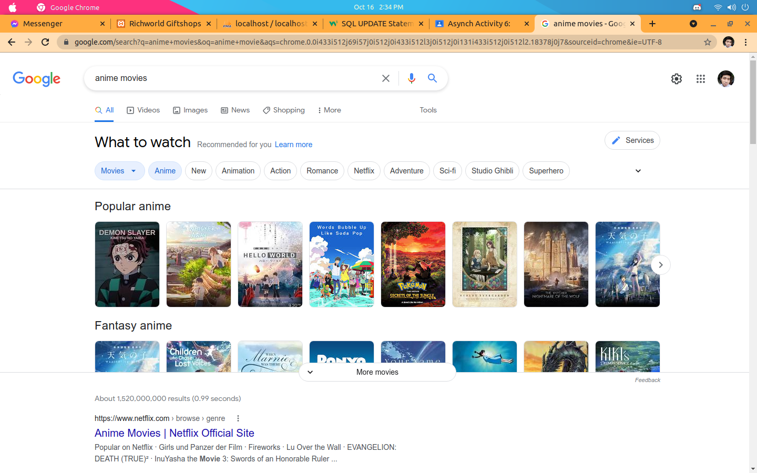

**With dork**

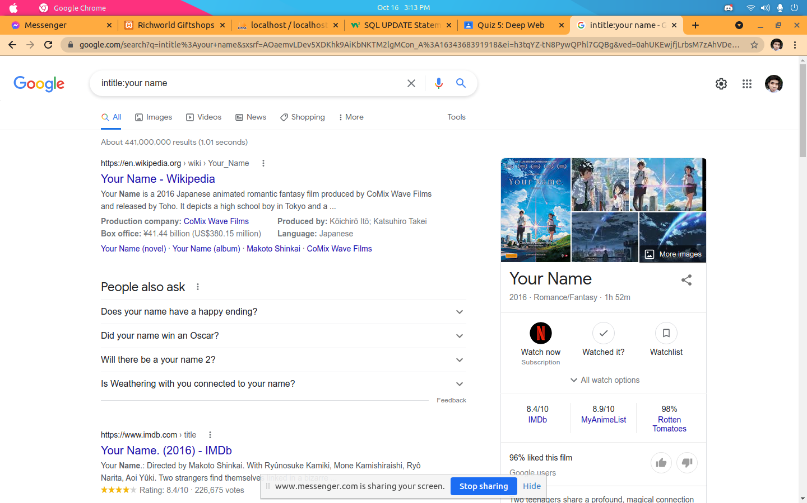

**Without dork –** When searching without dork the search engine will show all the relevant result.

**With dork -** When using dork,You can specify what you really want to search in the web.

2.

Normal search

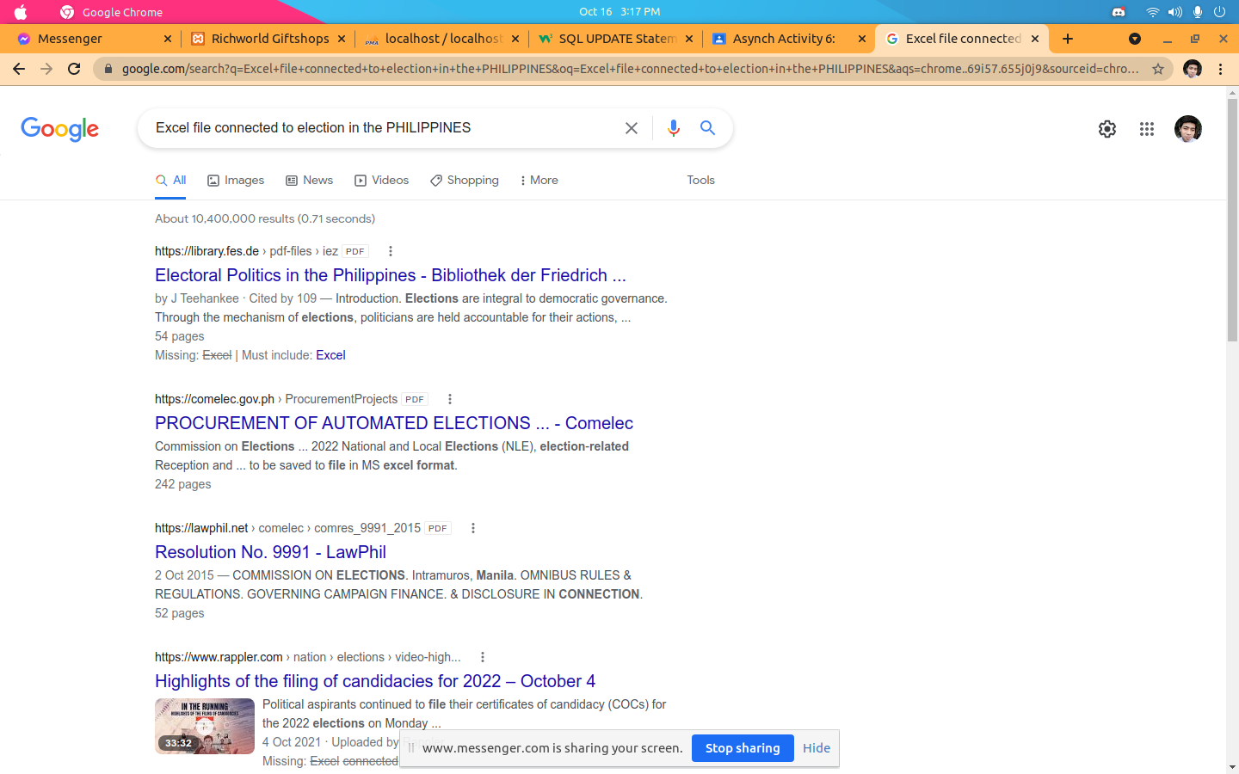with dork

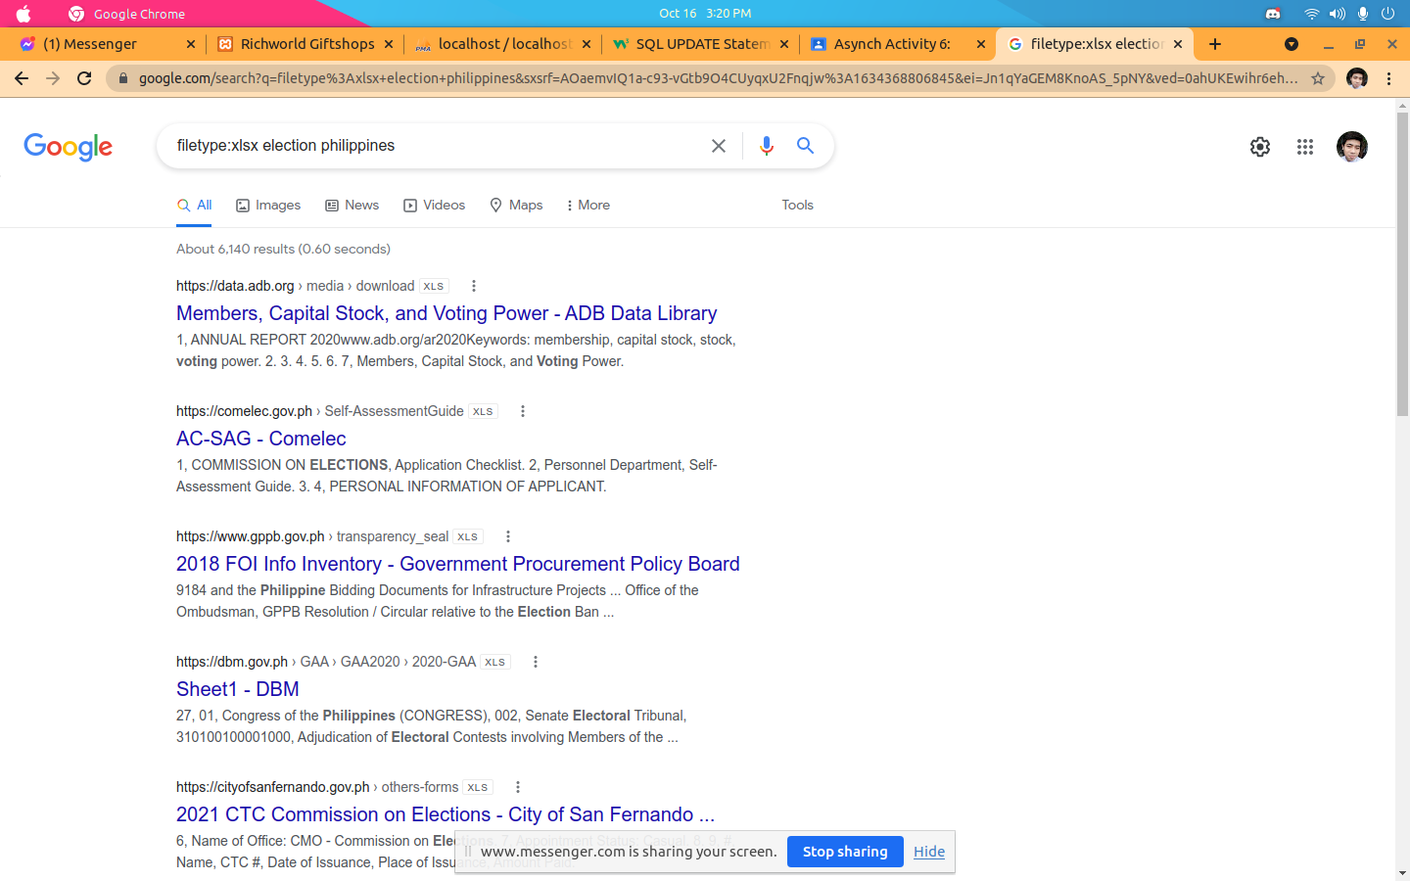

3.

without dork

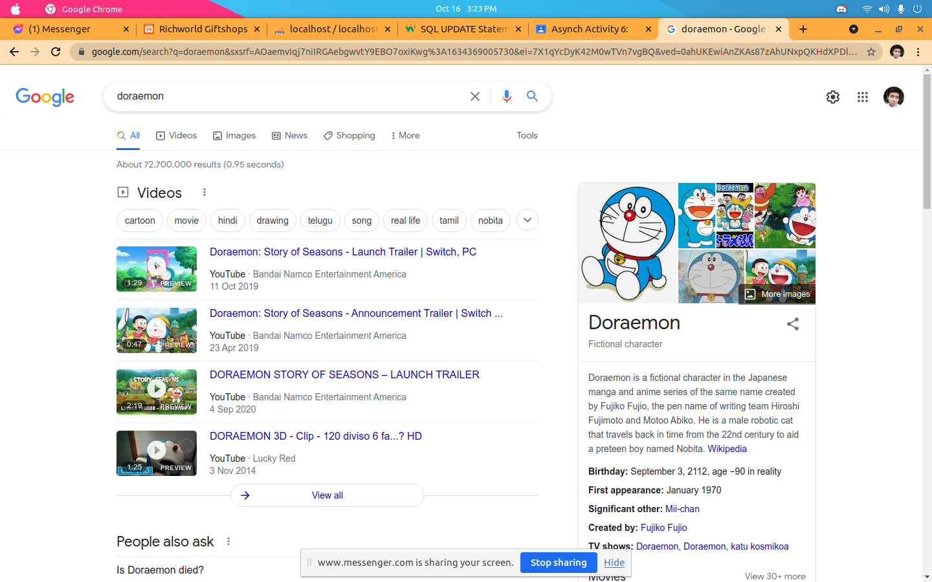

with dork

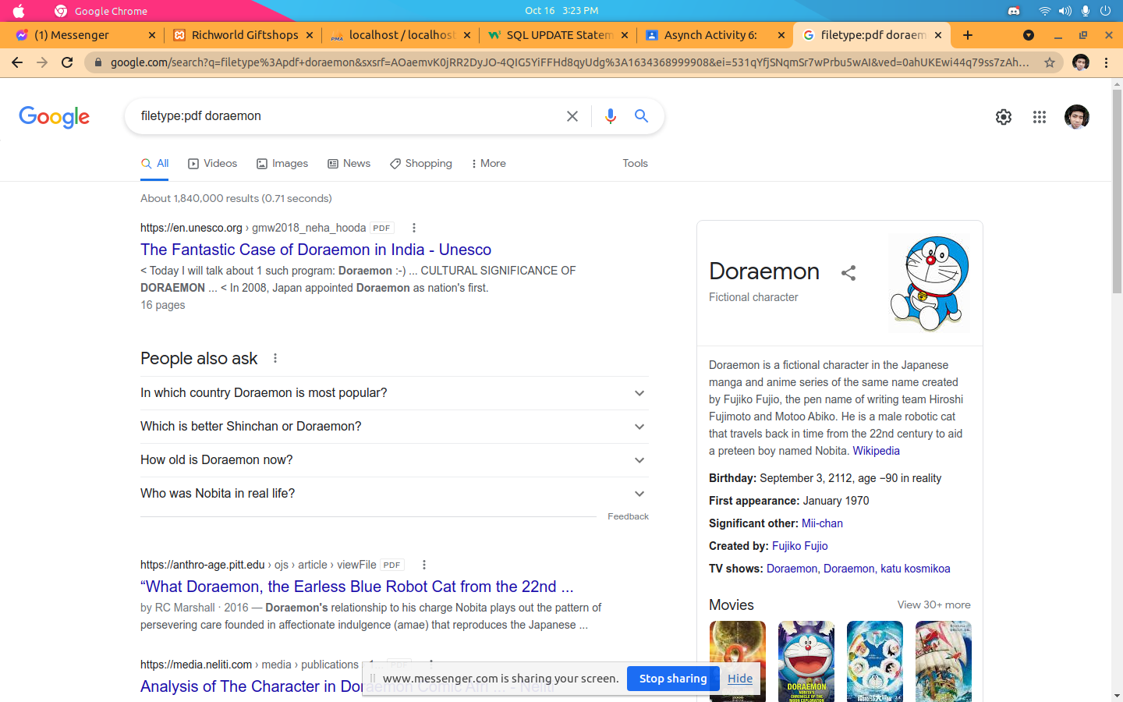

4. PHP my admin

