- Revision

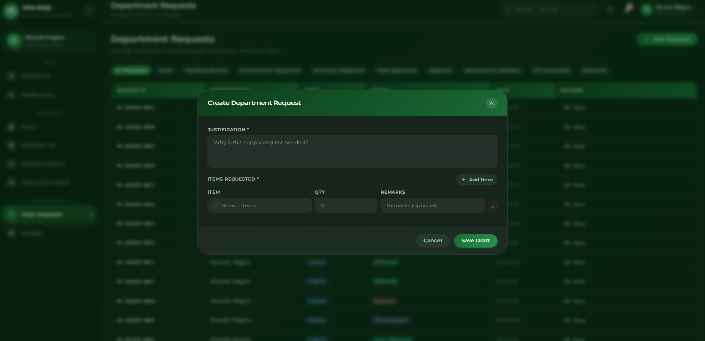

Dito po sa part ng Department Head, kapag gagawa po ng request, dapat po masunod yung actual request form na ginagamit sa PPH para mas realistic at aligned po sa current process nila. Dapat din po may option kung anong department ang nagre-request, para malinaw kung saang department kailangan yung supplies. Yung mga items naman po dapat naka-categorize, halimbawa Pharmaceutical, Laboratory Supplies, Medical Supplies, Janitorial Supplies, at iba pa. Then, para hindi po matagal sa pag-select ng items, kailangan po ng mas convenient na way tulad ng search bar, category filter, or grouped item selection para mas mabilis mahanap at mapili yung kailangan nilang supplies.

List of data need:
Number of Departments
Data of Number ng Items and Supplies
Request Form ng PPH
Procurement Request Form (Not Sure)
NOTE: Isesend ko nalang po ung data na need within this week thru gdrive sir

- Revision
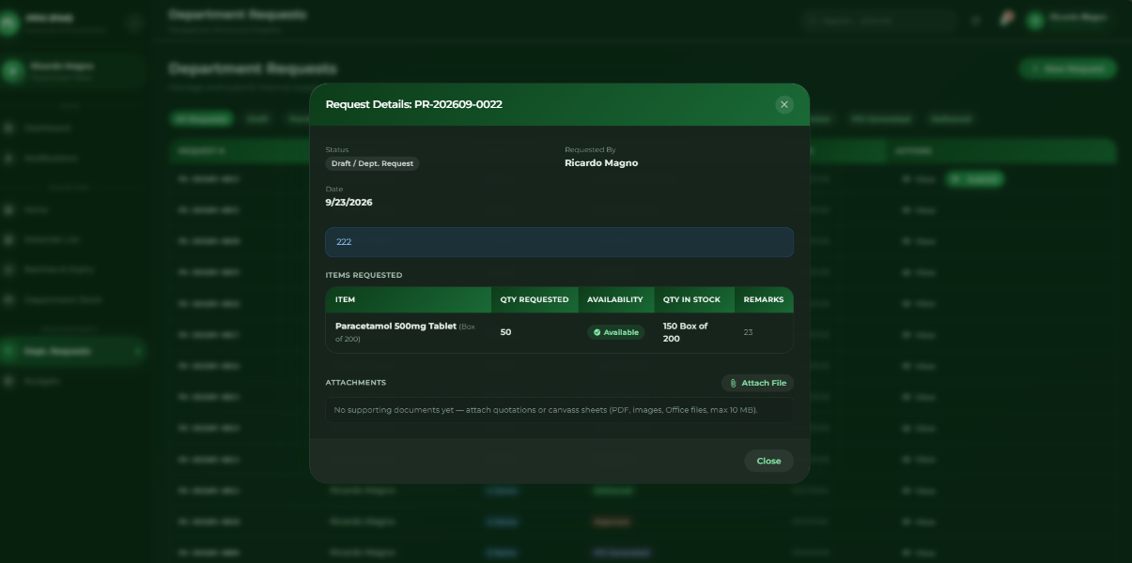

Dito po sa part ng pag-submit at pag-view ng request, dapat po after mag-submit ang Department Head, pwede pa rin niyang ma-view yung mga items na ni-request niya. Dapat may option din po na i-edit yung request, tulad ng pag-change ng quantity, pag-add or remove ng item, at may option din po na i-cancel yung request kung hindi na kailangan. Pero dapat po available lang yung edit at cancel habang hindi pa fully processed or approved yung request.

- Revision

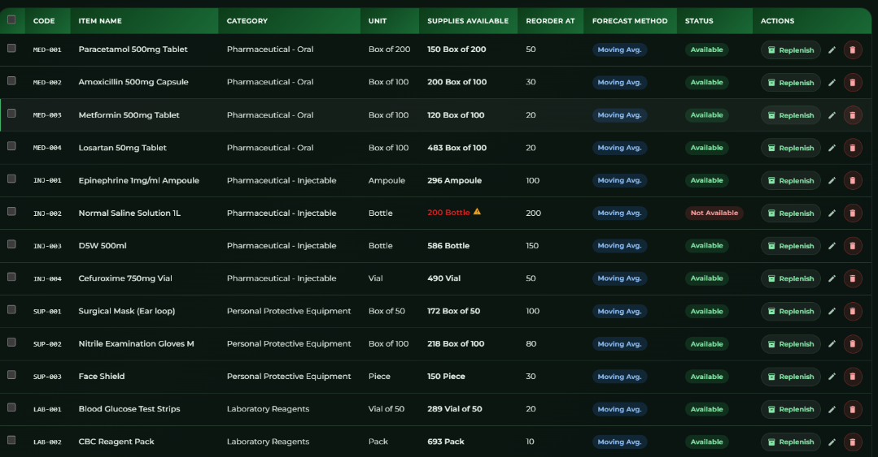

Dito po sa part ng list items dapat daw po parihas ung data na andito at andoon sa PPH kung paano daw po ung nasa spreadsheet

- Revision
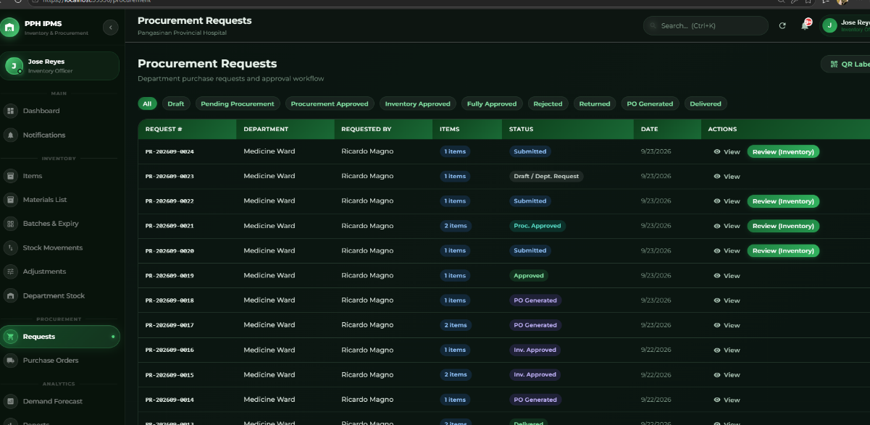

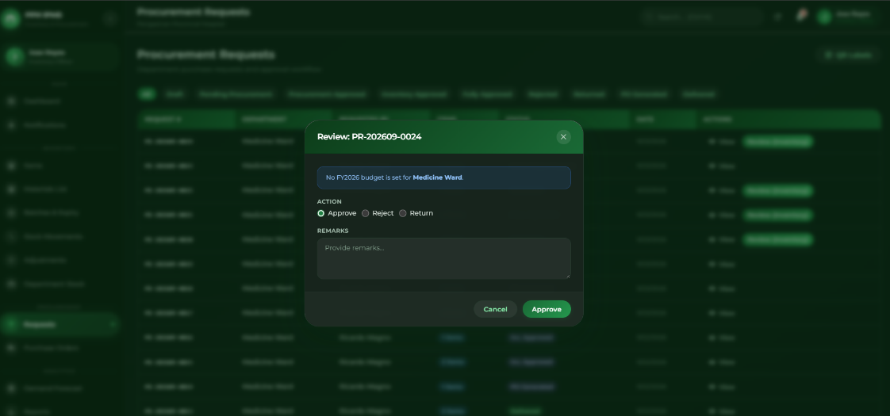

Dito po sa part ng Inventory Officer, kapag may mga request na galing sa iba't ibang departments, dapat po may option si Inventory na i-edit or i-adjust yung quantity ng request kapag hindi sapat yung available stock. Halimbawa po, ang Pharmaceutical ay nag-request ng 30 gloves, Laboratory ay 20, at Janitorial ay 40, pero 80 gloves lang po ang available. Kapag pinagsama, 90 gloves ang kailangan, kaya hindi po sapat ang stock para maibigay nang buo lahat ng requests.
Dapat po makita ng Inventory Officer na limited yung stock at magkaroon ng way para ma-adjust yung quantity na matatanggap ng bawat department. Halimbawa, imbes na maubos agad yung 80 gloves sa unang mga request, pwedeng magkaroon ng fair-share allocation, kung saan hahatiin nang proportional o ayon sa defined rules yung available stock para lahat ng requesting departments ay mabigyan. Ang ganitong approach ay ginagamit sa inventory allocation kapag mas mataas ang total demand kaysa sa available supply.
So ang gusto po ng revision ay hindi lang “approve or reject” ang ginagawa ng Inventory Officer. Dapat may adjust/allocate quantity din. Makikita rin po dapat kung magkano ang requested quantity, available stock, allocated quantity, at remaining stock, para mas malinaw kung bakit nabawasan o na-adjust ang request. This also helps prevent one department from consuming stock that may still be needed by other departments.

Example:
But the hospital only has 80 gloves available.
Instead of allowing all requests to be approved for 90, the Inventory Officer should be able to adjust the quantities and distribute the available 80 fairly among the departments.
This is basically a fair-share inventory allocation approach, where limited stock is distributed among competing requests instead of letting one request consume too much of the available stock.

- Revision
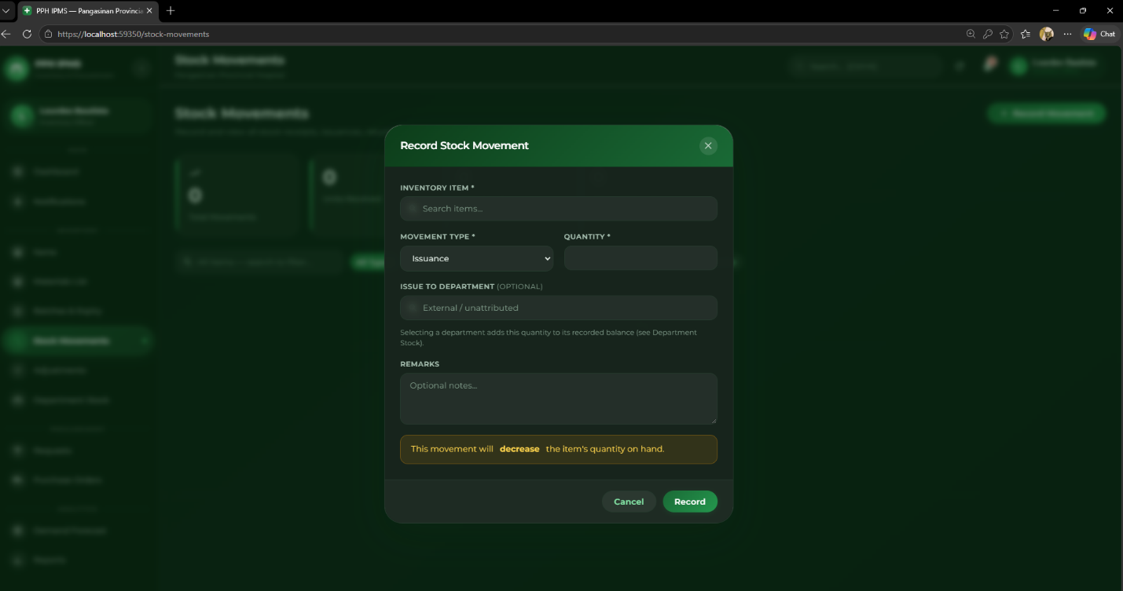

Dito po sa part ng department request, kapag na-approve na po yung request ng Inventory Manager at Hospital Administrator, at sufficient naman po yung available stock, hindi na kailangan na mag-type pa ulit si Inventory ng quantity para i-release yung items. Dapat po automatic na gamitin ng system yung approved quantity from the request.
For example, kung nag-request ang Medicine Ward ng 20 boxes of gloves, at may 80 boxes naman sa central inventory, once approved na po ng Inventory Manager at Admin, automatic na dapat mabawasan ang central inventory from 80 → 60 boxes, then yung 20 boxes ay automatic na ma-record sa Medicine Ward Department Stock.
So magiging flow po:
Department Request → Inventory Manager Approval → Admin Approval → System checks stock → Sufficient stock → Automatic deduction from Inventory → Automatic transfer to Department Stock → Request marked as Released/Received
Ang purpose po nito ay para hindi na doble-doble ang pag-input ni Inventory. Since approved na yung exact quantity, gamitin na mismo ng system yung approved request para ma-update ang central inventory at department stock.

6.Revision
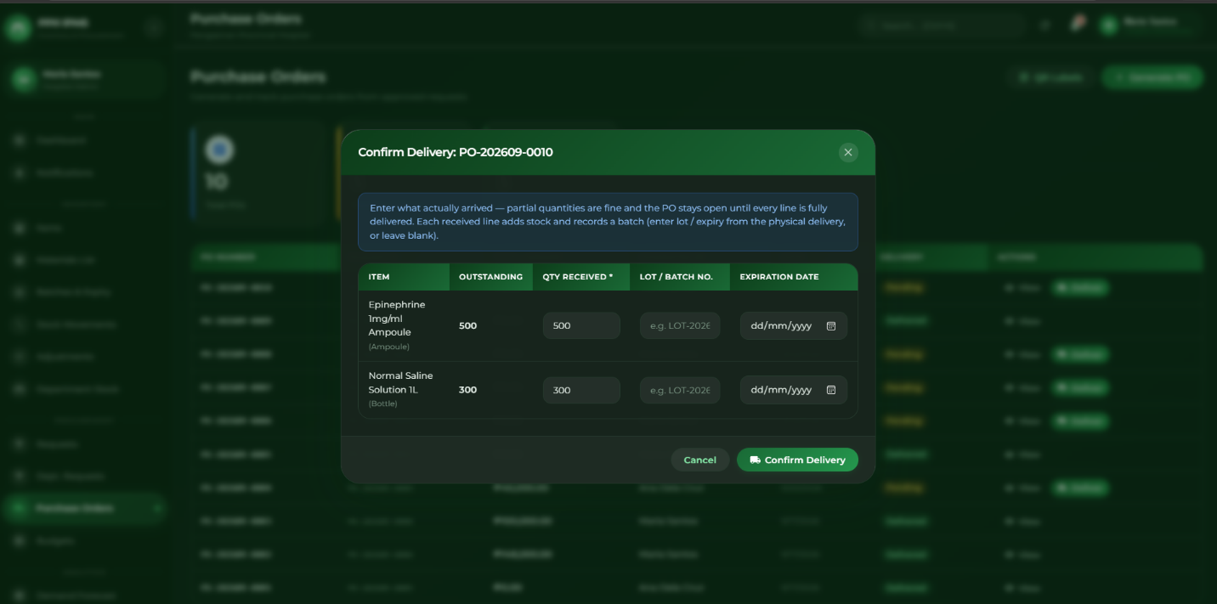

Dito po sa delivery/receiving part, kapag dumating na po yung items from the supplier, Procurement Staff na po ang responsible sa pag-record ng actual quantity na na-receive. Sila rin po ang maglalagay ng Lot/Batch Number at Expiration Date ng mga items. Hindi na po dapat si Hospital Administrator ang gumagawa ng data entry para sa receiving details.
For example, kung ang Purchase Order ay 100 boxes, pero 95 boxes lang ang actual na dumating, Procurement Staff ang maglalagay ng 95 sa Received Quantity. Then, ilalagay din nila yung corresponding Lot/Batch No. at Expiration Date ng natanggap na items.

CURRENT PROCESS OF PPH
Ito po ung flow or process ng PPH
just this process [Department Heads]
↓
Request a specific medical product
↓
[Inventory / Inventory System]
→ Checks current stock availability
→ If stock is sufficient: Product is released/provided to the requesting department
→ If stock is insufficient or critical: System identifies the product for replenishment
↓
[Supply Officer]
→ Reviews the critical/low-stock recommendation
→ Creates a Purchase Request (PR) for the product to be replenished
↓
[Chief of the Hospital]
→ Reviews and approves the Purchase Request
↓
[PHMO – Provincial Hospital Management Office] (Procurement)
→ Receives the approved Purchase Request
→ Proceeds with the appropriate procurement process
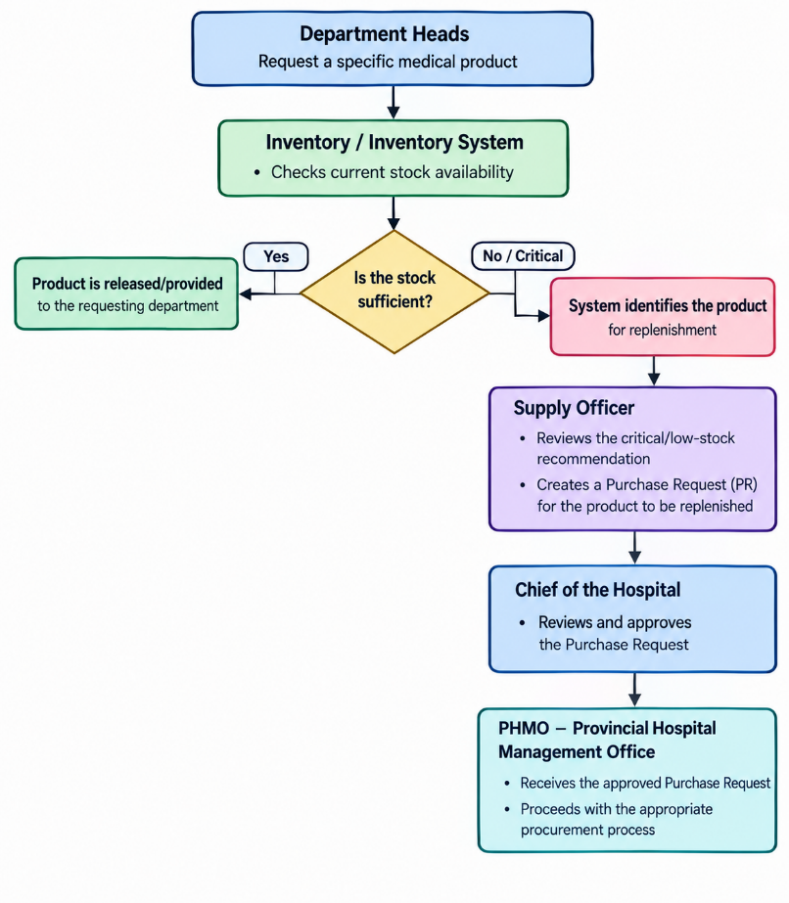

Ito Din po suggestion ng Client

Ang requirement po ng client is hindi lang Department Head ang dapat makapag-request ng supplies. Dapat makikita rin ng mga members or staff ng bawat department yung inventory nila, kasi possible na wala, busy, or hindi nakapasok yung Department Head pero may kailangan na supply yung mga staff. Para hindi na sila maghintay sa Department Head, dapat kaya rin nilang mag-submit ng supply request through the system.
Pero hindi naman kailangan na lahat ng members ay magkaroon ng sariling account. Ang setup is puwedeng magkaroon ng isang designated/shared PC or device per department na ginagamit ng mga members kapag kailangan nilang mag-request. Sa device na iyon, makikita nila yung inventory ng kanilang department at makakapag-request sila ng needed supplies. Yung request ay recorded pa rin under that department, then dadaan pa rin sa required approval process. So basically, the shared PC is for accessibility, habang yung approval and other restricted functions ay mananatili pa rin sa authorized users.

Note 1 by Chair panel
Ito naman po sir ito ung dapat Flow or process na makikita sa system namin sabi ng Chair panel naming parang Cycle lang daw po
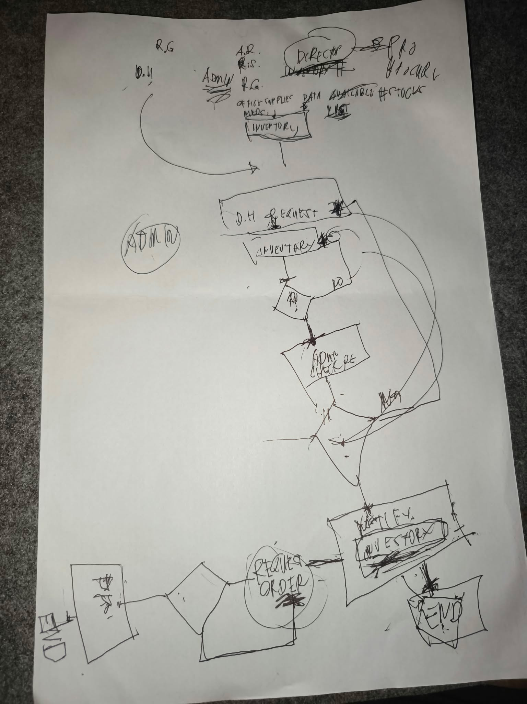

More Clear note of Chair Panel
Ito sir pina generate ko sa AI ung process kasi medyo magulo po ung sinulat ng chair panel namin
