Manual to deploy/excecute Falcon-UI inside the Ambari View

- Make sure you have the falcon-ambari-view project, It should be at the same level as the falcon-ui.
- Deploy falcon-ui so it copies all the ui resouces in the falcon-ambari-view project, mvn clean install.
- Deploy falcon-ambari-view to generate the .jar file e.g. dist/falcon-ambari-view-0.6-incubating-SNAPSHOT.jar.
- Copy the generated .jar inside the sandbox in the folowing route: /var/lib/ambari-server/resources/views.
- Restart the ambari server via the ui or use the following command: ambari-server restart.
- Go to the Ambari administration panel: 127.0.0.1:8080, credentials:admin/admin.
- Go to «Manage Ambari»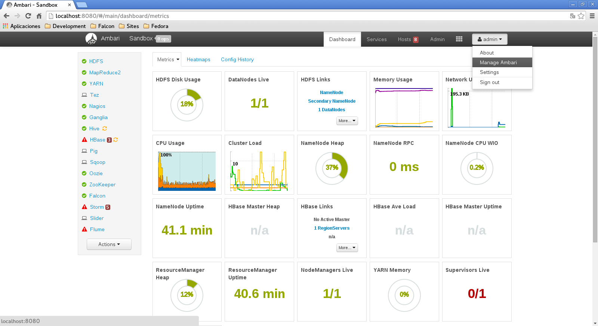
- Go to «Views» 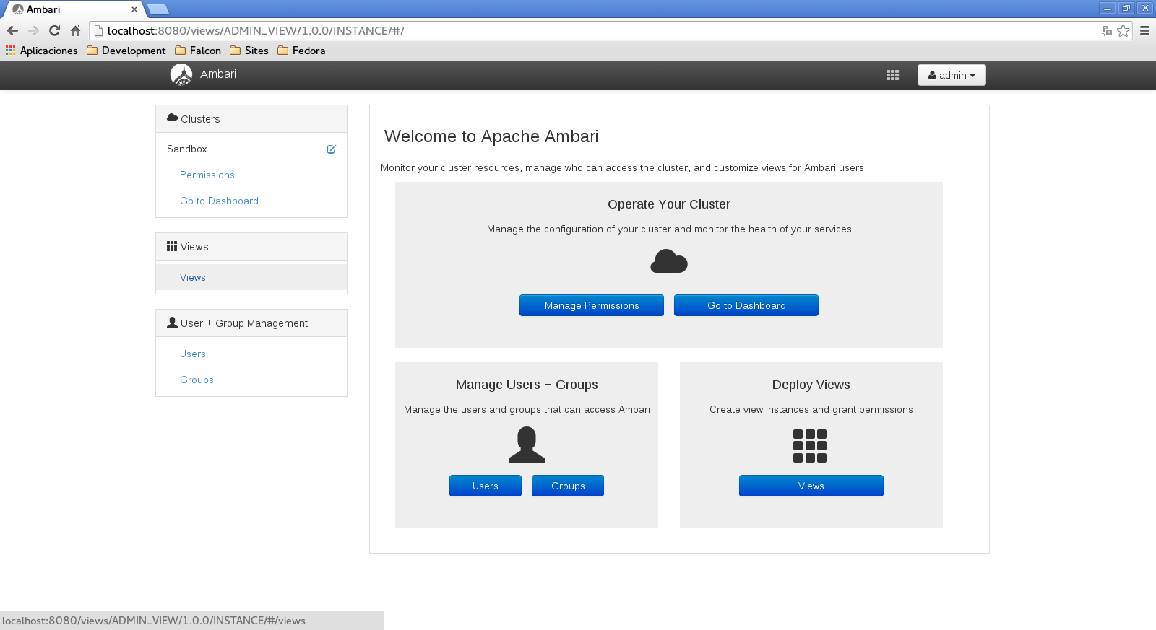
- If the deploy was correct at the ambari restart the Falcon Ambari View should appear in the views, click on it and go to «Create Instance». 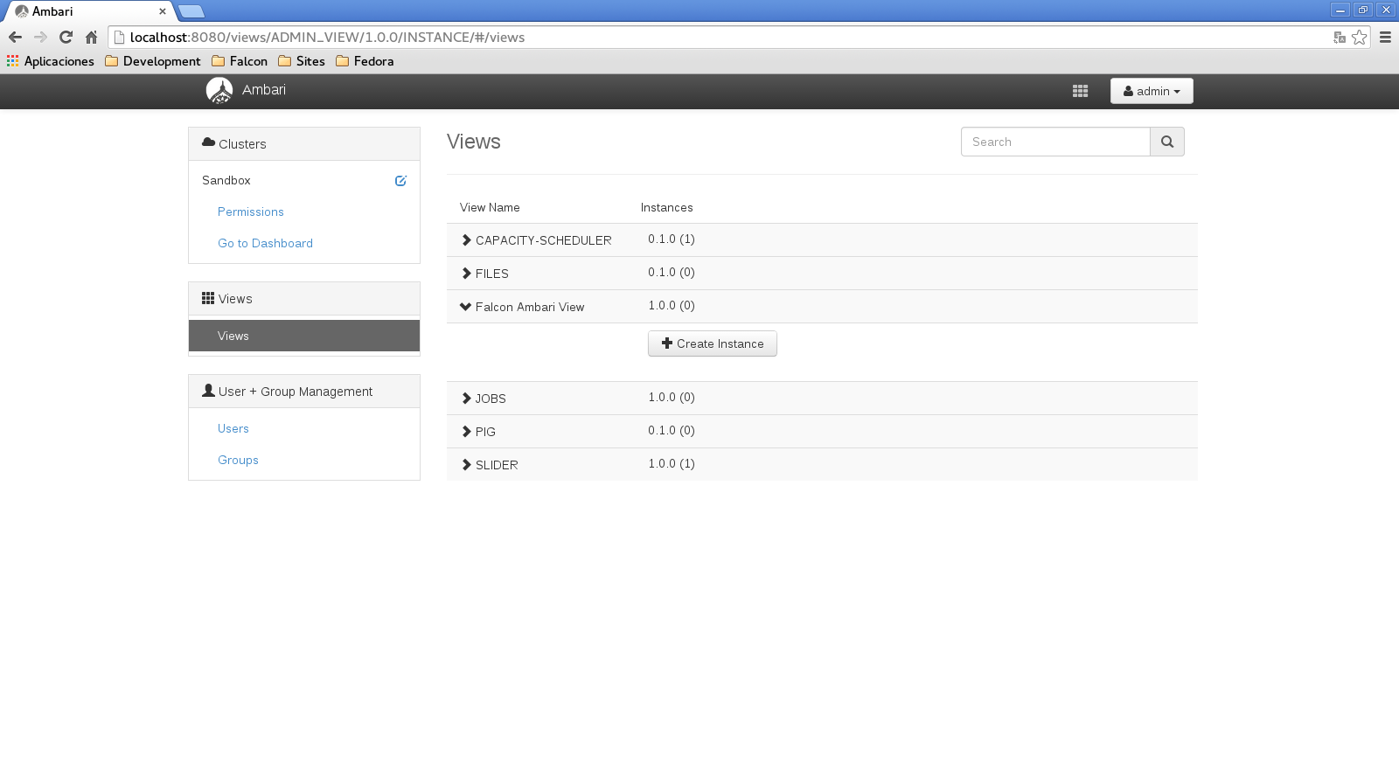
- Fill the following data configuration in order to create an instance: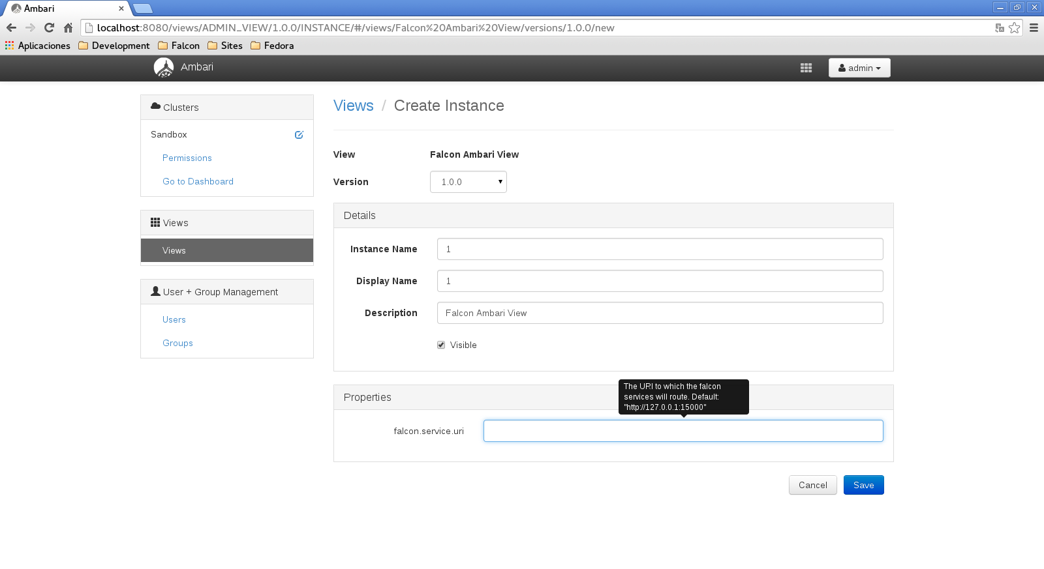You can provide an alternative server to atend the falcon API, if dont the local will be taked as the default server for the falcon API(127.0.0.1:15000).
- Save the instance, you should recieve a success message and a link to go to the instance, go to «Go to instance» 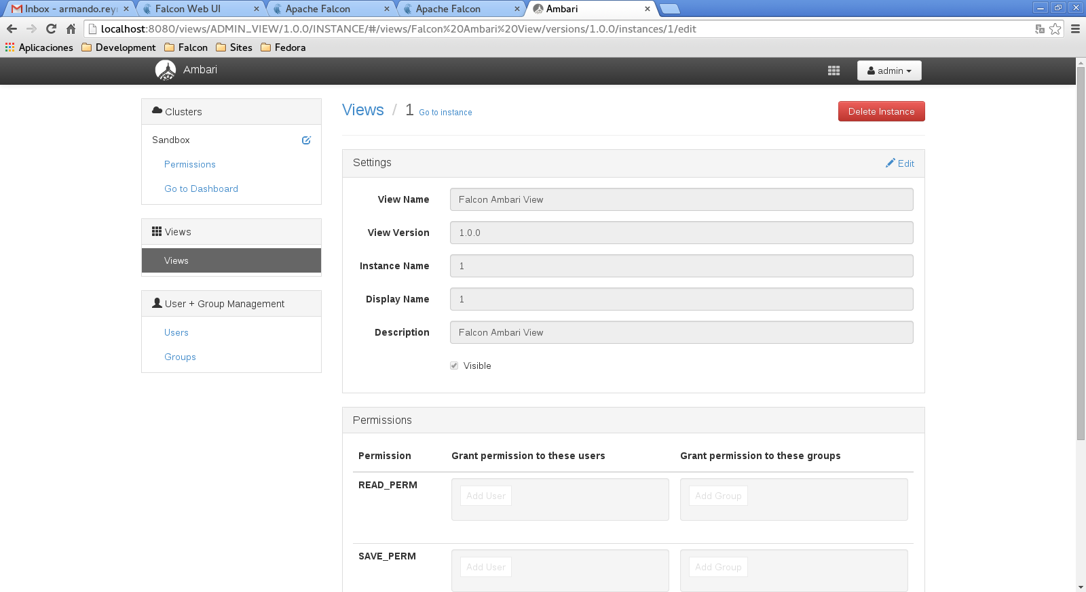
- The falcon-ui should be displayed inside ambari