Kenney Kwan

Guided Capstone Project Report

Big Mountain Resort in Montana is a premium ski resort that offers spectacular views of Glacier National Park and Flathead National Forest. For the upcoming season, the resort has installed an additional chair lift to help increase the distribution of visitors across the mountain. Costs will increase by $1,540,000 this season to pay for the lift. Big Mountain Resort wants to look into a different pricing strategy to get an even better value from their ticket price.

Problem Statement

* **What opportunities are there for Big Mountain Resort to increase their value of tickets either by cutting costs or by increasing ticket prices to make up for the operational costs of having an additional chair lift installed?**

For our problem we were provided data from 330 resorts around the country that are in the same market value as Big Mountain Resort. During our analysis, we looked at a heatmap (figure 1) of our features and how they were correlated.

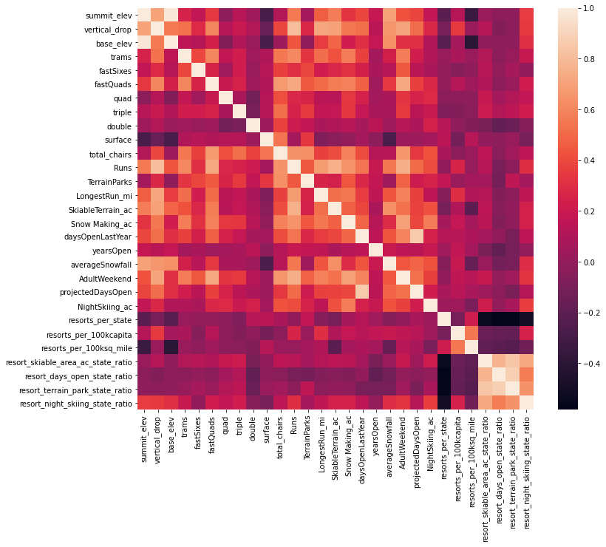

Figure 1

Our target was to look at ‘AdultWeekend’ price and found a few reasonable correlations.

‘fastQuads’ – number of fast 4 person chairs

‘Runs’ – the number of runs at the resort

‘Snow Making_ac’ – the total number of acres provided by snow making machines

‘total_chairs’ – sum of all the chairlifts at the resort

We can expect ticket price to be positive correlated to these 4 features. E.g as the number of runs increase, so does ticket price across our data of 330 resorts. However, we now need to see how these features relate when they are together.

To develop our model, we ran a linear regression model and a random forest selection on our data. The linear regression found that our model is the most accurate when it considers 8 features. While with random forest, there was a boarder inclusion of features.

Each analysis found that the top 4 features were almost identical.

Linear regression

* Vertical drop
* Snow making
* Total chairs
* Fast quads

Random Forest model

* Fast quads
* Runs
* Snow making
* Vertical drop

Linear regression has total chairs, while random forest model has runs as their dominant 4 features. After comparing both models, we chose to use the random forest model. The model found that on average it could predict the price within $9.53 with a standard deviation of $1.35.

Our model suggests that Mountain Resort’s ticket price is lower than the predicted model by 18.36%, Big Mountain Resort’s price should be $95.87. The resort gave us 4 potential scenarios for either cutting costs by closing runs or increasing ticket price by increasing vertical drop, adding acres snow making or increasing the longest run.

**Scenario 1**

* Permanently closing down up to 10 of the least used runs. This doesn't impact any other resort statistics.

Our model shows that shutting down 1 run will have no effect on ticket price or revenue. However, closing 2 runs will reduce ticket price and revenue. Shutting down 3 runs is the same as shutting down 4 or 5 runs. The pattern also repeats on shutting down 6 runs. We can expect the same amount of revenue loss when we shut down 7 or 8 runs as we do when we shut down 6 runs. (Figure 2)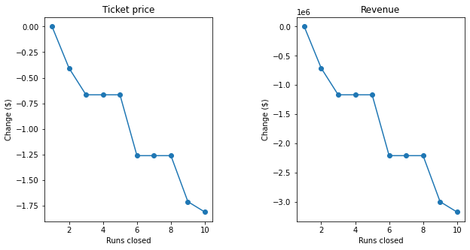

Figure 2

**Scenario 2**

* Increase the vertical drop by adding a run to a point 150 feet lower down but requiring the installation of an additional chair lift to bring skiers back up, without additional snow making coverage

This scenario increases support for ticket price by $1.99. Over the season, this could be expected to amount to $3,474,638.

**Scenario 3**

* Same as number 2, but adding 2 acres of snow making cover

This scenario increases support for ticket price by $1.99. Over the season, this could be expected to amount to $3,474,638.

This small amount of snowmaking does not make a difference in our model.

**Scenario 4**

* Increase the longest run by 0.2 mile to boast 3.5 miles length, requiring an additional snow making coverage of 4 acres

This model showed that there was no change to ticket price or revenue price when accounting for this change.