# User Manual for Bull and Cow game

1. Have project2.asm file ready in your system
2. Download and install Java (jre) if not installed: <https://www.java.com/en/download/>
3. Download Mars software: <http://courses.missouristate.edu/KenVollmar/mars/download.htm>
4. Double click on Mars icon **Mars4_5.jar** to start Mars 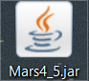, The Mars user interface is displayed as follow:

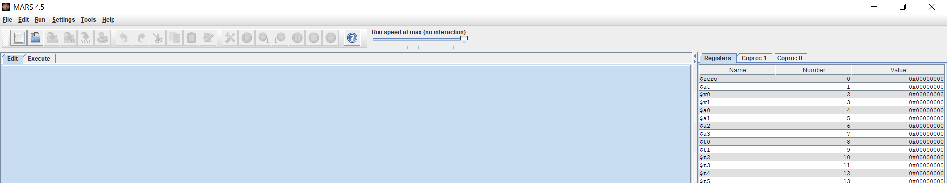

1. Click on the open file  icon in the top left corner
2. Locate the Project2.asm file in the file system and click 

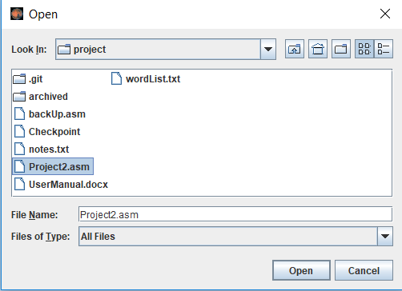

1. Click on assemble button , and then click on run button  next to it, the game is now started in the Run I/O window in the bottom of the screen:

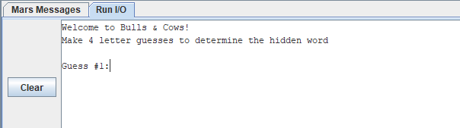

1. Start entering 4 letter word guesses. The game will validate your inputs and show errors if any. Otherwise, it will print out number of bulls and number of cows. The game will stop when your guess is correct, or when you give up by entering the string “!END”

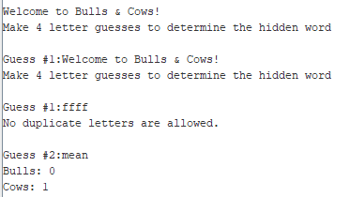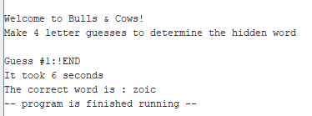

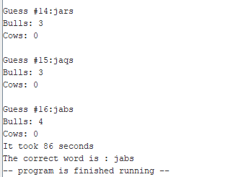

To start the game again, repeat step 7