Project 2

Angie, Brett, CJ, Kenn

Hypothesis: There is a positive correlation between the number of fast food restaurants and the rate of poverty within a zip code. Side note, just for us, we did not decide on county or zip code yet.

Our group has decided to look at the relationship between the number of restaurants and poverty level within a zip code. We wanted to see if we saw more fast food located in areas where the poverty level was higher. There are many reasons this is important but two significant ones are the health of the individuals in that area and the costs associated with eating out more frequently. An increase in the number of fast food restaurants in any given area would mean the area is sustaining those establishments. Individuals in that area would be spending more on fast food, which would also mean there is a likelihood they are not eating as many healthy meals.

For our analysis, we are looking at using data from multiple sources:

1. Poverty Rate information – [www.census.gov](https://www.census.gov/data-tools/demo/saipe/#/?map_geoSelector=aa_c)
2. 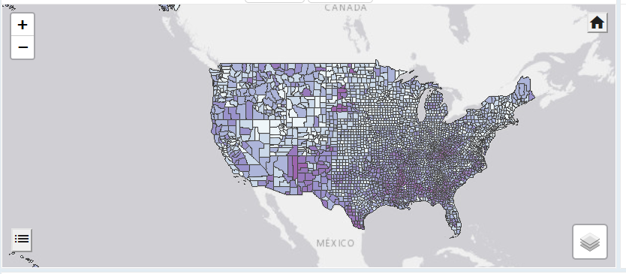Fast Food Information – [www.kaggle.com](http://www.kaggle.com)
3. Fast Food Information- [www.yelp.com](http://www.yelp.com/developers)
4. Poverty Rate Information – [data.ers.usda.gov](https://data.ers.usda.gov/reports.aspx?ID=17826)
5. Poverty Rate Information – [www.povertyusa.org](https://www.povertyusa.org/data)

We have decided to create a format similar to the homework done

for week 11 (Web Design). This will allow us to showcase the

information in a user-friendly format.

Data Map from census.gov

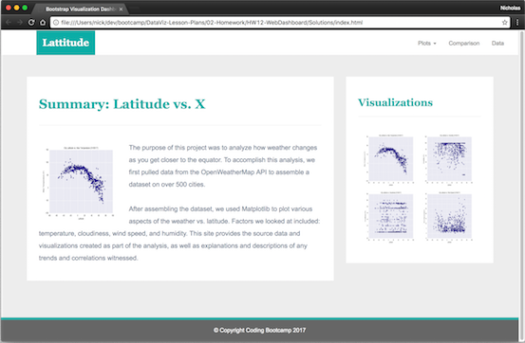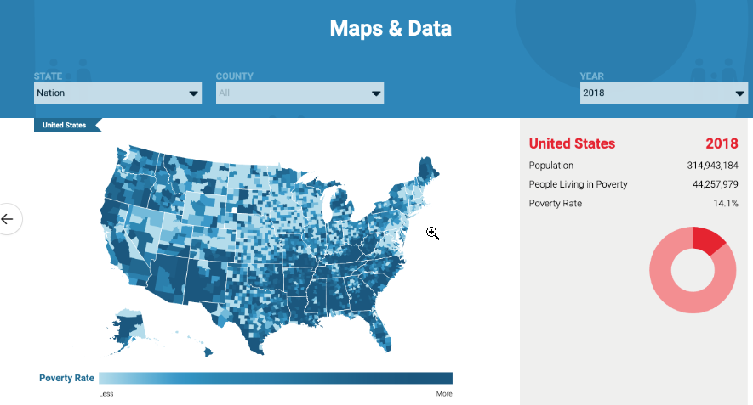

Example of final products look.

Data Map from povertyusa.org

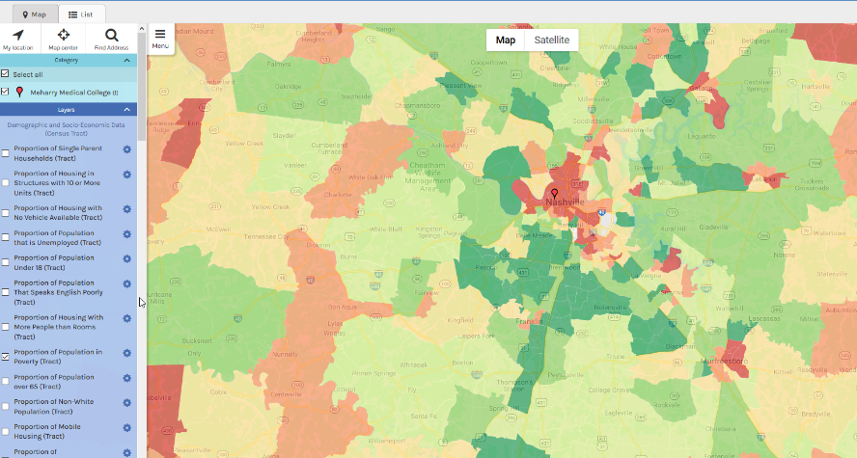

communitymappingforhealthequity.org

Our project will be stored at <https://github.com/kennknisley/project_two>