**UNIVERSIDAD REGIONAL AMAZÓNICA IKIAM**

Nombre: Kenny Muyolema

1.10.1 Next Generation Sequencing Data

1. Change directory to CSB/unix/sandbox.

2. What is the size of the file Marra2014_data.fasta?

3. Create a copy of Marra2014_data.fasta in the sandbox and name it

my_file.fasta.

4. How many contigs are classified as isogroup00036?

5. Replace the original “two-spaces” delimiter with a comma.

6. How many unique isogroups are in the file?

7. Which contig has the highest number of reads (numreads)? How many

reads does it have?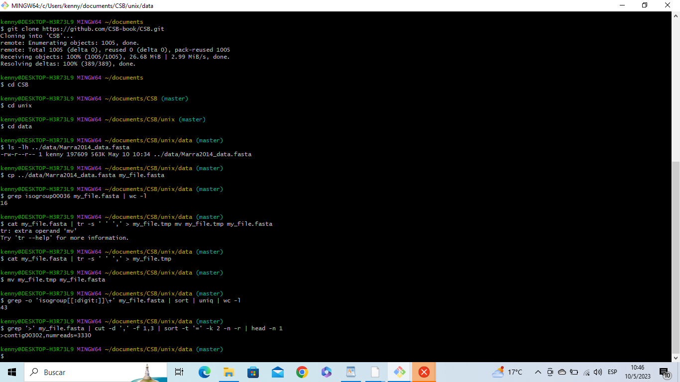



**ejercicio 2**

1. How many times were the levels of individuals 3 and 27 recorded?

2. Write a script taking as input the file name and the ID of the individual,

and returning the number of records for that ID.

3. [Advanced] Write a script that returns the number of times each

individual was sampled.

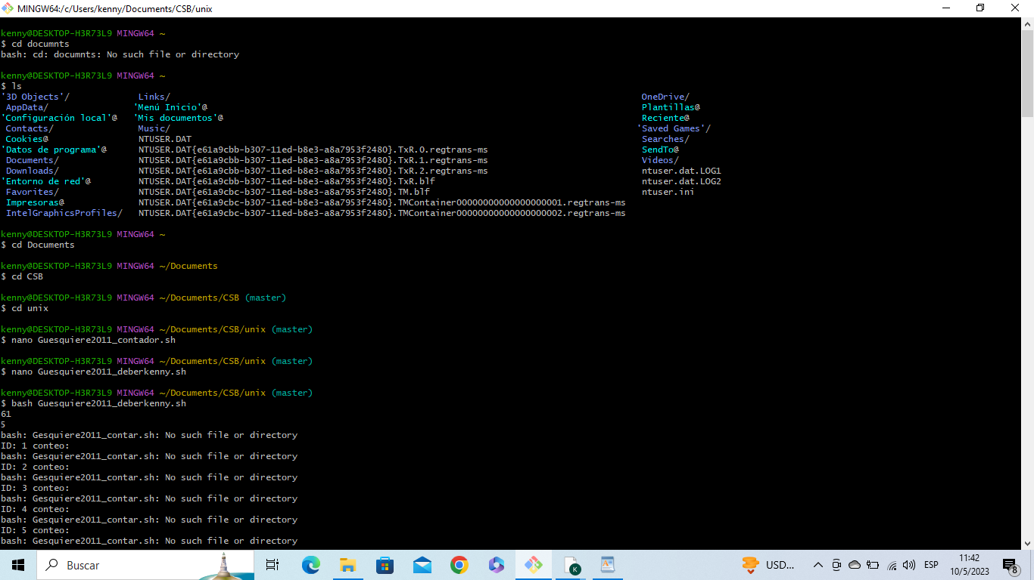

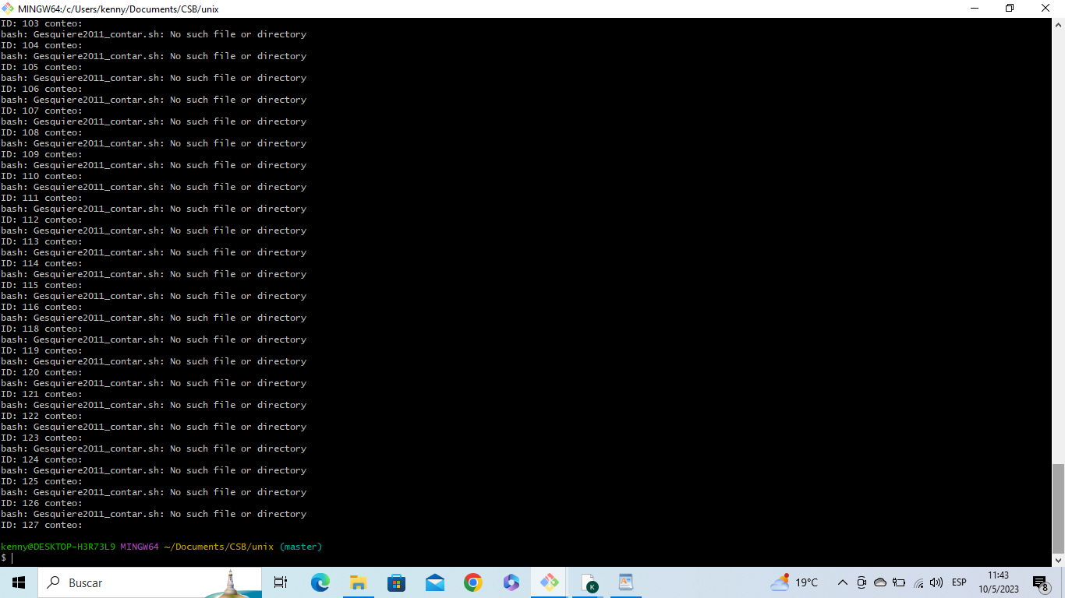

**ejercicio 3**

