CRIANDO CLASSES COM PUPPET

Uma classe serve para ser reaproveitada evitando reescrever o código.

exemplo de uma classe ntp:

[root@puppet-server puppet]# vim class-ntp.pp

class ntp {

# tratando distribuicoes

case $operatingsystem {

CentOS,RedHat: {

$package_name = 'ntp'

$service_name = 'ntpd'

$conf_file = 'ntp.conf.el'

}

Debian,Ubuntu: {

$package_name = 'ntp'

$service_name = 'ntp'

$conf_file = 'ntp.conf.debian'

}

}

# declarando pacote

package { "$package_name":

ensure => present,

}

# declarando servico

service { "$service_name":

ensure => running,

enable => true,

hasrestart => true,

hasstatus => true,

require => Package['ntp'],

}

# declarando arquivo de configuração

file { '/etc/ntp.conf':

ensure => present,

source => "/root/puppet/${conf_file}",

notify => Service["$service_name"],

require => Package["$package_name"],

}

}

#chamando a classe para ser executada.

class {'ntp': }

[root@puppet-server puppet]# puppet apply class-ntp.pp

Notice: Compiled catalog for puppet-server in environment production in 1.02 seconds

Notice: /Stage[main]/Ntp/File[/etc/ntp.conf]/content: content changed '{md5}dc9e5754ad2bb6f6c32b954c04431d0a' to '{md5}b7f46347bfe72d2e02f611959616f10c'

Notice: /Stage[main]/Ntp/Service[ntpd]/ensure: ensure changed 'stopped' to 'running'

Notice: Finished catalog run in 0.43 seconds

PARA INCLUIR MÓDULOS

include ntp  
include zabbix  
include apache

Antes devemos saber onde os módulos estão sendo buscados, para isso o comando abaixo será útil.

[root@puppet-server puppet]# puppet apply --configprint modulepath

/etc/puppet/modules:/usr/share/puppet/modules

[root@puppet-server puppet]#

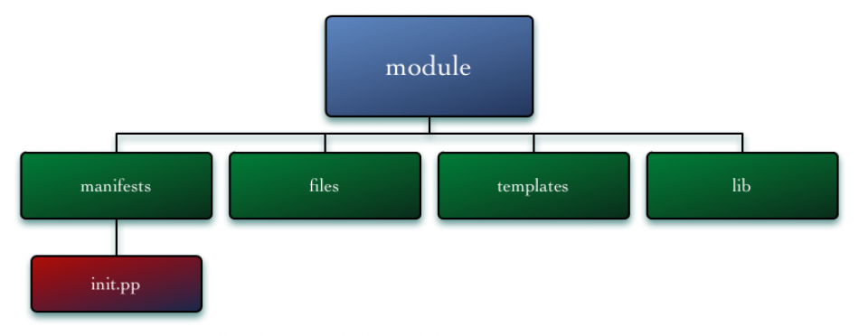

CRIANDO E INCLUINDO UM MODULO

[root@puppet-server puppet]# cd /etc/puppet/modules

[root@puppet-server modules]# mkdir template files lib manifests

[root@puppet-server modules]# cd manifests/

[root@puppet-server manifests]# vim init.pp

class ntp {  
   
 # tratando distribuicoes  
   
 case $operatingsystem {  
 CentOS,RedHat: {   
 $package_name = 'ntpd'  
 $service_name = 'ntpd'  
 $conf_file = 'ntp.conf.el'  
 }  
 Debian,Ubuntu: {   
 $package_name = 'ntp'  
 $service_name = 'ntp'  
 $conf_file = 'ntp.conf.debian'  
 }  
 }  
   
 # declarando pacote  
   
 package { "$package_name":  
 ensure => present,  
 }  
   
 # declarando servico  
   
 service { "$service_name":  
 ensure => running,  
 enable => true,  
 hasrestart => true,  
 hasstatus => true,  
 require => Package['ntp'],  
 }  
   
 # declarando arquivo de configuração  
   
 file { '/etc/ntp.conf':  
 ensure => present,  
 source => "/root/puppet/ntp/${conf_file}",  
 notify => Service["$service_name"],  
 require => Package["$package_name"],  
 }  
}

[root@puppet-server manifests]# echo "include ntp" >> include-classes.pp

EXECUTANDO INCLUDE DIRETAMENTE

puppet apply -e "include ntp"

EXECUTANDO INCLUDE DIRETAMENTE USANDO MODULEPATH

puppet apply -e "include ntp" --modulepath=/root/puppet/modules