Short-Shot Fill Balance DOE
Plastic Injection Molding Technical Manual
For process engineers, tooling engineers, setup technicians, quality engineers, validation teams, and production leaders
Field | Value
Document type | Technical reference / DOE work instruction template
Scope | Short-shot fill balance DOE, with linked viscosity-curve, melt-temperature verification, fill-only, shot-size/cushion, and troubleshooting studies
Status | Draft technical manual generated for internal review
Critical caveat | This is not a substitute for the resin supplier processing guide, customer validation requirements, medical QMS requirements, or safety instructions for the specific machine and tool.

Terminology control
This document intentionally separates three studies that are often confused on the floor: (1) a melt-temperature verification DOE confirms actual melt temperature; (2) a viscosity-curve DOE finds a robust injection speed/fill-time window; (3) a short-shot fill-balance DOE evaluates how evenly the mold distributes melt before pack/hold can mask imbalance. A shot-size/cushion study is related, but it is primarily a machine-shot repeatability and process-window confirmation tool, not a cavity-balance test by itself.

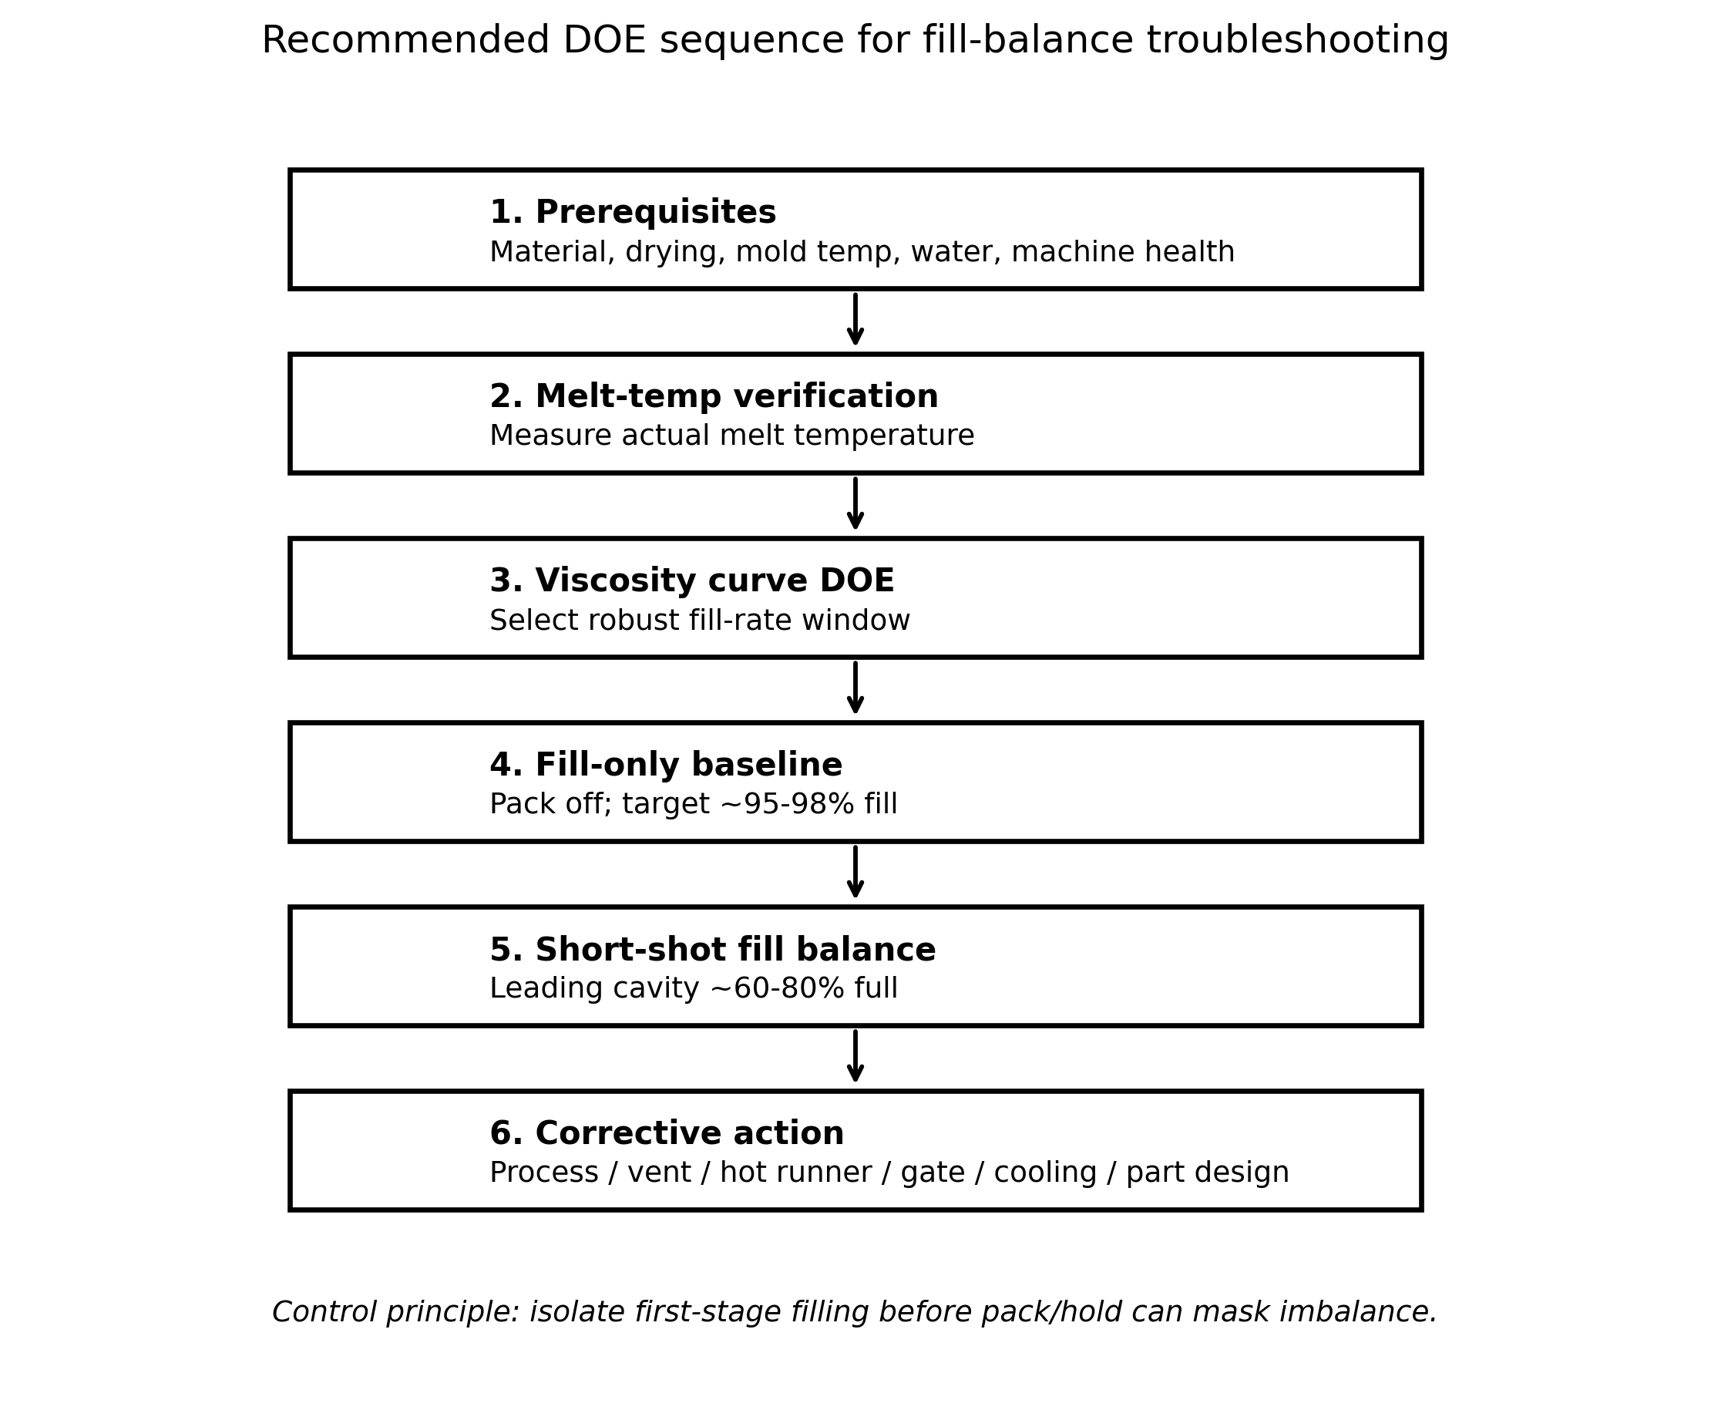
Figure 1. Recommended DOE sequence. Original diagram generated for this manual.

Table of Contents
1. Definition and Overview
2. Root Causes and Why the DOE Is Performed
3. Real-World Examples and Case Studies
4. Diagnostic Techniques
5. Preventive Measures and Optimization Actions
6. Redesign and Post-Processing Strategies
7. Industry Best Practices
8. Emerging Technologies and Research
9. Troubleshooting Guide
Appendix A. DOE Work Instruction
Appendix B. Data Collection Forms and Calculations
Appendix C. References

1. Definition and Overview

1.1 Precise technical definition
A Short-shot fill balance DOE is a controlled injection molding experiment in which the processor intentionally produces incomplete, pack-free parts at a fixed and validated fill rate, then compares the degree of fill by cavity, by flow path, and by melt-front progression to determine whether the mold, material, machine, and process distribute molten polymer uniformly before the pack/hold phase begins. In a multi-cavity tool, the primary measured response is cavity-to-cavity fill balance. In a single-cavity tool, the primary response is flow-front symmetry and hesitation/racetrack behavior within the cavity.
The test is normally run after the mold is already capable of making a stable fill-only part. Pack and hold pressure are removed or reduced to the machine minimum so that second-stage pressure does not hide the true first-stage fill pattern. The shot size or transfer position is then reduced until the most-filled cavity is approximately 60-80% full. Multiple labeled short shots are collected so that cavity ID, shot-to-shot repeatability, and pattern repeatability can be assessed. Beaumont Technologies describes short-shot mold diagnostics as a method that reveals mold filling and multi-cavity imbalance; its published procedure recommends removing hold pressure, achieving a fill-only baseline, reducing shot until the most-filled cavity is roughly 60-80% full, and collecting multiple labeled shots [1].
A robust DOE does not simply ask whether a part is short. It asks why one cavity, wall section, gate, valve gate, tip, runner branch, flow path, or process condition fills ahead of another. The output is a decision package: process optimization, hot-runner adjustment, vent service, valve timing change, gate steel change, runner modification, mold cooling correction, material change, machine maintenance, or part redesign.
Operational distinction
A production short shot is a defect. A DOE short shot is an intentionally created diagnostic part. The difference is process control: in the DOE, the processor controls fill rate, shot volume, transfer, pack-off condition, and sampling method to expose the mold’s natural filling behavior.

1.2 What the DOE actually measures
Response | How it is measured | What it means
Cavity-to-cavity short-shot weight | Weigh each cavity or runner/part group at the same reduced shot condition. | Quantifies balance in a multi-cavity mold; useful when visual percent fill is subjective.
Percent fill by cavity | Estimate by volume, image analysis, CAD volume comparison, or consistent weighing. | Shows which cavities fill first and which lag.
Melt-front location | Photograph each part side-by-side by cavity ID, preferably with fixed lighting and scale. | Reveals hesitation, racetrack effect, weld-line creation, trapped air locations, and flow path bias.
Injection pressure curve | Machine trace, nozzle pressure, or in-mold pressure if available. | Indicates freeze-off, pressure limitation, viscosity drift, and whether the machine is still velocity controlled.
Screw position stability | Record screw position at transfer, cushion, and hold phase with pack off. | Ensures the machine is not creeping forward during the zero-pack short-shot phase.
Cavity pressure arrival and integral | In-mold sensor, if installed. | Higher fidelity indicator of melt arrival, peak, and packing potential.

The best response variable depends on the mold. For an eight-cavity closure mold, short-shot weight by cavity is usually stronger than a visual estimate. For a thin-wall medical connector or a consumer product with complex ribs, melt-front photography may be more valuable because the first failure mode is not always cavity-to-cavity imbalance; it can be local hesitation at a feature, air entrapment, or a local wall-thickness transition.

1.3 Relationship to viscosity curve, melt-temperature verification, and shot-size/cushion study
A short-shot fill balance DOE should not be run blindly at a random injection speed. Polymer melts are shear-thinning and temperature-sensitive; Toray explains that melt viscosity decreases as shear rate increases and also decreases as melt temperature rises, while TA Instruments notes that fillers increase melt viscosity and alter non-Newtonian behavior [5][6]. The viscosity-curve DOE establishes a practical injection-speed window before the fill-balance DOE is run. If the speed is too low, short shots may be caused by artificial freeze-off. If it is too high, shear heating, pressure limitation, jetting, or material degradation may distort the fill pattern.
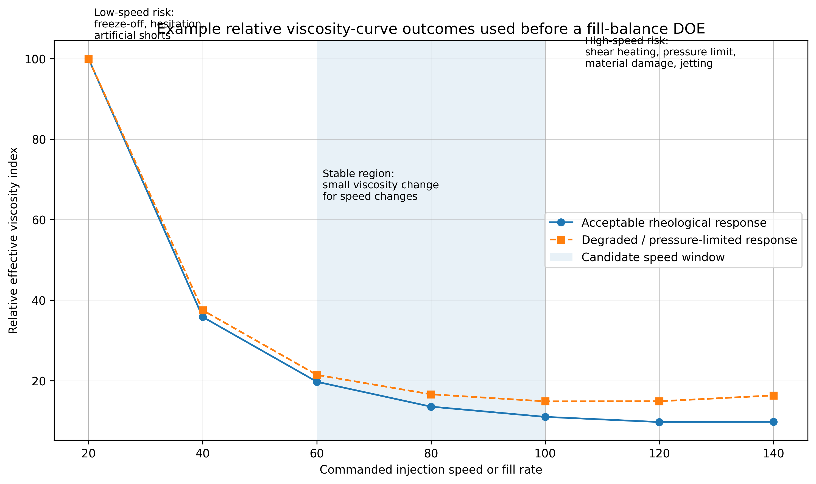
Figure 2. Example relative viscosity-curve outcomes. Original diagram generated for this manual.
A melt-temperature verification DOE checks whether the actual melt delivered to the mold matches the intended thermal condition. Barrel zone setpoints do not equal melt temperature. Back pressure, screw recovery speed, residence time, screw design, check-ring leakage, material shear, colorant, and regrind can all shift the real melt temperature. If actual melt temperature is not known, an apparent fill imbalance can be caused by thermal drift rather than a mold distribution issue.
A shot-size/cushion study verifies that the injection unit can deliver the required shot consistently with a stable cushion and without operating too close to the machine’s pressure, velocity, or shot-capacity limits. It does not, by itself, prove that each cavity receives melt at the same rate. However, an unstable cushion will invalidate a fill-balance DOE because the injected volume is not repeatable.
Study | Primary purpose | Typical output | Why it matters to fill balance
Melt-temperature verification DOE | Confirm actual melt temperature under production-like recovery and residence conditions. | Actual melt temperature range; thermal stability decision. | Melt temperature directly changes viscosity and freeze-off risk.
Relative viscosity curve DOE | Find the injection speed/fill time where effective viscosity response is stable and not pressure-limited. | Recommended fill rate / fill time window. | The fill-balance DOE must be run at a representative speed.
Fill-only study | Separate fill from pack/hold by turning second stage off and targeting near-full fill. | 95-98% fill-only baseline; transfer position. | Creates the process foundation for the intentional short shots.
Short-shot fill balance DOE | Expose natural cavity or flow-path imbalance before pack/hold masks it. | Balance index, flow-front maps, action plan. | Directly diagnoses mold/process distribution performance.
Shot-size/cushion study | Confirm machine shot delivery stability and remaining cushion. | Cushion mean/range, shot volume repeatability. | Unstable shot delivery makes balance data unreliable.

2. Root Causes and Why the DOE Is Performed
A short-shot fill balance DOE is performed when production risk cannot be resolved by looking at a finished part alone. Pack/hold can force lagging areas to complete, hide early imbalance, increase flash in fast cavities, overpack early cavities, and create dimensional spread that is mistakenly blamed on cooling or material. The DOE isolates first-stage filling so the team can see the natural flow hierarchy.

2.1 Business and technical triggers
- New mold qualification: prove that a multi-cavity mold fills acceptably before production release.
- Process transfer: confirm that a qualified process remains balanced on another press, facility, hot-runner controller, or resin lot.
- Dimensional spread: determine whether cavity-to-cavity size or weight variation starts during fill rather than pack or cooling.
- Intermittent short shots: identify whether shorts are random machine/material variation or a repeatable mold-flow weakness.
- Flash/short combination: detect the classic condition where one cavity is full or flashing while another cavity is short.
- Weld-line/air-trap complaints: trace where fronts meet and where air cannot escape.
- Medical, automotive, or regulated production validation: document process understanding, not just settings.
- Hot-runner restart or repair: verify that tip temperatures, valve pins, manifold zones, and flow channels still distribute material correctly.

2.2 Material factors
Material is often the first hidden variable. A short-shot balance DOE is sensitive to viscosity, thermal stability, filler loading, moisture, regrind, colorant carrier, lubricant package, fiber orientation, and lot-to-lot molecular-weight distribution. Since the test intentionally operates near incomplete fill, small material changes can exaggerate differences that a full packed shot might hide.
Material factor | Mechanism | Expected DOE effect | Controls before testing
Viscosity / MFR / molecular weight | Higher viscosity increases pressure drop and freeze-off risk; lower viscosity can reduce pressure but may increase flash or overpacking in leading cavities. | High-viscosity lots make lagging cavities look worse. Low-viscosity lots can reduce visible imbalance but increase flash sensitivity. | Record resin lot, MFR/MVR, supplier certificate, colorant, regrind %, and actual melt temperature.
Melt temperature | Higher melt temperature reduces viscosity and delays freeze-off; excessive temperature can degrade material or create gas/burns. | Warmer melt may improve fill in long/thin paths but can hide weak runner/gate balance. | Run melt-temperature verification using a consistent purge/air-shot method or approved sensor method.
Additives and fillers | Glass, mineral, flame retardant, pigments, nucleators, slip agents, and recycled content alter viscosity and shear response. Fillers generally increase melt viscosity and non-Newtonian effects [5]. | Filled grades magnify pressure drop and wall-thickness sensitivity; fiber-filled grades can show orientation-driven pressure and warp effects. | Use production-intent material and color. Do not qualify balance on natural resin if production uses heavy pigment or filled resin.
Moisture | Hydrolysis, bubbles, splay, viscosity change, and volatiles can change flow and vent loading. | False air-trap/burn signatures and inconsistent short-shot patterns. | Dry to supplier specification and document dryer dew point, time, hopper load, and moisture test if critical.
Regrind and recycled resin | Recycled content can vary in molecular weight, contamination, moisture, and MFR. | Can cause cycle-to-cycle viscosity drift. ENGEL notes viscosity fluctuations are a challenge when processing recyclates and bioplastics [8]. | Lock regrind percentage and sieve/handling method; consider machine or cavity pressure monitoring for high recycled content.

2.3 Polymer-specific expectations: PP, ABS, PC, and filled grades
Polymer family | Typical fill-balance behavior | DOE caution
PP | Semi-crystalline, generally good flow, strong shrinkage sensitivity, and often fast freeze behavior in thin sections. High-flow PP can mask runner imbalance during fill but later show pack/cooling dimensional spread. | Do not accept balance based only on full-shot part weight; compare short-shot progression and later pack response. Recycled PP may have viscosity drift.
ABS | Amorphous, moderate viscosity, surface-sensitive, and weld-line/cosmetic-sensitive. Melt temperature and shear affect appearance and weld-line integrity. | A fill pattern that is acceptable structurally may still be unacceptable cosmetically. Watch for burning at vents and colorant viscosity effects.
PC | High melt viscosity and high processing temperature; sensitive to moisture and shear/thermal degradation. Thin ribs and long flow lengths expose pressure limits quickly. | Use validated drying, high enough mold temperature, and verify the machine is not pressure-limited before calling the tool imbalanced.
Glass-filled PP/PA/PBT/PPS/PC | Higher viscosity, abrasive flow, fiber orientation, higher shear sensitivity, and possible gate wear over time. Reinforcement content can reduce fluidity [6]. | Balance can change as gates wear. Mold steel, gate land, vent wear, and screw/check-ring wear matter more than with unfilled resin.
PVC and thermally sensitive materials | Narrow processing window, high viscosity, low thermal conductivity, and degradation risk. A 2022 Moldex3D/Taguchi study notes PVC injection molding has constrained temperature and shear-rate ranges because of temperature sensitivity and high viscosity [3]. | Do not solve imbalance by simply adding heat or speed. Multi-stage injection rate optimization may be safer than steel changes or aggressive thermal changes.

2.4 Process parameters
The fill-balance DOE must be run under a controlled process window. Changing one parameter without understanding the coupled effect can convert the DOE from a diagnostic study into random trial-and-error. The critical process variables are injection speed profile, peak pressure utilization, melt temperature, mold temperature, transfer position, decompression, recovery consistency, back pressure, cushion, screw recovery time, pack/hold disablement, and cooling time.
Parameter | Effect on DOE | False conclusion risk
Injection speed / fill time | Controls shear rate, shear heating, viscosity, pressure drop, and freeze-off timing. Autodesk Moldflow guidance notes that closely spaced fill-time contours can indicate hesitation, and hesitation can cause a short shot if a thin section freezes before full fill [4]. | Too slow makes every long-flow feature look worse; too fast may pressure-limit the press or induce jetting.
Injection pressure limit | If the machine reaches pressure limit, commanded velocity is not achieved and fill pattern becomes pressure-controlled. | Processor blames mold imbalance when the press is simply maxed out.
Mold temperature | Warmer steel delays freeze-off; colder steel magnifies hesitation and thin-wall sensitivity. | A blocked water line can look like a gate or runner imbalance.
Cooling rate | Does not directly fill the cavity, but changes steel temperature and residual melt-front mobility between cycles. | Unstable cycle time or robot delay changes apparent balance over time.
Transfer position / shot size | Defines whether the test is a fill-only baseline or a reduced short-shot condition. | Using inconsistent transfer positions creates non-repeatable data.
Pack/hold pressure | Must be off or at the minimum practical value for the short-shot study. | Pack masks imbalance and can complete slow cavities, making bad balance look acceptable.
Back pressure and recovery | Changes melt homogeneity, temperature, and air entrainment. Excess back pressure can overheat or degrade material. | Different recovery settings between DOE and production invalidate the comparison.

2.5 Gate design, gate size, and gate location
Gate design sets the first local pressure loss into the cavity. In a short-shot fill-balance DOE, gate differences show up as different cavity fill percentages, unbalanced flow-front entry, jetting, gate blush, burning near the end of fill, or local freeze-off. Gate land wear or blocked tunnel gates can create a cavity that short-shots even when the runner looks balanced. Gate location also determines weld-line position, air-trap location, fiber orientation, cosmetic flow marks, and pressure needed to fill thin or remote features.
- A gate that is too small may appear balanced during full-shot pack but reveals lagging fill at short-shot conditions.
- A gate that is too large may reduce pressure drop but worsen vestige, shear, blush, freeze-off timing, or gate-seal variation.
- A gate into a thin section can cause hesitation and freeze-off; a gate into a thicker section can create racetrack flow into thin ribs.
- Submarine/tunnel gates in cold-runner tools can wear, break, or trap slivers; tip and valve gates in hot-runner tools can become thermally imbalanced or mechanically delayed.
- Family molds require special treatment: balance by function and quality requirement, not equal percentage fill, because cavities have different volumes and flow paths.

2.6 Mold design: cold runner versus hot runner
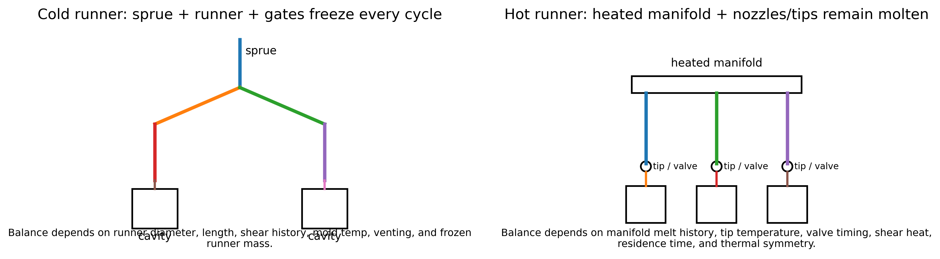
Figure 3. Cold-runner versus hot-runner balance mechanisms. Original diagram generated for this manual.
Cold-runner molds and hot-runner molds can both be geometrically balanced and still fill poorly. Geometric balance means equal nominal runner length and diameter; rheological balance means the melt reaching every cavity has comparable shear, temperature, pressure, and residence history. The latter is what matters to the DOE.
Mold type | Primary imbalance mechanisms | DOE interpretation
Cold runner with sprue and runners | Runner diameter mismatch, polishing/machining variation, runner shear imbalance at branches, cold slug, sprue puller effects, gate land variation, runner freeze, runner-to-cavity temperature gradients. | Short-shot parts should be collected with runner attached when possible. Weighing only parts can miss runner imbalance. Gate and runner steel changes are common corrective actions.
Naturally balanced hot runner | Manifold thermal gradients, tip temperature variation, heater/thermocouple placement, valve pin timing, nozzle leak, drool/stringing, material hang-up, residence-time differences. | A balanced CAD manifold does not guarantee balanced melt. Verify zones, actual tip temperatures, valve-pneumatic/hydraulic response, and short-shot symmetry. Husky frames hot-runner balance as a key issue in mold qualification and notes that short-shot balance is affected by more than geometric melt-channel balance [7].
Valve-gated hot runner | Valve opening/closing timing, pin stroke, pin wear, seat damage, actuator delay, sequential gate logic, pressure spikes. | Run valve-timing sweeps only after baseline balance is understood. A valve timing adjustment can improve fill-front control but may create local overpack or weld-line movement.
Family mold | Different cavity volume, thickness, flow length, gate size, and fill priority by design. | Do not apply equal fill percentage as the only acceptance criterion. Use critical-to-quality features, weights, and simulated/expected sequence.

2.7 Runner and gate design flaws
- Dead corners, sharp turns, undersized branches, and abrupt diameter transitions increase pressure drop and shear-heating asymmetry.
- Fishbone runners can favor inner cavities; H-pattern runners can show shear-induced imbalance even when lengths are equal. A Moldex3D case study on an eight-cavity tact switch found inner portions filled faster because of the fishbone runner design and resolved several issues with runner and part/mold design changes [12].
- Cold-slug wells that are too small or poorly placed can send cold material into one branch, producing a repeatable lagging cavity.
- Runners polished or repaired differently between branches can change local shear heating and flow resistance.
- Hot-runner manifolds with poor thermal uniformity can deliver melt of different viscosity to different nozzles.

2.8 Wall thickness variation and its effect on shot size / cushion study
Wall thickness variations create racetrack effects. Melt preferentially follows the path of least resistance, often a thicker wall or rib junction, while thin sections hesitate or freeze. A shot-size/cushion study can reveal whether the machine has enough controlled shot volume to fill and pack the part, but it does not explain where the melt goes inside the cavity. Short-shot progression reveals the flow path. Autodesk Moldflow documentation states that a balanced fill-time result has flow paths finishing at the same time, while one path finishing before another can indicate overpacking, and unfilled areas appear translucent in a short shot [4].
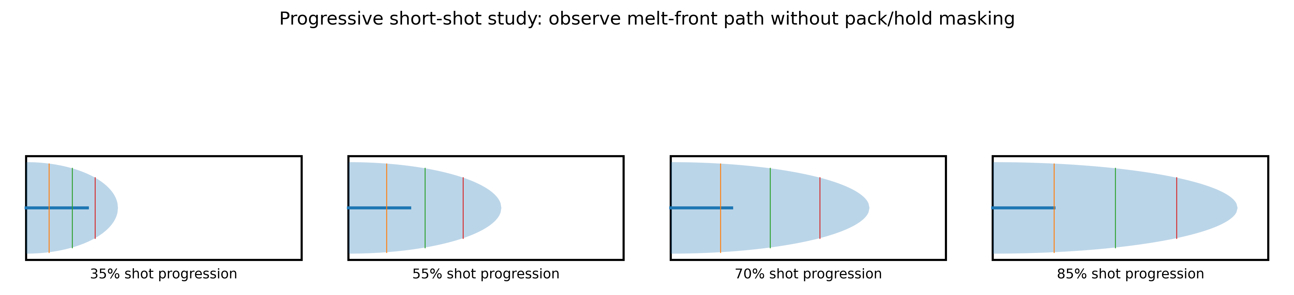
Figure 4. Progressive short-shot pattern. Original diagram generated for this manual.
In thick-to-thin geometry, the short-shot DOE often shows the thick section filling first while remote thin ribs remain empty. Increasing shot size may complete the part but can leave early areas overpacked and dimensions high. A cushion study may show stable cushion, yet the part still fails balance because the issue is flow-path impedance rather than shot delivery.

2.9 Venting issues and air traps
Venting problems show up clearly in short-shot studies because air is still being displaced during first-stage fill. Poor venting creates end-of-fill shorts, burns, dieseling, hesitation, and inconsistent cavity fill. A cavity can be geometrically favored and still short if the air has no exit. Nanoplas summarizes cavity balance conditions to include flow length, flow diameter, shear, cooling, venting, and clamp pressure; it notes that poor venting can cause a cavity to burn or short [11].
- Check vents before and after DOE; contamination can invalidate results.
- Excess clamp force can compress vents and create artificial shorts or burns.
- Too little clamp force can cause flash, which changes local venting and can make a cavity appear better filled than it would be under normal clamp.
- Vacuum venting, porous inserts, vent depth restoration, or parting-line vent cleaning may be required before tool-steel changes are considered.

2.10 Machine factors
Machine factor | Mechanism | DOE consequence
Screw design | Poor mixing, wrong compression ratio, inadequate L/D, or wrong design for the resin can create unmelt, thermal nonuniformity, or degradation. | Short-shot pattern shifts over time as melt quality changes.
Screw/barrel wear | Reduces plasticizing efficiency and shot consistency; can raise recovery time and melt variation. | DOE repeatability is poor; apparent balance changes shot to shot.
Check ring leakage | Allows melt to backflow during injection; reduces delivered volume and changes pressure response. | Cushion may look inconsistent; fill-only parts vary.
Back pressure | Improves mixing within limits but increases shear heat and recovery load. | Too low may create unmelt or color streaks; too high may degrade resin or change viscosity.
Pressure/velocity capability | Press may fail to maintain commanded velocity if pressure-limited. | Fill-balance results reflect machine limitation, not mold behavior.
Clamp force | Affects flash, vent compression, mold deflection, and parting-line venting. | Both over-clamping and under-clamping can distort balance data.

2.11 Auxiliary equipment roles
Auxiliary system | Role in the DOE | Failure mode to control
Chillers | Maintain water temperature and heat-removal capacity. | Low flow, fouled circuits, wrong setpoint, or unstable supply temperature changes mold temperature and freeze-off behavior.
Thermolators / mold-temperature controllers | Control cavity/core steel temperature and startup thermal stability. | Incorrect plumbing, blocked circuit, reversed supply/return, poor turbulence, or unstable heater output changes local fill.
Hot-runner temperature controllers | Maintain manifold, nozzle, and tip thermal balance. | Zone mismatch, thermocouple error, heater failure, or wrong standby/startup sequence can create cavity imbalance. Husky markets mold controllers for high-cavitation hot-runner applications and emphasizes troubleshooting and startup support [10].
Robots / take-out automation | Stabilize cycle time, part removal, and reject segregation; can preserve labeled DOE samples. | Extended mold-open time changes steel temperature; failure to segregate short-shot samples destroys traceability.
Sprue pickers | Remove cold runners consistently in cold-runner tools. | Inconsistent runner removal, runner hang-up, or delayed cycle can change thermal state and sample integrity.
Dryers and material loaders | Maintain moisture and material consistency during the DOE. | Moisture drift, loader purge contamination, or inconsistent blend/regrind ratio changes viscosity.

3. Real-World Examples and Case Studies
Integrity note on firsthand accounts
The public sources located for this manual include practitioner procedures, OEM guidance, and published case studies. They are not private shop-floor interviews. Where this manual uses “field account,” it means an anonymized composite scenario based on common production patterns and cited technical evidence, not a verbatim interview with a named technician.

3.1 Electronics/consumer micro-feature case: eight-cavity tact switch
A Moldex3D case study from Diptronics involved a high-output T3C tact switch, 3 mm x 2 mm x 0.6 mm, in an eight-cavity mold. The product had air-trap, weld-line, lack-of-material, runner imbalance, cycle-time, and conduction-risk issues. The case reported that the inner part filled faster than the outer part due to a fishbone runner design; the selected S-shaped runner improved balance, reduced shear stress from 7 MPa to 3 MPa, reduced maximum cooling time from 8 s to 5 s, saved 11% material, and contributed to a 39.68% yield increase and 16% cycle-time reduction [12].
This case matters because it shows the core lesson of short-shot balance work: a runner change can improve filling, but weld-line and air-trap problems may still require part and mold changes. In this case, a concave hole and ejector-pin arrangement also needed to be modified to move or eliminate defects. A short-shot DOE would be expected to show early runner-induced imbalance first, then remaining local flow defects after the runner balance was improved.

3.2 Consumer household hot-runner case: easy-to-pick can
A Moldex3D case study for Felli Co., Ltd. described a consumer household food-storage product with a long and narrow geometry. The hot-runner system caused flow imbalance and associated air traps and weld lines. The team used fluid-structure interaction/core-shift analysis and then used valve-gate hot runner changes, product thickness changes, and cavity/core plate temperature adjustments to improve flow balance and weld-line behavior. The reported production yield increased from 0% to 99.7% [13].
The production lesson is that short-shot balance is not always multi-cavity balance. A single cavity with multiple gates or a long slender core can experience internal fill imbalance that creates core shift, wall-thickness variation, and weld-line weakness. In this class of problem, the short-shot DOE should capture flow-front progression and gate-arrival timing, not merely final part weight.

3.3 Medical product example: syringe/core-deflection style imbalance
Moldex3D’s medical-product discussion explains that hotter melt can reach a cavity earlier, and that balancing by longer runners or moving split locations can require extensive guessing and mold fixes. It also notes that valve-gate timing can balance entry timing but adds cost and maintenance, while simulation can determine runner adjustment or valve on/off control earlier in design. The same source describes a syringe-like product in which flow traveled faster on one side than the other, causing pressure-driven core deflection and uneven wall thickness [14].
For medical parts, the control plan should not stop at appearance. A fill-balance DOE should be tied to dimensional capability, wall-section measurement, CT or sectioning when appropriate, functional leak testing, and validation documentation. The DOE is evidence of process understanding, not a final release by itself.

3.4 Automotive multi-shot case: PP+GF30 and EPDM gasoline tank casing
A FARPLAS automotive case used Moldex3D for a multi-shot gasoline tank casing involving PP+GF30 and EPDM. The first shot had warpage concerns due to glass-fiber orientation and deformation; the second EPDM filling risked incomplete fill. Moldex3D analysis helped modify part geometry and thickness so the second-shot EPDM filling could complete without short shot, and the study reported close agreement between simulation and experimental behavior [15].
This case illustrates why polymer family and filler loading matter. Glass-filled substrates may pass a short-shot fill balance evaluation but fail later because fiber orientation and warpage change the second-shot cavity condition. In multi-shot processes, a “short-shot fill balance DOE” may need to be staged: first-shot fill balance, first-shot deformation validation, insert/transfer condition, then second-shot fill balance.

3.5 Field account composites
Composite field account | Observed symptom | DOE finding | Resolution
Technician account: 16-cavity cold-runner closure mold | Cavities 3, 7, 11, and 15 intermittently short while adjacent cavities flashed. | Short shots at 70% showed the same four cavities lagging. Runner branch polish and gate land measurements found gate restrictions from prior repair. | Gate steel was corrected, vents cleaned, and fill-only weights rechecked before packing process was rebuilt.
Process engineer account: hot-runner medical cap mold | Full parts passed weight average but two cavities had dimensional high/low split and occasional burn near a latch. | Short-shot samples showed two tips leading and two lagging; hot-runner zone audit found thermocouple offset and one slow valve pin. | Tip zones were balanced by actual response, valve pin maintenance completed, and valve timing locked in validation protocol.
Quality engineer account: ABS cosmetic consumer housing | Weld line visible near boss; increasing hold pressure improved appearance slightly but created sink elsewhere. | Progressive short shots showed racetrack around thick boss and trapped air at the boss backside. | Gate relocation was rejected due cost; venting and boss geometry were modified, then speed profile and mold temp were optimized.

4. Diagnostic Techniques

4.1 How to identify whether a short-shot fill balance DOE has already been done
Finished production parts rarely prove that a short-shot fill balance DOE was performed. A finished part can tell you that the process is currently capable of making a complete part; it does not show whether pack/hold is masking fill imbalance. To verify that the DOE was performed, look for evidence artifacts.
Evidence artifact | What to look for | Red flag
Labeled short-shot samples | Cavity ID, date/time, press number, mold number, resin lot, fill speed, shot size/transfer, pack off. | Loose unlabeled shorts in a box are not controlled DOE evidence.
Process setup sheet | Pack/hold disabled or set to minimum, fill-only baseline, injection speed, transfer position, cushion, screw position. | Only full-shot settings are recorded.
Photographs | Side-by-side cavity layout with fixed orientation and scale. | Photos do not show cavity ID or process condition.
Weight/percent-fill spreadsheet | 3-5 shots per cavity, mean, range, imbalance index, acceptance criterion. | Only one shot recorded; no cavity mapping.
Machine pressure curves | Same fill rate, pressure limit not reached, stable curves across repetitions. | Curves missing or show pressure-limited injection.
Deviation/change record | Action taken after DOE: vent cleaning, tip changes, gate correction, process lock. | DOE performed but no disposition or owner assigned.

Visual inspection can identify that a part is a short shot, but it cannot verify a controlled DOE. Microscopy may reveal flow-front freeze lines, weld lines, burn residue, glass-fiber orientation, and gate shear marks, but the production record is still required to prove the conditions under which samples were molded.

4.2 Visual inspection and sample handling
- Mark each sample with cavity ID immediately. If the cavity ID is not molded into the part, tag the runner/cavity group before parts are separated.
- Collect at least three shots at each DOE condition. Five is better when the process is noisy or material is recycled.
- Keep runners attached for cold-runner tools when practical. Runner fill pattern and cold slug behavior are part of the evidence.
- Photograph samples in mold layout order. Avoid stacking parts in a way that hides incomplete features.
- Use a fixed lighting setup. Short-shot edges, burn marks, and flow-front lines can disappear under inconsistent lighting.
- Record whether parts ejected cleanly. Some short-shot conditions cannot be ejected safely and should not be forced if tooling damage is likely.

4.3 Microscopy and metallurgical-style inspection
Microscopy helps when the short-shot edge, weld line, burn, or gate defect is too small to evaluate visually. Stereo microscopy is useful for knit-line appearance, gate land damage, glass-fiber wash, air-trap burns, splay/volatiles, and local freeze-front texture. Cross-sectioning can reveal internal voids, poor knit fusion, or frozen skin/core structure, but it is destructive and should be used on retained DOE samples only after photography and weight data are captured.

4.4 Mold flow analysis software
Moldflow, Moldex3D, Sigmasoft, Moldex3D Viewer workflows, and other CAE tools can predict flow-front progression, short shots, pressure, shear rate, air traps, weld lines, temperature distribution, fiber orientation, cooling, and warpage. Autodesk Moldflow documentation explains that fill-time results display simultaneous fill regions by color, show unfilled short-shot areas as uncolored/translucent, and can be overlaid with weld-line and air-trap results [4]. Moldex3D states that its flow capabilities can predict air traps, voids, and short shots, and evaluate runner layout for balancing [16].
Simulation does not replace the DOE. It narrows the hypothesis set before steel is cut, helps select gate location and runner layout, and allows DOE scenarios to be tested virtually. The real DOE then validates whether the actual resin lot, machine response, vent condition, water circuits, hot-runner controller, and mold craftsmanship match the simulated assumptions.
Simulation output | Use in fill-balance DOE | Limitations
Fill time / flow front | Predicts sequence of cavity and feature filling. | Requires accurate material data, gate geometry, mesh, and process assumptions.
Pressure drop | Identifies pressure-limited risks and high-resistance branches. | Machine pressure response and check-ring leakage may not match model.
Air traps | Predicts venting locations and end-of-fill air capture. | Actual vent depth, contamination, clamp force, and mold fit are shop-floor variables.
Weld lines | Predicts front meeting zones. | Weld-line strength requires material, temperature, pressure, and molecular diffusion assessment.
Shear rate / shear stress | Flags gate damage, material degradation risk, and fiber breakage risk. | Material limits must be obtained from supplier and validation data.
Cooling / mold temperature | Shows thermal imbalance that can distort fill and shrinkage. | Water circuit fouling and plant water stability must be measured physically.

4.5 Other ways to get equal or better information
Method | Comparable or improved insight | When to use
Cavity pressure sensors | Detect melt arrival, peak pressure, pack response, and pressure integral by cavity. RJG emphasizes cavity pressure data for real-time insight into part quality, mold performance, and process consistency [17]. | High-cavitation, medical, safety-critical, expensive scrap, or chronic imbalance tools.
In-mold temperature sensors | Detect flow-front arrival thermally and verify thermal balance. | Thin-wall, hot-runner, or high-speed applications.
Nozzle or injection pressure integral | Provides effective viscosity/energy signal across shots. | When cavity sensors are unavailable; useful for process monitoring but not cavity-specific.
Short-shot image analysis | Quantifies percent fill from photographs or scanned samples. | When weighing is unreliable due small features or runner attachment.
Valve-gate timing sweep | Optimizes sequential gating and multi-gate internal balance. | Valve-gated hot-runner tools, family molds, long-flow single cavities.
Designed virtual DOE | Uses simulation and statistical design to test multiple parameters without machine time. | Before steel changes, gate relocation, or expensive qualification iterations.

4.6 Non-destructive testing methods for internal flow-line or defect severity
NDT can supplement a fill-balance DOE when internal defects matter. It generally cannot prove balance alone because balance is a process-history question. However, NDT can reveal voids, cracks, poor knit-line regions, internal weld defects, and density discontinuities. ASNT describes radiographic testing as using X-rays or gamma rays to image internal structure and ultrasonic testing as using high-frequency sound waves to detect surface and subsurface discontinuities [18]. Madison Group notes that CT imaging can detect and quantify void size and count in plastic parts without altering the part [19].
NDT method | What it can detect | Limitations for molded plastics
X-ray / CT scanning | Voids, inclusions, wall thickness, knit-line-associated voiding, short-fill internal geometry, metal inserts. | Cost, scan time, resolution limits for very thin cosmetic weld lines; polymer density contrast may be low.
Ultrasonic inspection / scanning acoustic microscopy | Delamination, internal interfaces, weld-line quality, cracks, bonding defects. | Complex geometry and high attenuation in plastics can complicate signal interpretation.
Infrared thermography | Thermal nonuniformity, cooling variation, potential flow-front thermal history immediately after molding. | Requires controlled timing and emissivity; not a direct weld-line strength measurement.
Optical microscopy / polarized light | Flow-front skin, stress patterns in transparent materials, weld lines, burn residue. | Often surface-based or destructive if sectioning is needed.
Dimensional scanning | Warpage, core shift, thickness imbalance, shrinkage pattern. | Shows outcome, not root cause, unless tied to DOE data.

5. Preventive Measures and Optimization Actions

5.1 Material selection
Material selection is preventive control. The best-designed runner cannot compensate indefinitely for the wrong resin grade, excessive filler load, poor drying, incompatible colorant, or uncontrolled regrind. ASTM D3641 states that plastic test specimens molded under different conditions can have significantly different properties and that material specifications or suppliers should be consulted for molding conditions [20]. That same principle applies to production fill-balance studies: the test must be done with the production-intent material condition.
- Choose a resin with MFR/MVR and rheology appropriate for the flow length-to-wall ratio, not just nominal tensile or impact properties.
- Use flow leaders, lubricants, or flow promoters only after confirming they do not compromise regulatory, mechanical, chemical-resistance, weld-line, or aging requirements.
- For color changes, validate the colorant carrier because it can shift viscosity, dispersion, and vent loading.
- For filled materials, select screw, barrel, gate, and tool steel suited to abrasive flow and inspect gate wear periodically.
- For medical/pharmaceutical closure applications, lock approved material, colorant, and regrind policy before validation.

5.2 What the DOE tells us and how to use it
The DOE produces decision-grade information. It tells the team whether the mold naturally fills uniformly, which cavity or feature leads, which lags, whether the imbalance is repeatable, whether pack/hold is masking the problem, whether hot-runner tuning can resolve the issue, whether process changes are robust enough, and whether steel or part design changes are required.
DOE finding | Likely interpretation | Optimization response
All cavities short equally with repeatable pattern | Mold is reasonably balanced at first-stage fill. | Proceed to fill-only, pack/hold optimization, gate seal, cooling, dimensions, capability.
One cavity consistently lags | Gate restriction, runner issue, vent issue, local cooling, hot-tip/valve issue. | Inspect gate/runner/vent/tip first; avoid global pressure increase as permanent fix.
Inner cavities lead, outer cavities lag | Runner shear imbalance, geometry-induced imbalance, manifold or fishbone layout effect. | Evaluate runner redesign, melt rotation, branch dimensions, tip/manifold thermal balance.
Pattern changes shot to shot | Machine shot inconsistency, check-ring leakage, material variation, moisture, unstable water/hot runner. | Stabilize machine/material/auxiliary systems before modifying tool steel.
Thin ribs or remote features lag in every cavity | Part geometry flow restriction or mold temperature issue. | Gate relocation, wall thickness improvement, local venting, speed/melt/mold temperature optimization.
End-of-fill burn/short combination | Air trap or vent collapse, sometimes excessive speed. | Clean/restore vents, adjust clamp, evaluate vent depth/location, consider vacuum venting.

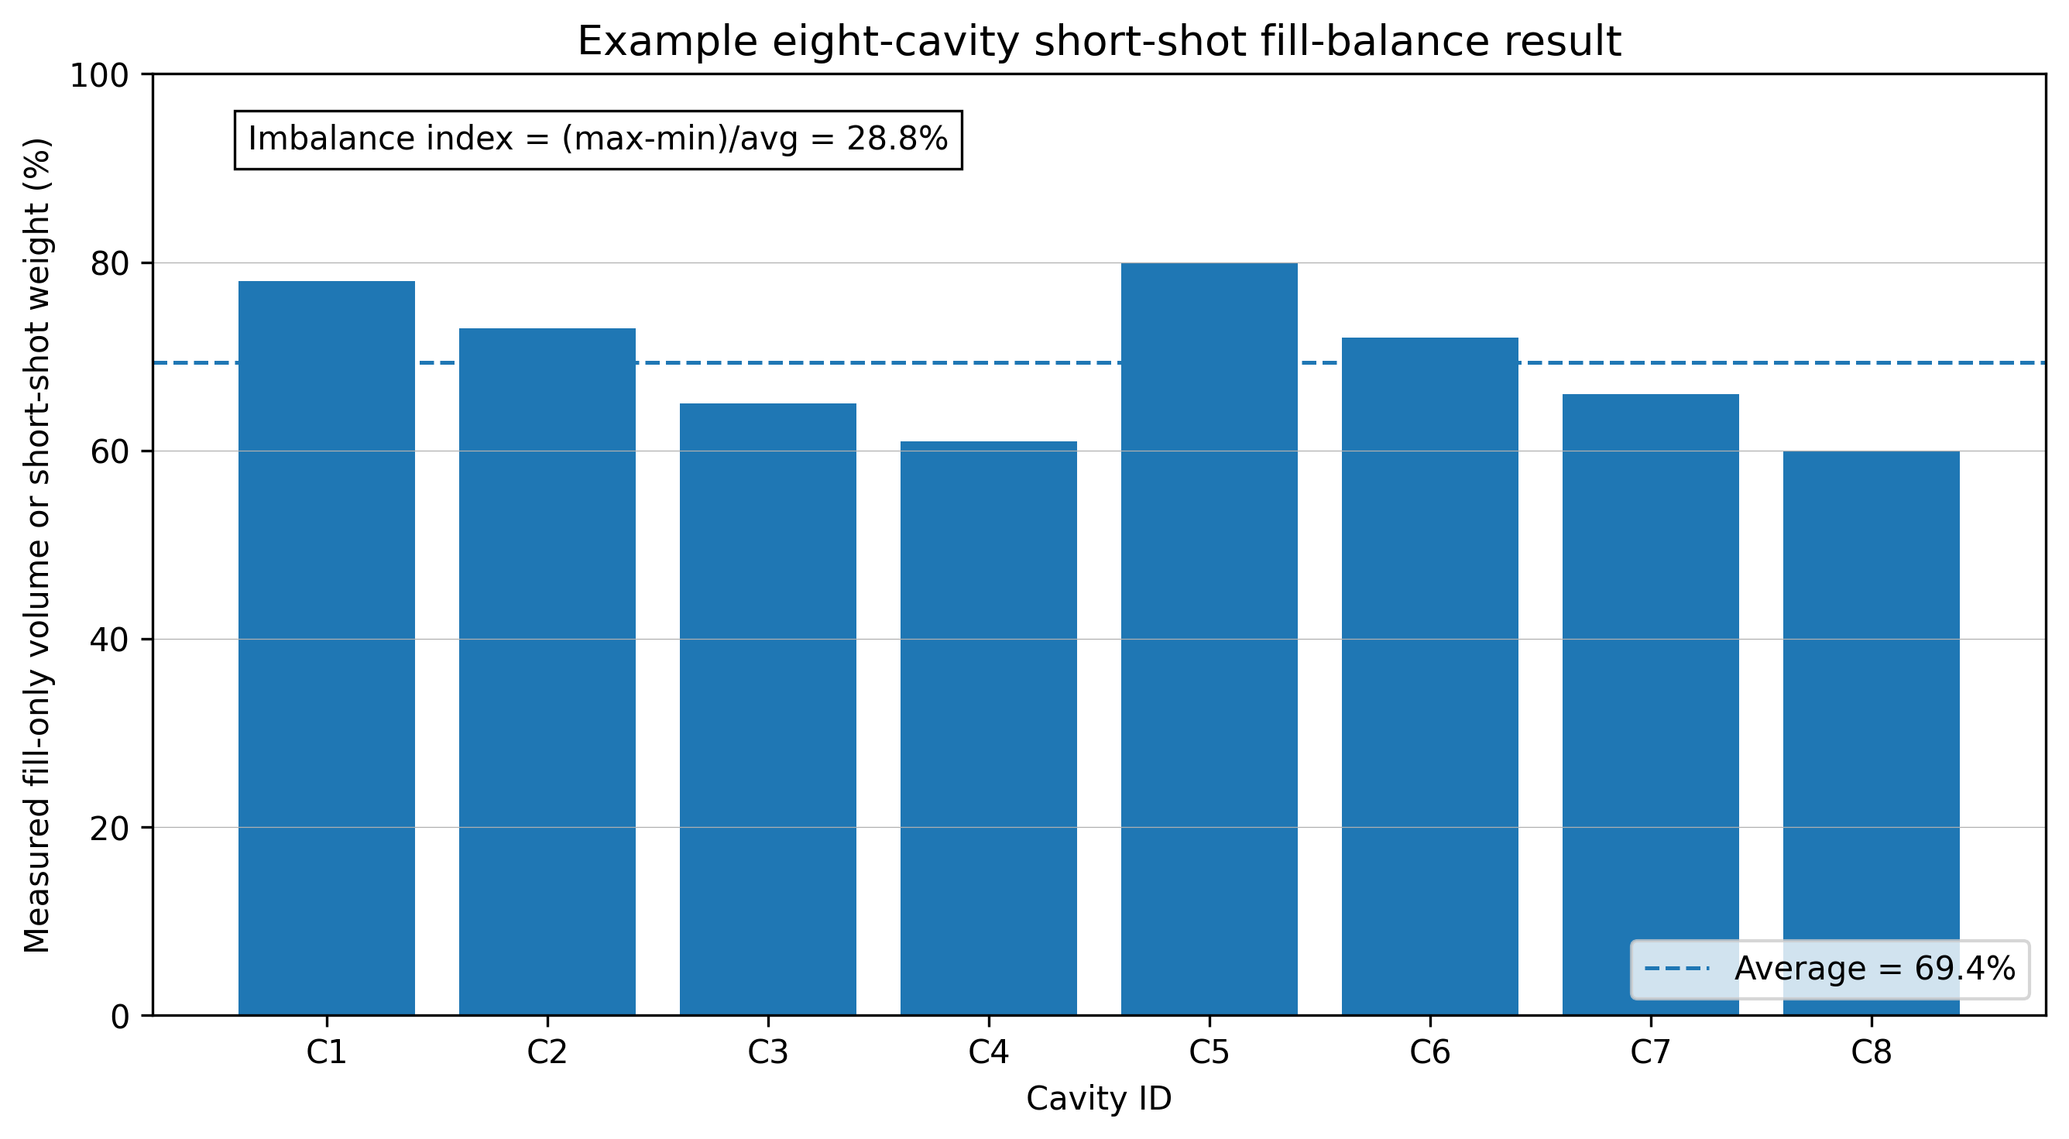
Figure 5. Example multi-cavity fill balance output. Original diagram generated for this manual.

5.3 Injection speed, pressure, and temperature profiles: cold runner versus hot runner
Cold-runner and hot-runner process optimization differ because the thermal history of the melt is different. In a cold runner, the runner freezes each cycle and contributes to shot size, pressure loss, and cold-slug behavior. In a hot runner, the manifold remains molten and adds residence-time and thermal-balance risk.
Adjustment | Cold-runner interpretation | Hot-runner interpretation
Increase injection speed | May reduce viscosity via shear thinning and fill thin sections before freeze; may increase shear heating in gates and runner. | May reduce freeze-off in cavity, but can expose tip shear, valve timing, pressure spikes, drool, or stringing.
Increase melt temperature | Improves flow but increases runner cooling load, cycle time, drool/stringing at sprue, and degradation risk. | Improves flow but may worsen residence-time degradation, manifold drool, valve sealing, or color-change purge time.
Increase mold temperature | Delays freeze and improves weld-line strength; may increase cycle time. | Same cavity benefit; also interacts with hot-tip vestige and local gate freeze/seal.
Raise pressure limit | Only valid if pressure-limited and within safe machine/tool limits. Does not fix balance root cause. | Same; pressure-controlled hot-runner systems may respond differently if cavities are inactive or tips differ.
Multi-stage speed profile | Can avoid jetting at gate, then fill rapidly through main body, then slow near vents. | Can coordinate with valve gates and reduce pressure spikes; requires timing validation.

5.4 Multi-stage injection strategies
A multi-stage injection profile is often determined or justified through the DOE sequence. The viscosity curve identifies acceptable speed regions. The short-shot fill-balance DOE shows where fast or slow segments affect flow-front order. A practical profile may use a controlled low speed through the gate to avoid jetting, a high speed through the main flow path to beat freeze-off, and a reduced speed near the end of fill to lower vent burn and pressure spike risk. For valve-gated tools, sequential timing can control weld-line location and core deflection, but it must be validated because it can create localized overpack.

5.5 Mold design improvements
- Optimize gate location to reduce flow length, avoid thin-section gating, and move weld lines away from critical features.
- Resize gate land and runner sections based on pressure drop, shear rate, and gate freeze requirements.
- Balance runners rheologically, not only geometrically. Equal length and diameter do not guarantee equal shear and temperature history.
- Ensure uniform wall thickness; use coring and rib guidelines to reduce racetrack flow and sink/voids.
- Add or restore vents at true end-of-fill locations revealed by short-shot samples and simulation.
- Audit cooling circuits for thermal symmetry; aim for measured steel temperature consistency, not just matching water setpoints.

5.6 Machine calibration and maintenance
- Check screw, barrel, and check ring condition when fill-only weight or cushion varies more than expected.
- Verify injection velocity calibration and pressure limit behavior; a machine that cannot maintain velocity invalidates the DOE.
- Confirm cushion is stable and not near zero unless intentionally bottoming out to prevent screw creep during a pack-off short-shot condition.
- Calibrate thermocouples, pressure transducers, mold-temperature controllers, and hot-runner zones according to maintenance schedule.
- Trend recovery time, torque/load, cushion, peak pressure, transfer pressure, and fill time as early warning indicators.

5.7 In-process adjustments
In-process adjustments should be governed by the DOE conclusion, not by symptom chasing. For example, adding shot size to remove a short may be correct if the whole fill-only part is uniformly underfilled. It is wrong if one cavity is already leading and flashing while another is lagging. In that case, the global adjustment hides imbalance and can create worse dimensional spread.
Symptom during production | Allowed short-term containment | Permanent corrective direction
All cavities uniformly light/short | Increase shot size or transfer volume within validated range; verify cushion. | Confirm material viscosity, melt temperature, and machine repeatability.
One cavity short, another flashes | Segregate/reject and reduce pack if safe; do not simply add volume. | Fix balance: gate, runner, vent, tip, valve, cooling, or steel.
Burn at end of fill | Reduce end-fill speed or clamp if excessive; clean vents. | Restore venting or redesign vent path.
Weight drift with stable settings | Use approved viscosity compensation or process adjustment. | Investigate material lot, moisture, check ring, hot runner, water stability.
Hot-runner cavity inactive or cold tip | Shut down and segregate as required; do not run around a failed zone without validation. | Repair heater/thermocouple/valve; rerun fill balance.

6. Redesign and Post-Processing Strategies

6.1 Post-processing after a short-shot DOE
Post-processing is rarely a true corrective action for fill imbalance. It can hide or remove cosmetic evidence, but it does not repair poor molecular knit-line formation, weak weld lines, internal voids, trapped gas degradation, or an underpacked feature. For regulated or functional parts, post-processing must not be used to disguise a process defect without engineering approval and validation.
Post-process option | Cold-runner mold | Hot-runner mold | Risk
Degating / trimming | Common for runner and gate vestige; can improve appearance after runner/gate correction. | Used for vestige grooming if hot-tip or valve-gate mark is unacceptable. | Can hide gate issue but not balance issue.
Polishing | May reduce witness marks or improve cosmetic surfaces after tooling changes. | May help gate area or flow-mark appearance. | Polishing cannot fix internal weak knit lines.
Painting / coating | May hide flow lines or color variation. | Same. | Cosmetic-only; not acceptable for dimensional or structural defects.
Annealing | Can reduce residual stress in selected materials. | Same. | May change dimensions; must be validated.
Machining secondary features | Can remove features that cause weld lines if design allows. | Same. | Adds cost and dimensional risk.

6.2 Redesign strategies
- Move gates so the flow front reaches critical features at controlled temperature and pressure.
- Add flow leaders or thicken local transitions cautiously; avoid creating sink, differential shrink, or stress risers.
- Core out thick sections and normalize wall thickness to reduce racetrack effects.
- Relocate holes, bosses, ribs, or knit-line-generating interruptions away from high-stress areas.
- Use multiple gates or valve sequencing only when weld-line location and pack balance can be validated.
- Collaborate with mold makers before cutting steel. Provide short-shot photos, cavity weights, simulation, and proposed action with expected effect.

6.3 Tooling collaboration package
A tooling change request should include objective DOE evidence. The strongest package contains the original problem statement, mold layout, cavity ID map, resin lot, process settings, fill-only baseline, short-shot samples, photos, weights, pressure curves, simulation overlay if available, water/hot-runner audit, vent inspection, proposed steel change, expected result, and validation plan. Without this package, tooling changes become opinion-driven and can create secondary defects.

7. Industry Best Practices

7.1 Scientific molding discipline
Best practice is to decouple fill from pack and pack from cooling. RJG describes establishing a 95-98% fill-only part as an essential step in developing a decoupled molding process, and notes that multi-cavity imbalance complicates that baseline [2]. For troubleshooting a short shot, RJG also recommends turning off second-stage pressure/time and making a fill-only part to understand the cavity flow pattern [21].
- Never build a fill-balance conclusion from full parts only.
- Run the DOE at a validated injection speed derived from rheology/viscosity behavior.
- Use cavity IDs. If a sample cannot be traced to a cavity, it should not be used for cavity balance decisions.
- Separate process, material, machine, auxiliary, and steel hypotheses before cutting metal.
- Do not use pack pressure to solve first-stage imbalance unless the risk is understood and validated.
- Document environmental and auxiliary conditions: plant water, ambient conditions if relevant, material drying, hot-runner temperatures, startup shot count, and robot cycle.

7.2 Standards and quality-system alignment
There is no single ASTM or ISO standard that fully defines a production short-shot fill-balance DOE for all molds. Standards are still relevant because they define disciplined molding documentation, test specimen preparation, dimensional acceptance, and quality-system expectations. ASTM D3641 covers general principles for injection molding thermoplastic test specimens, emphasizes that molding conditions affect properties, and points users to material specifications or supplier guidance for conditions [20]. ISO 20457 specifies manufacturing tolerances and acceptance conditions for plastic molded parts, but explicitly does not address surface imperfections such as sink marks, undesired flow structures, roughness, or joint lines [22].
Reference | Relevance | Practical use
ASTM D3641 | Injection molding thermoplastic test specimen practice and reporting discipline. | Use its logic: document molding steps, material conditions, and process conditions.
ISO 294 series | Injection molding of test specimens of thermoplastic materials; referenced by ASTM D3641 as equivalent in parts. | Use for material test specimen discipline when producing data for material comparison.
ISO 20457 | Tolerances and acceptance conditions for plastic molded parts. | Use for dimensional acceptance discussion, not for weld-line or cosmetic flow-line acceptance.
IATF 16949 / automotive customer-specific requirements | Process validation, APQP/PPAP, capability, control plan requirements. | Attach fill-balance DOE to mold qualification and capability evidence.
ISO 13485 / FDA process validation context for medical | Requires process control and validation where output cannot be fully verified by subsequent inspection. | Use fill-balance DOE as part of OQ/PQ evidence when fill imbalance affects critical quality attributes.

7.3 OEM and supplier guidance
Modern machine OEMs increasingly treat viscosity and fill stability as controllable process variables. ENGEL states that iQ weight control compares the injection pressure curve of each cycle with a reference curve, calculates changes in viscosity and material quantity, and adjusts switchover and holding pressure to keep part weight constant [8]. ARBURG describes GESTICA adaptive process control as monitoring and regulating injection molding to keep processes stable, and its FillAssist as visualizing mold filling based on screw position and calculating injection process parameters during setup [9][23]. These tools do not eliminate the need for a short-shot fill-balance DOE; they make it easier to control and monitor the process once the DOE establishes the right target state.
Supplier / source | Applicable insight | How to use in fill-balance work
Beaumont Technologies | Short-shot data collection procedure and warning that incorrect testing creates false information [1]. | Use as a procedural backbone for multi-cavity short-shot collection.
RJG | Fill-only and decoupled molding discipline [2][21]. | Use fill-only baseline before balance study; use cavity pressure when risk justifies instrumentation.
Husky | Hot-runner balance affects mold qualification and more than geometric melt-channel balance [7]. | Do not assume a hot runner is balanced because CAD channels are symmetric.
ENGEL | Pressure-curve comparison and viscosity compensation [8]. | Use machine analytics to detect drift after the balance DOE has defined acceptable behavior.
ARBURG | Adaptive control and FillAssist filling visualization [9][23]. | Use setup assistance to reduce startup variation and support reproducible DOE execution.
Moldex3D / Autodesk Moldflow | Simulation of fill time, air traps, weld lines, short shots, runner balance [4][16]. | Use simulation to plan DOE and reduce steel-change risk.

8. Emerging Technologies and Research

8.1 Smart molding and IoT-enabled monitoring
Smart molding converts the short-shot DOE from a one-time qualification event into a monitored process signature. In-mold pressure, contact temperature, machine pressure curves, screw position, hot-runner zone data, water-flow data, dryer data, and part weight can be connected to a manufacturing execution system or historian. The target is not merely data collection; it is correlation between process signals and critical-to-quality outputs.
- Cavity pressure sensors can detect changes in melt arrival and pressure integral before a visible short shot occurs.
- Hot-runner controllers can trend heater output and thermocouple deviations that predict future balance shifts.
- Water-flow and delta-T monitoring can identify blocked circuits that change fill via mold temperature.
- Machine learning models can use historical pressure, temperature, time, and quality results to classify good and bad cycles, but they require clean labels from DOE and validation work.

8.2 AI-driven process optimization
Recent research is moving from offline DOE toward closed-loop and semi-autonomous control. A 2025 study on AI-driven cognition for injection molding reports using cavity pressure sensors in critical mold areas and a machine-learning model relating cavity pressure deviations to process parameters in order to detect and mitigate quality issues [24]. A 2025 closed-loop machine-learning study for recycled polypropylene describes adaptive prediction of processing inputs and quality outcomes to improve stability where recycled materials vary [25]. A 2025 polymer melt stability monitoring study describes an LSTM-based data-driven framework for monitoring melt stability in injection molding [26].
The practical implication is that a short-shot fill-balance DOE can become the labeled baseline for AI. The model needs to know what “balanced” means for the specific mold. Without DOE-derived labels, AI can learn historical behavior but may reinforce a bad process. The sequence should be: perform disciplined DOE, define acceptable signatures, validate with quality outputs, then monitor or optimize using AI/closed-loop tools.

8.3 Material science innovations
Material innovation affects balance work through rheology and thermal behavior. Nano-additives, long-fiber compounds, recycled-content blends, biopolymers, and self-healing polymer systems can shift viscosity, heat transfer, weld-line behavior, moisture sensitivity, degradation, and filler orientation. These innovations do not remove the need for fill-balance testing; they increase the need to validate with production-intent resin and aging conditions. New materials often carry narrower process windows and greater lot-to-lot risk until the supply base matures.

9. Troubleshooting Guide
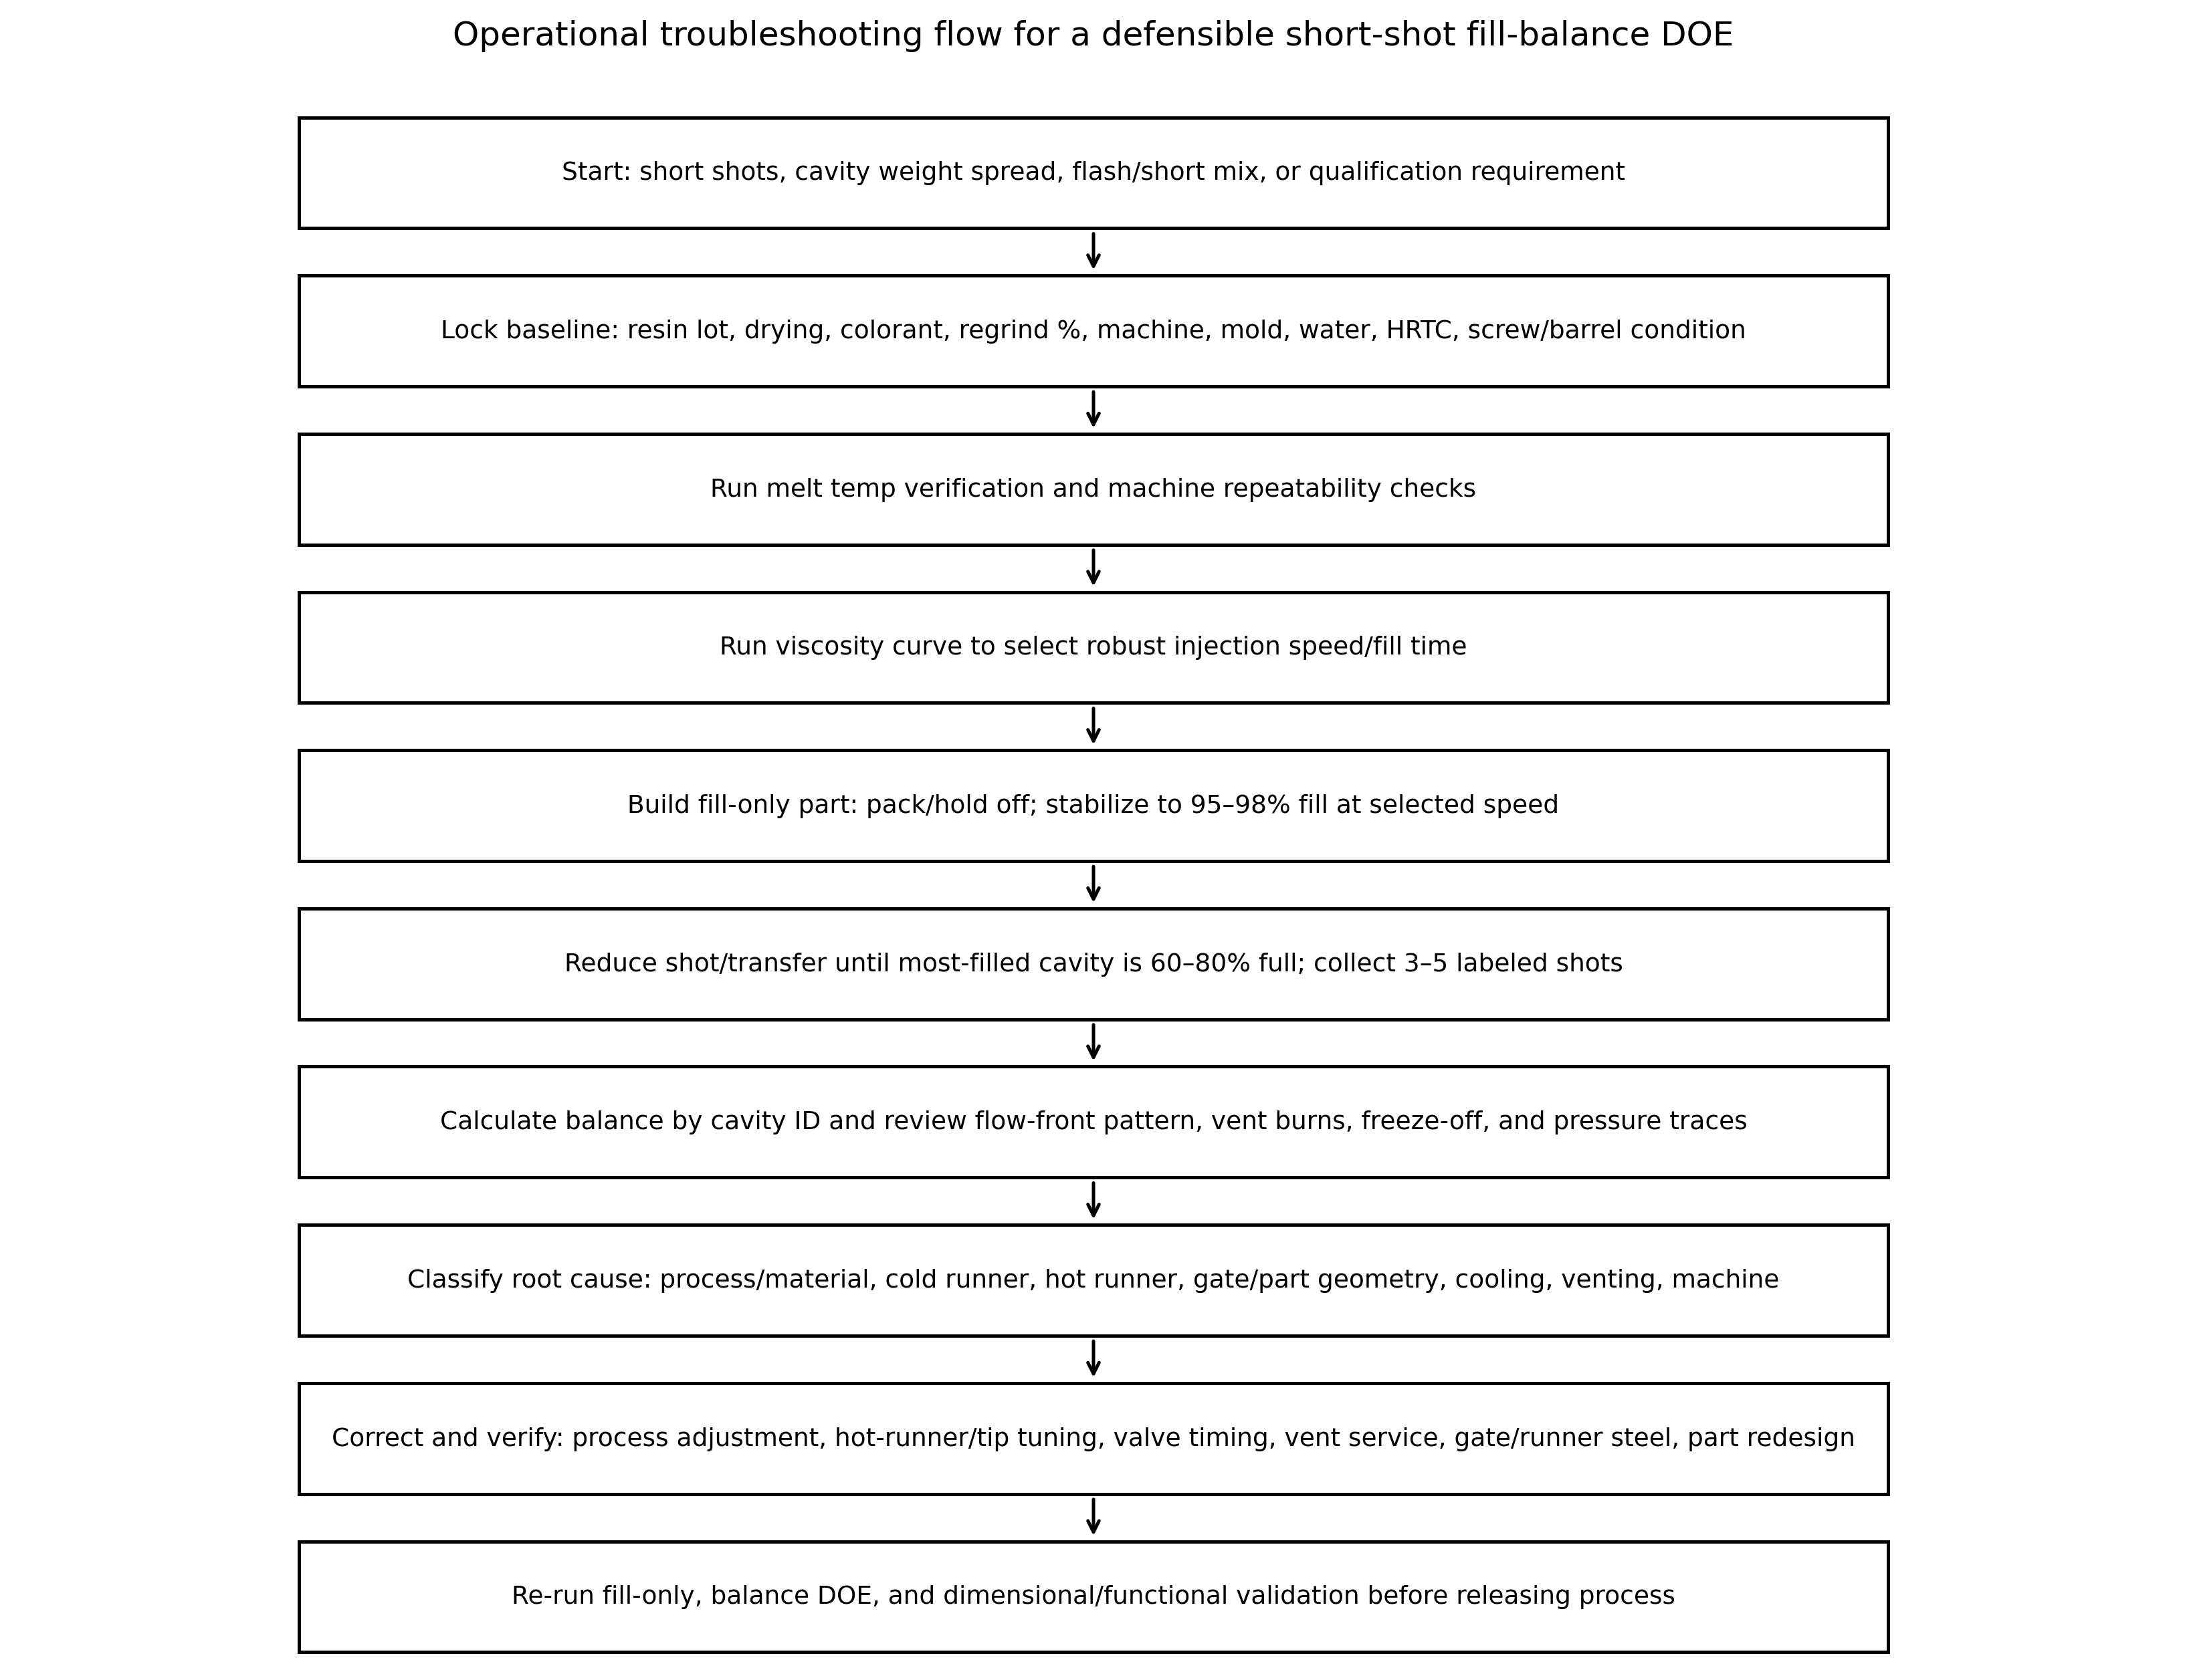
Figure 6. Troubleshooting flowchart. Original diagram generated for this manual.

9.1 Pre-DOE checklist
Checkpoint | Required condition | Why it matters
Safety | Machine, mold, hot runner, robot, and purging hazards controlled. Follow plant lockout and PPE requirements. | Short-shot studies often require nonstandard sample handling.
Material | Production-intent resin/color/regrind; dryer stable; lot recorded. | Material changes alter viscosity and fill.
Mold temperature | Water circuits verified for setpoint, flow, and supply/return orientation. | Thermal imbalance can mimic flow imbalance.
Hot runner | All zones at setpoint and heat-soaked; tips/valves functioning. | Cold tips or delayed pins dominate balance results.
Machine | Check ring and cushion stable; pressure/velocity limits not exceeded. | Machine instability invalidates DOE data.
Process baseline | Known stable production or qualification process established. | DOE must start from a controlled reference.
Documentation | Cavity map, data sheet, camera, scale, sample bins, labels ready. | Traceability is the difference between evidence and scrap.

9.2 Step-by-step DOE work instruction
- Confirm the mold is at thermal equilibrium. Run enough cycles for steel, runner, hot runner, and water system to stabilize.
- Verify actual melt temperature using the approved plant method. Record the result and compare against resin supplier guidance.
- Run or confirm the viscosity-curve DOE. Select an injection speed/fill time that is representative, stable, and not pressure-limited.
- Return to the selected process speed. Disable pack/hold pressure and hold time or set them to the minimum safe practical value.
- Adjust shot size or transfer position until the part is approximately 95-98% full for a fill-only baseline. For a badly imbalanced multi-cavity mold, record whether this is based on average cavity fill or the leading cavity.
- Check screw position during the pack-off period. If the screw creeps forward, the machine may still be adding uncontrolled volume; correct this before collecting DOE data.
- Reduce shot size or move transfer earlier until the most-filled cavity is approximately 60-80% full. Do not allow any cavity to be close to fully packed because pack-like behavior can mask balance.
- Collect three to five consecutive shots. Keep cavity ID intact. Photograph every shot in mold layout order. Weigh by cavity or cavity group if practical.
- Calculate mean fill response by cavity, range, and imbalance index. Review flow-front shape, vents, burns, weld lines, hesitation, and runner fill.
- Classify the root cause. Assign corrective action and verification method. Rerun the DOE after changes before releasing the process.

9.3 Common pitfalls and how to avoid them
Pitfall | Effect | Avoidance
Running at arbitrary injection speed | Creates false imbalance due to artificial freeze-off or shear. | Run viscosity curve first or justify selected fill rate.
Leaving pack/hold active | Masks fill imbalance and completes lagging cavities. | Turn off second stage or set to minimum and verify screw does not creep.
No cavity IDs | Data cannot be tied to mold features. | Mark cavities or retain runner/cavity map.
Only one short shot collected | Cannot separate repeatable imbalance from random variation. | Collect 3-5 shots per condition.
Tool not heat soaked | Startup thermal transients distort results. | Stabilize mold, manifold, and water circuits before DOE.
Pressure-limited injection | Machine is not following set speed. | Raise allowable limit within safe range or reduce speed; verify machine capability.
Changing multiple factors between shots | Invalid DOE; root cause cannot be isolated. | Use controlled plan and record every change.
Using non-production material/color | Balance may not transfer to production. | Use production-intent material condition.
Ignoring vents | Venting problem misdiagnosed as flow restriction. | Clean/inspect vents before cutting gates or runners.
Using post-processing as correction | Cosmetic masking without root-cause correction. | Validate structural and dimensional performance; fix flow root cause.

9.4 Decision tree for corrective action
DOE result | First checks | Likely corrective action
All cavities similar but all underfilled | Shot size, pressure limit, melt/mold temperature, resin viscosity. | Increase fill volume or adjust melt/mold/injection speed within process window.
Same cavity always low | Gate damage, blocked vent, cold tip, water circuit, local steel restriction. | Repair or adjust local defect; rerun cavity balance.
Cavities alternate high/low by runner branch | Runner shear imbalance, branch diameter/length, thermal asymmetry. | Runner balancing, melt rotation, manifold thermal audit, gate balancing.
Hot-runner cavities vary by nozzle | Tip temperature, heater/thermocouple, valve pin stroke/timing, manifold blockage. | HRTC audit, pin maintenance, valve-timing study, manifold service.
Thin feature short in every cavity | Wall thickness, gate location, mold temp, injection speed, venting. | Part redesign, local venting, speed profile, mold temperature increase, gate relocation.
DOE pattern not repeatable | Machine check ring, cushion, material moisture/lot, dryer, recovery, water stability. | Stabilize process inputs before tooling changes.

Appendix A. DOE Work Instruction Template
Use this template as a controlled shop-floor document. Adapt fields to plant QMS requirements.
Field | Entry
Mold number / revision
Press number / barrel size / screw design
Resin / lot / color / regrind %
Dryer settings and measured moisture
Melt temperature measured
Mold temperature and water flow data
Hot-runner controller zones and actuals
Injection speed / fill time selected from viscosity curve
Pack/hold condition during DOE
Fill-only transfer/shot size and approximate percent fill
Short-shot transfer/shot size and target leading-cavity percent fill
Number of shots collected
Cavity IDs verified?
Photos stored at
Disposition / corrective action

Appendix B. Data Collection Forms and Calculations
Recommended calculations:
- Cavity mean short-shot weight = average of each cavity over 3-5 shots.
- Balance index (%) = (maximum cavity response - minimum cavity response) / average cavity response x 100.
- Shot-to-shot repeatability (%) = range or standard deviation of each cavity response divided by mean.
- Cushion coefficient of variation (%) = standard deviation of cushion / average cushion x 100.
- Pressure utilization (%) = observed peak fill pressure / machine pressure limit x 100. Investigate if the process is near the pressure limit or changes from velocity to pressure control during fill.
Cavity | Shot 1 weight | Shot 2 weight | Shot 3 weight | Mean | Rank | Notes
C1
C2
C3
C4
C5
C6
C7
C8
C9
C10
C11
C12
C13
C14
C15
C16

Appendix C. References
[1] Beaumont Technologies, “Proper Procedure for Collecting Short Shots,” 2015. https://www.beaumontinc.com/proper-procedure-for-collecting-short-shots/
[2] RJG, “Establishing a Fill Only Part: Sometimes Easier Said Than Done,” 2016. https://rjginc.com/establishing-a-fill-only-part-sometimes-easier-said-than-done/
[3] H.-H. Tsai et al., “Filling-Balance-Oriented Parameters for Multi-Cavity Molds in Polyvinyl Chloride Injection Molding,” Polymers, 2022. https://www.mdpi.com/2073-4360/14/17/3483
[4] Autodesk Moldflow Advisor Help, “Fill time result.” https://help.autodesk.com/cloudhelp/2014/ENU/MoldflowAdvisor/files/GUID-7A85D18E-4D00-4439-8A8E-BF94FED55270.htm
[5] TA Instruments, “Introduction to Polymer Melt Rheology and Its Application in Polymer Processing.” https://www.tainstruments.com/applications-notes/introduction-to-polymer-melt-rheology-and-its-application-in-polymer-processing/
[6] Toray Plastics, “Melt Viscosity Properties | TORELINA.” https://www.plastics.toray/technical/torelina/tec_017.html
[7] Husky, “Hot Runners and Optimizing System Balance,” 2021. https://www.husky.co/en/resources/blog/hot-runners-play-a-key-role-in-optimizing-system-balance/
[8] ENGEL, “Compensate for fluctuations in plastic viscosity.” https://www.engelglobal.com/en/us/digital-solutions/digital-solutions-injection-molding-manufacturing-process/optimize-plastic-viscosity
[9] ARBURG, “GESTICA machine controller.” https://www.arburg.com/en/us/smart-manufacturing/control-system/
[10] Husky, “Altanium’s Next Generation: Neo6, Delta6, and Matrix6.” https://www.husky.co/en/solutions/mold-controllers/altanium-new-generation/
[11] Nanoplas, “6 Key Factors for Perfect Mold Cavity Balance.” https://nanomoldcoating.com/perfect-cavity-balance/
[12] Moldex3D, “Solving the Unbalance Flow, Weld Line and Air Trap Issues at Once,” 2021. https://www.moldex3d.com/blog/customer_success/solving-the-unbalance-flow-weld-line-and-air-trap-issues-at-once/
[13] Moldex3D, “Application of Mold Filling Analysis to Improve Flow Imbalance and Core Shift in Single-Cavity Hot Runner,” 2023. https://www.moldex3d.com/blog/customer_success/application-of-mold-filling-analysis-to-improve-flow-imbalance-and-core-shift-in-single-cavity-hot-runner/
[14] Moldex3D, “Resolving Flow Imbalance in Medical Product Molding,” 2013. https://www.moldex3d.com/blog/top-story/resolving-flow-imbalance-in-medical-product-molding/
[15] Moldex3D, “FARPLAS Using Moldex3D to Overcome Difficult Molding Issues in Multi-shot Injection Molding,” 2016. https://www.moldex3d.com/blog/customer_success/farplas-using-moldex3d-to-overcome-difficult-molding-issues-in-multi-shot-injection-molding/
[16] Moldex3D Flow product page. https://www.moldex3d.com/products/software/moldex3d-ic-packaging/flow/
[17] RJG, “The Importance of Cavity Pressure Data,” 2024. https://rjginc.com/the-importance-of-cavity-pressure-data/
[18] ASNT, “Explore Nondestructive Testing Methods.” https://www.asnt.org/what-is-nondestructive-testing/methods/
[19] Madison Group, “Non-Destructive Analysis of Plastic Parts Using CT Imaging.” https://madisongroup.com/non%E2%80%90destructive-analysis-of-plastic-parts-using-ct-imaging/
[20] ASTM D3641-21, “Standard Practice for Injection Molding Test Specimens of Thermoplastic Molding and Extrusion Materials.” https://store.astm.org/d3641-21.html
[21] RJG, “How to Prevent and Troubleshoot Short Shots,” 2021. https://rjginc.com/short-shots-whats-the-deal/
[22] ISO 20457:2018, “Plastics moulded parts — Tolerances and acceptance conditions.” https://www.iso.org/standard/68097.html
[23] ARBURG, “Increase productivity,” FillAssist section. https://www.arburg.com/en/us/smart-manufacturing/increase-productivity/
[24] E. Arslan et al., “AI-driven cognition for advanced injection molding and industrial implementation,” 2025. https://link.springer.com/article/10.1007/s00170-025-15611-x
[25] J. Krantz et al., “Machine Learning-Based Process Control for Injection Molding of Recycled Polypropylene,” 2025. https://pmc.ncbi.nlm.nih.gov/articles/PMC11991421/
[26] P. Costa et al., “Polymer Melt Stability Monitoring in Injection Moulding Using LSTM,” 2025. https://pmc.ncbi.nlm.nih.gov/articles/PMC12787767/

