Back-Pressure / Screw-RPM Matrix
for Plastic Injection Molding
A technical reference for engineers, processors, setup technicians, tooling engineers, quality engineers, and production leadership.
Scope: thermoplastic reciprocating-screw injection molding with cold-runner and hot-runner tools.
Prepared as a source-grounded technical draft. It must be reviewed and approved by qualified site process engineering, tooling, maintenance, quality, and safety personnel before conversion into a plant SOP.
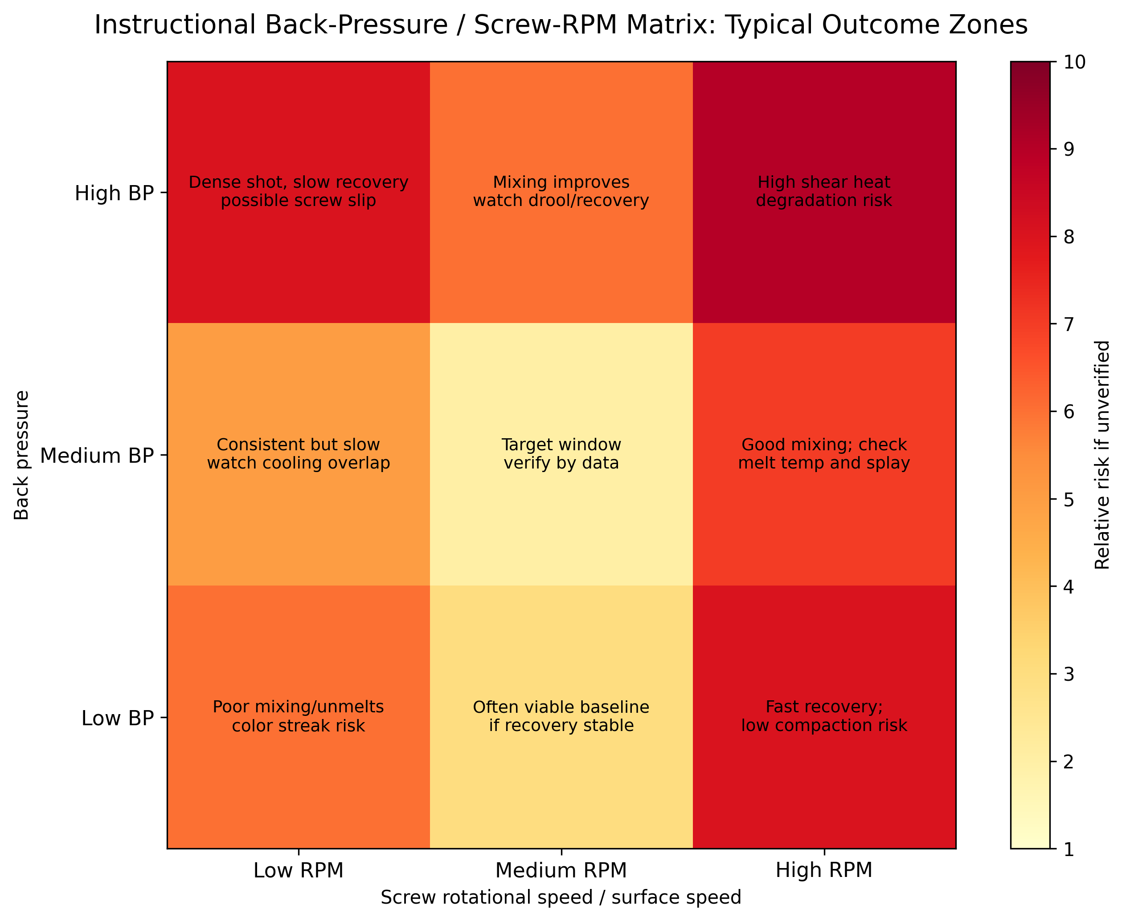
Cover Figure: Instructional BP/RPM matrix outcome map. The cell descriptions are typical response patterns, not universal limits. Replace with measured site data during validation.

Executive Summary
A back-pressure / screw-RPM matrix is a two-factor melt-preparation DOE. It varies back pressure and screw rotational speed, while controlling material condition, barrel profile, mold temperature, hot-runner settings, injection/pack/cool parameters, and machine state. The purpose is to identify a repeatable plasticizing window that produces stable recovery, consistent shot density, homogeneous melt, acceptable melt temperature, acceptable color/additive dispersion, and no evidence of shear damage or gas/moisture-related defects.
This study should not be confused with a viscosity curve. A viscosity curve normally varies injection speed or fill time to characterize apparent in-mold viscosity during filling. The BP/RPM matrix characterizes melt preparation before injection. The two studies interact: an unstable melt-preparation window can corrupt the results of a viscosity curve, pressure-drop study, cavity-balance study, gate-seal study, and production capability run.
The practical selection rule is conservative: use the lowest back pressure and lowest screw surface speed that provide repeatable recovery, repeatable shot weight, acceptable dispersion, acceptable melt temperature, and recovery completion within the cooling window without starving the cycle. High back pressure and high RPM may improve mixing, but they also increase recovery time, mechanical work on the melt, drool risk, fiber attrition, thermal degradation risk, and apparent process changes caused by melt-density changes.
Hot-runner and cold-runner molds respond differently. Cold runners introduce solid runner/sprue weight, runner freeze, larger pressure-drop sensitivity, regrind feedback, and often higher shear in small cold channels. Hot runners remove runner scrap from the shot, but add manifold thermal balance, tip temperature, valve timing, residence-time, dead-spot, and controller stability variables. The DOE must be designed and interpreted differently for each system.

1. Definition and Overview

1.1 Precise technical definition
Back pressure is the controlled resistance applied to the rearward movement of the reciprocating screw during screw recovery/plasticizing. On hydraulic machines it is generally created by controlling hydraulic resistance; on electric machines it is generated by servo control resisting screw return. Screw RPM is the screw rotational speed during plasticizing. It should be converted to screw surface speed when comparing different screw diameters because the shear input at 100 rpm on a 25 mm screw is not the same as 100 rpm on a 75 mm screw.
A back-pressure / screw-RPM matrix is a structured factorial experiment in which back pressure and screw RPM are stepped through predefined levels while measuring melt-preparation and part-quality responses. It is normally conducted after material drying, mold thermal stabilization, barrel-temperature verification, and baseline process documentation. The independent variables are back pressure and RPM. The dependent responses usually include screw recovery time, recovery-time range, shot weight/range, cushion/range, melt temperature, screw torque or load, pressure at transfer, part weight, appearance defects, cavity balance, dimensional response, and evidence of degradation or poor dispersion.
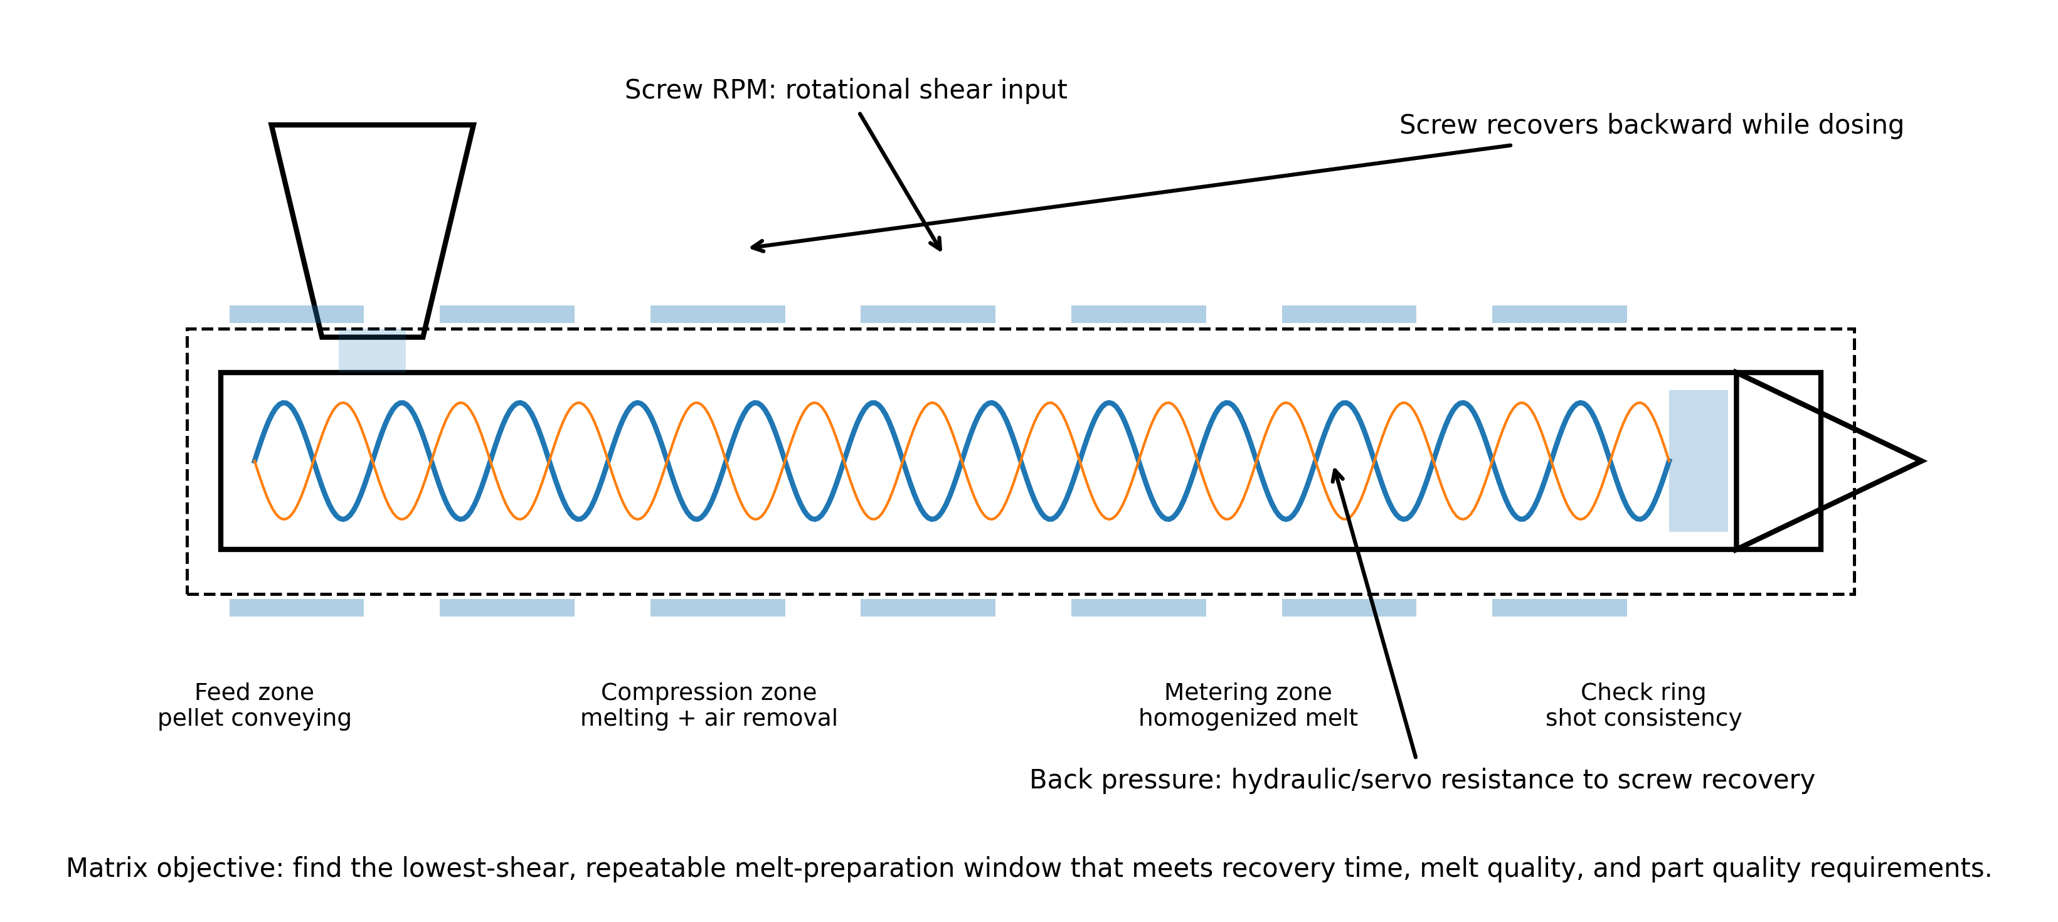
Figure 1. Plasticizing unit mechanics controlled by a BP/RPM matrix. The study evaluates the interaction between screw rotational shear and resistance to screw recovery.

1.2 What the matrix is expected to reveal
- Minimum back pressure required to produce stable shot density and acceptable mixing.
- Maximum back pressure before recovery becomes unstable, too slow, or starts causing slippage, drooling, excessive shear, or degraded material.
- Minimum screw speed that completes recovery within the cooling window while leaving a small, controlled recovery delay before mold open.
- Maximum screw speed before melt temperature, splay, silver streaks, odor, discoloration, fiber breakage, or torque load becomes unacceptable.
- Interaction between BP and RPM. A safe RPM at low BP can become risky at high BP, and a safe BP at low RPM can become thermally aggressive at high RPM.
- Whether the process is limited by melt-preparation capacity rather than fill pressure, pack pressure, cooling, mold balance, or material condition.

1.3 Units, conversions, and required terminology
Term | Technical meaning | Practical control note
Hydraulic back pressure | Pressure displayed on hydraulic side of a hydraulic injection unit. | Cannot be compared machine-to-machine without knowing intensification ratio and control architecture.
Plastic/specific back pressure | Estimated pressure on the melt in front of the screw. | Preferred basis for scientific processing. Convert from hydraulic pressure using the machine intensification ratio where applicable.
Screw RPM | Rotations per minute during screw recovery. | Use as machine setpoint only. For cross-machine transfer, convert to screw surface speed.
Screw surface speed | Circumferential speed at screw OD. V = pi x D x RPM / 60. | Better predictor of shear input than RPM alone. D is screw diameter in meters and V is meters/second.
Recovery time | Time from start of screw rotation to charge complete. | Should be repeatable and normally completed before the end of cooling, without large idle residence time.
Decompression/suckback | Controlled screw pullback after recovery or injection. | Can reduce drool but can pull air/moisture into the nozzle or hot runner if excessive.
Cushion | Material remaining ahead of screw at end of pack/hold. | Cushion stability is a key indicator of check-ring and shot consistency.

1.4 Interpreting typical visual and data outcomes
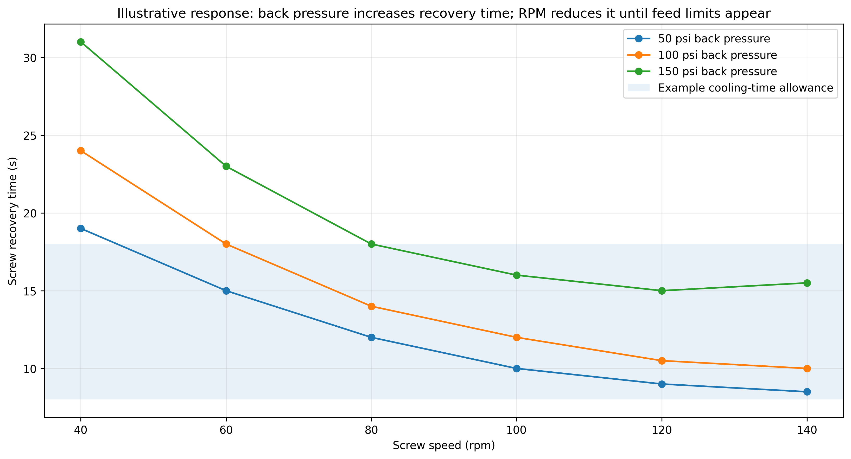
Figure 2. Illustrative recovery-time response. Values are representative only; actual curves must be generated with plant data, material-specific limits, and verified machine units.
A defensible matrix produces a data table and a response map. The target cell is not automatically the lowest recovery time. It is the region where recovery time is stable, recovery completes within the available cooling time, melt temperature is inside supplier limits, shot weight range is minimized, color/additive dispersion is acceptable, and no cosmetic or mechanical quality risk is created. For heat-sensitive or filled materials, the best cell is often a lower-shear compromise, not the fastest recovery cell.

2. Why a Back-Pressure / Screw-RPM Matrix Is Done

2.1 Primary business and technical triggers
A matrix is justified when melt preparation is suspected as a root cause or uncontrolled input. It is especially valuable during new-mold qualification, material conversion, color conversion, masterbatch changes, regrind introduction, transfer to a different press, hot-runner commissioning, cycle-time reduction work, and chronic troubleshooting where setup changes are masking the true source of variation.
Trigger | Why BP/RPM may be involved | What the matrix should prove or disprove
Color streaks, unmixed concentrate, pearlescent swirl | Insufficient mixing, poor pellet/concentrate distribution, too few screw turns, low back pressure. | Minimum BP/RPM needed for acceptable dispersion without overheating.
Splay, silver streaks, bubbles | Moisture, entrained air, excessive decompression, high shear heat, wet regrind, hot-runner drool/degradation. | Whether increased compaction reduces gas or whether high shear worsens streaking.
Brown/black specks or odor | Excessive residence time, high surface speed, high back pressure, dead spots, hot-runner stagnation. | Upper shear/temperature limit and whether the issue is machine/hot-runner contamination.
Recovery-time drift | Feed-zone starvation, additive slip, worn screw/barrel, blocked feed throat cooling, high BP, too-low rear-zone temp. | Whether recovery responds normally to RPM/BP or points to mechanical/material feed issue.
Cavity imbalance changes after color/material change | Different viscosity, filler, masterbatch, thermal sensitivity, hot-runner balance sensitivity. | Whether melt uniformity is stable before changing gates or hot-runner tips.
Part-weight range or cushion variation | Shot density variation, check-ring instability, air in melt, inconsistent recovery. | Whether BP improves repeatability or whether check ring/screw wear is suspected.
Cycle-time reduction project | Recovery may be consuming cooling time or forcing excessive idle residence time. | Fastest safe recovery setting without thermal or dispersion penalty.

2.2 Material factors

2.2.1 Viscosity and shear-thinning behavior
Most thermoplastic melts are shear-thinning: apparent viscosity decreases as shear rate increases. Increasing screw RPM raises shear rate in the barrel, while increasing back pressure increases resistance, compaction, and shear work. The matrix is needed because viscosity response is material-specific and geometry-specific. A semi-crystalline commodity resin, an amorphous engineering resin, and a glass-filled flame-retardant compound can respond very differently even if the same numeric setpoints are used.
The key error to avoid is assuming that higher back pressure or higher RPM is automatically better. Higher shear can improve dispersion and melt homogeneity, but it can also reduce molecular weight, break fibers, increase melt temperature, create volatiles, and accelerate degradation. Material supplier processing windows take precedence over generic shop rules.

2.2.2 Melt temperature and residence time
Actual melt temperature must be measured with an air-shot and needle probe or other validated method; it should not be inferred only from barrel zone setpoints. The rear, center, front, nozzle, manifold, and tip setpoints only describe heat input capability. Screw work and residence time determine actual melt state. When RPM is too low, material can sit longer and degrade even at moderate barrel temperatures. When RPM is too high, shear heating can overrun the barrel setpoints. When back pressure is excessive, recovery time can increase and compaction/shear may push melt temperature or density into a different process state.

2.2.3 Material composition, additives, fillers, and regrind
Material condition | Effect on BP/RPM matrix | Typical control action
Masterbatch/color concentrate | May require additional mixing or higher screw turns; poor letdown can mimic low BP. | Verify blend ratio and feeder first; then test incremental BP/RPM increases.
Glass/mineral fiber | High shear can reduce fiber length, increase anisotropy, and shift shrink/warp. | Use the lowest shear that disperses material; watch mechanical properties and dimensions.
Lubricants/mold release additives | Can reduce friction and alter feed pickup; may lengthen or destabilize recovery. | Audit additive level before blaming screw or barrel.
Regrind | Particle size and thermal history affect feed, melt, color, and volatiles. | Control percentage, granulate size, drying, and blending; do not use matrix data from uncontrolled regrind.
Moisture-sensitive polymers | Wet material can generate splay regardless of BP/RPM; high shear may make it worse. | Validate dryer dew point, residence time, hopper loading, and moisture content before DOE.
Flame retardants or heat-sensitive stabilizers | Can degrade under high shear/temperature or long residence. | Narrow DOE limits and verify with appearance, odor, MFR, and mechanical testing where critical.

2.2.4 Polymer-specific behavior examples
Polymer / family | Expected BP/RPM sensitivity | Matrix interpretation guidance
PP | Generally processes over a broad window; often does not need high back pressure. Additives and pigments can affect feed and mixing. | Start with modest BP and moderate RPM. Increase only if dispersion or recovery data justify it. Watch shrink, sink, and gate freeze interactions.
ABS | Amorphous; cosmetic surface and degradation are important. Excessive shear can create streaks or discoloration; insufficient mixing can show color variation. | Use matrix to balance surface appearance, gloss, color, and recovery. Confirm dryer/material condition if splay appears.
PC | Moisture and thermal residence are high-risk. High shear and hot residence can degrade; drying discipline is mandatory. | Do not use BP/RPM as a substitute for drying. Use conservative RPM and BP; confirm actual melt temperature and residence time.
PC/ABS | Blend morphology and flame-retardant packages can be sensitive to shear and residence; hot runners add stagnation risk. | Matrix must include hot-runner zone stability and tip appearance. Avoid using high BP/RPM to hide wet material or hot-runner dead spots.
Nylon/PA | Moisture strongly affects viscosity and part dimensions. Reinforced grades are sensitive to fiber length. | Document moisture and drying. Include dimensional aging checks if moisture regain matters.
Acetal/POM | Thermally sensitive; degradation gases are hazardous. Never overheat or allow incompatible contamination. | Use supplier limits, purge procedures, and safety controls. Avoid aggressive shear unless explicitly approved.
TPU/TPE | Often shear-sensitive; high BP may homogenize but can degrade or make ejection/cooling worse. | Use low-to-moderate shear; verify melt uniformity and cycle stability.

2.3 Process parameter factors

2.3.1 Injection speed and pressure
Injection speed and pressure are downstream of melt preparation. A poor melt-preparation window can shift the apparent viscosity entering the mold, which changes pressure at transfer, fill time, weld-line strength, burn tendency, and pressure loss. During a BP/RPM matrix, injection velocity, transfer position, pressure limit, pack/hold profile, decompression, and cooling must remain locked unless the DOE plan specifically includes them. Otherwise, the response cannot be attributed to BP/RPM.
Pressure-limited processes must be identified before the matrix. If the machine is already pressure-limited during fill, a change in melt density or melt temperature can look like a BP/RPM success while actually masking an undersized gate, cold slug, blocked vent, plugged nozzle, or insufficient machine capacity.

2.3.2 Cooling rate, mold temperature, and thermal equilibrium
Mold temperature is a covariate in the matrix. A mold that is not at thermal equilibrium can make early cells look different from later cells, producing a false optimum. The DOE should not start until water flow, thermolator setpoints, chiller load, mold-surface temperature, and hot-runner temperatures are stable. For semi-crystalline materials, mold temperature strongly affects crystallization, shrinkage, warpage, and gate freeze. For amorphous materials, it affects surface gloss, molded-in stress, weld-line appearance, and dimensional stability.

2.3.3 Gate design, gate size, and gate location
A BP/RPM matrix can reveal process sensitivity, but it cannot correct a fundamentally wrong gate. Small gates and long flow lengths increase shear and pressure drop, so a cell with higher melt temperature may appear to fill better but create degraded material. Gates located away from thick sections may cause packing inefficiency and sink that no plasticizing study will eliminate. Restricted gates can make high RPM/high BP appear beneficial because the hotter, lower-viscosity melt fills easier; this is a process workaround, not a robust root cause correction.

2.4 Mold design: cold runner versus hot runner
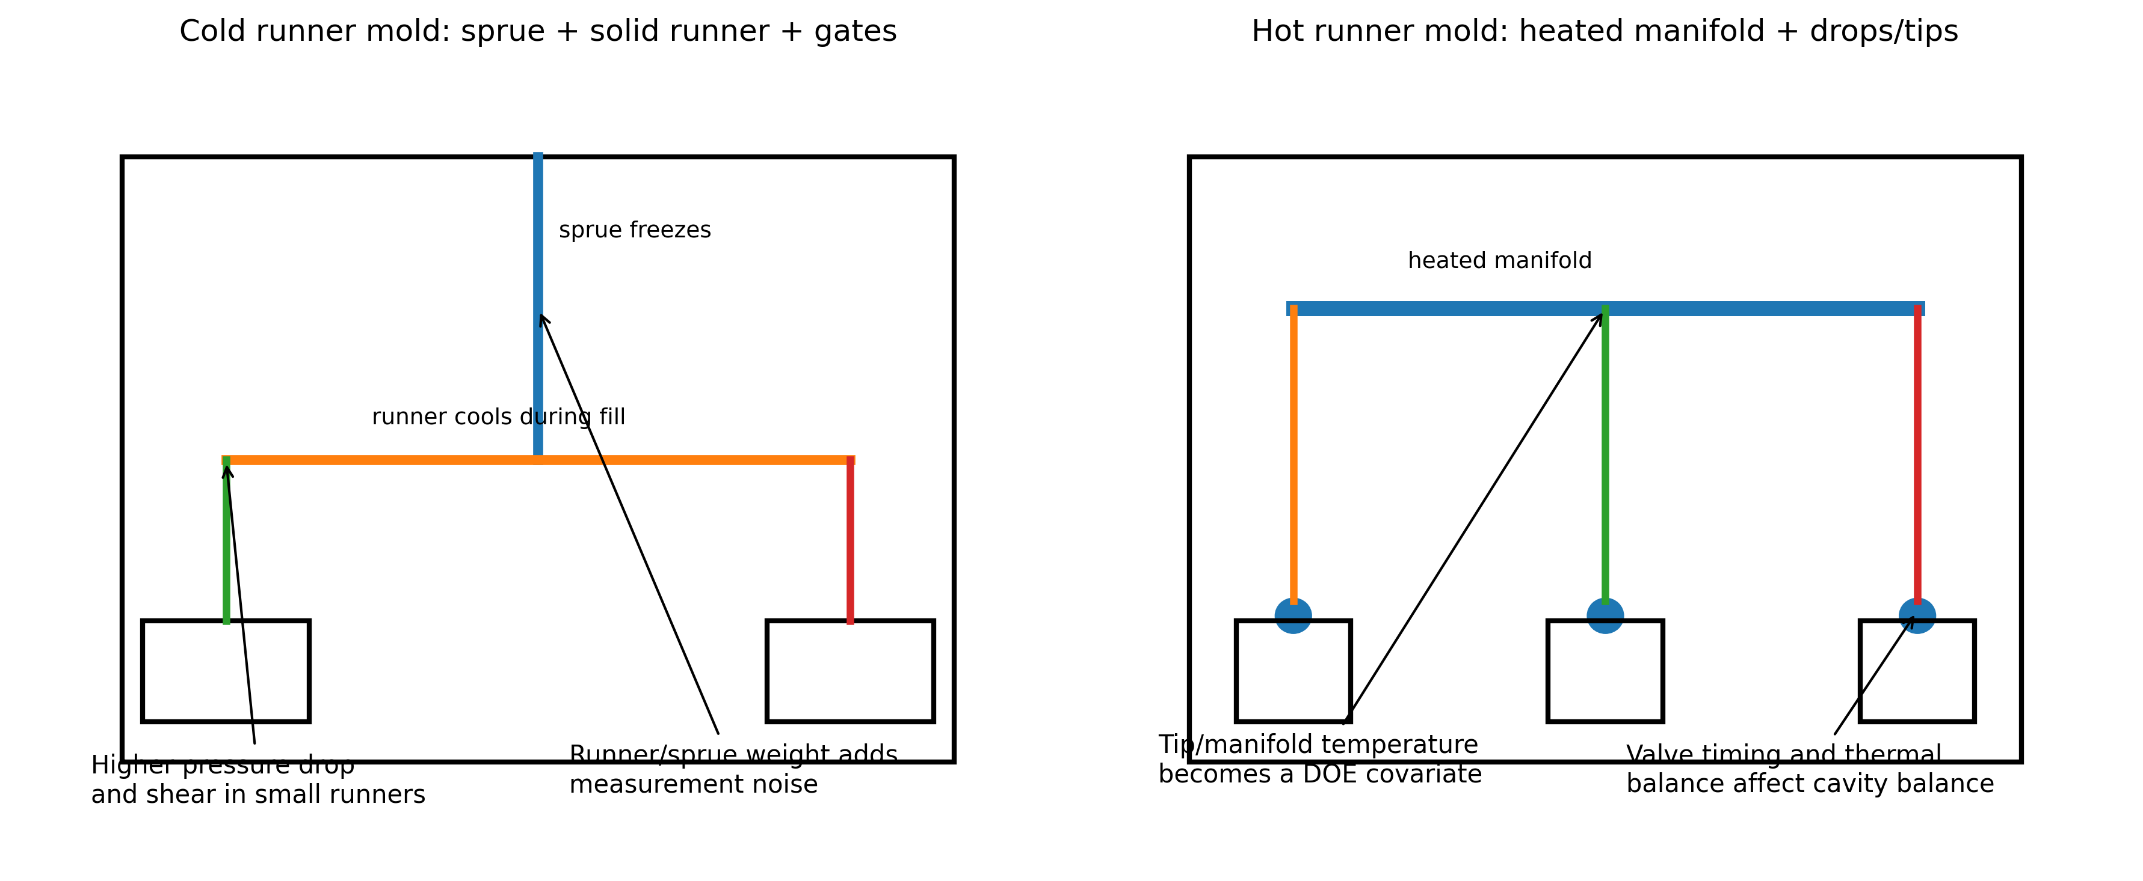
Figure 3. Cold-runner and hot-runner architecture change how a BP/RPM matrix is designed, measured, and interpreted.
Topic | Cold runner molds | Hot runner molds
Shot-weight measurement | Usually includes part plus sprue/runner unless separated. Runner weight may dominate small parts and obscure cavity response. | Usually part weight only. No cold runner to weigh, but manifold/tip drool or gate stringing can contaminate samples.
Thermal behavior | Runners freeze every cycle. Effective runner diameter reduces during fill; cold slug control matters. | Manifold and tips keep material molten. Thermal balance, controller accuracy, thermocouple placement, and residence time become critical.
Shear and pressure drop | Small cold runners can create high shear and pressure drop. Runner sizing affects BP/RPM conclusions. | Pressure drop can be lower, but manifold layout, tips, valve gates, and dead spots can create imbalance or degradation.
Regrind feedback | Runner/sprue can become regrind, changing material history and feed behavior if recycled. | Less runner regrind. Material history may still change through purging and residence in manifold.
Gate seal / pack study | Gate-freeze study by part weight is normally applicable for cold gates. | Conventional gate-freeze by weight is often not valid with open/valve hot runners; use cavity pressure, valve timing, or part response methods.
Typical false conclusion | Higher RPM looks better because it offsets cold runner freeze or undersized gates. | Higher BP/RPM looks better because it pushes through a cold tip or imbalanced manifold, while masking hot-runner thermal root cause.
DOE safeguard | Separate part and runner weights where possible. Track regrind percentage and runner condition. | Trend each zone, compare cavity balance, verify tip temperatures, valve timing, and manifold residence.

2.4.1 Runner and gate design flaws
Runner and gate flaws can distort the matrix. Undersized runners, sharp corners, dead-ended runners, unbalanced flow paths, poor cold-slug wells, restricted submarine gates, and excessive land length raise shear and pressure. A matrix can identify sensitivity to melt preparation, but mold correction should be considered when the stable process window is too narrow, when acceptable parts require high shear, or when pressure drop is excessive.

2.4.2 Wall thickness variation
Wall thickness variation changes local cooling rate and local pressure demand. Thick-to-thin flow is preferred when packing is required; thin-to-thick flow can cause hesitation, sink, voids, and knit-line weakness. A BP/RPM matrix may show that hotter, more sheared melt reduces hesitation, but that is not a design cure. For high-value molds, use the matrix as evidence for part/mold redesign when the process is only stable at damaging shear levels.

2.4.3 Venting issues and air traps
Poor venting produces burn marks, shorts, splay-like streaks, hesitation, and high pressure at end of fill. Raising BP/RPM can make venting symptoms move or temporarily improve flow, but it can also increase gas load and shear heating. Any DOE result associated with burns, dieseling, or erratic end-of-fill pressure must trigger vent inspection before process setpoints are locked.

2.5 Machine factors
Machine factor | How it affects the matrix | Verification method
Screw design | General-purpose, barrier, mixing, low-compression, or high-compression screws create different shear and melting behavior. | Document screw type, L/D, compression ratio, mixer, check-ring design, and screw diameter.
Screw/barrel wear | Causes poor conveying, inconsistent recovery, poor melt, and temperature variability. | Trend recovery, cushion, screw turns, torque; inspect screw/barrel clearance during maintenance.
Check ring/non-return valve | Leakage causes cushion variation and part-weight variation that can be misread as BP/RPM effect. | Cushion repeatability, static leak test, dynamic pressure decay, short-shot consistency.
Pressure calibration | Displayed hydraulic pressure may not equal plastic pressure; electric/hydraulic systems differ. | Use intensification ratio and calibration records. Compare actual trend data, not only setpoints.
Feed throat temperature | Poor feed cooling or bridging changes solids conveying and recovery. | Verify water flow, feed throat temperature, hopper throat condition, and pellet feed stability.
Clamp force | Does not directly prepare melt, but insufficient clamp can create flash that falsely favors lower melt temperature or lower fill pressure. | Verify clamp tonnage, parting-line witness, vent land condition, projected area, and cavity pressure where available.

2.6 Auxiliary equipment factors
Auxiliary | Role in BP/RPM matrix | Cold runner emphasis | Hot runner emphasis
Dryer / material handling | Controls moisture and feed consistency. Wet material invalidates splay conclusions. | Runner regrind must be dried/blended consistently. | Purge and residence history must be controlled before sampling.
Chiller / thermolator | Controls mold thermal equilibrium, crystallization, gloss, stress, and cycle time. | Runner cooling changes runner freeze and part/runner separation. | Nozzle gate area cooling can interact with tip temperature.
Hot-runner temperature controller | Not applicable unless hot sprue/bushing present. | Hot sprue bushings must be stable if used. | Zone actuals, thermocouple integrity, heater balance, valve-gate timing, and alarms are DOE inputs.
Robot / sprue picker | Cycle timing changes residence time and recovery idle time if interruptions occur. | Sprue picker failures can alter cycle and runner regrind handling. | Robot delays can increase residence in hot runner and barrel.
Granulator / blender | Controls particle size, fines, and regrind letdown. | High importance because runners may be reground continuously. | Less runner scrap but still relevant for rejected parts or start-up scrap.
Mold-temperature monitoring | Prevents false conclusions from thermal drift. | Runner/cavity surface differential matters. | Manifold heat loss to mold base and tip cooling matter.

3. Real-World Examples and Case Studies

3.1 Limits on firsthand accounts
This document does not invent interviews. The practitioner comments summarized below come from public forum discussions and industry technical articles. They are useful as field signals, not as controlled experiments. Before adopting any practice, validate it against material supplier data, machine capability, the actual mold, and plant quality requirements.

3.2 Public practitioner observations relevant to BP/RPM
Field observation | Technical interpretation | How to use it
A processor described back pressure as resistance during recharge; too much can push material out the nozzle. | Back pressure compacts and resists screw return, but excessive BP can cause drool or unwanted nozzle pressure. | Include drool/stringing observations in the matrix, especially with open nozzles and hot runners.
A technician recommended setting recovery to finish shortly before the end of cooling, not excessively early. | Finishing recovery too early can increase idle residence; finishing too late extends cycle. | Select RPM only after knowing cooling time, recovery variation, and material residence sensitivity.
An Eng-Tips contributor advised reducing screw back pressure and screw surface speed when degradation was suspected. | Brown/silver streaks can be caused by shear/residence/check-ring leakage rather than fill speed alone. | If high BP/RPM cells create streaks or odor, stop and verify actual melt temperature and check ring.
A forum contributor noted that different machines may not reproduce the same numeric pressure/speed setpoints. | Screen values are machine-specific; hydraulic pressure, screw diameter, drive type, and control loop differ. | Transfer studies should use plastic pressure, surface speed, melt temp, recovery response, and part data, not raw setpoints.
A molder reported that layered regrind/virgin feed and inadequate blending caused variation, and that more back pressure sometimes reduced it. | BP can improve mixing but does not fix uncontrolled material handling. | Audit blending first; use BP/RPM only after material feed condition is controlled.

3.3 Case study A: PP closure, cold runner, color dispersion and recovery
Scenario: A cold-runner, multi-cavity PP closure mold shows intermittent color swirls and a recovery-time range of 2.5 s. The process includes 15 percent cold-runner regrind. Operators have been increasing back pressure during the shift to hide color streaks, but recovery time is encroaching on cooling time and occasional splay appears after long runs.
Matrix design: BP levels 50, 100, 150 psi plastic equivalent; RPM levels 60, 90, 120 rpm on the same screw. Injection velocity, transfer position, pack/hold, mold temperature, regrind percentage, and color letdown are locked. For each cell, 15 shots are run after stabilization; parts plus runners are weighed separately, recovery time is trended, color is visually rated under a fixed light source, and actual melt temperature is measured.
Result pattern: The low BP/low RPM cell shows visible color swirl and highest shot-weight range. The medium BP/medium RPM cell shows acceptable color, lowest recovery range, and recovery inside cooling time. High BP/high RPM improves color slightly but raises melt temperature, increases runner stringing, and produces occasional splay. The selected condition is not the fastest cell; it is the lowest-shear cell that meets dispersion and repeatability.
Resolution: The shop locks the selected BP/RPM, then optimizes fill speed and pack. A blender audit also finds inconsistent regrind feed. After feeder correction, the process is less dependent on high BP.

3.4 Case study B: PC/ABS hot-runner electrical housing, splay and gate blush
Scenario: A PC/ABS hot-runner mold produces gate blush and silver streaking near several valve-gated locations. Operators increase screw speed to recover before cooling ends, and raise back pressure for color consistency. Streaking gets worse after long pauses and is cavity-specific.
Matrix design: Before running the matrix, dryer dew point, resin moisture, manifold actuals, tip actuals, valve timing, and purge history are verified. The DOE includes only BP/RPM cells that stay within supplier melt-temperature limits. Each cell records cavity-specific defects, melt temperature, recovery time, transfer pressure, and part weight. Hot-runner zones are trended and not adjusted mid-cell.
Result pattern: High BP/high RPM cells increase silver streaking and odor. One cavity shows defects across all cells, indicating a hot-runner tip or valve timing imbalance rather than plasticizing alone. Medium RPM with low-to-medium BP gives acceptable global melt quality, but the cavity-specific streak remains until the hot-runner zone and valve timing are corrected.
Resolution: The matrix prevents the team from wrongly specifying aggressive plasticizing. The final corrective action is hot-runner thermal/timing balance plus a conservative melt-preparation setting.

3.5 Case study C: glass-filled PP automotive bracket, mechanical property risk
Scenario: A glass-filled PP bracket has dimensional drift and occasional short shots. High RPM and high BP fill the mold more easily, but stiffness data is inconsistent and warpage increases.
Matrix design: The DOE adds fiber-sensitive outputs: ash/fiber check if available, mechanical coupon data or part functional testing, weight, pressure at transfer, and dimensional orientation. Gate, runner, and vent inspection are performed before increasing shear.
Result pattern: High shear cells reduce fill pressure but increase warpage and reduce mechanical consistency. A lower RPM with moderate BP requires a minor melt-temperature adjustment and gate/vent cleanup, but produces more stable dimensions.
Resolution: The matrix shows that using shear to compensate for tooling restriction damages robustness. The production window is based on acceptable mechanics, not only short-shot elimination.

4. Diagnostic Techniques

4.1 How to identify whether a matrix has already been performed
There is no reliable physical signature proving that a BP/RPM matrix was performed after production is already running. You can only infer it from documentation, retained samples, machine history, and process discipline. A part cannot be inspected and conclusively shown to have come from a completed matrix. The correct audit question is: Is there evidence that the melt-preparation window was characterized and locked before downstream parameters were optimized?
Evidence type | Strong evidence | Weak or misleading evidence
Process documentation | DOE worksheet with BP/RPM cells, dates, resin lot, machine, screw, mold, hot-runner zones, results, selected cell, approval signatures. | Setup sheet showing one back pressure and one RPM value with no study data.
Machine historian / controller data | Trended recovery time, cushion, screw position, pressures, and alarms across multiple cells. | A screenshot of final settings only.
Retained samples | Labeled sample sets from each cell with weights and defect ratings. | Good current parts without historical samples.
Quality data | Before/after variation reduction tied to locked settings and controlled material conditions. | Reduced scrap after many simultaneous adjustments.
Operator/technician record | Signed run log with cell sequence and actual observations. | Verbal statement that back pressure was adjusted until parts looked good.

4.2 Visual inspection
Visual inspection remains the first-line diagnostic tool, but it must be standardized. Use fixed lighting angle, fixed color temperature, magnification where needed, and side-by-side retained samples. Record gate-area blush, splay, silver streaks, black specks, color swirls, unmelts, sink, flow marks, weld/knit lines, burns, gloss shift, and drool/stringing artifacts. For hot-runner molds, record by cavity and by drop. For cold-runner molds, inspect the runner and sprue as well as the molded part; degradation or unmelted material may be more visible in the runner system.

4.3 Microscopy, sectioning, and lab checks
Microscopy can show unmelts, filler dispersion, contamination, pigment streaks, fiber orientation, voids, and weld-line morphology. Cross-sectioning through gates, knit lines, streaks, and thick sections is useful when visual defects are ambiguous. Polarized light is useful for evaluating residual stress in transparent or semi-transparent materials. Melt-flow-rate testing before and after molding can indicate degradation through molecular-weight change, but it is not a substitute for part testing when mechanical performance is critical.

4.4 Non-destructive testing
Method | Useful for | Limitations
Industrial CT / X-ray CT | Voids, internal shorts, porosity, inclusions, weld-line geometry in some parts, dimensional metrology. | Cost, scan time, resolution limits on large parts, contrast limitations for similar-density materials.
Ultrasonic / scanning acoustic microscopy | Weld-line characterization, delamination, voids, internal discontinuities in suitable materials. | Requires coupling/setup expertise; geometry and material attenuation matter.
Terahertz imaging | Some polymer weld lines, moisture/filler distribution, nonconductive polymer inspection. | Specialized equipment; not standard on most shop floors.
Infrared thermography | Mold thermal imbalance, hot-runner tip thermal patterns, part cooling differences. | Surface temperature only; emissivity and timing matter.
Cavity-pressure sensing | Fill/pack repeatability, viscosity shifts, gate seal, cavity balance. | Requires sensor installation and interpretation skill.

4.5 Mold-flow simulation and digital modeling
Mold-flow software is valuable for predicting fill pattern, pressure drop, weld lines, air traps, cooling imbalance, warpage, gate options, and hot-runner effects. However, a BP/RPM matrix is still a real-machine study because standard mold filling simulation generally starts from a defined melt entering the mold. It does not fully characterize pellet feed, screw plasticizing, screw/barrel wear, check-ring behavior, trapped air in the melt, or real dryer/hopper variability. Use Moldflow or Moldex3D to narrow mold and process hypotheses; use the BP/RPM matrix to validate the actual melt-preparation behavior on the press.
For hot runners, simulation can be especially useful because manifold temperature distribution, pressure drop, shear heating, mold-base heat transfer, and runner balance can be studied before steel changes. For cold runners, simulation is useful for runner sizing, pressure loss, gate location, air trap prediction, and cooling adequacy. Neither software result should override actual melt-temperature measurements, cavity pressure, or retained sample data.

4.6 Alternative or complementary studies
Study | Purpose | Relationship to BP/RPM matrix
Viscosity curve / in-mold rheology | Find stable fill-speed region by varying injection speed/fill time. | Run after melt preparation is stable, or its result can be corrupted.
Pressure-drop study | Quantify losses through nozzle, runner, gate, and cavity. | High BP/RPM may hide pressure losses by changing melt temperature/density.
Cavity-balance study | Evaluate multi-cavity fill balance at short-shot state. | Essential for hot runners and multi-cavity cold runners.
Gate-seal study | Determine pack/hold time needed for cold gate freeze. | Usually valid for cold runners; use caution or alternate methods for hot runners.
Cooling-time study | Find minimum cooling time for dimensions/ejection. | RPM selection depends on recovery fitting inside cooling time.
Residence-time study | Determine material exposure time in barrel/hot runner. | Critical for PC, acetal, PVC, flame-retardant materials, and hot runners.
Dryer validation / moisture study | Verify material condition before molding. | Mandatory when splay or degradation is being investigated.

5. Preventive Measures Before and After the DOE

5.1 Material selection and preparation
Preventive control starts with resin selection and material handling. Use a resin grade with a flow index, viscosity curve, thermal stability, and filler system appropriate for the part wall thickness, flow length, gate type, hot-runner exposure, and regulatory requirements. Do not use back pressure and RPM to force an unsuitable resin through a restrictive mold unless the risk has been formally accepted by engineering and quality.
- Verify supplier processing window for melt temperature, mold temperature, drying, maximum residence time, screw speed guidance, and back pressure guidance.
- Confirm resin lot, moisture level where applicable, hopper/dryer residence time, dew point, and regrind percentage.
- Validate masterbatch letdown, feeder calibration, blender performance, and pellet/regrind consistency.
- Avoid uncontrolled lubricants, mold release, or additive changes during the DOE.
- For filled polymers, include mechanical or dimensional checks that can detect fiber damage or orientation changes.

5.2 Process optimization after the matrix
The matrix tells the team how the melt-preparation system behaves. It does not finish the entire molding process. After a BP/RPM window is selected, the process should be rebuilt or verified in a disciplined sequence: short-shot fill, injection velocity/viscosity curve if needed, transfer position, pressure-drop check, cavity balance, pack/hold pressure, gate seal or valve-gate timing, cooling time, decompression, and final capability run. Any downstream changes that significantly affect pressure, residence, cycle time, or thermal state may require a matrix re-check.

5.2.1 Cold-runner optimization sequence
- Lock material drying, regrind percentage, barrel profile, and selected BP/RPM.
- Perform short shots without pack/hold to verify fill pattern and runner balance.
- Separate part and runner weights when possible. Track sprue/runner defects because they affect regrind and pressure drop.
- Optimize fill speed using a viscosity curve or pressure/appearance response.
- Optimize transfer position to approximately 95-98 percent filled when appropriate for the process method.
- Run pack/hold pressure and gate-freeze studies by weight or cavity pressure.
- Optimize cooling only after recovery time is confirmed inside the cooling window.
- Document whether the runner will be reground and whether regrind changes require DOE verification.

5.2.2 Hot-runner optimization sequence
- Lock material drying, barrel profile, selected BP/RPM, manifold zones, tip zones, valve timing, and decompression.
- Verify hot-runner thermal stability with actual zone trends and, where possible, thermal imaging or cavity balance results.
- Perform short shots by cavity/drop. Do not assume equal fill because the manifold is nominally balanced.
- Tune valve-gate timing, tip temperatures, and manifold balance only by documented plan, not by random cavity chasing.
- Use cavity pressure or cavity-specific part weight/dimension response for pack/hold decisions; conventional cold-gate freeze logic may not apply.
- Control residence time in the manifold during start-up, breaks, alarms, and robot interruptions.
- Include drool, stringing, cold slug, gate blush, and tip vestige in the response sheet.

5.3 Mold design improvements
Improvement | Expected benefit | When to prioritize
Increase or rebalance gate size | Reduces pressure drop and shear heating, improves packing. | Acceptable parts require high melt temperature or high injection pressure.
Move gate to thick section or better flow path | Improves pack efficiency and reduces weld-line weakness. | Sink/voids/welds persist across all BP/RPM cells.
Improve venting at end of fill and weld areas | Reduces burns, shorts, dieseling, and pressure spikes. | High pressure, burns, or air traps appear during short shots.
Balance cold runner or hot manifold | Reduces cavity-to-cavity variation. | BP/RPM changes shift but do not solve cavity imbalance.
Reduce sharp transitions/dead spots | Reduces stagnation and shear degradation. | Black specks or streaks appear after residence or color changes.
Improve cooling uniformity | Reduces thermal drift, warp, and false matrix results. | DOE cells trend with time rather than setpoint.

5.4 Machine calibration and maintenance
A BP/RPM matrix is only valid if the machine can execute setpoints repeatably. Preventive maintenance should include screw/barrel wear inspection, check-ring condition, heater-band operation, thermocouple accuracy, pressure calibration, feed-throat cooling, hydraulic oil condition on hydraulic machines, servo/load-cell function on electric machines, and controller trend verification. A worn check ring or unstable feed throat can create a false optimum because BP/RPM appears to influence a problem that is actually mechanical.

5.5 In-process adjustments
After the matrix, operators should not freely adjust BP/RPM for routine defects. These setpoints are melt-preparation controls and affect the entire process. Approved in-process adjustments should be bounded and documented. If a defect appears, first check material, dryer, hot-runner zones, mold temperature, water flow, cycle interruptions, cushion, recovery time, and recent changes. Adjusting BP/RPM should require escalation unless the control plan explicitly defines a small allowable range and the expected response.

5.6 Post-processing and containment
Post-processing can contain cosmetic consequences but cannot repair degraded resin, broken fibers, weak weld lines, voids, or molded-in stress. Polishing, painting, flame treating, laser marking, machining, or gate trimming may be acceptable for appearance or assembly requirements, but they are not corrective actions for an invalid melt-preparation window. For medical, safety, automotive, or pressure-retaining parts, post-processing must be validated against functional performance and regulatory requirements.
System | Post-processing reality | Risk
Cold runner | Gate trimming, runner separation, regrind handling, deflashing, polishing, painting. | Runner regrind can feed the defect back into production if not controlled.
Hot runner | Gate vestige trimming, degating witness correction, cosmetic polishing/painting. | Tip degradation, drool, or gate blush may indicate process/hot-runner instability rather than a surface-only issue.

5.7 Redesign strategies
If the matrix only produces acceptable parts at high-risk settings, the correct response is engineering escalation, not operator heroics. Redesign options include thicker gates, shorter flow lengths, better wall uniformity, improved venting, alternative resin grade, lower-viscosity resin, revised hot-runner tip, valve-gate conversion, balanced runner geometry, added cold slug well, improved cooling, or part-geometry changes that reduce hesitation and weld-line stress.

6. Recommended BP/RPM DOE Procedure
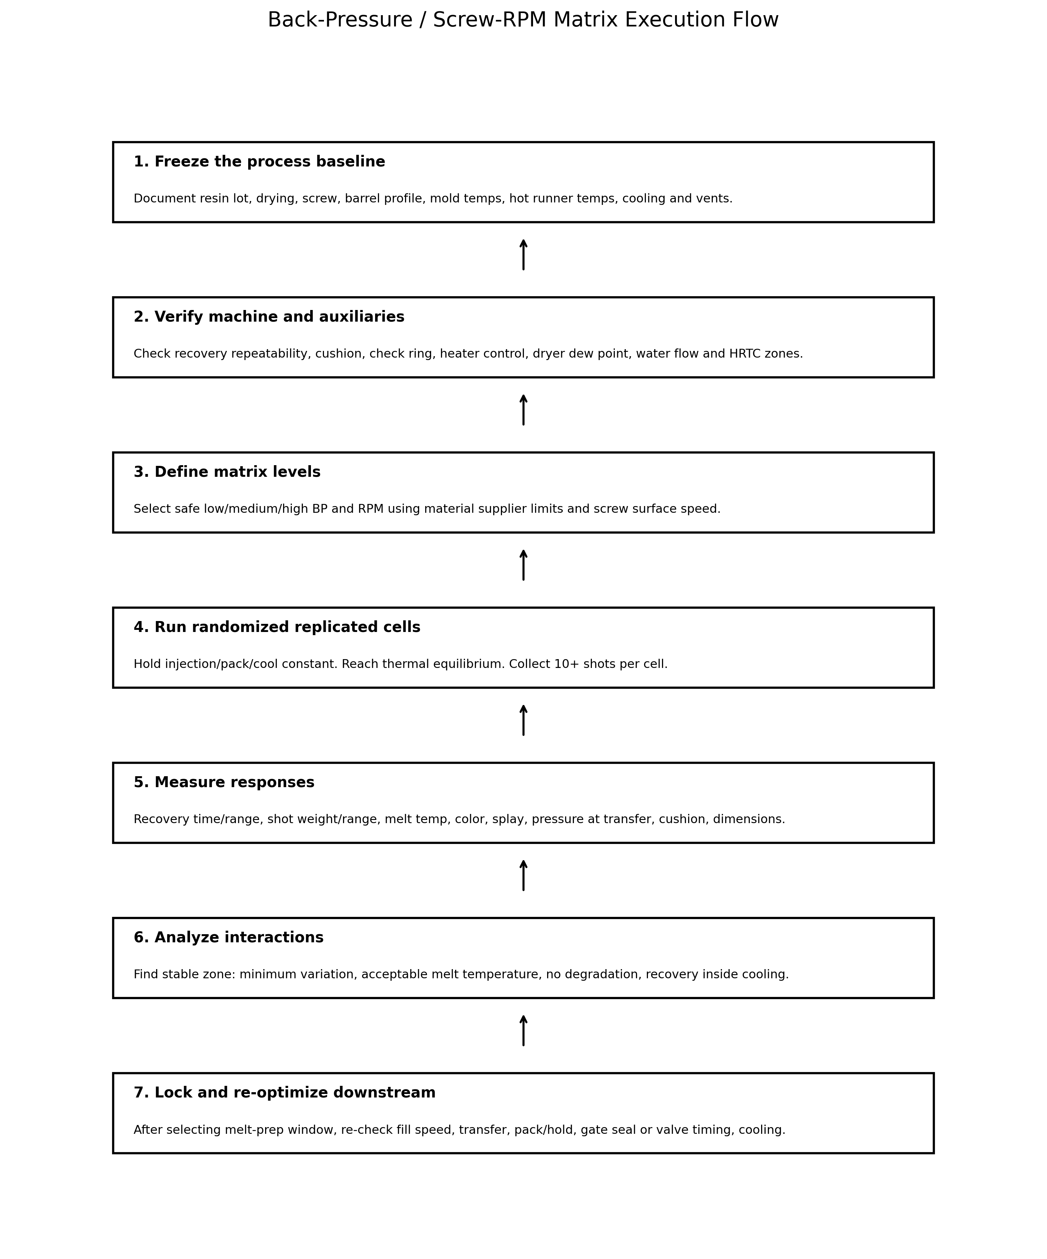
Figure 4. Execution flow for a defensible BP/RPM matrix.

6.1 Pre-run checklist
Category | Required status before DOE
Safety | PPE, guarding, hot-surface awareness, purge procedure, material-specific hazards, lockout rules, and hot-runner safety followed.
Material | Correct resin lot, drying validated, regrind controlled, color/additive feeder calibrated, purge history documented.
Machine | Correct screw/barrel/nozzle, check ring acceptable, heaters stable, pressure units understood, RPM actual available if possible.
Mold | Tool cleaned, vents open, cooling connected and flowing, mold at thermal equilibrium, cavity identification active.
Hot runner if applicable | All zones stable, alarms cleared, thermocouples verified, valve timing documented, manifolds purged.
Cold runner if applicable | Sprue/runner release stable, runner balance known, regrind handling fixed, sprue picker stable.
Measurement | Scale calibrated, melt probe ready, sample labels ready, data sheet prepared, lighting/magnification defined.
Baseline | Current process settings, cycle, recovery, cushion, defects, and parts retained.

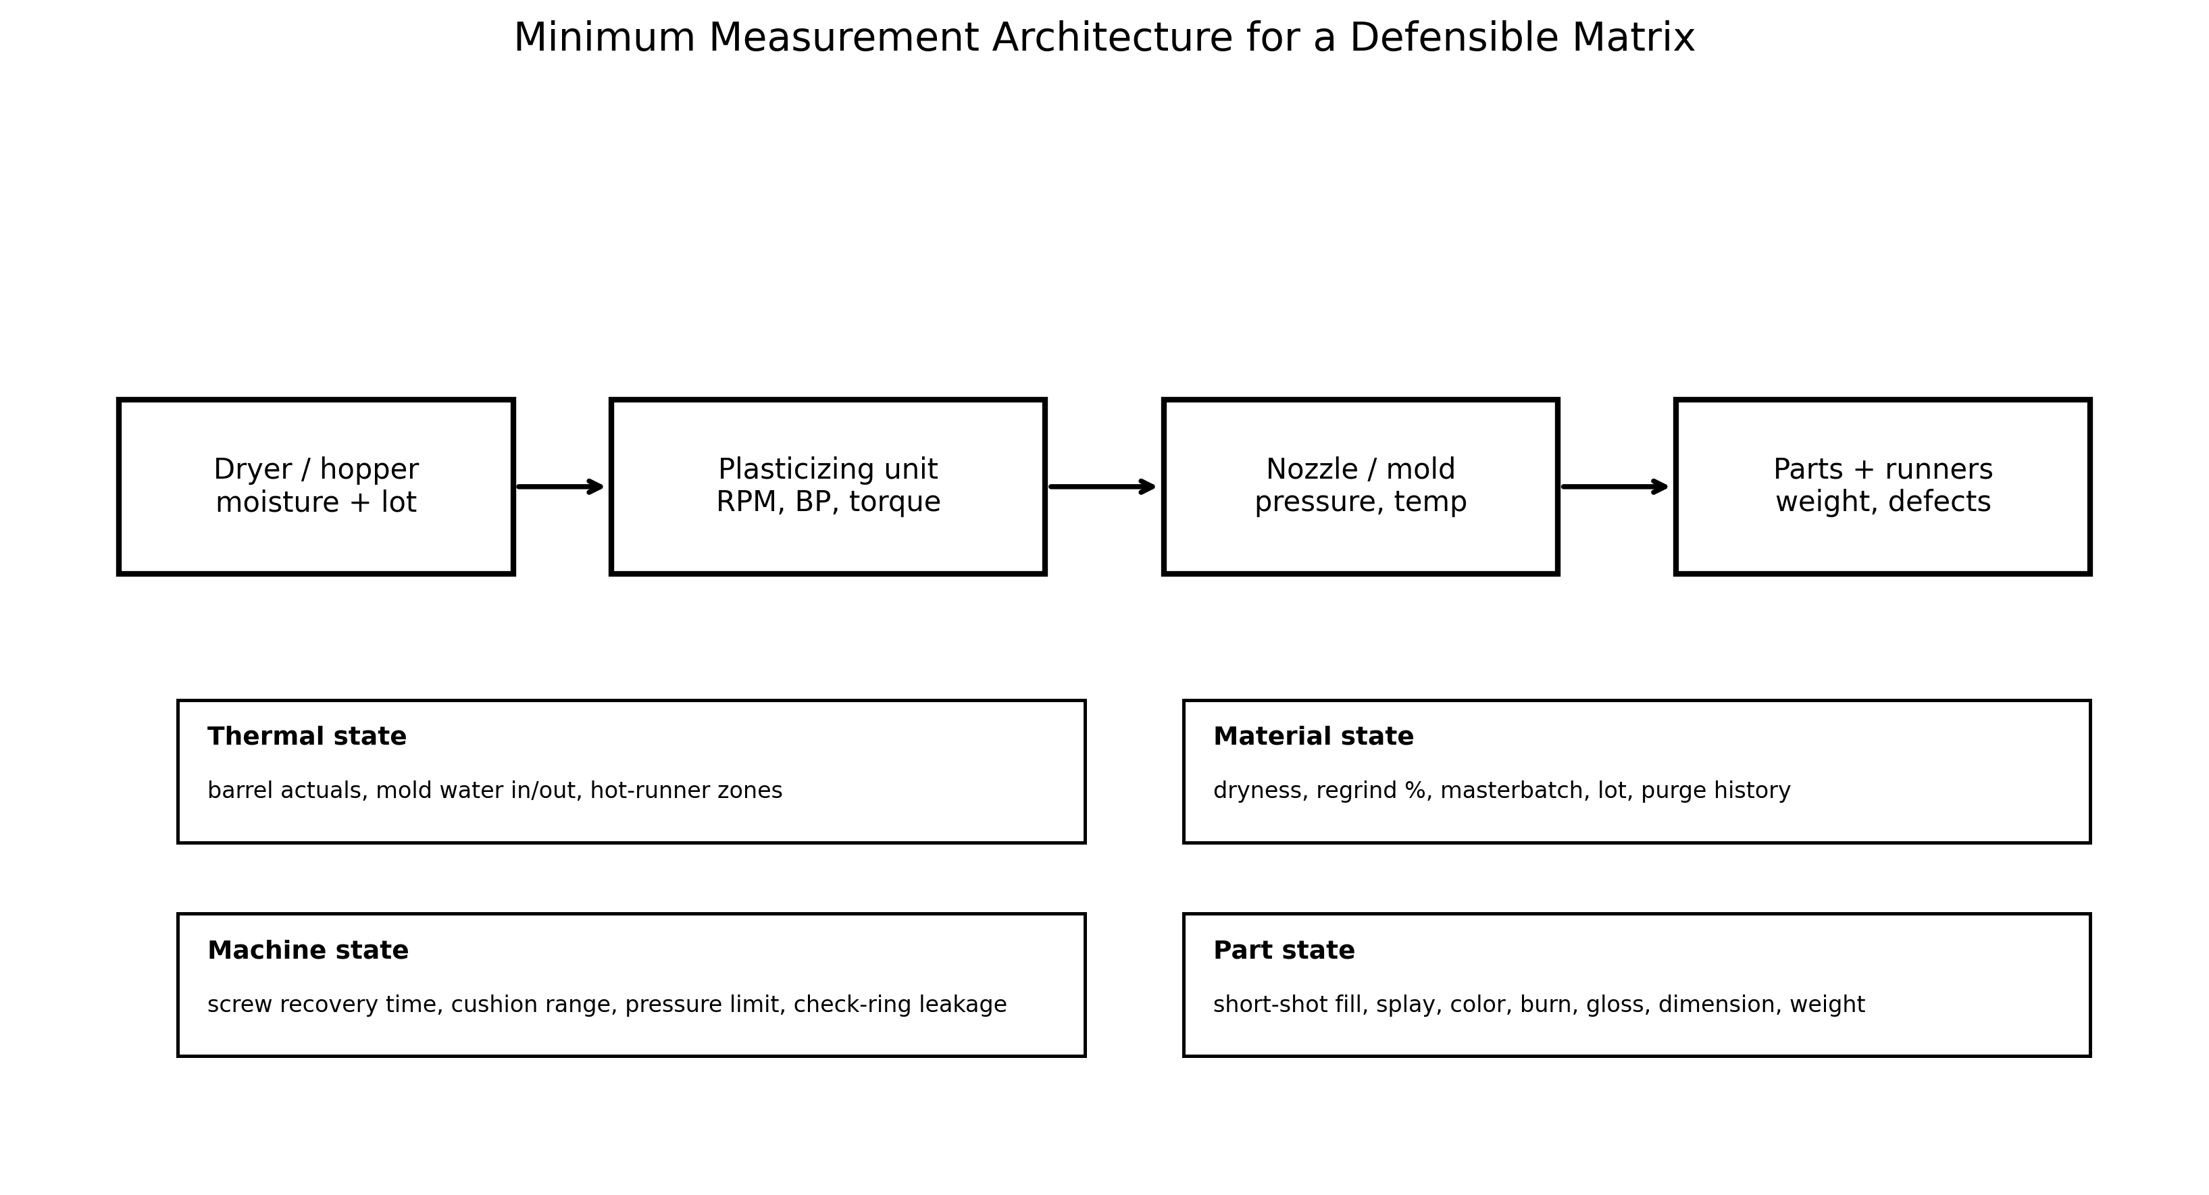
Figure 5. Minimum measurement architecture. A matrix without material, machine, mold, and part measurements is not a defensible DOE.

6.2 Factor-level selection
Select matrix levels using material supplier limits, machine limits, and historical process data. Do not choose unsafe or obviously damaging cells just to fill a mathematical grid. For many production studies, a 3 x 3 matrix is enough to detect direction and interaction. For high-value validation, use 4 x 4 or central composite design with replication. Randomize the run order where practical to reduce thermal drift bias; if randomization is impossible due to start-up risk, document the reason and repeat the suspected optimum at the end.
Level | Back pressure selection | Screw-speed selection
Low | Lowest value that maintains dosing without severe air/unmelt risk, or supplier-recommended low end. | Slowest speed that can complete recovery without extending cycle or causing long residence.
Medium | Historical or supplier-recommended nominal value. | Historical or supplier-recommended nominal speed/surface speed.
High | Upper safe value below drool, screw slip, recovery instability, shear damage, or supplier limit. | Upper safe speed below excessive surface speed, melt temperature, torque, noise, or degradation.
Center repeat | Repeat chosen center condition at beginning/end. | Confirms whether mold/machine thermal drift biased the study.

6.3 Run rules
- Change only the planned factor for the planned cell. Do not chase defects during a cell.
- Allow the process to stabilize after each setpoint change. The stabilization count depends on shot size, barrel residence, hot-runner volume, and material sensitivity.
- Collect at least 10 consecutive production-intent shots per cell after stabilization. Use more for high-cavitation or high-precision parts.
- Record actual values, not only setpoints: recovery time, cushion, transfer pressure, screw position, cycle time, hot-runner actuals, mold temperatures, and alarms.
- Measure actual melt temperature consistently. For safety and repeatability, follow plant purge/air-shot procedures and material-specific hazards.
- Retain labeled samples and identify cavity number. Keep defect samples from rejected cells; they teach future technicians what bad outcomes look like.
- Stop the DOE if any cell creates unsafe pressure, nozzle drool, severe degradation, abnormal noise/load, mold damage risk, or material-specific hazard.

6.4 Data sheet columns
Column group | Minimum data
Identification | Date, press, mold, part number, resin, lot, color, regrind %, operator, processor, hot/cold runner type.
Material condition | Dryer setpoint, dryer actual, dew point, drying time, moisture result if applicable, hopper level.
Machine setpoints | BP setpoint with units, RPM, decompression, barrel profile, screw delay, shot size, transfer, pack, cooling.
Machine actuals | Recovery time, recovery range, cushion, cushion range, transfer pressure, torque/load, cycle time, alarms.
Thermal actuals | Melt temperature, mold surface/in-out water, hot-runner zones, nozzle temperature.
Part data | Part weight, runner weight if cold runner, shot weight, dimensions, cavity balance, defect code/rating.
Decision | Pass/fail by response, reason for rejection, selected cell, follow-up process changes.

6.5 Selection criteria
A selected cell should satisfy all critical responses. Do not choose a cell only because it makes the best-looking part in one short run. The selected cell should be robust against material lot variation, normal water-temperature drift, machine restart, and typical operator handoff. The recommended decision hierarchy is: safety, material supplier limits, no degradation, stable recovery inside cycle, stable shot/cushion, acceptable melt quality, acceptable cavity balance, acceptable part quality, and only then cycle-time improvement.

7. Industry Best Practices

7.1 Standards and documentation discipline
ASTM and ISO injection-molding specimen standards emphasize that different molding conditions can produce different properties and that molding conditions must be documented. A BP/RPM matrix should follow the same philosophy: record enough process detail that another qualified engineer can reproduce the study or understand why it cannot be directly transferred. Use ASTM D3641, ISO 294, ASTM D1238, ASTM D638, and relevant material specifications as reference points for reporting, material flow testing, and mechanical validation where applicable.

7.2 Scientific molding alignment
The matrix supports scientific molding because it creates a stable melt-preparation foundation before fill, pack, and cooling studies. It should be integrated with the standard process development sequence rather than treated as an isolated adjustment. The most common best-practice error is using BP/RPM as a quick defect knob after the process is already qualified. That behavior destroys traceability and can change melt density, transfer behavior, pack response, and apparent viscosity.

7.3 Machine-manufacturer and equipment recommendations
Machine suppliers increasingly provide more precise screw-speed and back-pressure profiling. Profiling can be useful when the screw must transition gently near charge completion, when drool must be minimized, or when a material benefits from different plasticizing intensity through the stroke. However, profiling adds complexity and must be validated. A flat BP/RPM setting that is stable and documented is better than an elaborate profile that nobody trends or understands.

7.4 Practical rules from experienced processors
Rule | Why it matters | Caution
Finish recovery near the end of cooling, not extremely early. | Reduces idle residence while preserving cycle time. | Very short cycles may require different timing; do not starve recovery.
Use actual melt temperature, not barrel setpoints. | Screw work can change melt temperature significantly. | Air-shot technique must be safe and consistent.
Do not compare raw RPM across screw diameters. | Surface speed changes with diameter. | Use supplier limits and machine capability.
Do not fix wet material with high back pressure. | Moisture remains a material-handling defect. | High shear can worsen degradation and splay.
Do not fix blocked vents with higher melt temperature. | Venting is a tooling issue. | Higher shear may hide burns until conditions drift.
Repeat the chosen cell at the end of the DOE. | Detects time/thermal drift. | If repeat differs, do not approve the matrix.

8. Emerging Technologies and Research

8.1 Smart molding and IoT-enabled monitoring
Smart molding platforms can capture screw recovery, cushion, pressure curves, cavity pressure, melt temperature proxies, torque/load, hot-runner actuals, mold water temperature, dryer dew point, robot cycle time, and reject signals. These data streams make the BP/RPM matrix more defensible because they show whether each cell was actually stable. The business value is not more data by itself; it is automatic detection when production drifts outside the approved melt-preparation window.

8.2 AI-driven process optimization
AI and machine-learning models can rank factor effects, detect drift, recommend DOE cells, and predict quality from process signatures. For BP/RPM, useful models require clean labels: resin lot, moisture, screw, mold, hot-runner zones, BP/RPM actuals, recovery, weights, defects, and downstream process settings. AI should not be allowed to recommend higher shear outside material limits or tooling safety constraints. Human process engineering remains accountable for the approved window.

8.3 Digital twins and simulation integration
A mature workflow links simulation predictions, machine historian data, cavity-pressure traces, hot-runner thermal trends, and quality measurements. Simulation can propose likely pressure-drop and thermal-balance issues; the matrix tests whether the actual machine and material preparation are stable. This combined approach reduces trial-and-error, especially in high-cavitation medical, packaging, and automotive molds.

8.4 Material-science innovations
Nano-additives, advanced compatibilizers, self-reinforcing polymers, recycled-content blends, chemically recycled resins, and self-healing materials can all change shear sensitivity and dispersion requirements. These materials may have narrower processing windows than legacy commodity resins. Treat every new compound as a new melt-preparation system until a matrix or equivalent data proves otherwise.

9. Troubleshooting Guide
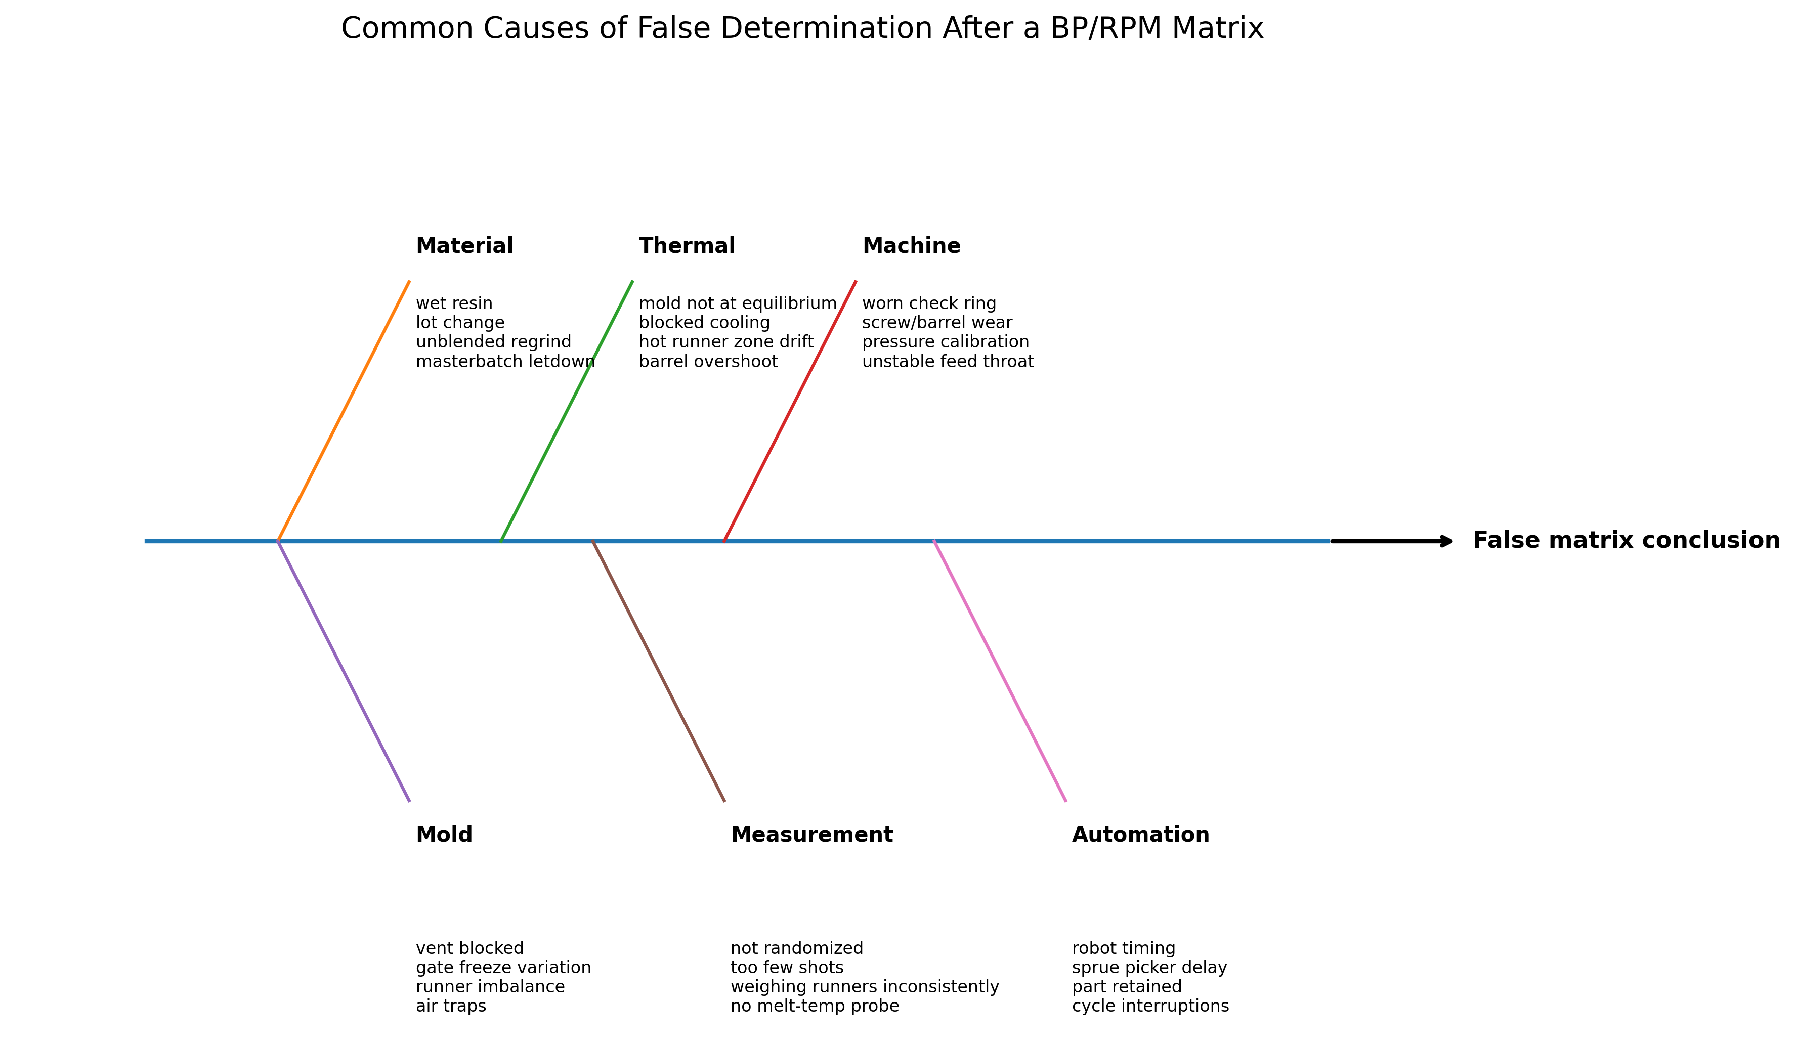
Figure 6. False determination fishbone. These causes must be controlled before accepting the matrix conclusion.

9.1 Step-by-step troubleshooting flow
Step | Question | Action if no | Action if yes
1 | Is the material correct, dry, blended, and within allowed regrind/additive limits? | Stop DOE. Correct material handling and purge before retest. | Proceed. Record lot and material condition.
2 | Are machine, screw, check ring, pressure units, and heaters verified? | Fix mechanical/calibration issue; matrix data would be invalid. | Proceed. Record screw diameter and units.
3 | Are mold temperature, cooling flow, vents, and hot-runner zones stable? | Stabilize thermal system or repair tooling issue. | Proceed. Retain baseline samples.
4 | Can the baseline make safe short shots without pressure limit or mold damage risk? | Resolve fill/pressure/tooling risk first. | Define safe BP/RPM levels.
5 | Do low BP/RPM cells show poor mixing, unmelts, or high shot range? | If no, low-shear window may be acceptable. | Increase BP/RPM incrementally and observe response.
6 | Do high BP/RPM cells show splay, odor, discoloration, drool, high melt temp, or slow recovery? | Upper range may still be safe but choose conservatively. | Reject high-shear cells and investigate moisture/residence/hot-runner dead spots.
7 | Is the selected cell repeatable at the end of the matrix? | Do not approve. Check thermal drift, material feed, and measurement error. | Lock selected setting and re-optimize fill/pack/cooling.
8 | Does production remain stable for the capability run? | Escalate to process/tool/material review. | Release with documented control limits and reaction plan.

9.2 Symptom-to-action matrix
Symptom during matrix | Likely causes | Immediate action | Long-term correction
Recovery time too long at all cells | Low rear-zone temp, feed issue, worn screw/barrel, additive slip, undersized plasticizing unit. | Check feed throat, rear zone, material feed, screw load. | Maintenance inspection or press/screw sizing review.
Recovery time unstable | Bridging, feed-throat heat, inconsistent regrind, check-ring issue, screw slip at high BP. | Stop and verify feed/material; reduce high BP cells if slip suspected. | Blender/granulator control, screw/barrel/check-ring maintenance.
Color streaks at low shear only | Insufficient mixing, poor masterbatch letdown, too few screw turns. | Try moderate BP/RPM; verify feeder. | Improve blending, screw/mixer design, letdown ratio.
Splay worsens at high shear | Wet resin, excessive shear heat, excessive decompression, hot-runner degradation. | Measure melt temp and moisture; reduce shear. | Drying control, decompression limit, hot-runner maintenance.
Brown/black specks after pauses | Residence degradation, dead spots, hot-runner stagnation, contamination. | Purge, lower residence/shear, inspect hot runner/nozzle. | Material residence study, hot-runner refurbishment, purge SOP.
Part flashes in hotter/high-shear cells | Lower viscosity, excessive pack, low clamp/vent land issue. | Do not solve by degrading melt; re-check pack/clamp/vents. | Tooling or clamp/process correction.
Cavity imbalance changes with BP/RPM | Shear/thermal imbalance, hot-runner tip differences, cold-runner imbalance. | Run cavity balance and pressure-drop study. | Runner/hot-runner balance correction.
Selected cell fails next shift | Uncontrolled environment, material lot, water temp, dryer, operator adjustment. | Compare actual trends to DOE data. | Control plan, alarms, training, material/water management.

9.3 Common pitfalls
- Running the matrix before the mold reaches thermal equilibrium.
- Changing injection speed, pack pressure, transfer, or cooling during the matrix and then attributing the result to BP/RPM.
- Using hydraulic pressure values without knowing plastic pressure or intensification ratio.
- Comparing RPM values between machines with different screw diameters.
- Ignoring hot-runner zone actuals and valve timing.
- Weighing cold-runner shots inconsistently, especially when runners stick or break.
- Using high BP/RPM to hide wet resin, blocked vents, undersized gates, or hot-runner dead spots.
- Approving a setting that creates acceptable cosmetics but damages mechanical properties.
- Failing to repeat the selected cell after the run order, which allows thermal drift to create a false optimum.
- Not writing a reaction plan, so operators later treat BP/RPM as unrestricted defect knobs.

10. Actionable Shop-Floor Recommendations
- Treat BP/RPM as a locked melt-preparation system once validated. Do not allow uncontrolled shift-to-shift changes.
- Convert RPM to screw surface speed when transferring a process or comparing screw sizes.
- Use measured actual melt temperature and recovery data. Barrel setpoints and screen values are not enough.
- For cold runners, separate runner/sprue effects from part effects. Control regrind or remove it from the DOE.
- For hot runners, trend all zones and valve events. Cavity-specific defects are often hot-runner balance problems, not global plasticizing problems.
- If high shear is required to make acceptable parts, escalate to tooling, material, or machine review. Do not normalize a fragile process.
- Use retained samples from good and bad cells as training aids for the next generation of molders.
- Write control limits for recovery time, cushion range, melt temperature, hot-runner actuals, and defect reaction. A final setpoint without limits is not process control.
- Re-run or partially re-run the matrix after resin grade changes, major color/additive changes, screw/check-ring replacement, hot-runner refurbishment, major mold repair, or transfer to another press.
- Use AI, simulation, and dashboards to support decision-making, but require material limits, tooling safety limits, and human engineering approval.

11. References and Further Reading
The following sources were used to ground this technical draft. Some public forum references are included only as practitioner observations; they are not treated as controlled evidence. Always prioritize OEM manuals, current material supplier data sheets, validated plant SOPs, and safety requirements.
[1] RJG, Inc.. Mastering Back Pressure in Injection Molding. https://rjginc.com/what-is-back-pressure-in-injection-molding-why-is-it-important/
[2] Shibaura Machine. Improve Product Quality with Better Screw Speed and Back Pressure Control. https://shibaura-machine.com/articles/im-2022-03-09-improve-product-quality-with-better-screw-speed-and-back-pressure-control/
[3] FimmTech / Suhas Kulkarni. How to Optimize Back Pressure. https://fimmtech.com/2019/02/14/how-to-optimize-back-pressure/
[4] FimmTech. Scientific Molding - The 6-Step Study. https://fimmtech.com/knowledgebase-2/scientific-molding-the-6-step-study/
[5] BASF. Elastollan Processing - Injection Moulding. https://www.basf.com/dam/jcr:db114308-e458-3dcf-bd1d-ca262c80ac3a/Elastollan_Processing_en-injection-moulding.pdf
[6] INEOS Olefins & Polymers USA. Polypropylene Processing Guide. https://www.ineos.com/globalassets/ineos-group/businesses/ineos-olefins-and-polymers-usa/products/technical-information--patents/ineos_polypropylene_processing_guide.pdf
[7] ExxonMobil. Polypropylene Quick Processing Reference. https://www.exxonmobilchemical.com/-/media/media-assets/media-library-assets/23/neat_polypropylene_process_parameters_en.pdf
[8] SABIC CYCOLOY guide mirror. CYCOLOY PC/ABS Processing Guide - use official supplier version when available. https://cn.hongrunplastics.com/public/uploads/images/20250616/Sabic%20PC%2BABS%20Cycoloy%20CYCOLOY.pdf
[9] Autodesk. Moldflow overview. https://www.autodesk.com/products/moldflow/overview
[10] Moldex3D. Hot Runner System Simulation. https://www.moldex3d.com/solutions/solutions-by-industry/hot-runner/
[11] ASTM International. ASTM D3641 - Standard Practice for Injection Molding Test Specimens. https://store.astm.org/d3641-21.html
[12] ISO. ISO 294-1 - Plastics - Injection moulding of test specimens. https://www.iso.org/standard/67036.html
[13] Husky. Hot Runners and Optimizing System Balance. https://www.husky.co/en/resources/blog/hot-runners-play-a-key-role-in-optimizing-system-balance/
[14] Mold-Masters. Hot Runner Balance and the Effects of Shear. https://www.moldmasters.com/blog/hot-runner-balance-and-the-effects-of-shear
[15] Beaumont. Hot Runner Considerations, Part 1. https://www.beaumontinc.com/hot-runner-considerations-part-1/
[16] Reddit r/InjectionMolding. Back pressure practitioner discussion. https://www.reddit.com/r/InjectionMolding/comments/uingaj/back_pressure/
[17] Reddit r/InjectionMolding. Recommendations on Screw Speed discussion. https://www.reddit.com/r/InjectionMolding/comments/xqdogi/recommendations_on_screw_speed/
[18] Eng-Tips. EVA processing help - screw back pressure and surface speed discussion. https://www.eng-tips.com/threads/eva-processing-help.161027/
[19] Eng-Tips. Different parts with same molding conditions. https://www.eng-tips.com/threads/different-parts-with-same-molding-conditions.29971/
[20] ACO Mold forum. Injection moulding gurus - molding quandary. https://www.acomold.com/forum/injection-moulding-gurus-can-you-solve-this-moulding-quandary

Appendix A: BP/RPM Matrix Template
Cell | Back pressure | RPM | Recovery time avg/range | Cushion avg/range | Melt temp | Weight avg/range | Defect rating | Decision
A1 | Low | Low
A2 | Low | Medium
A3 | Low | High
B1 | Medium | Low
B2 | Medium | Medium
B3 | Medium | High
C1 | High | Low
C2 | High | Medium
C3 | High | High
R | Repeat selected cell

Appendix B: Control Plan Recommendations
Control item | Recommended control | Reaction plan
Back pressure | Locked setpoint with approved upper/lower range in plastic pressure or qualified machine units. | If changed outside range, segregate product since change and notify process engineering.
Screw RPM/surface speed | Locked setpoint with recovery-time target and max actual melt temperature. | If recovery drifts, check material feed, dryer, feed throat, screw/barrel, and water before increasing RPM.
Recovery time | Target and allowable range established from selected DOE cell. | If out of range for 3 consecutive shots, stop for investigation or escalate by SOP.
Cushion | Target and range tied to transfer/pack strategy. | If cushion unstable, check check ring, material feed, short-shot weight, and pressure limit.
Melt temperature | Measured range; frequency based on risk. | If high, reduce shear/residence or check barrel/hot-runner control; do not continue critical production.
Hot-runner actuals | Zone actual limits, valve timing, alarms captured. | If cavity-specific defects appear, inspect zone trend before changing BP/RPM.
Cold-runner regrind | Percent, particle size, drying, and blending method controlled. | If regrind changes, revalidate dispersion/recovery or run partial matrix.

