Data Science Task
Overview:
This task is to determine the best location for meetings from 6 different locations. To select the best location, proximity to restaurants, event center and venue of upcoming events are features to be considered. For the purpose of this task, zip codes were used to determine proximity to keep it simple.
This task is implemented in 4 steps which are Data collection, Data transformation, Model Building and Presentation.
Data Collection:
Data related to Restaurants, Event centers that can be used for conferences and Venue of upcoming event in Indianapolis were collected. Find below the links to the data collected:
Restaurants: https://www.eater.com/maps/best-restaurants-indianapolis
Event Centers: https://www.eventective.com/indianapolis-in/party-event-venues/
Upcoming events: Google search

Data transformation:
The data was not in the exact form that can used by the model, so it was cleaned and transformed so as to get accurate results
Data cleaning includes the following
Incomplete Record: The dataset was cleaned to removed incomplete information
Anomaly: Some restaurants, event centers and upcoming event venues have zip codes that are too far from the Six locations under consideration. Such are considered anomalies for the purposes of this task and are removed as this can affected the clustering result.

Model Building:
Clustering technique was used for the model. Each of the six locations represent a cluster. Restaurants, event centers and upcoming event venues were selected into different clusters using zip codes. Each item was added to the cluster closest to it based on the zip codes. Python was used for the implementation and the following packages were used: Panda, Matplotlib and Networkx.
Presentation:
The model was able to identify 5 clusters. One of the six locations (zWORKS) does not have any restaurants, event centers or an upcoming event venues closest to it and so it was no longer considered. For the purpose of this ask, the best location is a location that is surrounded by most resturants, event centers and upcoming event venue. Which is The Speak Easy:
Find below the analysis
Location | Address | ZipCode
IUPUI | 415 Porto Alegre Str Indianapolis IN 46202 | 46202
The Speak Easy | 5255vWinthrop Ave #110, Indiapolis IN 46220 | 46220
zWorks | 85 E cedar St #1502 Zionville IN, 46077 | 46077
Launch Fisher | 12175 Visinary way fisher, IN 46038 | 46038
Industrious Mass Ave | 350 Massechusetts Ave Suite 300, Indianapolis IN 46204 | 46204
Lunch Indy | 525 S Meridian Str Indaianpolis In 46225 | 46225
The six locations and the address and Zip codes

Clusters
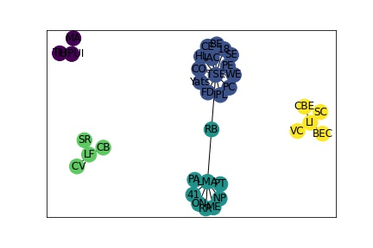
Key
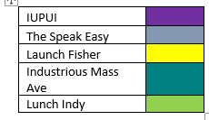
Other documents
Dataset: (Ds_Task_dataset.xlsx) Excel file for the dataset used. The first sheet contains the dataset before cleaning while the second sheet is the cleaned dataset.
Python Code: For the implementation of the model.

