Narratives:

Application introduction

This mobile application provides an easy way to estimate the calories and nutrition facts of the food. The users only need to take a photo of the food to track his/her diets in a minute.

Target population

The targets of the app are people who want to have a healthy diet and care about their bodies. We believe this app is competitive among similar apps because we use state of the art computer vision technologies to provide the most convenient user experience. Most other apps would require cumbersome inputs of the users, which we think is not tolerable.

Goal

The goal of the application is to provide the users the most convenient way to estimate and track the calories and nutrition facts of the food they eat.

Sketches:

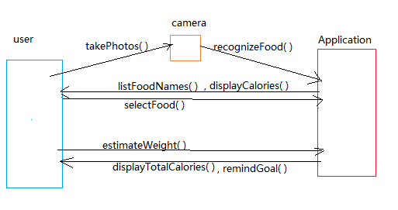

Lists of use cases:

|  |  |  |
| --- | --- | --- |
| Use Case | Purpose | Description |
| 1. Take pictures | Record food with the camera/album | Users use the camera to record their foods. |
| 1. Recognize food | Recognize the food in the photos | Application receives the photos users provide and recognizes the food through the google cloud vision api. |
| 1. List food names | Provide several food names for users to choose | Application shows a list of food name after recognizing the photos |
| 1. Select food | Select exact food | Users clicks on the name in the food list |
| 1. Display food calories | Provide food’s calories | Application will find the value of calories of the food using the nutritionix api and output to the user |
| 1. Estimate food weight | Give an estimated value of food weight | User measures the weight of food and input it. |
| 1. Estimate total calories | Give a result of total calories of food | Application calculates the total calories with the weight the user provided. |