有一个lsd_1.6的源文件

Makefile内容如下：

1 # -----------------------------------------------------------------------------

2 #

3 # LSD - Line Segment Detector on digital images

4 #

5 # Copyright (c) 2007-2011 rafael grompone von gioi <grompone@gmail.com>

6 #

7 # This program is free software: you can redistribute it and/or modify

8 # it under the terms of the GNU Affero General Public License as

9 # published by the Free Software Foundation, either version 3 of the

10 # License, or (at your option) any later version.

11 #

12 # This program is distributed in the hope that it will be useful,

13 # but WITHOUT ANY WARRANTY; without even the implied warranty of

14 # MERCHANTABILITY or FITNESS FOR A PARTICULAR PURPOSE. See the

15 # GNU Affero General Public License for more details.

16 #

17 # You should have received a copy of the GNU Affero General Public License

18 # along with this program. If not, see <http://www.gnu.org/licenses/>.

19 #

20 # -----------------------------------------------------------------------------

21

22 all: lsd lsd_call_example

23

24 lsd: lsd.c lsd.h lsd_cmd.c

25 cl -o lsd lsd_cmd.c lsd.c -lm

26

27 lsd_call_example: lsd.c lsd.h lsd_call_example.c

28 cl -o lsd_call_example lsd_call_example.c lsd.c -lm

29

30 doc: lsd.c lsd.h doxygen.config

31 doxygen doxygen.config

32

33 clean:

34 rm -f lsd lsd_call_example

35

36 cleandoc:

37 rm -rf doc

38

39 # -----------------------------------------------------------------------------

**去windows下打开这个：**

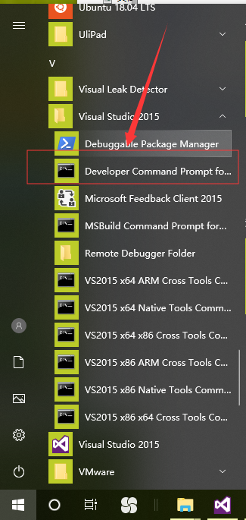

 然后 执行下面的命令，进入到lsd_1.6目录下：

cd /d D:\GitHub\lsd_1.6

进入目录后执行编译命令：

nmake -f Makefile

编译通过了。

总结：

1.如果需要使用nmake来编译cpp文件，必须安装Visual studio。

2.makefile的写法和Linux的很相似。

makefile实例：编译D:\samples\nmakedemo下面的文件

|  |
| --- |
| all:getmax getmin  getmax: getmax_main.cpp getmax.cpp  cl -o getmax getmax_main.cpp getmax.cpp -lm  getmin:getmin_main.cpp getmin.cpp  cl -o getmin getmin_main.cpp getmin.cpp -lm    clean:  rm *.o getmax getmin |

3.**注意：必须打开vs2017开发人员命令提示符然后转到有cpp和makefile的目录**

**然后输入：nmake –f makefile**