maven项目报错:找不到编译器

原创Apologize_zhang 最后发布于2016-04-05 19:42:27 阅读数 1969 收藏

展开

在运行maven项目时,报错

[ERROR] Failed to execute goal org.apache.maven.plugins:maven-compiler-plugin:3.2:compile (default-compile) on project taotao-manager-pojo: Compilation failure

[ERROR] No compiler is provided in this environment. Perhaps you are running on a JRE rather than a JDK?

[ERROR] -> [Help 1]

[ERROR]

[ERROR] To see the full stack trace of the errors, re-run Maven with the -e switch.

[ERROR] Re-run Maven using the -X switch to enable full debug logging.

[ERROR]

[ERROR] For more information about the errors and possible solutions, please read the following articles:

[ERROR] [Help 1] http://cwiki.apache.org/confluence/display/MAVEN/MojoFailureException

[ERROR]

[ERROR] After correcting the problems, you can resume the build with the command

大概的意思是说，在当前环境没提供编译器。于是打开 window->preferences->java->install JREs，发现jre是正常配置的。

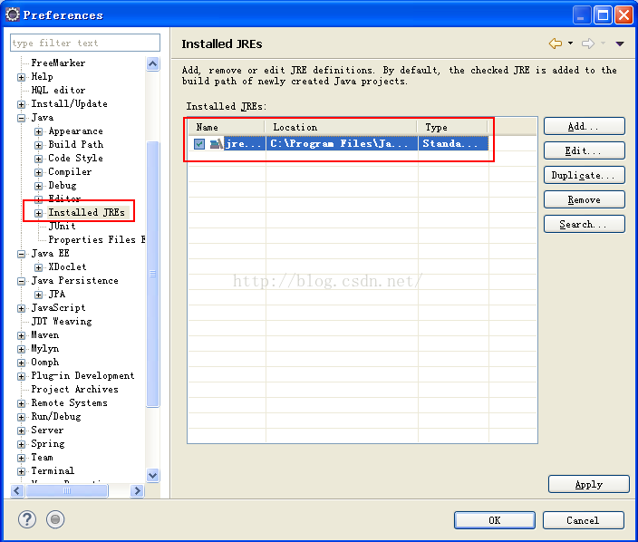

但是错误报的是找不到编译器，也就是JDK，后面还提醒了一句，也许你是在jre里面运行，而不是jdk。对照上图可以看到，确实是选择的只是jre。我们在安装java的时候，会在java目录下生成jre文件夹，同时在jdk文件夹下也生产jre文件夹。

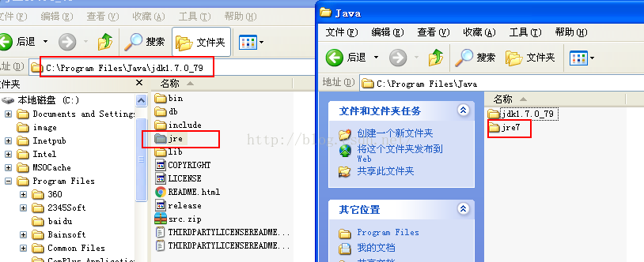

所以，解决办法就是选择jdk目录下的jre，而不是java目录下的jre。点击edit->directory->选择jdk目录下的jre，就像这样

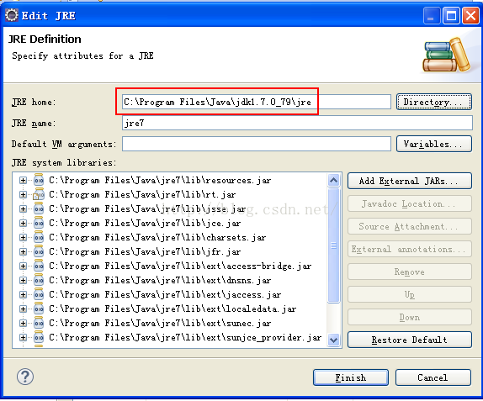

点击finish，然后在项目上右键->maven->update project，再运行，成功。问题解决