C#操作注册表实例
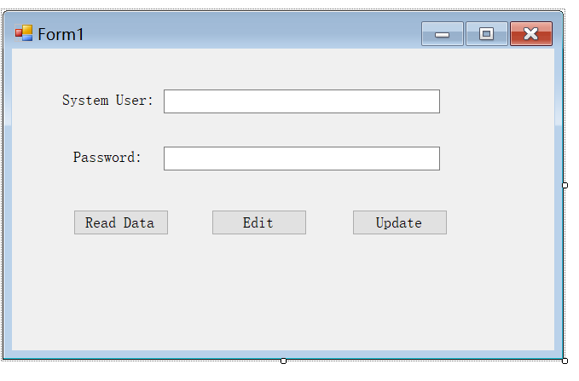

using System;
using System.Collections.Generic;
using System.ComponentModel;
using System.Data;
using System.Drawing;
using System.Linq;
using System.Text;
using System.Windows.Forms;
using Microsoft.Win32;

namespace cSharpregistry
{
public partial class Form1 : Form
{
RegistryKey key;
public Form1()
{
InitializeComponent();
}

private void Form1_Load(object sender, EventArgs e)
{
textBox_user.Enabled =false;
textBox_pass.Enabled = false;
}

private void btnRead_Click(object sender, EventArgs e)
{
RegistryKey hkcu = Registry.CurrentUser;
RegistryKey hkSoftWare = hkcu.OpenSubKey(@"Software", true);
try
{
RegistryKey key = hkSoftWare.OpenSubKey(@"mysoftware\\pos\\kenny\\kenny pos\\sodacajero\\registered\\user\\system user", true);
if (!key.Handle.IsInvalid)
{
textBox_user.Text = key.GetValue("User Name").ToString();
textBox_pass.Text = key.GetValue("Password").ToString();
}

}
catch(Exception ex)
{
MessageBox.Show("key do not exist!");
}
}

private void btnUpdate_Click(object sender, EventArgs e)
{
RegistryKey hkcu = Registry.CurrentUser;
RegistryKey hkSoftWare = hkcu.OpenSubKey(@"Software", true);
RegistryKey key = hkSoftWare.CreateSubKey(@"mysoftware\\pos\\kenny\\kenny pos\\sodacajero\\registered\\user\\system user");
if (textBox_user.Text.Trim() == "")
{
MessageBox.Show("Please Enter User Name!");
textBox_user.Focus();
}

else if (textBox_pass.Text.Trim() == "")
{
MessageBox.Show("Please Enter Password!");
textBox_pass.Focus();
}
else
{
key.SetValue("User Name", textBox_user.Text.Trim());
key.SetValue("Password", textBox_pass.Text.Trim());
key.SetValue("type", "system");
MessageBox.Show("Success");
}
}

private void btnEdit_Click(object sender, EventArgs e)
{
textBox_user.Enabled = true;
textBox_pass.Enabled = true;
textBox_user.Focus();
}

}
}

