Happy Learning Python Word
Python是一门非常流行的编程语言，它SimpleAndElegant.

Heading,Level1
Intense quote
- first item in unordered list
- second item in unordered list
- first item in ordered list
- second item in ordered list
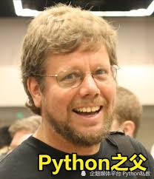

NAME | GENDER | JOB
Jack | Male | 35 | Programmer
Mary | Female | 30 | Debugger
Frank | Male | 25 | Programmer
Jade | Female | 25 | Software Architect

