1. cppreference

<https://en.cppreference.com/w/>

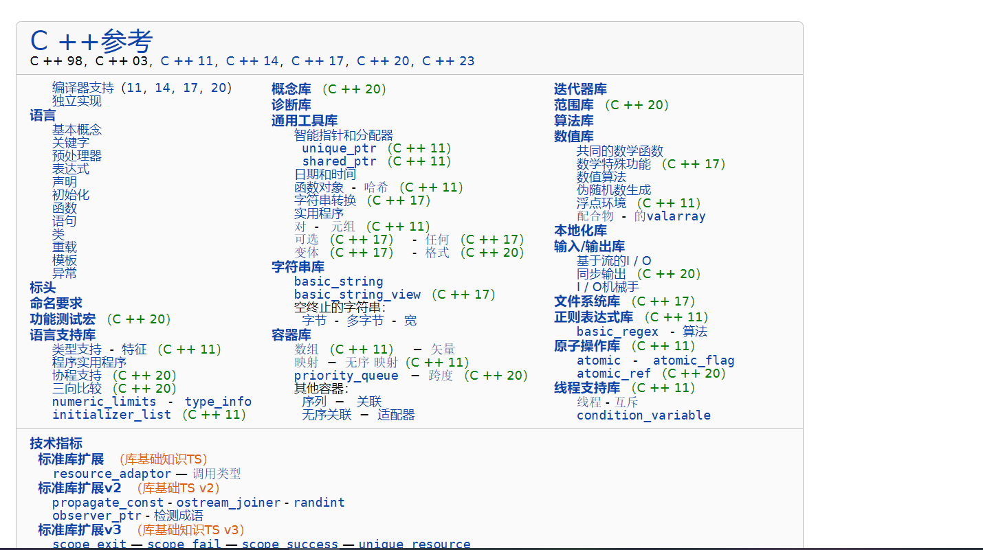

2.learnCPP

<https://www.learncpp.com/>

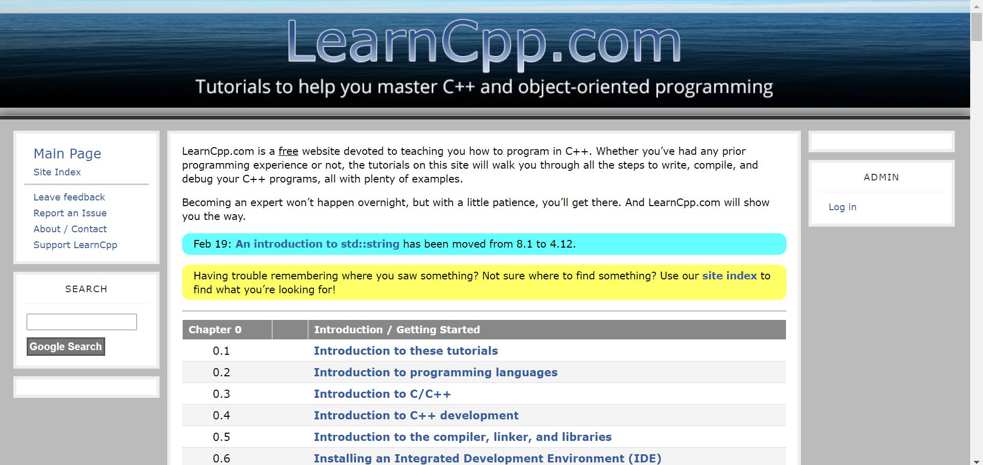

3. cplusplus

<https://www.cplusplus.com/>

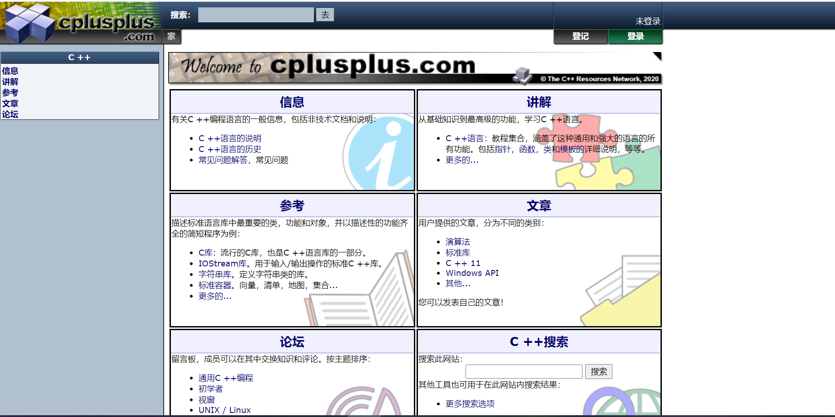

4 tutorialspoint

<https://www.tutorialspoint.com/cplusplus/index.htm>

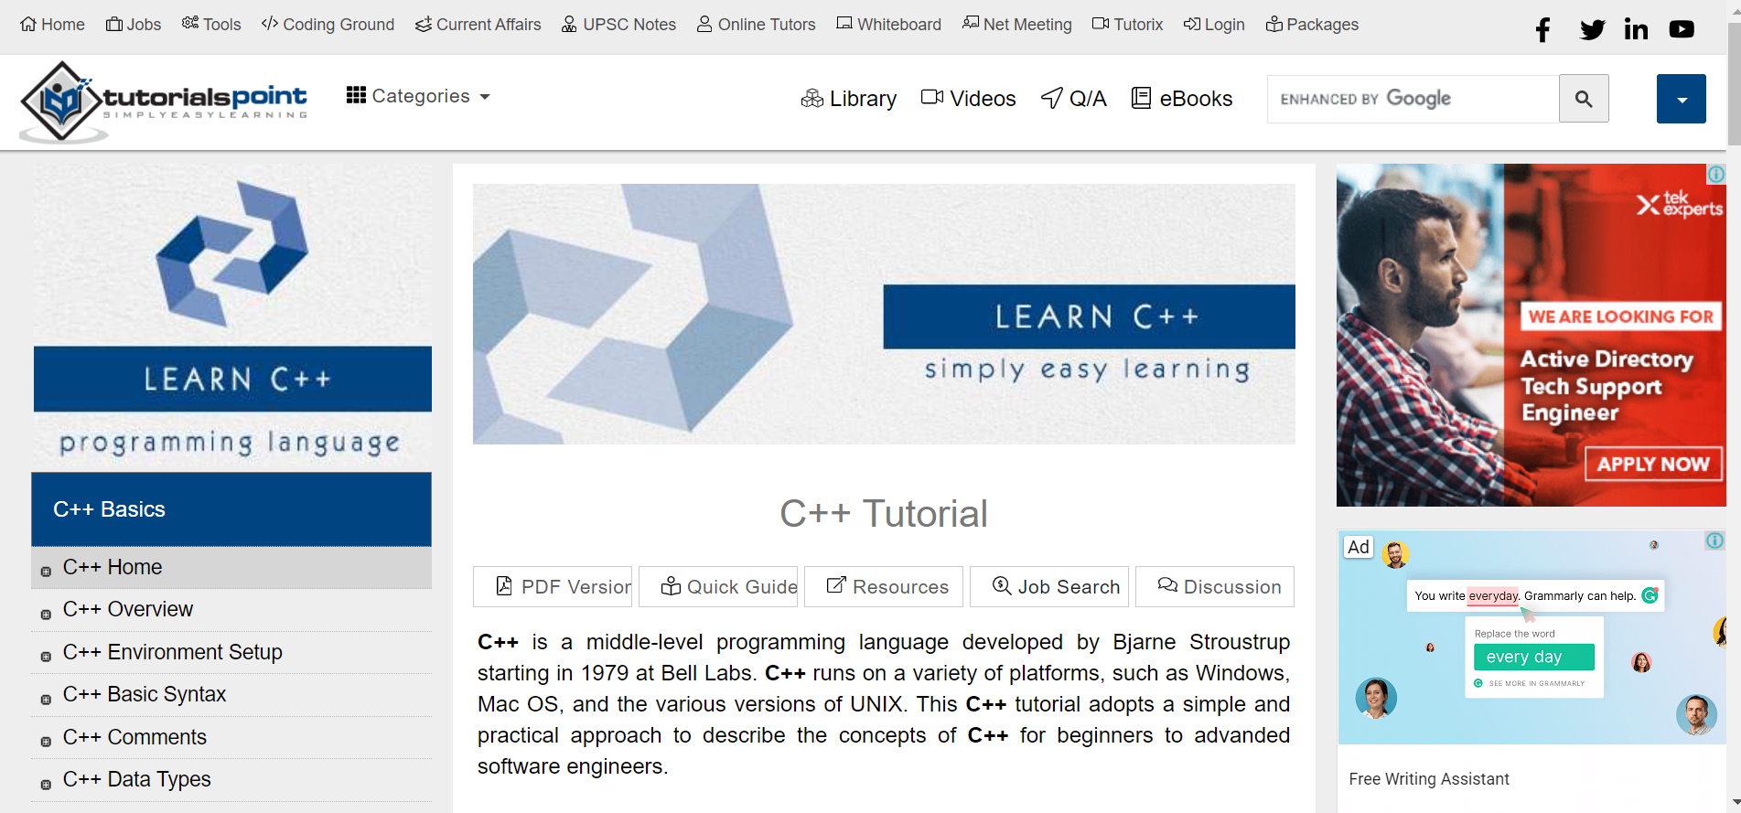

5.Awesome C++

<https://github.com/rigtorp/awesome-modern-cpp>

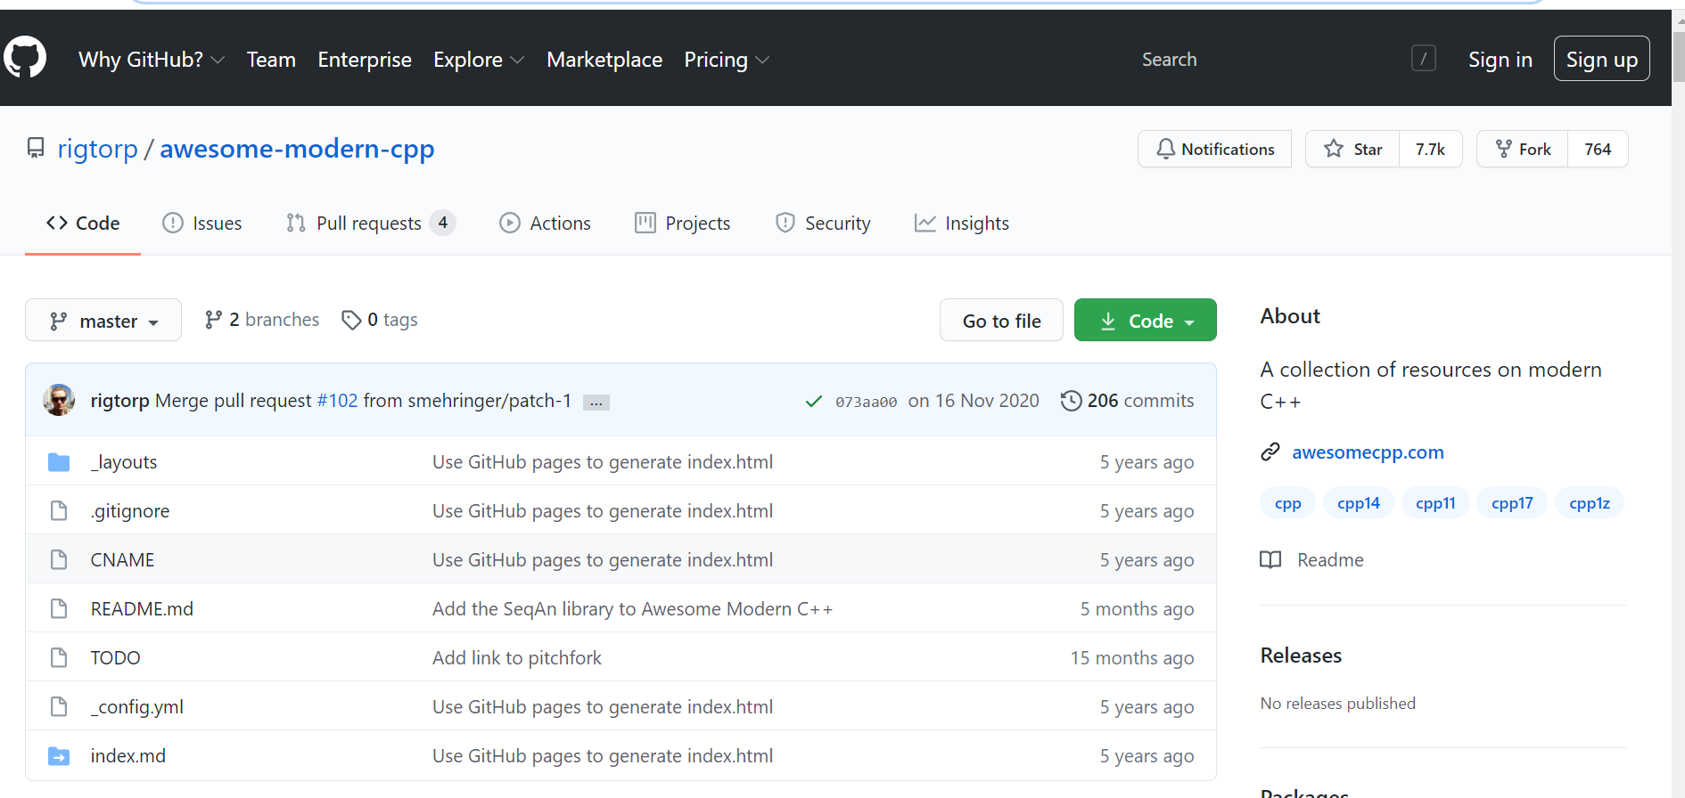

<https://github.com/fffaraz/awesome-cpp>

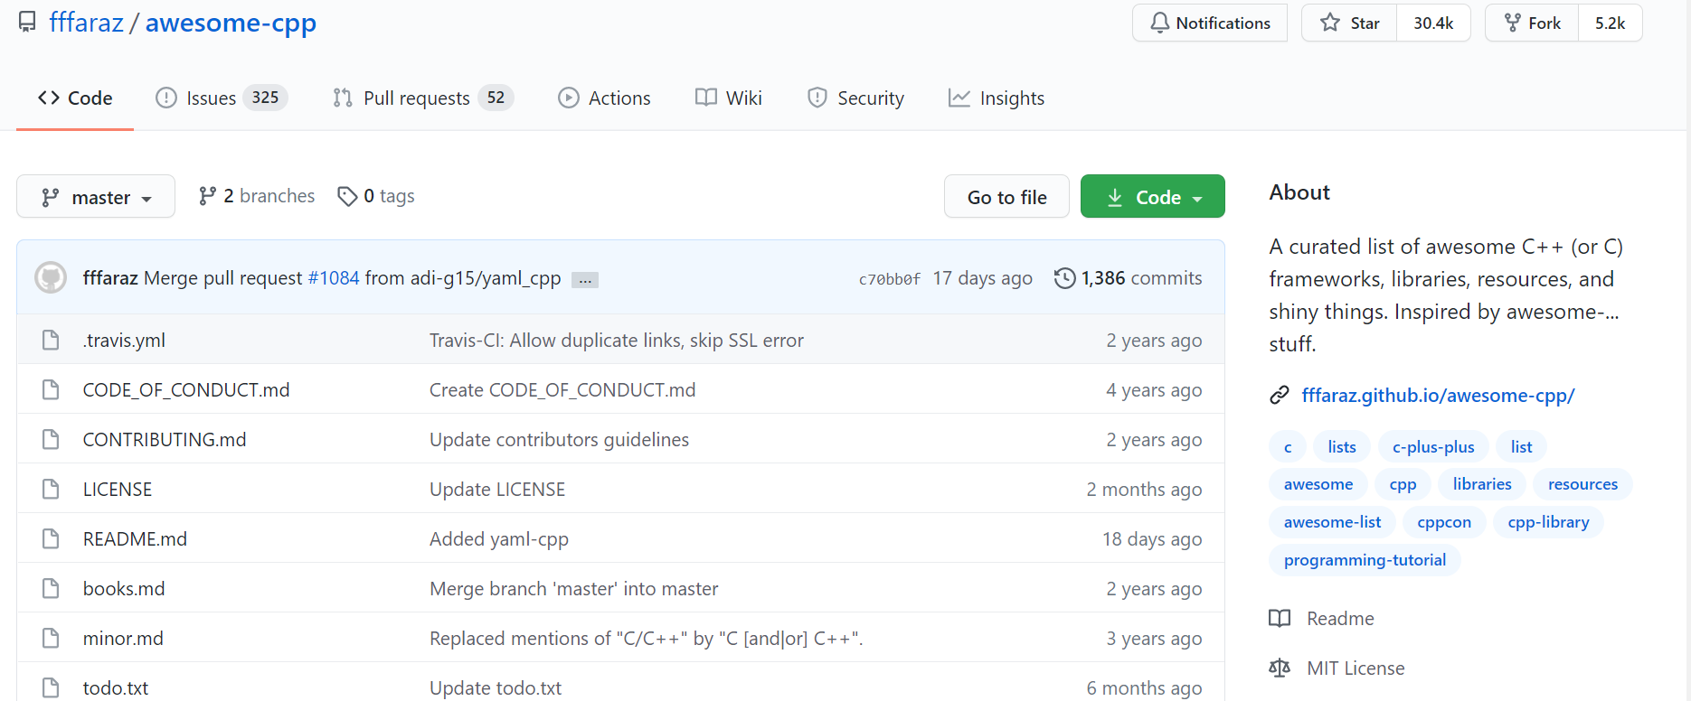

<https://riptutorial.com/cplusplus/awesome-learning/community>

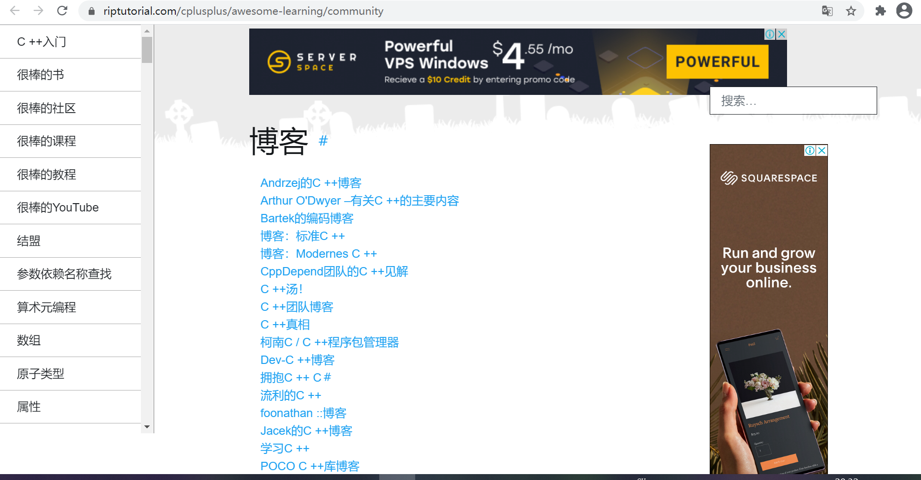

<https://cpp.libhunt.com/>

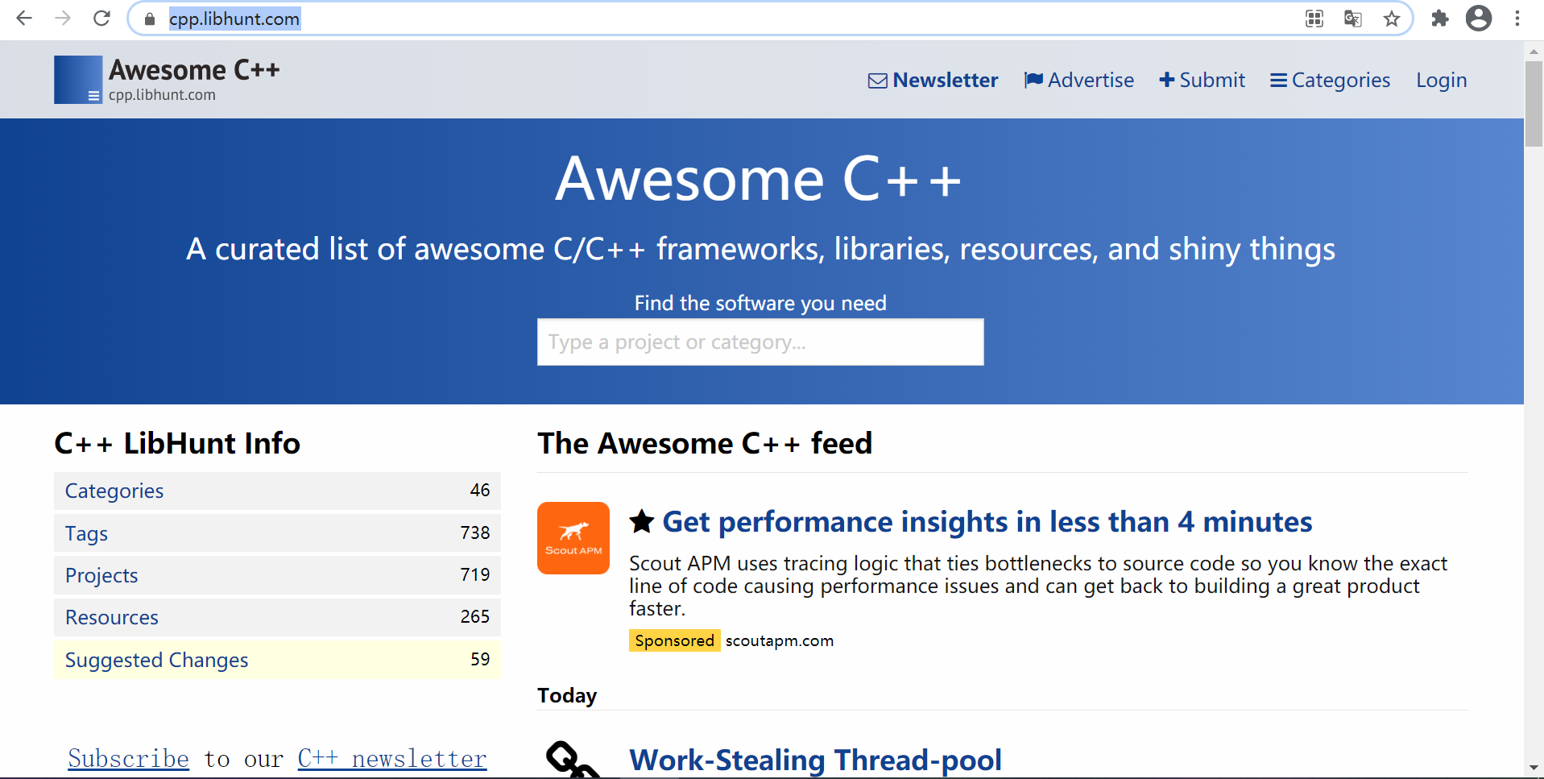

<https://gitee.com/leslie_lee/awesome-cpp>

