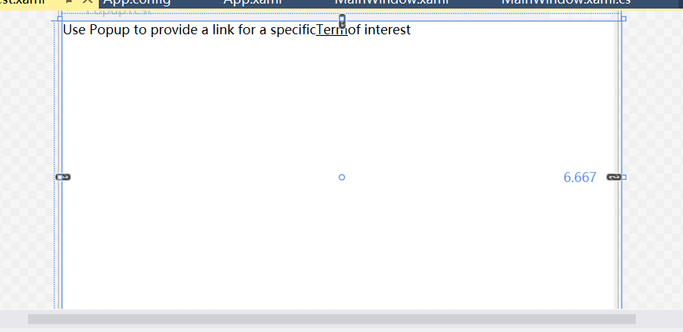

Xaml配置文件：

<Window x:Class="WpfControlClass.PopupTest"

xmlns="http://schemas.microsoft.com/winfx/2006/xaml/presentation"

xmlns:x="http://schemas.microsoft.com/winfx/2006/xaml"

Title="PopupTest" Height="560.025" Width="519.9">

<Grid Margin="0,0,-6.667,0" Height="529" VerticalAlignment="Top">

<TextBlock TextWrapping="Wrap" Height="529" VerticalAlignment="Top">Use Popup to provide a link for a specific<Run TextDecorations="Underline"

MouseEnter="Run_MouseEnter">Term </Run>of interest</TextBlock>

<Popup Name="topLink" StaysOpen="False" Placement="Mouse" MaxWidth="200"

PopupAnimation="Slide" AllowsTransparency="True">

<Border BorderBrush="Beige" BorderThickness="2" Background="White">

<TextBlock Margin="10" TextWrapping="Wrap">

for more information,see

<Hyperlink NavigateUri="http://en.wikipedia.org/wiki/Term" Click="lnk_Click">Wikipedia</Hyperlink>

</TextBlock>

</Border>

</Popup>

</Grid>

</Window>

Cs代码：

using System;

using System.Collections.Generic;

using System.Linq;

using System.Text;

using System.Threading.Tasks;

using System.Windows;

using System.Windows.Controls;

using System.Windows.Data;

using System.Windows.Documents;

using System.Windows.Input;

using System.Windows.Media;

using System.Windows.Media.Imaging;

using System.Windows.Shapes;

using System.Diagnostics;

namespace WpfControlClass

{

/// <summary>

/// PopupTest.xaml 的交互逻辑

/// </summary>

public partial class PopupTest : Window

{

public PopupTest()

{

InitializeComponent();

}

private void Run_MouseEnter(object sender, MouseEventArgs e)

{

topLink.IsOpen = true;

}

private void lnk_Click(object sender, RoutedEventArgs e)

{

Process.Start(((Hyperlink)sender).NavigateUri.ToString());

}

}

}