NCBI Blast Activity Sample

**Objective:**

The main objective of this sample is to demonstrate the use of NCBI Blast Activity in Trident. The NCBI Blast Activity has been created using the Microsoft Biology Foundation.

**NCBI Blast:**

In bioinformatics, **B**asic **L**ocal **A**lignment **S**earch **T**ool, or **BLAST**, is an algorithm for comparing primary biological sequence information, such as the amino-acid sequences of different proteins or the nucleotides of DNA sequences. A BLAST search enables a researcher to compare a query sequence with a library or database of sequences, and identify library sequences that resemble the query sequence above a certain threshold. Different types of BLASTs are available according to the query sequences. For example, following the discovery of a previously unknown gene in the mouse, a scientist will typically perform a BLAST search of the human genome to see if humans carry a similar gene; BLAST will identify sequences in the human genome that resemble the mouse gene based on similarity of sequence.

**How to use:**

This sample demonstrates the use of NCBI Blast Activity in Trident. The sample contains one activity. Please import the workflow package “TestBlast_New.twp” using Trident composer. For more information on how to import a workflow package please refer [Trident Workflow Composer User Guide](http://tridentworkflow.codeplex.com/Project/Download/FileDownload.aspx?DownloadId=129207).

After you import the workflow package, you will be able to see the NCBI Blast activity in the “Uncategorized” section of the Activities in the left pane of the Trident composer. The main functionality of this activity is to read a file in the FASTA format and store the BLAST result in an XML formatted string.

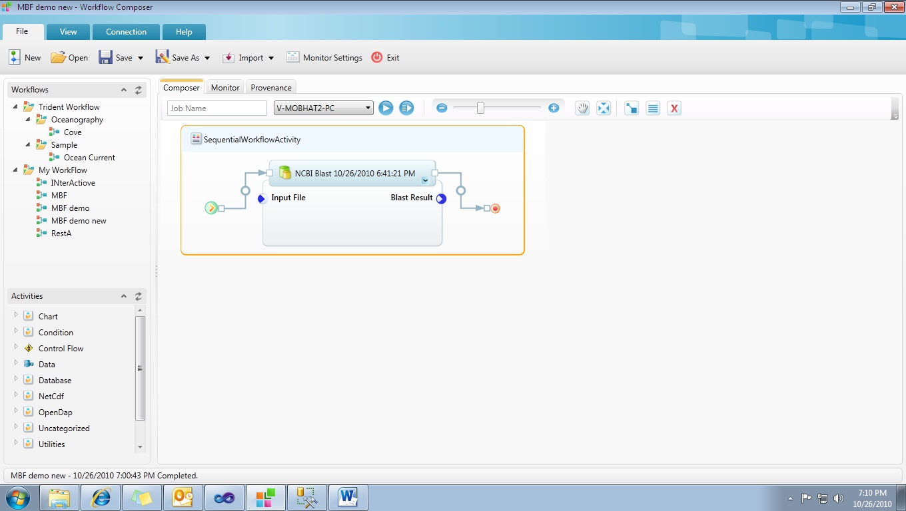

For successfully running this workflow you need to provide the following information:

1. Input File – The path of the FASTA formatted file to be read in.

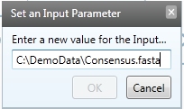

1. BLAST Result – An XML Formatted string which stores the output of the NCBI BLAST performed on the FASTA formatted input file.

**Result:**

After the successful execution of the workflow, the user can view the resultant string which is in the XML format. Below is a sample view of the output string:

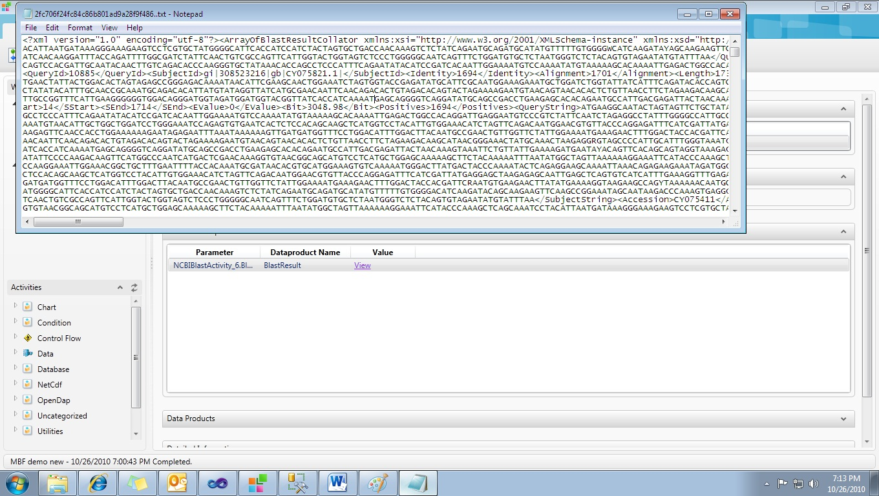

**Summary:**

Through this sample we have demonstrated the usage of NCBI Blast Activity in Trident.