
Trident Workbench: A Scientific Workflow System
Microsoft External Research
December 8, 2008
This paper introduced the design rationale, architecture, and early examples for the Microsoft Research Trident Workbench, built on top of the Windows Workflow Foundation, to enable automated data analysis and visualization and to compose, run, and catalog experiments.
The current version of this paper and new information about the Trident Workbench is available at: http://research.microsoft.com/en-us/collaboration/tools/trident.aspx
Feedback: Please submit comments and queries at:
https://connect.microsoft.com/Survey/
© 2008 Microsoft Corporation. All rights reserved.
Terms of Use |Trademarks |Privacy Statement
Contents
Introduction 2
Why Workflow Systems? 4
What Are Scientists Looking for in Workflows? 5
Why Not Use a Conventional Workflow System? 7
Why Trident Workbench? 7
Trident Workbench Goals 8
Technical Pillars of Trident 9
Sustainable Ecosystem for Scientific Workflow Computing 11
Trident Architecture 12
Trident Logical Architecture 12
Trident Functional Components 14
Visual Authoring Workbench 14
The Trident Registry 15
Visualization 16
Workflow Administration 16
High-Performance Computing 18
Fault Tolerance 20
Trident Semantic Provenance Framework 20
Services and Software for Scientific Workflow 21
Trident Services 21
Microsoft Software Supporting Trident 22
Appendix: Trident Partners 23
Pan-STARRS Sky Survey 23
University of Washington, Monterey Bay Aquarium and Microsoft Research 25
Other Academic Partners 26

Introduction
Science is undergoing a sea change. Instead of the small, private, periodic data sets currently being used, large, sophisticated, remote-sensor systems soon will bring enormous amounts of real-time data to be shared by multidisciplinary scientists. One such example is Project Neptune for oceanography. To cope with this shift from data-poor to data-rich science, new tools are needed to help scientists work effectively with these systems and with the enormous amount of data that they will generate.
The Microsoft Research Trident Workbench began as a collaborative scientific and engineering partnership among the University of Washington, the Monterey Bay Aquarium, and Microsoft External Research, intended to provide Project Neptune with a scientific-workflow workbench for oceanography. The Trident workbench is built on top of the Windows Workflow Foundation. Trident enables users to:
- Automate analysis
- Visualize and explore data
- Compose, run, and catalog experiments
- Create a workflow starter kit that makes it easy for users to extend the functionality of Trident
- Learn by exploring and visualizing ocean and model data

Because the end users for Trident are not seasoned programmers, Trident offers a graphical interface that enables construction of workflows, launching workflows, monitoring workflows, and administration of workflows. The authoring of a workflow is an important aspect of any workflow system, allowing the researcher to specify both steps and control dependencies in the data analysis pipeline. Trident allows users to visually author workflows using a catalog of existing activities and complete workflows, using a desktop application or a web browser. Trident also provides a tiered library that hides the complexity of different workflow activities and services for ease of use.
An increasing number of tools and databases in the sciences are available as Web Services. As a result, researchers are not merely faced with a data deluge but also face a service deluge and need a tool to organize, curate and search for services of value to their research. Trident provides a registry that enables the scientist to include services from his or her particular domain. The registry enables a researcher to search on tags, keywords, and annotations to see what services are available:
- Semantic tagging enables researchers to find a service based on what it does, or is meant to do, and what it consumes as inputs and produces as outputs.
- Annotations allow a researcher to understand how to operate it, configure it correctly; the registry records when and by whom a service was created, its version history and tracks its version.

The Trident registry service also includes a harvester that automatically extracts WSDL for a service, to allow scientists to use any service as it was presented. Users simply provide the URI of the service, and the harvester extracts the WSDL and creates an entry in the registry for the service. Curation tools are available to review and semantically describe the service before moving it to the public area of the registry.
Microsoft Research is partnering with oceanographers involved in the NEPTUNE project at the University of Washington and the Monterey Bay Aquarium to use Trident as a scientific workflow workbench. A Trident prototype has been developed for workflow authoring and integrating workflow authoring and workflow execution with the Registry.
This paper describes the requirements that informed the project requirements, plus a detailed look at the architecture and services that the Trident Workbench provides.
See also: What others say about the Microsoft Research Trident Workbench
Video Preview: Our team in Microsoft External Research is developing a Windows Workflow Foundation-based workflow Composer for scientists. The design can be adopted for other domains. Jared Jackson from our team presented the Composer as a use case for custom designers in the PDC 2008 session TL147-"WF 4.0: A First Look" by Kenny Wolf (~10-minute segment). To view the PDC session video at https://sessions.microsoftpdc.com/public/timeline.aspx, click Speakers, and then click Kenny Wolf's name at the end of the list.

Why Workflow Systems?
Over the past two decades, we have seen a revolution in the way science and engineering are conducted. Computation has become an established “third branch” of science alongside theory and experiment. Advances in computing technology are transforming discovery in nearly all scientific fields, in two important ways:
- Massive experiments are being carried out by simulating the real world using computer systems with thousands of processors.
- Large numbers of tiny but powerful sensors are being deployed to gather data on the sea floor, on glaciers in the Swiss Alps, and in living organisms.

These approaches share a common trait: they produce enormous amounts of data that must be captured, transported, stored, accessed, visualized, and interpreted in order to extract knowledge. This “computational knowledge extraction” is at the heart of discovery in the 21st Century.
The goal of e-Science workflow systems is to provide a specialized programming environment to simplify the programming effort required by scientists to orchestrate a computational science experiment.
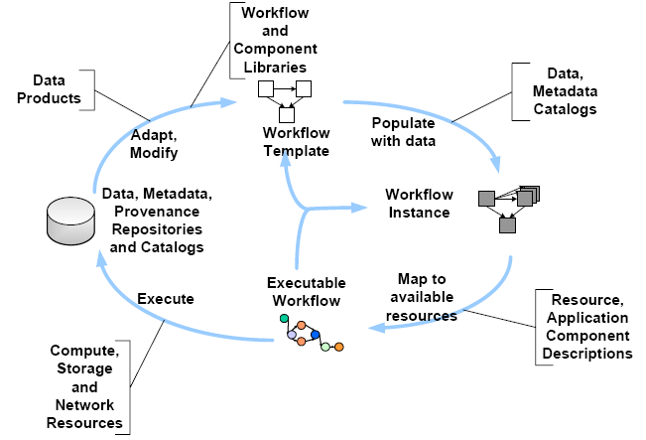
Figure 1. The Workflow Lifecycle
In general we can classify these different phases of the workflow lifecycle, illustrated in Figure 1:
- Composition, Representation and Data Model: The composition of the workflow (abstract or concrete) through a number of different means, such as text and graphical.
- Mapping: The process of mapping from the (abstract) workflow to the underlying resources.
- Execution: Enactment of the mapped workflow on the underlying resources.
- Provenance: The recording of metadata and provenance

During workflow composition, the user creates a workflow either from scratch or by modifying a previously designed workflow. The user can rely on workflow component and data catalogs, as well as service registries. The workflow composition process can be iterative, where portions of the workflow need to be executed before subsequent parts of the workflow are designed.
Once the workflow is defined, portions or all of the workflow can be sent for mapping and then execution. During that phase, various optimizations and scheduling decisions can be made.
Finally, the data and all associated metadata and provenance information are recorded and placed in a registry that can then be accessed to design a new workflow. Even though we delineate data recording as a separate phase of the workflow lifecycle, this activity can and often is part of the workflow execution.
Scientific workflows are proving to be the preferred vehicle for computational knowledge extraction and for enabling science at a large scale. The scale can be measured in terms of the size and scope of the scientific analysis itself and its complexity, as well as in terms of the number of scientists and the number of organizations that collaborate in the process of scientific discovery.
Workflows provide a useful representation of complex analyses composed of heterogeneous steps. This representation facilitates overall creation and management of the computation and also builds a foundation upon which results can be analyzed and validated.

What Are Scientists Looking for in Workflows?
Workflows are useful for bringing sophisticated analysis to a broad range of users. Experts formulate workflows, set parameters of individual components, annotate components or the overall workflow, and validate the result. Once this is complete, the workflow can be shared with members of the community, other experts or even researchers and students that are not familiar with all the details of the analysis to the point where they can set all the necessary parameters themselves, but are fully able to make use of the workflow for their own work.
- Domain scientists consider workflow as a crucial and underrepresented computational resource.
Today there is a marked disparity between the tremendous growth in the performance of computers, sensors, data storage, networks, and other system elements.
Many scientists will argue that this disparity is due, in part, to the increasing complexity of managing ever larger and more distributed computations and data. Although data and computational resources are growing exponentially, the number of scientists is roughly constants. Scientists also express concern that because sequences of computational activities are typically performed manually, the repeatability of scientific processes becomes very challenging.
These two concerns both point to a need for scientific workflow systems that can assist with and/or automate the creation, execution, and management of sets of computations and the data that those computations produce. Such systems should support collection of critical metadata in form of provenance information for verification and validation of experimental results/process or system information (such as performance values, exception states, resource allocation) for maintenance/improvement of workflow workbench.
The various forms of metadata can be used for the convenient re-execution of a computational process with alternative data, re-enactment of previous workflow runs for validation or mining for discovery of useful workflow patterns. For all these reasons, the scientific community views workflow systems as being an increasingly important foundation for scientific progress. However, there is frustration in the community at the lack of readily available computational tools for authoring and managing scientific workflows.
- Computer scientists consider workflow as an enabler to automate and manage complex distributed computations.
Computer scientists engaged in building scientific workflow systems such as Taverna, Kepler, LEAD, et al. assert that workflow can play a valuable role in scientific work by providing a formal and declarative representation of complex processes that can then be managed efficiently through their lifecycle from assembly to execution and sharing.
However, important issues crucial to the more widespread application of workflow tools, such as workflow representation, execution management, and sharing are largely unexplored. Although existing academic workflow systems can address some of these issues in limited ways, current techniques are unlikely to adequately address the challenges of future scientific workflows in terms of complexity, scope, interactivity, collaborative nature, and execution management.

Research in workflow for scientific applications has yielded several specialized workflow engines such as Taverna, Kepler, LEAD, and Pegasus. However, we are still in the early stages of the scientific workflow hype cycle. Increasing demands are being placed on these scientific workflow systems, in terms of number of users, exponential growth in data and computational resources, demand for new features and pressure to track evolving technologies. Building and maintaining industrial-strength middleware is an expensive and labor-intensive endeavor. There is a danger this might constrain the future capabilities of these scientific workflow systems and possibly overwhelm the development efforts.
Workflows have been used for decades to represent and manage business processes. Today there are standards for workflow representations and commercial quality software to manage these workflows. Examples in the literature of workflows in business applications are data intensive, highly parallel, and so on. Yet, there is a perceived tension between the requirements of scientific workflow and the constraints imposed by existing production workflow systems. This tension is largely superficial because commercial workflow systems, out of necessity, have not been designed to address specific requirements of scientific workflows. Rather, they aim to meet the needs of a broader community.
In this respect, we believe it will be crucial for scientific workflow to take advantage of existing workflow infrastructure, in order to benefit from the inertia behind commercial workflow engines and focus on the unique capabilities required to support scientific workflows.

Why Not Use a Conventional Workflow System?
Although conventional business workflows are more control-flow oriented, scientific workflows tend to be dataflow-oriented. In a scientific workflow, the design of a workflow focuses on how the input data are streamlined into various data analysis using data channels to produce various intermediate data products and final workflow output data products, forming various "data flows." Furthermore, workflow result provenance is essential for scientific workflows to support reproducibility, result interpretation and diagnosis, while such a facility is not necessary for business workflows.
Although a business workflow is usually designed with a good understanding of business rules and thus will stabilize for some period of time, a scientific workflow is exploratory in nature. A domain scientist needs to design, modify, and reengineer a scientific workflow with ease.
We must consider services and extensions appropriate for the scientific domain. It is important, therefore, to support:
- Comparative analysis of the results of repetitive runs of a scientific workflow
- Reuse, sharing, and adaptation of a scientific workflow
- Fault tolerance and reliability

Why Trident Workbench?
Although existing workflow systems are able to support complex computations and data repositories in a distributed environment, they do not meet the emerging requirements from scientists to collaborate across disciplines in a geographically distributed environment on the Internet. We want to enable users to access scientific workflow environments from the Web. This includes:
- Workflow construction
- Leveraging distributed data sources and workflow services
- Managing the runtime services
- Easily sharing workflow activities and outputs

We want a robust workflow infrastructure that can scale out and scale up in a service oriented environment. Equally important, we want Trident to be sustainable, building necessary support on top a commercial workflow engine—Windows Workflow Foundation—to take advantage of existing functionality. As a result we can focus on tools and services of value to scientists. This means we want to:
- Work with scientists to understand the requirements across multiple domains
- Demonstrate prototypes and proof of concepts
- Develop software tools, frameworks, and reference implementations to support a workflow platform for science
- Leverage this experience and transfer to new research communities so it is easy to extend, deploy, and share scientific workflow activities

Figure 2 illustrates the functional areas. We have placed the scientists and researchers at the center of the diagram, showing key functions.
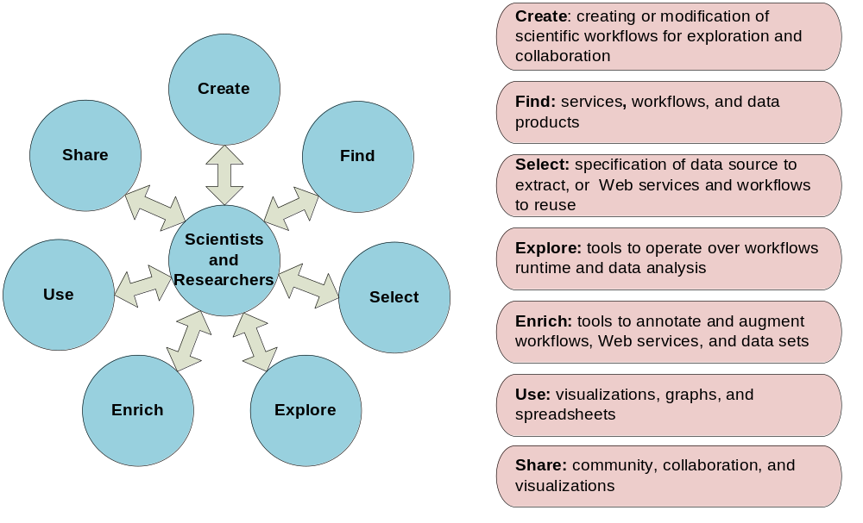
Figure 2. Functional Areas for Scientific Workflow

Trident Workbench Goals
The goals for the Trident work bench are to:
- Allow users to explore and visualize data, regardless of the source
- Automate tedious data cleaning and analysis pipelines
- Compose, run and catalog experiments, and save the results
- Provide a workflow starter kit that will allow users to easily extend Trident functionality
To achieve this, Trident supports a variety of users interacting with the system:
- Community – easy access to regularly generated data products (model output, images, visualizations)
- Researchers – access to quasi-live or historical data through thin client (Web browser), and the ability to:
- Access data and create visualizations on demand
- Author both data analysis pipelines and visualizations remotely
- Principal Investigators – direct access to their own instrument for live access, add new instruments, and introduce new analysis codes and algorithms into the system

Objectives for supporting science:
- Study existing solutions from visualization to distributed databases for scientific computing and recommend an eResearch platform based on best practices.
- Demonstrate the eResearch platform by using real science projects - Neptune.
- Provide the state of the art tools to increase the productivity for scientists.

Technical objectives:
- Develop a visual programming environment for developing workflows that can be used by scientists.
- Develop solid scientific workflow framework and foundation services for hosting Windows workflow runtime for scientific computing.
- Scale to the cloud.
- Enable partner extensibility and a community of participation. Engage the community and collaborate with academic teams and partners to build a healthy and sustainable ecosystem for an eResearch platform.
- Provide a sharing environment for scientific workflows and data services.
- Provide product development feedback for the product teams such as Windows Workflow, High Performance Computing, and SQL Server.

Objectives for supporting science:
- Study existing solutions from visualization to distributed databases for scientific computing and recommend an eResearch platform based on best practices.
- Demonstrate the eResearch platform by using real science projects such as Neptune.
- Provide the state of the art tools to increase the productivity for scientists.

Technical objectives:
- Develop a visual programming environment for developing workflows that can be used by scientists.
- Develop solid scientific workflow framework and foundation services for hosting Windows workflow runtime for scientific computing.
- Scale to the cloud.
- Enable partner extensibility and a community of participation. Engage the community and collaborate with academic teams and partners to build a healthy and sustainable ecosystem for an eResearch platform.
- Provide a sharing environment for scientific workflows and data services.
- Provide product development feedback for the product teams such as Windows Workflow, Windows Server 2008 High Performance Computing, and SQL Server.

Technical Pillars of Trident
Scientific workflows and their supporting environments must reflect the modeling paradigm of the scientist, not the underlying computational paradigm of the execution engine or implementation.
Too often scientific workflow languages and tools reflect the technology, not reality. For example, nearly all the GUIs of current workflow engines present themselves as drag-and-drop wiring diagrams. However, a scientist faced with scheduling a data pipeline between dozens of activities is not going to find such a tool of much practical use. This means presenting the workflow at the appropriate level of abstraction in terms of a user model, not a workflow model. Trident will devise a high-level GUI for the scientists to construct scientific workflows, store workflows in a library for easy reuse, and execute workflows to create on-demand visualization.
None of the existing workflow authoring tools supports access from the Web, requiring instead installations of client programs on each user’s workstation. This limits users' ability to share and collaborate in a distributed environment. The new wave of Web development technologies such as AJAX and Microsoft Silverlight allow developers to build better and richer user experiences for Web applications. Trident will offer a clear demonstration of how the scientist can construct and invoke workflows via a Web user interface. Trident will allow users to quickly and easily find services and adapt previous workflows to build workflows effectively.
As the target end users for Trident are not necessarily expert programmers, Trident will provide a Web-based portal for authoring and launching workflows. It will use semantic technologies to provide service descriptions that are closer to the scientists' view of their experiments and data than implementation-specific syntactic types. Users will use the authoring tool to modify and aggregate existing workflows with the use of the metadata services to guide this process. Trident will have a tiered library that hides the complexity of different workflow activities and services to enable the user to think about the experiment rather than its execution.
Trident offers two main development experiences for Trident:
- Developers can use Visual Studio.NET, Trident scientific workflow framework, and Windows Workflow framework to develop libraries of custom workflow activities. These activities can be general purpose or domain specific. See Figure 3.
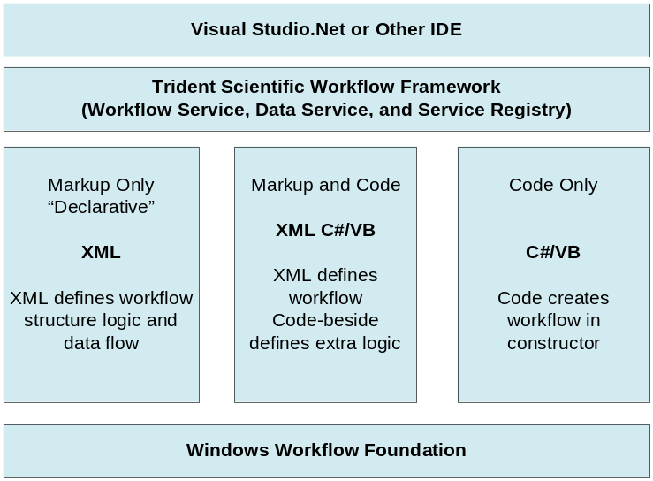
Figure 3. Developer's Experience for Workflow Authoring
- Scientists can use Trident Workbench to develop, catalog, and manage domain specific workflows using the libraries of workflows, Web services, and data visualization services. See Figure 4.
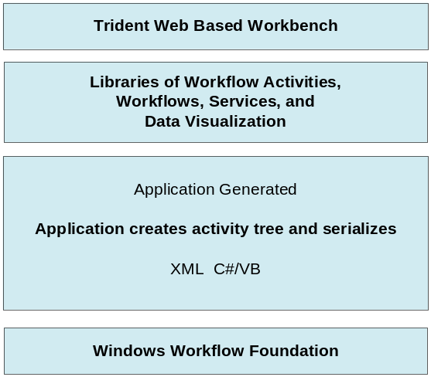
Figure 4. Scientists' Experience for Workflow Authoring

Sustainable Ecosystem for Scientific Workflow Computing
Trident is not designed to be a solution to cover all workflow activities for scientist out of the box. However, it will provide a foundation framework and reference implementations of custom activities so that the community of developers and researchers can develop custom activities and domain specific packages by using its runtime services.
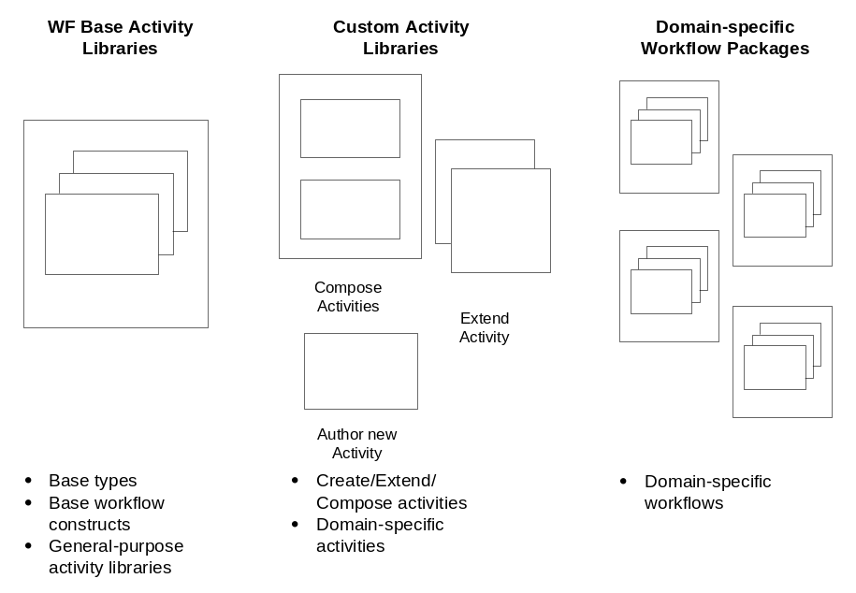
Figure 5. Trident: An Extensible Approach
Sharing best practices and scientific methods are essential in science, accelerating both knowledge dissemination and education. Trident will support the reuse of someone else’s workflow or reuse of your own by maintaining workflow libraries and associated metadata descriptions, classifications, and access controls. Trident will have a collaboration service for sharing workflows, reusing workflows, and maintaining different versions of workflows. The collaboration service will also allow user to provide feedback on different workflow packages

Trident Architecture
The Trident platform supports a set of tools that allow scientists, developers, and administrators to implement and host scientific workflows. The components of Trident are organized into a stack-based architecture. This section discusses the Trident stack, and provides some examples of how users interact with the architecture to create and manage workflow applications.

Trident Logical Architecture
Figure 1 is a diagram of Trident’s logical architecture. It represents how Trident’s functional components are organized, and how data passes between those components.
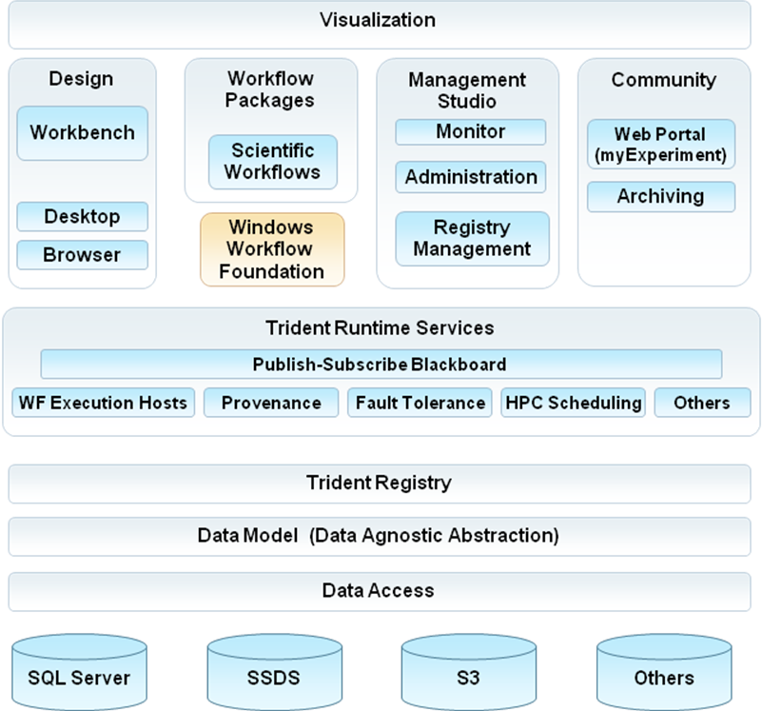
Figure 6. Trident Logical Architecture
The architecture has five primary layers:
Visualization
This layer supports visualization of data across all phases of a workflow application, including design, runtime, sharing, and archiving...
The User Interface
The Trident user interface consists of four primary components—Design, Workflow Packages, Management Studio, and Community. For example:
- Scientists use the Design component’s visual authoring environment to construct workflows and create deployment packages.
- Scientists use the workflow packages from Trident to take advantage of Windows Workflow Foundation services, including provenance, fault tolerance, monitoring, and workflow scheduling for Windows HPC Server 2008. Developers can develop domain specific workflows with Visual Studio and import them to Trident for scientists to use.
- An administrator or scientist uses the Management Studio component to start, stop, pause, or resume workflow execution, schedule workflows, monitor workflows, and manage the Trident Registry where workflow meta data is stored
Scientists use the Community component to share or comment on published workflows, services, and data, such as sharing Trident workflows on the myExperiment site (http://www.myexperiment.org/home).They can also use this component to access archived workflows.
Runtime Services
Trident runtime services include:
- The Publish-Subscribe blackboard.
- Workflow Foundation execution hosts.
- Provenance.
- Fault tolerance.
- Windows Server HPC 2008 scheduling.

Services communicate each other via the publish-subscribe blackboard. For example, Trident workflow execution host publishes data to the blackboard and provenance service subscribes data from the blackboard. Developers can develop custom services to take advantage of Windows workflow service and the blackboard.

Data Management
The data management layer includes Trident Registry and an abstraction layer for the underlying data storage technology. The upper edge communicates with the Runtime Services layer and handles the mechanics of passing the data to and from the selected data storage.
Data Storage
Trident data can be stored in a variety of ways, including:
- A Microsoft SQL Server database, running on a server or server cluster.
- A cloud database, such as SQL Server Data Services (SSDS) or Amazon Simple Storage Service (S3).

Trident Functional Components
This section provides some scenarios that describe how key Trident functional components are used to support workflow development and the Trident runtime. The scenarios include prototype of the some of the UI for the associated tools. The prototypes don’t represent the final UI experience, but they provide a visual guide and help present the functional features. Future documentation will provide detailed domain-specific UI scenarios based on example workflow packages.

Visual Authoring Workbench
A workflow specifies all the steps and dependencies that are required to perform a particular analysis, so composing the workflow is a key part of implementing Trident applications. The Visual Authoring Workbench simplifies workflow composition by providing the user with both a Windows desktop and a Web based visual workflow authoring environment.
The Visual Authoring Workbench is designed for scientists with a basic understanding of programming concepts. Users construct workflows from a set of graphical objects that represent various workflow components, including:
- Pre-packaged or custom workflows.
- Pre-packaged or custom activities.

To compose a workflow the user selects the appropriate objects and arranges them on the workbench’s design surface. To display the properties of an object on the design surface, the user simply selects the object, and the properties appear in the Property window.
Trident is designed to support data-flow centric analysis. For example, a workflow could take the form of a pipeline that integrates data from a number of resources for further analysis. Because the Windows Workflow Foundation does not support data flow programming “out of the box”, Trident supports data flow construction by graphically binding the properties of workflow activities.
Figure 7 is a prototype that shows an example of the visual authoring environment.
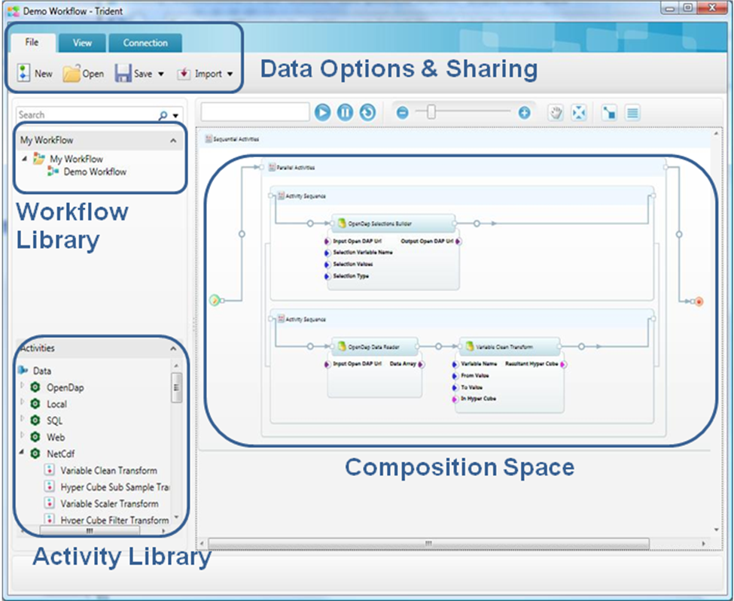
Figure 7. Trident Workflow Composer

The Trident Registry
Trident includes a repository—called the Registry—which stores metadata for Trident resources including workflows, services, data products, and users. The Visual Authoring Workbench and the Registry are fully integrated.
- Based on the Registry, the Workbench can display workflow libraries, activities, and render workflows graphically. It can also suggest list of data sources that are suitable for binding to a workflow or activity.
- A user can browse the reusable resources in the Registry and drag a selected resource directly to the design surface.
- A user can import workflows developed in Visual Studio from the design environment. It can also export a workflow with all the necessary references to rerun it by another user.

Users can also use the Registry to manage workflow versioning and curate workflows, services, and data products.

Figure 8 is a prototype that shows an example of the Registry manager.
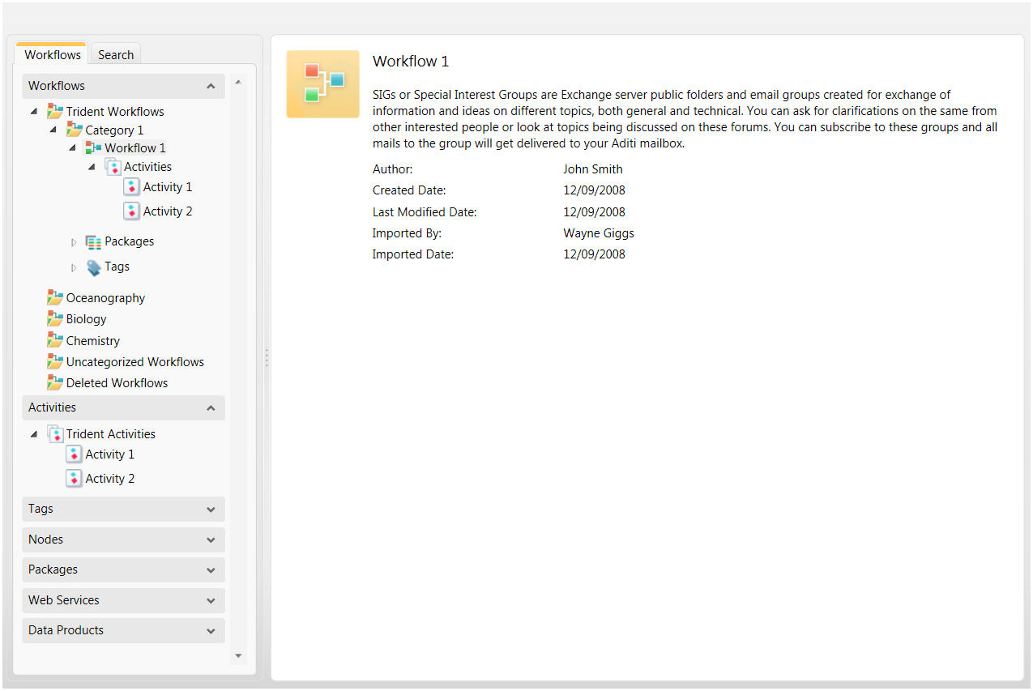
Figure 8. Registry Manager Prototype

Visualization
Many scientists spend a substantial amount of time and effort managing their remote data files and resources. Trident allows scientists to visualize distributed data outputs or products across all phases of a workflow application – design, runtime, sharing, and archiving. Trident also provides a framework for publishing intermediate or final results, so the visualization components—including custom components—can visualize data outputs. This feature allows users to integrate custom-developed visualization services into the Trident environment.
Trident allows developers to customize how a workflow will be rendered. Rendering a simple workflow—one with no more than a few dozen tasks—is relatively straightforward. However many scientific workflows are much larger and more complex, and they are usually represented by using some form of graphical nesting based on sub-workflow hierarchies. To handle these large complex work flows, Trident visualization supports multi-level rendering with subsections.

Workflow Administration
After development is complete, the workflow must be deployed. An administrator (role-based) uses the Trident Management Studio to deploy the workflow to the production servers and to manage the workflow’s subsequent operation. The Management Studio is used to:
- Deploy workflow packages to production servers
- Manage workflow instances on different nodes on the network.
- Manage Trident Registry
- Set access control permissions.

The Workflow Manager displays the workflows that are available to be launched and the user can either start a workflow synchronously or schedule it for execution at a specified time.
Figure 9 is a prototype of the Trident workflow Manager.
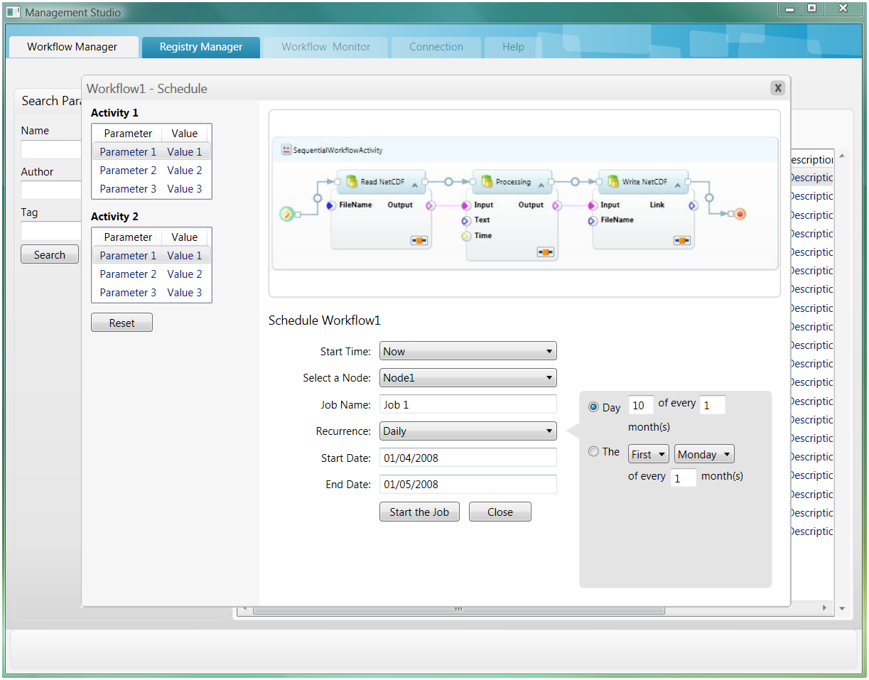
Figure 9. Workflow Manager

Trident provides a Workflow Monitor, which allows a user to monitor a running workflow. Figure 10 is a prototype of the Workflow Monitor’s user interface.
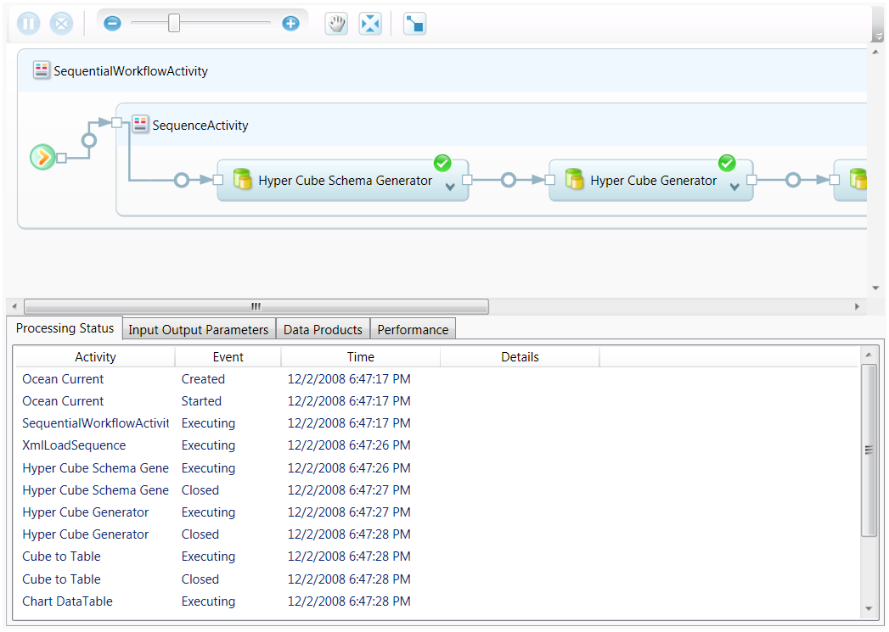
Figure 10. Workflow Monitor
The Workflow Monitor provides following data:
- The Processing Status window shows the current status of the workflow activities.
- The workflow diagram provides a visual representation of the selected workflow, color-coded for each activity.
- After inspecting intermediate results, users can modify workflow parameters as appropriate and restart the workflow.

High-Performance Computing
Scientific analyses often require large-scale data-intensive computations that are best handled by parallel and distributed computing. However, scientists often do not have the programming skills to fully take advantage of such computing resources. Trident allows scientists to easily integrate high performance computing capabilities into their workflows, which can significantly improve application throughput and performance by effectively using large scale and distributed computing resources.
By default, a workflow application running on a HPC cluster is limited to a single node. However, users can schedule a workflow job across multiple nodes by creating a workflow application that communicates with the HPC job scheduler to orchestrate parallel workflows across multiple nodes in a HPC cluster.
Trident supports a common pattern for workflow computations; run different computational models on the same data set on different computers and then merge the results back for comparison and visualization. Figure 11 is a diagram of a generic end to end computation scenario on a HPC cluster.
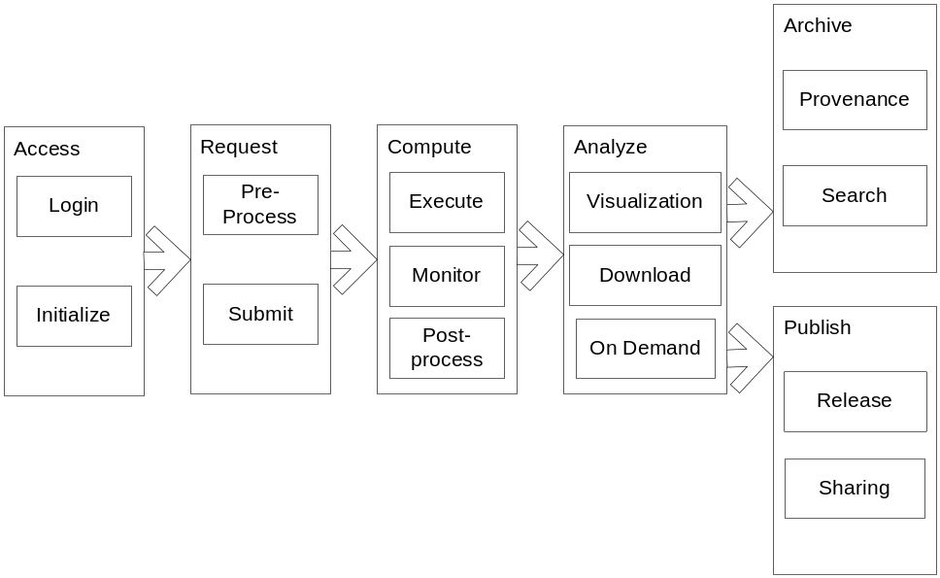
Figure 11. A Generic End-to-end Computation Scenario on an HPC Cluster
Table 1 describes the steps in Figure 11.
Table1. End-to- End Computation Scenario on an HPC Cluster
Step | Description
Access
Login | User authentication.
Initialize | Setup workspace or resource provisioning.
Request
Pre-process | Before a job starts, it might require preliminary steps such as creating a working directory, installing assemblies, splitting job input messages, and moving data sets to cluster nodes.  This can be accomplished with a pre-processing workflow or with setup scripts.
Submit | The user provides input parameters and submits the job to a HPC cluster. The job can be scheduled to run immediately or at a specified time.
Compute
Execute | The job executes across the cluster.
Monitor | The Monitor tracks the job execution status and provides feedback to the user or administrator.
Post-process | After the job is complete, resources that are no longer needed are cleaned up, either by a post-processing workflow or by scripts.
Analyze
Visualization | The user can analyze the results by using visualization tools in real time or near real time.
Download | The user can download results for further analysis.
On Demand | The user can request ad-hoc reports, graphs, spreadsheets, or 3D visualizations.
Archive
Provenance | The user can view an electronic log book of the job.
Search | The user can search previous jobs and look at the detail reports.
Publish
Release | The user can release scientific workflows for collaboration and reuse, including workflow definitions, provenance, and curation.
Sharing | Other researchers can view published workflows and data products on line.

Trident uses the tools provided by Windows HPC Server 2008 to manage the Access, Request, Compute, and Analyze tasks (Administration Console, Job Scheduling, Monitoring, and Reporting). The following areas require custom development effort:
- Job scheduling for “embarrassingly parallel” workflows.
Embarrassingly parallel workflows can run in parallel on multiple processors or nodes with no dependency or communication between them.
- HPC job monitoring.
- Pre-processing workflow.
- Combining intermediate results into final results.
- Post-processing workflows.

The goal of the custom development effort is to create a reference implementation for processing embarrassingly parallel workflows on HPC Server clusters, based on well-defined scenarios.

Fault Tolerance
Workflows must deal with fault handling at many levels. Data transfer can fail because of congested networks or the lack of available local storage. Computers can crash or can be taken away to handle higher priority tasks. Two essential components of fault tolerance are:
- Data services that can retain the intermediate results generated by each workflow step.
- Workflows can be restarted from any point.

Trident supports mechanisms to track a failed step in a workflow, suspend the action, allocate new resources, and then restart the workflow.

Trident Semantic Provenance Framework
Semantic provenance provides critical metadata for scientific analyses, but it has not been adequately addressed by existing workflow systems. Trident features a novel semantic provenance framework that uses semantic Web technologies to create comprehensive provenance for:
- Verification of scientific data.
- Validation of experimental processes.
- Tracking workflow evolution as services are added or modified.

Semantic Provenance as Metadata Layer for Management of Scientific Data. Metadata in the form of provenance information records the how, where, what, when, why, which, and by whom for data generated in a scientific experiment.
Scientists traditionally use provenance information—which is typically collected manually in lab notebooks or by using ad-hoc software applications—to accurately interpret and evaluate data. Scientists also use provenance information to validate their experimental procedures.
Trident can automatically create and store provenance information, which is characterized by the following essential attributes:
- Software-interpretable: Human mediation is inadequate to process, analyze, integrate, store, and query the petabytes of data and associated metadata generated by the large-scale scientific process. For metadata—specifically provenance information—to be used for large-scale scientific data management, it must be “computable” by software agents.
- Expressive: Provenance information should be expressive enough to incorporate the domain semantics of scientific data in a way that enables software agents to use the provenance information to accurately interpret the data in the correct context.

Trident semantic provenance support extends the scope of provenance to include not only workflow trace information but also domain semantics. Semantic provenance information is created with reference to a formal knowledge model or an ontology that imposes a domain-specific conceptual view on scientific data. The provenance information consists of formally defined concepts linked together using named relationships with a set of rules to represent domain constraints.”
Trident uses semantic provenance as a comprehensive metadata layer to enable scientists to not only verify results and validate experimental procedures, but also to integrate, store and retrieve scientific data and workflows.

Services and Software for Scientific Workflow
This section summarizes the services for the Trident Workbench and the supporting software from Microsoft.

Trident Services
In a service-oriented environment, applications are usually organized with a stronger separation of runtime service and data. Trident’s service-oriented architecture will allow users to run services both locally and remotely.
In the open environment of scientific computing, we have the problem of both resource description and discovery. In a closed world, it is possible to enumerate the entire set of available resources the workflow designer might want to use, but in a scientific computing environment this is not possible. This, therefore, raises a requirement for rich semantic metadata to describe services, and a searchable set of directory type systems in order for workflow designers to be able to locate service components to perform a particular task.
Trident will consist of the services described in Table 2.
Table 2. Trident Services
Service Name | Service Description | Purpose
Data storage and data access service | Data storage includes SQL Server and SQL Server Data Services (Cloud DB). We may include other data storage engines later. The data access service is storage neutral. | Data management of large amount of data (petabytes) against different data storage technologies.
Registry and metadata service  - Services and data registry  - Ontology registry | Management of Trident resources, including Web or REST services, data products, and workflows. This will also provide versioning, annotation and curation support for workflows and services. | Repository for resource discovery, validation, and reuse.  This applies to both design time and runtime.
Semantic provenance service for verification, validation and management of data and process | Providing provenance creation from workflow trace to expressive domain-specific provenance ontologies. Applicable to scientific results, processes, and evolution of workflows. | Semantic provenance will be used to enable verification and validation of results and procedure including re-run of workflows. It will be also used to reconcile semantic heterogeneity between sets of scientific results.
Fault-tolerance and recovery service | Providing fault-tolerance and recovery service for workflow processing. | Workflow reliability.
Monitoring service | Providing a framework and interfaces for monitoring workflow runtime activities. | System administration and runtime resource usage statistics.
HPC scheduling  service | Supporting workflow job scheduling on HPC clusters. | Run embarrassingly parallel workflows on HPC clusters.
Administration  service | Providing administrative tools for deploying, managing, and monitoring Trident runtime services. | Administration and monitoring of Trident workflows.
Visualization service | Providing extensible framework and data visualization service for data presentation. | Visualization of data outputs for monitoring, system administration, and data analysis.

Microsoft Software Supporting Trident
Both Microsoft Research teams and Microsoft product teams are contributing software components for the Trident Workbench:
- Microsoft Research – Visualization and Interaction for Business and Entertainment team
Today’s computer user is inundated with information, and making sense of this growing mountain of material is becoming an overwhelming task. The Microsoft Research VIBE team believes that more powerful methods for presenting the information users need to make sense out of can greatly reduce cognitive load. Also, by exploring elegant, subtle, peripheral awareness techniques, the team works to preserve the user’s task flow and minimize interruption. Please refer to the team’s Mission Statement for a longer discussion of the VIBE group.
- Microsoft Product components :
Windows Workflow Foundation
Microsoft codename "Oslo"
Windows Server 2008 Performance Computing (HPC)
Microsoft SQL Server

Appendix: Trident Partners

Pan-STARRS Sky Survey
The Panoramic Survey Telescope and Rapid Response System (Pan-STARRS) has begun deployment with the Pan-STARRS Telescope No. 1 (PS1) at Haleakala Observatories, Maui, Hawaii. The project uses the Trident Workbench in its software infrastructure, as shown in Figure A-1.
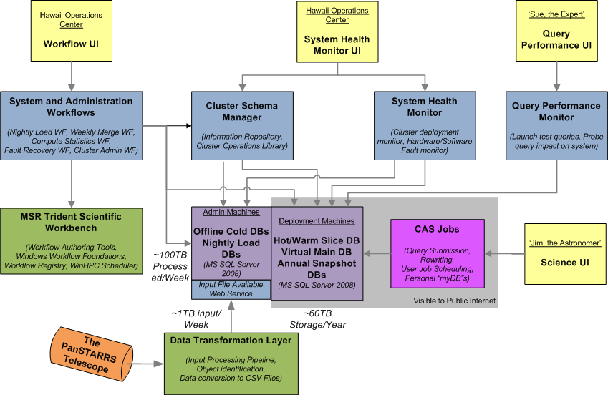
Figure A-1. PanSTARRS Basic Architecture

PanSTARRS Quick Facts:
- One of the largest visible light telescopes
- 4-unit telescopes acting as one
- 1 Gigapixel per telescope
- Surveys entire visible universe in 1 week
- Catalog solar system, moving objects/asteroids
- PanSTARRS 1:
- Detect ‘killer asteroids’, starting in November 2008
- Hawaii + JHU + Harvard + Edinburgh + Max Planck Society
- Data Volume:
- >1 Petabytes/year raw data
- Over 5B celestial objects plus 250B detections in DB
- 80TB SQL Server database built at JHU, largest astronomy DB in the world
- PanSTARRS 4:
- 4 identical telescopes in 2012, generating 4PB/year
- PanSTARRS Architecture:
- 30TB of processed data/year
- ~1PB of raw data
- 5 billion objects; 100 million detections/week
- Updated every week
- SQL Server 2008 for storing detections
- Distributed view over spatially partitioned databases
- Replicated for fault tolerance
- Windows Server 2008 HPC Cluster schedules workflow, monitor system
Pan-STARRS Consortium:
- Max Planck Institute for Extraterrestrial Physics
- Max Planck Institute for Astronomy
- Harvard Smithsonian Center for Astrophysics
- Las Cumbres Observatory Global Telescope Network
- Extragalactic Astronomy & Cosmology Research Group at Durham University
- Institute of Astronomy, University of Edinburgh
- Astrophysics Research Center, Queen's University Belfast
- Graduate Institute of Astronomy, National Central University
- University of Hawaii - Institute for Astronomy, Haleakala Observatories, Maui, Hawaii

University of Washington, Monterey Bay Aquarium and Microsoft Research
2007 eScience Workbench Research Award
Trident – Scientific Workflow for Project Neptune
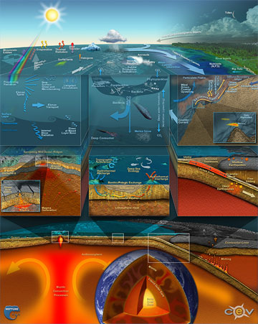
“Science is undergoing a sea change. Instead of the small, private, periodic data sets currently being used in most sciences, large sophisticated remote sensor systems will soon bring enormous amounts of real-time data to be shared by multidisciplinary scientists. To deal with this shift from data poor to data rich science, new interfaces and tools need to be designed and built to help scientists effectively work with these systems and with the enormous amount of data that they will generate”, reported Keith Grochow and Ed Lazowska, Computer Science Department, University of Washington, in their January 25, 2007 eScience Workbench Research awarded proposal.
The University of Washington is working closely with oceanographic and earth scientists in the Puget Sound and Monterey Bay regions to build these tools and interfaces. These are scientists that are already in the process of moving to data rich science. They currently have sensors and cameras that have collected large data sets and are adding more daily. The culmination of their work will be the NEPTUNE Regional Cabled Observatory (RCO), where eventually hundreds of miles of cable will provide power and bandwidth to thousands of instruments streaming back real-time data from the ocean floor.
Trident, a collaborative scientific and engineering partnership between The University of Washington, Monterey Bay Aquarium and Microsoft, is working to provide Project Neptune with the required scientific research, technical and engineering solutions by designing a scientific workflow workbench for Oceanography. The goals of Project Neptune will include allowing the users to automate, explore and visual data; compose, run and catalog experiments; create a workflow starter kit (easily allows users to extend functionality of Trident), and learn by exploring and visualizing ocean and model data.
Key contributors from the University of Washington include, Ed Lazowska, Principal Investigator for Project Trident, John Delaney, Professor of Oceanography and Jerome M. Paros Endowed Chair in Sensor Networks, Keith Grochow, graduate student of Professor Lazowska’s, Computer Science, Mark Stoermer, Department of Oceanography and Donald Averill, Department of Oceanography. Principal Investigator from Microsoft is Roger S. Barga, Architect in Microsoft External Research.
- For more information about Project Neptune, please visit: http://www.neptune.washington.edu/
- To view a video presentation about Project Neptune given by John Delaney, School of Oceanography, NEPTUNE program director, Jerome M. Paros Endowed Chair for Sensor Networks, University of Washington on the Research Channel, please visit:
http://www.researchchannel.org/prog/displayevent.aspx?rID=10281&fID=345

Other Academic Partners
- myExperiment team: University of Manchester and Southampton University. myExperiment makes it really easy to find, use, and share scientific workflows and other files, and to build communities. Trident uses myExperiment as the community site for sharing workflows, along with provenance traces.

- Center for Coastal Margin Observation and Prediction, Oregon Health & Science University
- Department of Electrical and Computer Engineering, Ohio State University
- IRIS: Incorporated Research Institutions for Seismology
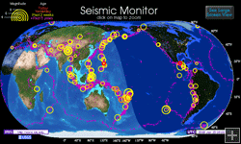
- COVE: A Visual Environment for Ocean Observatories
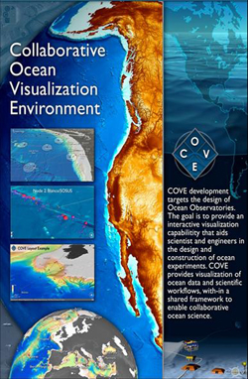
- The LEAD Team: Linked Environments for Atmospheric Discovery
  
  
  

