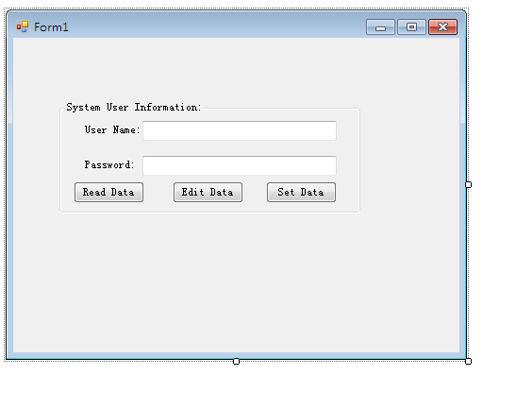

Imports Microsoft.Win32.RegistryKey
Public Class Form1

Private Sub BtnRead_Click(ByVal sender As System.Object, ByVal e As System.EventArgs) Handles BtnRead.Click
Dim key As Microsoft.Win32.RegistryKey = My.Computer.Registry.CurrentUser.OpenSubKey("Software", True)
Dim key1 As Microsoft.Win32.RegistryKey = key.OpenSubKey("pos\kenny software\kenny pos software\Super Cash Register\system user", True)
If IsNothing(key1) Then
MsgBox("No Data Found!")
Else
TextBox_setUser.Text = key1.GetValue("User Name", Nothing)
TextBox_setPass.Text = key1.GetValue("Password", Nothing)
End If
End Sub

Private Sub BtnCreatekey_Click(ByVal sender As System.Object, ByVal e As System.EventArgs) Handles BtnCreatekey.Click
If TextBox_setUser.Text.Trim = "" Then
MsgBox("Please enter data!")
TextBox_setUser.Focus()
ElseIf TextBox_setPass.Text.Trim = "" Then
MsgBox("Please Enter Password!")
TextBox_setPass.Focus()
Else
Dim subk As Microsoft.Win32.RegistryKey
Dim subk1 As Microsoft.Win32.RegistryKey
Dim subk2 As Microsoft.Win32.RegistryKey
Dim subk3 As Microsoft.Win32.RegistryKey
Dim subk4 As Microsoft.Win32.RegistryKey
Dim key As Microsoft.Win32.RegistryKey = My.Computer.Registry.CurrentUser.OpenSubKey("Software", True)
Dim key1 As Microsoft.Win32.RegistryKey = key.OpenSubKey("pos\kenny software\kenny pos software\Super Cash Register\system user", True)
If IsNothing(key1) Then
subk = key.CreateSubKey("pos")
subk1 = subk.CreateSubKey("kenny software")
subk2 = subk1.CreateSubKey("kenny Pos software")
subk3 = subk2.CreateSubKey("Super Cash Register")
subk4 = subk3.CreateSubKey("system user")
Else
'MsgBox(key1.Name)
key1.SetValue("User Name", TextBox_setUser.Text.Trim)
key1.SetValue("Password", TextBox_setPass.Text.Trim)
MsgBox("Success!")

End If

End If
TextBox_setUser.Text = ""
TextBox_setPass.Text = ""
disableTextboxes()
BtnCreatekey.Enabled = False
BtnEdit.Enabled = True
End Sub
Private Sub enableTextboxes()
TextBox_setPass.Enabled = True
TextBox_setUser.Enabled = True
End Sub
Private Sub disableTextboxes()
TextBox_setPass.Enabled = False
TextBox_setUser.Enabled = False
End Sub
Private Sub Form1_Load(ByVal sender As Object, ByVal e As System.EventArgs) Handles Me.Load
disableTextboxes()

End Sub

Private Sub BtnEdit_Click(ByVal sender As System.Object, ByVal e As System.EventArgs) Handles BtnEdit.Click
enableTextboxes()
TextBox_setUser.Focus()
BtnEdit.Enabled = False
BtnCreatekey.Enabled = True
End Sub
End Class

