Kenny Chan

004769092

Discussion 1B

11/07/2019

Lab Report Week 6

Goals for the week:

* Solder all the components onto their respective PCB.
* Assemble all 4 graduation hats using cardboard and adhesives.
* Write drivers to control the addressable RGB LEDs.
* Get each graduation cap to a state where my team members can begin programming on them to test MQTT communication.

What I accomplish at the end of the week:

* Soldered all the components onto 3 out of 4 of the PCBs.
* Verified that the hardware works properly-
  + Batteries can power the raspberry pi and users can SSH into them through wlan.
  + Voltage regulator can provide enough current for all the hardware.
  + Raspberry pis can control the LEDs.
  + Raspberry pis can communicate with the IMU.
* Got 3 of the raspberry pis to a state where my team members can begin programming on them to test MQTT communication.

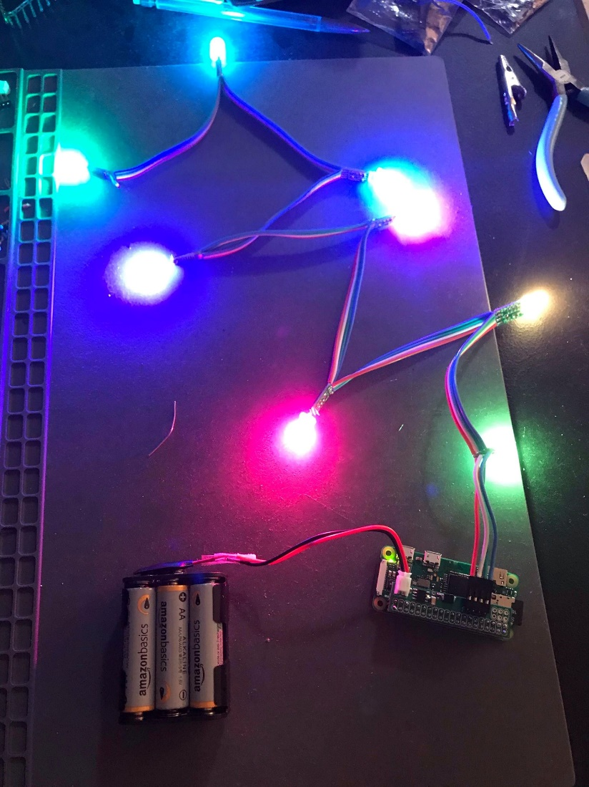

Raspberry Pi powered by batteries and wireless communicating with a master to control the LEDs.

What I couldn’t accomplish:

* I was not able to solder all 4 of the PCBs because of time constraints.
* I did not write drivers to control the addressable RGB LEDs because the sample code we are using provides functions that are easy enough to use and does everything we need.
* I was not able to assemble the graduation hats out of cardboard because of time constraints. However, this isn’t a major priority for our team since we want to make sure the software works first.

Goals for next week:

* Finish soldering the last PCB.
* Begin writing code for orientation detection with the IMU, LED color pattern should be able to “rotate” depending on the orientation of the raspberry pi.
* Help my team members with client/server side code.