Deliverable 1:

[a]

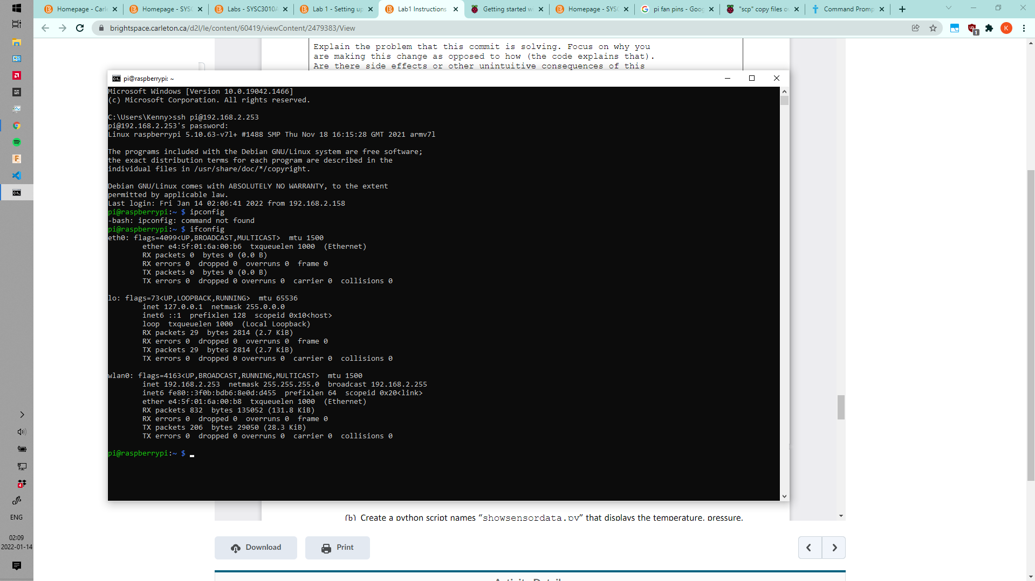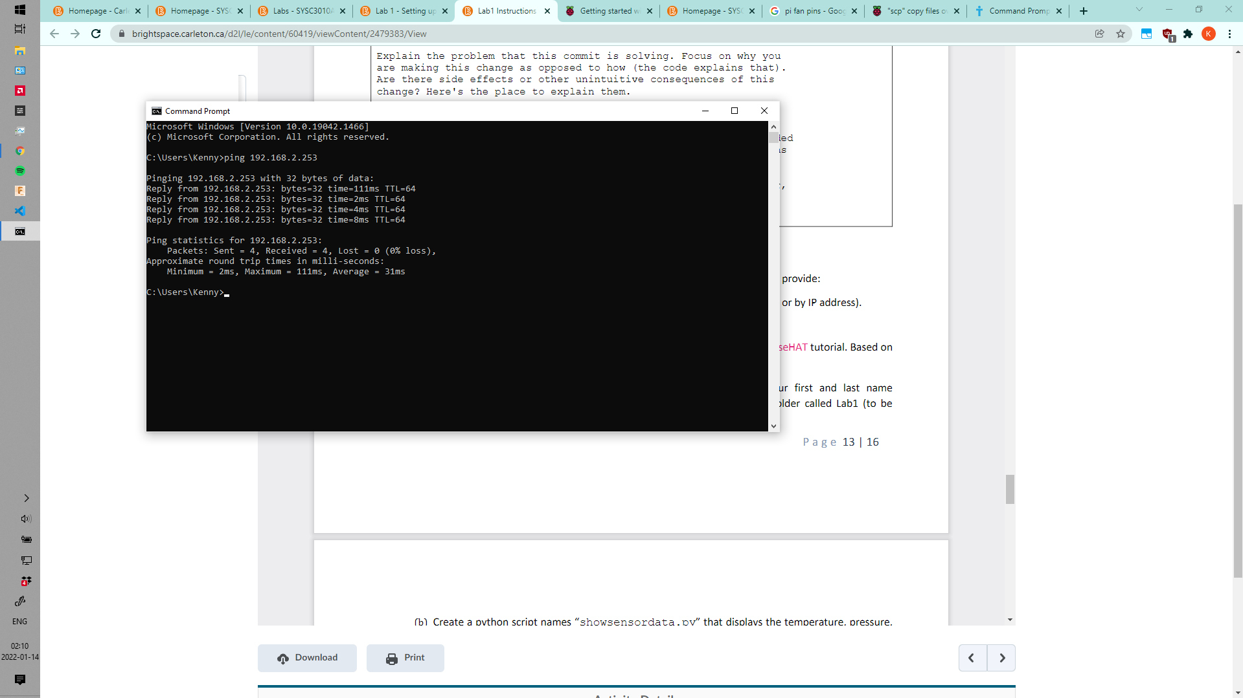

[b]

192.168.2.253 (shown in previous screenshot in 1a)