Introduction to Aspect-Oriented Programming
Objectives
Key objectives of this chapter:
- What is AOP?
- Cross-cutting concerns
- Proxy objects
- Implementing @Aspects
- Pointcuts

  - What is AOP?
- Aspect-oriented programming (AOP) allows you to define common code in a single place and apply it to multiple places within your codebase.
- AOP allows you to deal with cross-cutting concerns without duplicating code or violating the single responsibility principle.

What is AOP?
Aspect-oriented programming is a newer programming paradigm. It allows better code reuse and cleaner separation of concerns. Specifically, business logic and infrastructural logic (transaction management, logging, security, etc) can be kept separate, making code easier to maintain and understand.

  - Cross-Cutting Concerns
- Examples of cross-cutting concerns include logging, transactions, security, exception handling and resource setup/teardown logic.
- The logic is often simple, but required in many different places in the codebase.
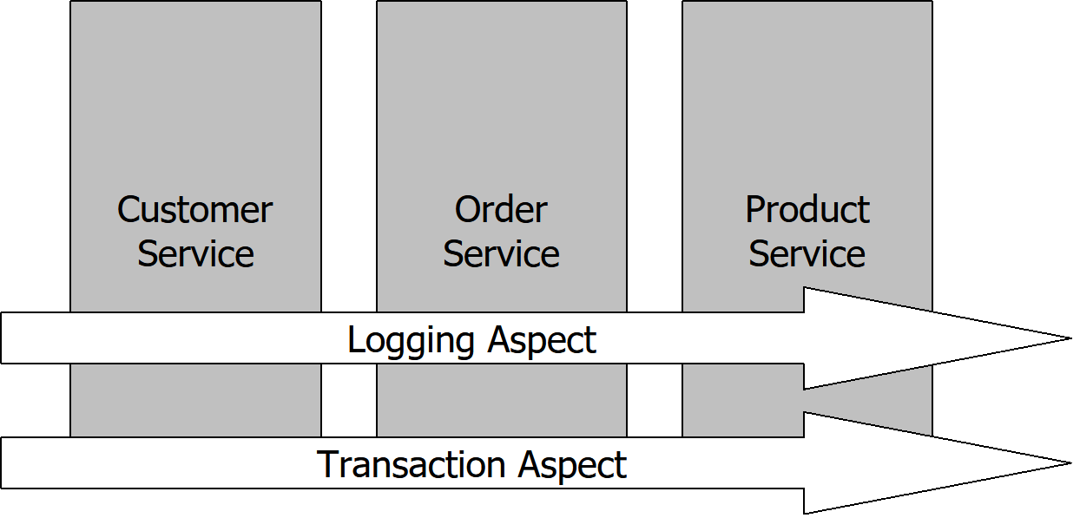
Cross-Cutting Concerns
Three business service objects all require common logging and transaction infrastructural services. One approach to providing these infrastructural services (cross-cutting concerns) is to use inheritance. Each of the business services could extend a base class that provides the services. However, this couples the infrastructure services into the business hierarchy, reduces the reusability of the infrastructure services for other hierarchies and results in an inflexible inheritance tree.
Delegation is another commonly used approach but this leads to redundant calls throughout the business services.
AOP allows you to define the common infrastructural services in separate objects and have them applied to the business services sometime after design time (i.e. compile-time or run-time). This frees the application developer from having to worry about mixing business and infrastructural logic.

  - Cross-Cutting Concern Example
- Consider the following business requirement:

record the user’s name, date/time, and activity
any time a modification is made to any table.

- “any time” – Indicates this requirement may be a cross-cutting concern; logic is needed in many places.
- “record the user’s name ...” - Describes WHAT we want to do.
- “any time a modification …” - Describes WHERE we need to do it.

  - AOP Terminology
- There are several AOP concepts to understand:
  - Joinpoint – Point in the code where logic can be introduced, i.e. method calls, exceptions thrown, etc.
  - Advice – Code describing WHAT to do.
  - Pointcut – Describes WHERE to apply Advice. Describes joinpoints of interest.
  - Aspect – Object combining Advice (what to do) and Pointcut (where to do it)
  - Weaving – Technique for applying Aspects to existing classes
  - Target – Class that has advice applied to it
  - Proxy – Object which weaves the Aspect into calls to Target methods.
AOP Concepts
AOP comes with its own lingo that you need to be familiar with. Some of the terms can be confusing at first so spend some time up front to understand them and refer back to this slide as needed during this chapter.
An aspect is the feature or cross-cutting concern that you are addressing such as logging.
Advice is the actual implementation (i.e. the code) that will be applied to address the aspect.
A joinpoint is a point in the code or execution where advice can be applied. Joinpoints in some AOP implementations can be method calls, points where fields are modified and points where exceptions are thrown. Spring supports method calls and exceptions.
Pointcuts are descriptions of joinpoints that should have advice applied to them. This is often done by matching class names or method names, either explicitly or with a partial matching mechanism like a regular expression.
A target object is the object being advised whereas a proxy object is the target plus the advice.

  - AOP in Spring
- There are several different implementations of AOP for Java
  - E.g. AspectJ, AspectWerkz, Spring AOP, etc
- Spring AOP is a pragmatic AOP implementation focusing on developer productivity rather than exhaustive implementation of AOP capabilities.
  - Spring defines Aspects as Spring beans. Advice is defined as methods within these beans. Pointcuts are described with annotations.
  - Spring uses proxy objects to weave Aspects into the @Beans
  - Spring only supports method-based joinpoints (i.e. method is called, method returns, etc.)
AOP in Spring
The creators of the Spring framework didn’t set out with the goal of providing the most complete AOP implementation. Rather, their goal was to provide an implementation that worked well with IoC and addressed common challenges in enterprise programming. As a result, you will find that Spring AOP is not as sophisticated as some other AOP technologies such as AspectJ.
AOP in Spring is implemented using Java. Some other AOP technologies use special languages to implement AOP. Although these languages provide more flexibility, they are more difficult to use because developers have to learn a new language.
Spring advice is provided at runtime rather than at compile time. This makes it simpler for developers since they do not need to take additional steps or use additional compilers at build time.
Spring uses one of two techniques to generate proxies. The preferred method is to use the java.lang.reflect.Proxy class to generate AOP proxies based on interfaces used by the target.
If the target does not implement interfaces, Spring can use the CGLIB library to generate a subclass of the target. Final methods on the target cannot be advised using this approach. It also requires an additional library in order to work. See http://cglib.sourceforge.net for more information about CGLIB.
Some AOP implementations support field joinpoints but Spring does not. This tends to violate encapsulation and usually isn’t required.

  - Understanding Proxy Objects
- A proxy object is an intermediary or surrogate object that stands in place of another object (Target).
  - Calls to the target object are routed through the proxy.
  - The proxy can add additional behaviors (Aspects) when the target’s methods are called.
  - Proxies are transparent to the target object.
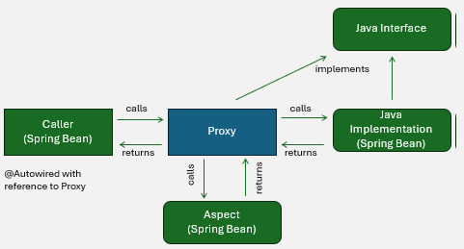
Spring proxy-based weaving
When coding to interfaces, the Caller is @Autowired with a reference to a Spring-generated proxy object, which implements the same interface as the implementation class. Calls to the @Autowired reference are really calls to the proxy which “weaves” the Aspect’s advice logic before and after calls to target methods.
Spring uses one of two techniques to generate proxies. The default approach is to use the java.lang.reflect.Proxy class to generate AOP proxies based on interfaces used by the target.
If the target does not implement interfaces, Spring falls back to CGLib proxies (next).
Some AOP implementations support field joinpoints but Spring does not.

  - CGLib Proxies
- When a target object does not implement any Java interfaces, Spring generates a CGLib subclass-based proxy
  - CGLib – Code Generation Library.
  - Final methods not supported.
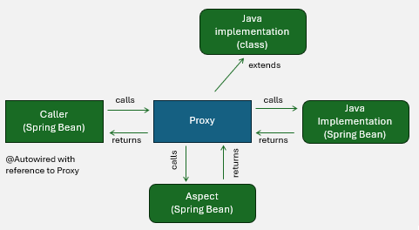

Spring proxy-based weaving
If the target does not implement interfaces, Spring uses the CGLIB library to generate a subclass of the target. Final methods on the target cannot be advised using this approach. The CGLib classes are included within the Spring JARs.
In this case, the Caller is @Autowired with a reference to a Spring-generated proxy object, which extends the implementation class. Calls to the @Autowired reference are really calls to the proxy which “weaves” the Aspect’s advice logic before and after calls to target methods.

  - AOP Example
- Imagine we wish to log a message any time a find*() method is called.
- Create a @Component annotated with @Aspect
  - ...or create it using @Bean.
- Define an advice method annotated with a Pointcut annotation like @Before.
  - (Pointcut syntax will be explained in a moment.)

@Component
@Aspect
public class LoggingAspect ... {

@Before("execution(* find*(..))")
public void myAdviceMethod() {
System.out.println("Find method called");
}
}

  - Result: Any call to any find*() method in any Spring bean will result in “Find method called” printed to the console.

.

  - Enabling Spring AOP
- To enable Spring AOP, add @EnableAspectJAutoProxy to your configuration class:
@Configuration
@EnableAspectJAutoProxy
@ComponentScan(...)
public class Config {
}

  - Five Advice Types
- Spring supports five types of advice, indicated by annotations on the advice method:
Annotation | Description | Use Cases
@Before | Advice method executes before the target method | Security checks, tracing
@AfterReturning | Advice method executes after the target method returns normally | Filtering, obfuscating sensitive data
@AfterThrowing | Advice method executes after the target method throws an Exception | Exception handling
@After | Advice method executes after the target method returns (finally) | Auditing, tracing
@Around | Proxy performs logic before and after it calls the target method | Performance monitoring, caching, transactions

  - Pointcut Syntax
- Spring uses AspectJ’s pointcut syntax – purpose built for defining joinpoints such as method invocations.

execution(modifier? ret-type declaring-type?name(params) throws?)

- execution – describes a method execution
- modifier – (optional) the method’s modifier, such as public or an annotation. (Usually omitted.)
- ret-type – Return type of the method, such as String or void. Use * for any return type.
- declaring-type – (optional) package and classname, such as com.example.service.CustomerService. May contain wildcards such as com.example.service.*Service.
- name – Method name, such as find* or *update.
- params - Parameter list. Parameters must be fully qualified except for well-known types like String. * indicates a single parameter, any type. “..” indicates any number of parameters (zero, one, or many).
- throws – (optional) expected Exceptions clause.

  - Pointcut Examples
- execution(* set*(..))
  - Match any method starting with “set”, taking any number of parameters, returning anything.
- execution(String com.example.CustomerService.*(..))
  - Match any method in the CustomerService class (or interface) taking any parameters and returning String.
- execution(void com.example.service.*.update*(*))
  - Match any method starting with “update” in the service package taking a single parameter of any type, returning void.
- execution(* update*(.., com.example.CreditCard,..))
  - Match any method starting with “update” that takes a parameter of type CreditCard as one of its parameters.
- execution(@com.example.Sensitive * *(..))
  - Match any method annotated with @Sensitive.

  - @Before Example
- The following example prevents non-administrators from executing any update method.
@Before("execution(* update*(..))")
public void advice() {

ThreadLocal<SecurityContext> holder
= new ThreadLocal<>();

if(!holder.get().isAdministrator()) {
throw new SecurityException("Unauthorized.");
}
}

  - ThreadLocal Java objects pass data, such as this “SecurityContext” in the current thread.
  - An Exception thrown in the @Before advice method prevents the target method from executing.

  - @AfterReturning Example
- The following example displays a message after a property has changed
  - JoinPoint provides information about the point of execution
  - Only executes if target method does not throw an Exception. Use @AfterThrowing to catch Exceptions.
@AfterReturning("execution(void set*(*))")
public void advice(JoinPoint jp) {
String property = jp.getSignature().getName();
Object value = jp.getArgs()[0];
String target = jp.getTarget();
System.out.println(
target + "." + property + " is now " + value
);
}

  - @Around Example
- The following example displays the elapsed time of any @Stopwatch method.
  - ProceedingJoinPoint extends JoinPoint. The proceed() method calls the target method.

@Around("execution(@com.example.Stopwatch * *(..))")
public Object advice(ProceedingJoinPoint point) {
long start = System.currentTimeMillis(); // (1)
Object result = joinPoint.proceed(); // (2)
long end = System.currentTimeMillis(); // (3)
long elapsed = end - start;
System.out.println(
joinPoint.getSignature() +
" executed in " +
executionTime + "ms");
return result; // (4)
}

    - Runs before the target method.
    - Calls the target method.
    - Runs after the target method.
    - Critical! Target’s return value must be returned to caller.

  - Knowledge Check #1
- Which part of the following requirements statement describes a Pointcut:
Whenever PII is requested,
reject the request
if the principal is not an “ADMIN”.

1. Whenever
2. PII is requested
3. If the principal is not an “ADMIN”
4. Reject the request

  - Knowledge Check #1
- Which part of the following requirements statement describes a Pointcut:
Whenever PII is requested,
reject the request
if the principal is not an “ADMIN”.

1. Whenever
2. PII is requested
3. If the principal is not an “ADMIN”
4. Reject the request

Whenever - Sign that this may be a cross-cutting concern, and a good place to use AOP
PII is requested - Describes WHEN or WHERE to do something: Pointcut
Reject the request if the principal is not an “ADMIN” – Describes WHAT to do: Advice

  - Knowledge Check #1
- When will the following advice method execute?
@AfterReturning("execution(String EmailService.*(..))")
public void advice() {
}

1. After any EmailService method returning a String returns without throwing an Exception.
2. After a method named EmailService taking any parameters and returning String returns.
3. After any method taking any parameters and returning an EmailService returns without throwing an Exception
4. After any EmailService method taking a single parameter returns without throwing an Exception

  - Knowledge Check #1
- When will the following advice method execute?
@AfterReturning("execution(String EmailService.*(..))")
public void advice() {
}

1. After any EmailService method returning a String returns without throwing an Exception.
2. After a method named EmailService taking any parameters and returning String returns.
3. After any method taking any parameters and returning an EmailService returns without throwing an Exception
4. After any EmailService method taking a single parameter returns without throwing an Exception

AspectJ’s Pointcut syntax is:
execution(modifier? ret-type declaring-type?name(params) throws?)
The matching method has any number of parameters, can have any name, must be defined on the EmailService class, and must return a String. The @AfterReturning advice method is only executed when selected methods return without throwing an Exception.

  - Summary
- AOP is an approach to add functionality to application components without adding code directly to the class being affected
- The behavior being applied as an “Aspect” can be thought of as being merged with the “Target” of the AOP “Advice”
- Spring Supports five different advice types and AspectJ pointcut syntax.

