In the video at about 07:30, I ask a few practice questions about the mic preamp.

For reference, here’s the circuit fragment in question:

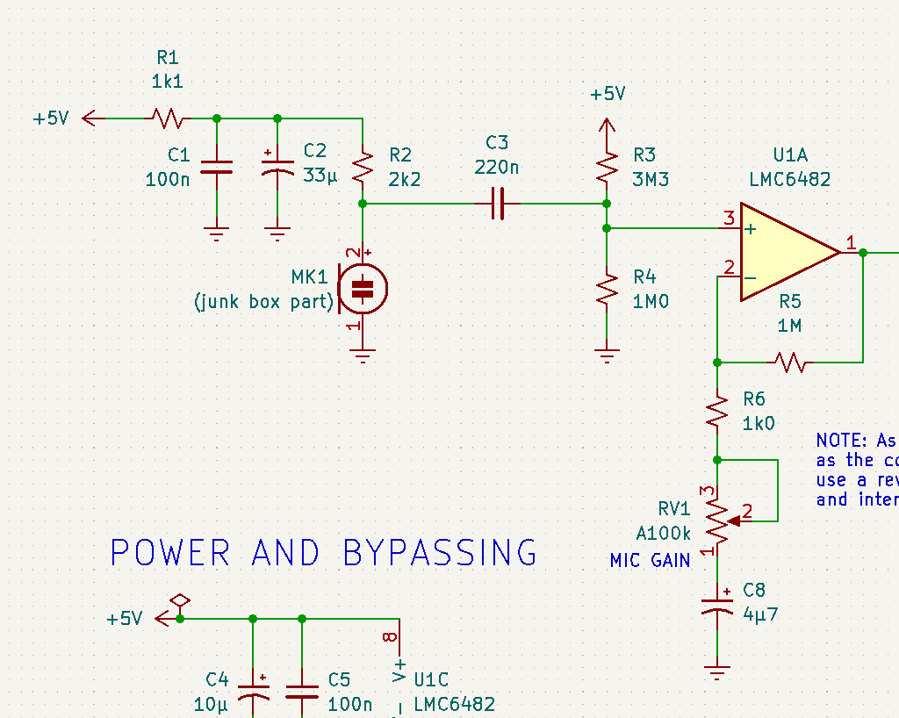

1. Is the input impedance high enough?

The capsule mic embeds a JFET common-source amplifier. The output impedance is just the value of the drain resistor, here 2.2 kΩ. The input impedance of the following stage at signal frequencies will be 3.3 MΩ im parallel with 1.0 MΩ, because C3 will look like a short circuit. We can ignore the input impedance of the op-amp, it’s effectively infinite here. That says the input impedance of the following stage is about 767 kΩ, hundreds of times the source impedance. We will lose only a fraction of 1% of the input voltage.

2. What is the corner frequency of the high-pass filter?
It’s just 1/[2π(R₃||R₄)C₃] or about 0.95 Hz.

3. Will the input RC network appreciably degrade the audio?

The corner frequency of the high-pass filter is more than a factor of 20 below the lowest frequency of interest (assuming that audio is 20-20000 Hz). The input impedance of the network is hundreds of times the impedance of the source feeding it. There should be negligible change to the signal.

We should also make sure that the high-pass filter in the feedback loop also won’t distort the audio. The worst case there is that the corner frequency will be 1/[2π(R₅+R₆)C₈] – about 35 millihertz. Clearly, I could have used a much smaller cap for C8! But I confess that I didn’t bother calculating, I just said, “this is clearly enough capacitance” and stuck it in. I don’t like using ceramic caps (other than NP0/C0G, which don’t come bigger than a nF or so) in the audio path, and the little electolytic was mechanically smaller than the polyester 0.27 µF one that I’d replace it with. Sometimes it doesn’t do to overthink things.

