Event Monitor

Recording Instructions:
- When you experience a symptom press the < or > button for ONE (1) SECOND then release.
- Keep nice and still for 5 seconds but make sure you keep breathing.
- The LCD will now show an event has been stored.
- Record in your diary the date, time, activity and what symptoms you felt.

*Remember – AUTOMATIC recordings can happen.

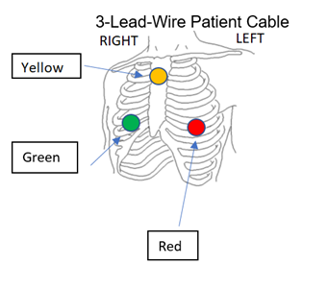

If you have any questions you can contact us at:
Burnaby Hospital Cardiology Department
(604) 431-2892

Monday – Friday 8:00 – 15:00 (Except holidays).

Patient Label

Return Date:

# | Date | Time | Symptom | Activity
 |  |  | Baseline
1
2
3
4
5
6
7
8
9
10
Event Monitor

Recording Instructions:
- When you experience a symptom press the < or > button for ONE (1) SECOND then release.
- Keep nice and still for 5 seconds, but make sure you keep breathing.
- The LCD will now show an event has been stored.
- Record in your diary the date, time, activity and what symptoms you felt.

*** Remember***
AUTOMATIC recordings can happen.

If you have any questions you can contact us at:
(604) 431 2892

Monday – Friday 8:00 – 15:00 (Except holidays).
**** DO NOT GET IT WET ****
Make sure you remove the device before showering/bathing or swimming.

Patient Operating Instructions
Skin Preparation Steps:
- Select an area of skin on the:
Upper MIDDLE side of your chest for the YELLOW lead, Lower rib on your LEFT side for the RED lead, and Lower rib on your RIGHT side for the GREEN lead.
- Use an alcohol wipe to clean the areas
- Use dry gauze to dry the areas.
- Using the skin tape lightly scratch areas selected twice.
- Attach the round electrodes on to the YELLOW, RED, and GREEN leads
- Place the YELLOW lead on your upper MIDDLE area, place the RED lead on your lower LEFT side rib area, and place the GREEN lead on your lower RIGHT side rib area.
Each Day:
- Remove electrodes and put new ones on.
- Place in a different area to avoid sores developing.

