NC State University
Department of Electrical and Computer Engineering
ECE 463/563: Fall 2017
Project #3: Dynamic Instruction Scheduling

by

<< KENNY KADAYIL PAUL>>

NCSU Honor Pledge: "I have neither given nor received unauthorized aid on this test or assignment."

Student’s electronic signature: KENNY KADAYIL PAUL
(sign by typing your name)

Course number: 563
(463 or 563 ?)

Graphs for gcc_trace_mem
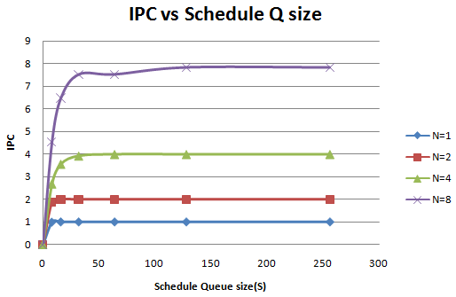
Issue Rate(s) | Scheduling Queue Size(n) | IPC
1 | 8 | 0.99
1 | 16 | 1
1 | 32 | 1
1 | 64 | 1
1 | 128 | 1
1 | 256 | 1
2 | 8 | 1.88
2 | 16 | 1.99
2 | 32 | 1.99
2 | 64 | 1.99
2 | 128 | 1.99
2 | 256 | 1.99
4 | 8 | 2.67
4 | 16 | 3.54
4 | 32 | 3.9
4 | 64 | 3.97
4 | 128 | 3.97
4 | 256 | 3.97
8 | 8 | 4.54
8 | 16 | 6.48
8 | 32 | 7.52
8 | 64 | 7.52
8 | 128 | 7.83
8 | 256 | 7.83

Graphs for perl_trace_mem
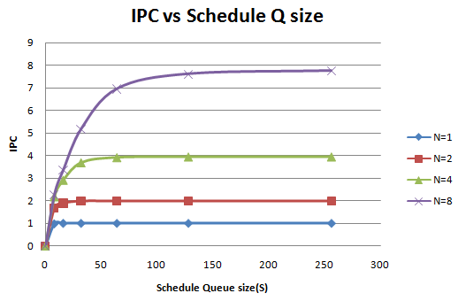
Issue Rate(s) | Scheduling Queue Size(n) | IPC
1 | 8 | 0.98
1 | 16 | 1
1 | 32 | 1
1 | 64 | 1
1 | 128 | 1
1 | 256 | 1
2 | 8 | 1.68
2 | 16 | 1.89
2 | 32 | 1.98
2 | 64 | 1.98
2 | 128 | 1.98
2 | 256 | 1.98
4 | 8 | 2.18
4 | 16 | 2.91
4 | 32 | 3.68
4 | 64 | 3.91
4 | 128 | 3.94
4 | 256 | 3.94
8 | 8 | 2.28
8 | 16 | 3.37
8 | 32 | 5.18
8 | 64 | 6.95
8 | 128 | 7.61
8 | 256 | 7.75

Notable Trends on the Graphs

- For a particular value of Fetch/Dispatch/Issue Queue size(N), as the size of reservation stations increase, the Instructions that can be executed per cycle(IPC) also increases. The first reason for this is that when S < N, in each cycle some of the units in the N execution blocks remains unutilized, which implies out of the N fetched instructions some does not get executed and the IPC reduces. The second case arises when S ≥ N where even if ideally we can launch N instructions into the execution state we are unable to achieve N IPC due to the data dependency among the instructions that are present in the reservation station.
- For each value of N, the maximum achievable value of IPC is also N. This is because in each cycle N instructions are fetched and the ideal case will be these fetched instructions takes the same duration to get executed and N instructions completes.
- As the reservation station size(S) increases, the IPC tends to approach the maximum achievable value of IPC. This is due to the fact that as the reservation station size increases, more and more instructions get their data dependency resolved in the same cycle.
- Beyond a certain value of S, the IPC saturates and gives diminishing returns. This is due to the reason that some instructions consume the execution units for greater clock cycles than others and there will be some instructions in the reservation station which has data dependency on some instruction in the execution queue. In this case the schedule queue gets filled up as N instructions enters the schedule queue bucket and some instructions remains there waiting for the data dependency to get resolved filling up the all the reservation station spots. Once these stations gets filled, no more instructions are added to issue queue and we get less than N instructions fetched per clock cycle. Thus the overall IPC reduces.
- The difference between the IPC obtained for a particular value of S and the maximum attainable IPC value increases as N increases. This is due to the fact that as N increases, the schedule queue gets filled fast and as mentioned in the previous point, this reduces the overall IPC.
- When the value of N is 1, an out of order superscalar processor behaves just like an in order processor with IPC also equal to one.

Comparison for the two trace files

The maximum IPC obtained for gcc trace file is 7.83
The maximum IPC obtained for perl trace file is 7.75

This shows that data dependency for the gcc trace might be less compared to the perl trace and the algorithm is able to exploit the parallelizing the independent instructions more in the gcc trace.

The difference between the maximum attainable IPC and the IPC for a particular value of S/N is more for perl trace than in gcc trace. This implies that the perl trace has more data dependency that is more widely spread from the dependent instruction than the gcc trace. Thus the reservation station gets filled up fast with these dependent instructions reducing the overall IPC

