Reactive Extensions

This document covers

Introduction

Scheduling

Implementing Observable

Hot and Cold Observables

Creating Sequences

Reducing Sequences

Examining Sequences

Aggregating Sequences

Partitioning Sequences

Transforming Sequences

Composing Sequences

Time Shifting Sequences

Testing RX

## Introduction

The Reactive Extensions API defines a framework for managing and co-ordinating asynchronous streams of data events. Because the elements of the stream are delivered as and when they are ready, Rx is ideal for modelling infinite streams of data. The Rx framework provides a set of operators for filtering, combining and transforming data streams.

Unlike LINQ which is a pull-based API, Reactive Extensions for .NET works with push-based sources. The core interface to an event source is IObservable<T> and the RX operators work on instances of this type in the same way LINQ operators work on instances of IEnumerable<T>

Listing 1 IObserver<T> and IObservable<T>

public interface IObserver<in T>

{

void OnNext(T value);

void OnError(T value);

void OnCompleted();

}

public interface IObservable<out T>

{

IDisposable Subscribe(IObserver<T> observer);

}

### A Simple IObservable<T> Implementation

Listing 2 SimpleObservable<T>

public class SimpleObservable<T> : IObservable<T>

{

➊ public IDisposable Subscribe(IObserver<T> observer)

{

Console.WriteLine($"Subscribe”);

_observers.Add(observer);

return new ActionDisposable(() =>

{

Console.WriteLine($"Dispose”);

_observers.Remove(observer);

});

}

➋ public void Publish(T val)

{

foreach (var observer in _observers)

{

observer.OnNext(val);

}

}

private readonly List<IObserver<T>>

_observers = new List<IObserver<T>>();

}

When clients invoke Subscribe ➊ we add the given IObserver to our list. We also define a Publish ➋ method (not part of IObservable<T>) which iterates the list and invokes OnNext on each subscribed observer. We use a special implementation of IDisposable that takes an Action in its constructor and invokes this action when its Dispose method is invoked.

### Basic Lifecycle

// (1) Create an instance of an Observable

SimpleObservable<int> observable = new SimpleObservable<int>();

// (2) Create an instance of an IObserver

IObserver<int> observer = new SimpleObserver<int>();

// (3) Subscribe the observer to the observable

IDisposable disposable = observable.Subscribe(observer);

// (4) Observerable delivers some events

observable.Publish(1);

observable.Publish(2);

// (5) After disposal the Observer no longer delivers

// events to the disposed observer

disposable.Dispose();

observable.Publish(3);

### Delegate Based Observers

We rarely ever explicitly implement IObserver<T> because the Reactive Framework combines a delegate-based implementation of IObserver with extension methods that enable us to subscribe for updates using delegates and lambdas. If the framework didn’t already do it for us we could do this ourselves as follows.

Listing 3 Delegate Based Observer

public class DelegateBasedObserver<T> : IObserver<T>

{

public DelegateBasedObserver(Action<T> nextAction)

{

_nextAction = nextAction;

}

public DelegateBasedObserver(Action<T> nextAction,

Action completedAction) : this(nextAction)

{

_completedAction = completedAction;

}

public DelegateBasedObserver(Action<T> nextAction,

Action<Exception> exceptAction, Action completedAction) :

this(nextAction, completedAction)

{

_exceptAction = exceptAction;

}

public void OnNext(T value)

{

_nextAction?.Invoke(value);

}

public void OnError(Exception error)

{

_exceptAction?.Invoke(error);

}

public void OnCompleted()

{

_completedAction?.Invoke();

}

private readonly Action<T> _nextAction;

private readonly Action _completedAction;

private readonly Action<Exception> _exceptAction;

}

Now we need to write a static extension method that takes an instance of IObservable<T> and an Action. The extension method then creates an instance of our DelegateBasedObserver type and subscribes it to updates from the observable.

Listing 4 Subscribe Extension Method

public static class MyObservable

{

public static IDisposable Subscribe<T>(this IObservable<T> obs,

Action<T> action)

{

return obs.Subscribe(new DelegateBasedObserver<T>(action));

}

}

We can then subscribe for notification by passing in a delegate as follows

Listing 5 Subscribing using delegates

SimpleObservable<int> observable = new SimpleObservable<int>();

observable.Subscribe( i => Console.WriteLine(i));

observable.Publish(5);

Questions - Introduction

What is the Reactive Extensions API?

*A framework for managing and co-ordinating asynchronous streams of data events*

What is RX ideal for?

Managing infinite streams of data

Why?

The events are delivered as and when they are ready

What does RX provide?

A set of operators for filtering, transforming and combining data streams

What are the benefits of RX?

Data can be buffered, throttled, and delayed as needed.

Compare Rx to LINQ?

Whereas LINQ is a pull-based API, RX is a push-based API

What are the core interfaces of RX?

IObservable<T> and IObserver<T>

What are the LINQ based equivalents of these interfaces?

IObservable<T> is Rx equivalent of IEnumerable<T>

IObserver<T> is the Rx equivalent of IEnumerator<T>

Why is it unlikely we will ever explicitly implement IObserver<T>?

*RX combines a delegate-based implementation of IObserver with extension methods that enable us to subscribe for updates using delegates and lambdas*

What is the single method of IObservable<T>?

IDisposable Subscribe(IObserver<T>)

What are the three method of IObserver<T>

Void OnNext(T)

Void OnError(Exception)

Void OnCompleted()

What is the implicit contract a stream should obey?

1. An Observable delivers 0..N items via OnNext followed by either OnError or OnCompleted
2. Rx calls cannot interleave form a single source. The source must wait for any methods it invokes to complete before invoking the net one

What are the two ways a sequence can be terminated?

By calling OnCompleted or OnError

What are the advantages of Rx versus events?

1. Rx sources are first class objects and can be passed as arguments to methods and stored in fields and properties
2. An event sources items are delivered in a well-defined order in the presence of multiple threads
3. Well defined mechanism for delivering errors
4. Well defined mechanism for notifying the end of the sequence

What are the difficulties of implementing IObservable<T>

A source needs to play nicely with RX Schedulers and multi-threaded scenarios.

What is the preferred way of creating observables?

Using Observable.Create

What does Observable.Create do?

We pass it a factory method and it creates a returns an instance of AnonymousObservable

When we invoke subscribe on AnonymousObservable it creates an AutoDetachObserver that decorates our observer

The AutoDetachObserver is then passed to our factory method.

AutoDetachObserver does not process items once disposed

What are the advantages of using Observable.Create to create sources?

Deals with stopping sending messages to disposed subscribers so you don’t have to.

How does one define a reactive scheduler?

Implement IScheduler

How does one unsubscribe from an observable?

Subscribe returns an instance of IDisposable

Calling dispose on it unsubscribes

Why was it done like this?

Language support via using

Why should one always dispose subscriptions?

The IDisposable an observable returns will not have a finalizer and so if you never dispose it you can create memory leaks

What is the exception?

## Scheduling

### Default Scheduling

// 1. Create the observable

var observable = new SimpleObservable<int>();

// 2. Create the observer

IObserver<int> observer = new SimpleObserver<int>();

// 3. Register the observer with the observable

var disposable = observable.Subscribe(observer);

// 4. Publish a value

observable.Publish(1);

// 5. Dispose the observer

disposable.Dispose();

### Schedulers

The core interface we must implement if we want to define a reactive scheduler is IScheduler. The following code shows how to specify the scheduler on which OnNext methods are invoked. We can create our own very simple Scheduler in

Listing 6 Custom Scheduler. We can then instruct our code to observe or subscribe on this custom scheduler.

Listing 6 Custom Scheduler



### Explicit Subscription

Listing 7 Explicit Subscription scheduling

// 1. Log out the calling thread

"ExplicitMultiThreadedSubsciption".Log();

Console.WriteLine("Current Thread {0}", Thread.CurrentThread.ManagedThreadId);

// 2. Create a scheduler with its own thread

IScheduler scheduler = new SingleThreadedScheduler("KennyScheduler");

// 3. Create the observable

var observable = new SimpleObservable<int>();

// 4. Create the observer

IObserver<int> observer = new SimpleObserver<int>();

// 5. Register the observer with the observable

var disposable = observable.SubscribeOn(scheduler).Subscribe(observer);

// Make sure the publish does not happen before the subscription as

// subscription is running on a separate thread

Thread.Sleep(100);

// 6. Publish a value

observable.Publish(1);

// 7. Dispose the observer

disposable.Dispose();

Listing 8 Output

ExplicitMultiThreadedSubsciption - Thread Main Query Thread 11

Current Thread 11

Subscribe on Thread "KennyScheduler:17"

OnNext(1) thread Main Query Thread:11

Dispose on Thread KennyScheduler:17

### Explicit Observation

Listing 9 Explicit Observation

// 1. Log out the calling thread

"ExplicitMultiThreadedObservation".Log();

// 2. Create a scheduler with its own thread and a

// wait handle to prevent premature completion

IScheduler scheduler = new SingleThreadedScheduler("KennysScheduler");

AutoResetEvent handle = new AutoResetEvent(false);

// 3. Create observable tell it we want to observer

// on our explicit scheduler

var observable = new SimpleObservable<int>();

var disposable = observable

.ObserveOn(scheduler)

.Subscribe(i => i.ToString().Log(), () => handle.Set());

// 4. Publish 2 messages and then complete

observable.Publish(1);

observable.Publish(2);

observable.Complete();

handle.WaitOne();

disposable.Dispose();

Listing 10 Output

ExplicitMultiThreadedObservation - Thread Main Query Thread 10  
Subscribe on Thread "Main Query Thread:10"  
1 - Thread KennysScheduler 11  
2 - Thread KennysScheduler 11  
Dispose on Thread KennysScheduler:11

Questions - Scheduling

What is the core interface we must implement to create a custom scheduler in Rx?

IScheduler

What are the schedulers that come with RX?

EventLoopScheduler Allows user to specify a specific thread for the scheduler

Scheduler.Default Scheduler work on platforms default scheduler (ThreadPool?)

DispatcherScheduler Actions marshalled to Dispatchers BeginInvoke

Scheduler.Immediate Single Threaded scheduler which executes immediately

Scheduler.Current Single Threaded using a message queue

How can we use difference schedulers?

Use the ObserveOn, SubscribeOn and overloads of other methods

What is the difference between Scheduler.Current and Scheduler.Immediate?

Both execute on the current thread. Current places the action on a queue and it executes once the current action is complete. Immediate executes it in line in the current action

What is Scheduler.Default?

Platform default scheduler. Probably the thread pool

How does one scheduler on the UI thread?

DispatcherScheduler

How does one specify a specific thread ?

EventLoopScheduler

## Implementing Observable

Although the IObservable<T> looks simple, a full compliant implementation is actually rather tricky. It has to handle disposals and work correctly in multithreaded scenarios introduced by different schedulers. Consider the following implementations of IObservable and IObserver

Listing Implementing IObservable



We then write code to subscribe an instance of MyObserver to MyObservable. Finally, we publish a value from MyObservable, dispose the observer and publish another value through the MyObservable.



As we might expect disposing the observable has no effect as our MyObservable returns an empty disposable from its Subscribe method. It has no logic to do the unsubscription.

The output from our code becomes

1

2

This highlights the first implicit behaviour we need to support when creating RX sources, namely unsubscribing observers when they are disposed.

### Observable.Create

We can fix the code from the previous section such that it stops delivering events to IObserver instances that have been unsubscribed by using the static Observable.Create method.



Now the output from running this code is what we want. The first publish causes the observer to write 1 to the console but the second publish after the dispose call is suppressed.

1

What happens here is that when we call Observable.Create it creates an instance of a framework type called AnonymousObservable which stores a reference to the factory method we pass into it.

Listing 12 AnonymousObservable

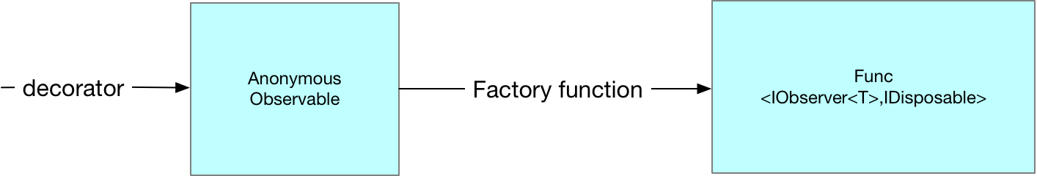

Then when we call Subscribe on our observable and pass in our MyObserver instance we are actually calling Subscribe on the AnonymousObservable instance. This is turn creates an instance of a type called AutoDetachObserver which it gives to the factory method we passed into Observable.Create. The AutoDetachObserver holds a reference to our actual MyObserver creating an extra layer of indirection.

Listing 13 AutoDetachObserver

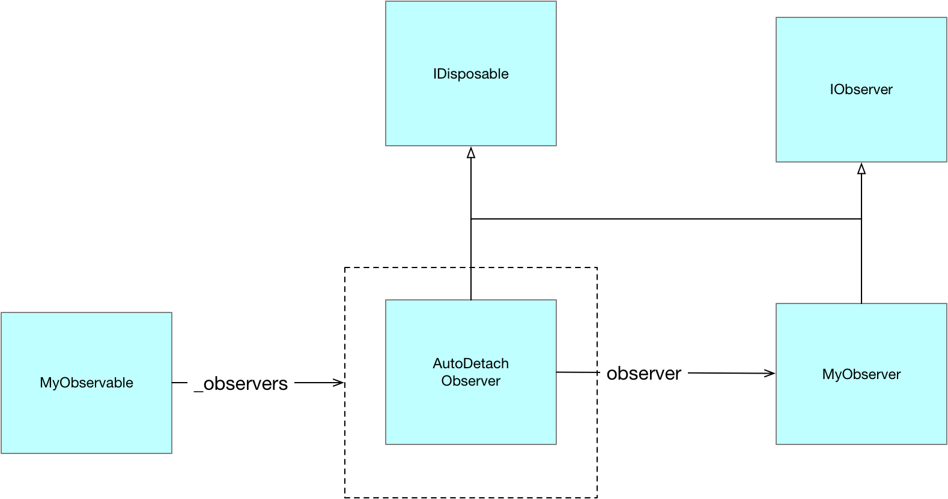

Notice how the AutoDetachObserver implement IDisposable. It is the AutoDetachObserver which is returned to the client when it invokes subscribe on the instance of Anonymous Observer. This enables the AutoDetachObserver to stop delivering updates to the MyObserver after dispose has been invoked on it.

Observable.Create is the prefered means of creating observable sequences as internally it has been carefully coded to ensure correct order of subscriptions and notification in multi threaded scenarios

Questions – Implementing Observable

What is implementing IObservable<T> tricky?

It has to handle disposals and work correctly in multithreaded scenarios introduced by different schedulers

What is the recommended way of creating Observables?

Using the Observable.Create factory method

What does this method do?

Creates an instance of AnonymousObservable whose subscribe method delegates to the given factory method. AnonymousObservable wraps any observers in AutoDetachObserver enabling it to avoid deliverable events to disposed subscriptions.

## Hot and Cold Observables

Rx makes the distinction between hot and cold observables. A cold observable only ever produces values at the point an observer subscribes, and each subscriber is given its own set of data. A subscriber can never miss out on data by subscribing late. A hot observable on the other hand is always producing data irrespective of whether any observers are subscribed. With a hot observable a subscriber can miss out on earlier values if it subscribes late. We consider cold and hot observables in turn.

### Cold Observable

The basic characteristic of a cold observable is that nothing is done until a subscription is made and each subscription gets different values

Listing 14 Basic Cold Observable

// We use a factory method together with Observable.Create to create

// an IObservable which delivers completely different values to each

// Subscription. This is the basic property of a ColdObservable.

// Nothing is delivered util a subscription is made and each

// subscription gets a different value.

int x = 0;

// Define a factory method that when invoked directly calls OnNext

IDisposable FactMeth(IObserver<int> observer)

{

observer.OnNext(x++);

return Disposable.Empty;

}

// Use Observable.Create to turn our factory method into an IObservable

var observable = Observable.Create((Func<IObserver<int>, IDisposable>)FactMeth);

// Perform two different subscriptions. Each IOBserver

// get different values to the nature of a cold observable

observable.Subscribe(i => Console.WriteLine($"A {i}"));

observable.Subscribe(i => Console.WriteLine($"B {i}"));

Listing 15 Basic Cold Observable Output

A 0  
B 1

### Connectable Observable

Listing 16 Connectable Observable

// As per the previous sample we use a factory method together

// with Observable.Create to create an IObservable which delivers

// completely different values from each subscription. The key

// difference is that we wrap this Observable

// with a ConnectableObservable

// using the Publish extension method. This extra layer allows us to

// share the values published from the originating Observable as the

// Connectable wrapper performs the multiplexing

int x = 0;

// Define a factory method that when invoked directly calls OnNext

IDisposable FactMethod(IObserver<int> observer)

{

observer.OnNext(x++);

return Disposable.Empty;

}

// Use the Observable.Create to turn our factory method into an IObservable

IObservable<int> observable = Observable.Create((Func<IObserver<int>, IDisposable>)FactMethod);

// Wrap the source Observable in a Connectable observable

IConnectableObservable<int> connectableObservable = observable.Publish();

// Even though we subscribe twice the connectable observable

// will make sure

// there is only one underlying Observable

// with the ConnectableObservable

// providing multi-plexing

connectableObservable.Subscribe(i => Console.WriteLine($"A {i}"));

connectableObservable.Subscribe(i => Console.WriteLine($"B {i}"));

// The subscription is now carried out and multiplexed out to the

// registered observers

connectableObservable.Connect();

Listing 17 Connectable Observale Output

A 0  
B 0

### Hot Observable

Listing 18 Hot Observable

// In this example we wrap our observable in a ConnectableObservable

// and connect it before we make any subscriptions. By doing this we are

// creating what is known as a Hot Observable. This Observable is still

// publishing values even though it has no subscriptions.

SimpleObservable<int> sourceObservable = new SimpleObservable<int>();

IConnectableObservable<int> hotObservable = sourceObservable

.Do(i => Console.WriteLine("Source({0}) thread {1}", i, Thread.CurrentThread.ManagedThreadId))

.Publish();

// Connecting to the IConnectableObservable causes it to subscribe on

// the sourceObservable thereby setting up a hot observable which will

// publish out even when the connectableObservable has no observers

IDisposable disposable = hotObservable.Connect();

// Tis logged via the Do call even though we have no observer on

// the connectableObservable

sourceObservable.Publish(1);

// now we subscribe on the connectableObservable

hotObservable.Subscribe(i => Console.WriteLine("OnNext({0}) thread {1}", i, Thread.CurrentThread.ManagedThreadId));

// this is now delivered to the IObserver

sourceObservable.Publish(2);

// Disposing of the connectableObservable turns off the publishing

disposable.Dispose();

sourceObservable.Publish(3);

// we can now reconnect to the same IConnectableObservable and once again

// messages are delivered

disposable = hotObservable.Connect();

sourceObservable.Publish(4);

Listing 19 Hot Observable Output

Subscribe on Thread "Main Query Thread:12"

Source(1) thread 12

Source(2) thread 12

OnNext(2) thread 12

Dispose on Thread Main Query Thread:12

Subscribe on Thread "Main Query Thread:12"

Source(4) thread 12

OnNext(4) thread 12

Questions – Hot and Cold Observables

What are the defining features of a cold observable?

Values only produced at the point of subscription

Each subscriber gets their own set of values

Subscriber can never miss out on data by subscribing late

What are the defining feature of a hot observable?

Always producing values irrespective of whether there are any subscribers

Subscribers can miss values by subscribing late

Given a cold observable how can one create a new observable such that all subscribers get the same value?

Create a connectable observable by calling Publish method on the original

Subscribe multiple observers

Call connect on the connectable observable

Given a cold observable how can one create a hot observable

Create a connectable observable by calling Publish method on the original

Call connect on the connectable observable

Subscribe subscribers

## Creating Sequences

Sequences can be created in three ways

* Factory methods
* Functional unfolds
* Transitioning from other entities (delegates, tasks, events)

### Factory Methods

Table Factory Method List

|  |  |  |
| --- | --- | --- |
| Empty<T> |  | Create an Observable<T> that delivers no values and call OnCompleted() |
| Return<T>(T obj) |  | Create an Observable<T> that delivers a single item of type T and calls OnCompleted() |
| Throw<T>(Exception) |  | Create an Observable<T> that calls OnError with the provided exception and then calls OnCompleted() |
| Create |  | Various overloads to create Observable sequences. Has logic to deal well with multi-threaded scheduling and disposed subscriptions |

#### Observable.Create

Contains various overloads to create observable sequences that behave well in multi-threaded schedulers.

Observable.**Create<int>**(o =>

{

o.OnNext(1);

o.OnNext(2);

o.OnNext(3);

o.OnCompleted();

return Disposable.Empty;

})

.Subscribe(o=>WriteLine(o),()=>WriteLine("OnCompleted()"));

1  
2  
3  
OnCompleted()

#### Observable.Empty

Returns an empty stream which simply invokes OnCompleted to end the sequence

Observable

.**Empty<int>**()

.Subscribe(e => {},() => WriteLine("OnCompleted()"));

OnCompleted()

#### Observable.Return<T>

Returns a stream consisting of a single value.

Observable.Return(1)

.Subscribe(WriteLine, () => WriteLine("OnCompleted"));

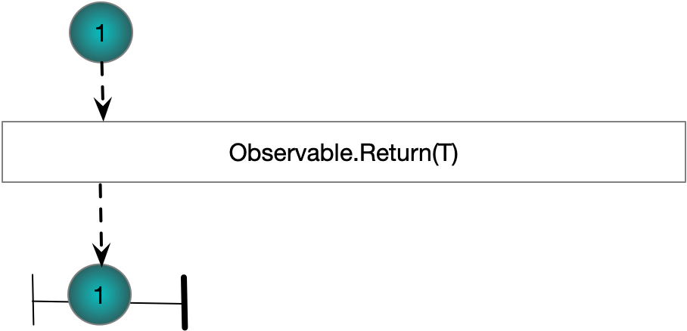

#### Observable. Throw

Returns a stream which calls OnError and then returns

IObservable<int> s =

Observable.Throw<int>(new Exception("An exception"));

s.Subscribe(i => WriteLine($"OnNext({i})"),

exception => WriteLine("OnException"),

() => WriteLine("OnCompleted"));

### Functional Unfolds

Table Functional Unfolds List

|  |  |
| --- | --- |
| Interval(TimeSpan period) | Delivers successive integers. The elapsed time between each element is defined by period |
| Timer(TimeSpan dueTime) | Delivers a single integer after dueTime |
| Timer(TimeSpan dueTime, TimeSpan period) | Delivers the first integer after dueTime and successive integers after each period |
| Range(int start, int count) | Return an observable range |
| Generate | Many overloads for generating sequences |

An unfold can be used to produce a possibly infinite sequence. Generate is the root Rx unfold method. The other unfold methods such as Range, Interval and Timer could be produced using Generate.

#### Observable.Generate

Supports the creation of more complex sequences of event.

IObservable<int> s =

Observable.Generate(0, i => i < 5, i => i + 1, i => i);

s.Subscribe(i => WriteLine($"OnNext({i})"),

exception => WriteLine("OnException"),

() => WriteLine("OnCompleted"));

#### Observable.Range(int,int)

Returns an observable over a sequence of consecutive integers

Observable.Range(1,3)

.Subscribe(WriteLine, () => WriteLine("OnCompleted"));

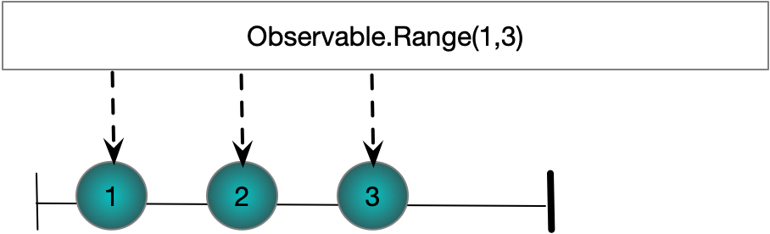

#### Observable.Interval(Timespan)

Produces incrementally increasing integers. The gap between elements is defined by the given Timespan

Observable

.Interval(TimeSpan.FromSeconds(0.25))

.Take(4)

.ObserveOn(Scheduler.Default)

.Subscribe(l => WriteLine($"{l}"),

() => tcs.SetResult(null));

#### Observable.Timer(TimeSpan)

Takes a timespan and creates a stream of one value. The single value is delivered after the specified TimeSpan has elapsed

TaskCompletionSource<string> tcs = new TaskCompletionSource<string>();

Observable

.Timer(TimeSpan.FromSeconds(1))

.ObserveOn(Scheduler.Default)

.Subscribe(l => WriteLine($"{l}"),() => tcs.SetResult(null));

#### Observable.Timer(TimeSpan,TimeSpan)

Takes two TimeSpan objects. The first determines how much time should be allowed to elapse before the first element is delivered. The second TimeSpan determines the interval between subsequent events.

TaskCompletionSource<string> tcs = new TaskCompletionSource<string>();

Observable

.Timer(TimeSpan.FromSeconds(2),TimeSpan.FromSeconds(0.1))

.Take(4)

.ObserveOn(Scheduler.Default)

.Subscribe(l => WriteLine($"{l}"),() => tcs.SetResult(null));

### Transitioning from Other APIs

Table Transitioning Methods

|  |  |
| --- | --- |
| Start | Delivers a single Unit after the delegate completes. If the delegate is an action delivers a IObservable<Unit> and if the delegate is Func<T> returns IObservable<T> |
| FromEvent | Transitions from a standard .NET event to an observable. On observable subscription the event handler add is called and on disposal the remove is called |
| Task.ToObservable extension | Transitions from a task |
| IEnumerable<T>.ToObservable | Transition from enumerable |

We can use the methods of Rx to create Observables form other .NET types.

#### Observable.Start(Action)

Creates a single value observable from an Action delegate

Action a = () => { };

Observable

.Start(a)

.Subscribe(unit => WriteLine($"OnNext({unit})"),

() => WriteLine("OnCompleted"));

#### Observable.Start(Func<T>)

Creates a single value observable from a Func<T>. The value is the value returned by the Func<T>

Action a = () => { };

Observable

.Start(a)

.Subscribe(unit => WriteLine($"OnNext({unit})"),

() => WriteLine("OnCompleted"));

#### Observable.FromEventPattern

Creates Observables from standard .NET events

IObservable<EventPattern<EventArgs>> obs

= Observable

.FromEventPattern<EventArgs>(h => MyEvent += h, h => MyEvent -= h);

obs.Subscribe(x => WriteLine(x.EventArgs));

MyEvent?.Invoke(this,new EventArgs());

#### Task.ToObservable

Creates Observables from standard tasks

TaskCompletionSource<string> tcs = new TaskCompletionSource<string>();

tcs.SetResult("Value");

tcs

.Task

.ToObservable()

.Subscribe(x => WriteLine($"OnNext({x})"), () => WriteLine("OnCompleted"));

WriteLine("Subscribed to already completed task\n");

Task

.Run(() => "Value")

.ToObservable()

.Subscribe(x => WriteLine($"OnNext({x})"), () => WriteLine("OnCompleted"));

WriteLine("Subscribed to running task");

#### IEnumerable<T>.ToObservable

Enumerable

.Range(0,3)

.ToObservable()

.Subscribe(x => WriteLine($"OnNext({x})"), () => WriteLine("OnCompleted"));

Questions – Creating Sequences

What are the three categories of creational methods?

Factory methods

Functional unfolds

Transitioning from other entities (delegates, tasks, events)

What are the factory methods?

|  |  |  |
| --- | --- | --- |
| Empty<T> |  | Create an Observable<T> that delivers no values and call OnCompleted() |
| Return<T>(T obj) |  | Create an Observable<T> that delivers a single item of type T and calls OnCompleted() |
| Throw<T>(Exception) |  | Create an Observable<T> that calls OnError with the provided exception and then calls OnCompleted() |
| Create |  | Various overloads to create Observable sequences. Has logic to deal well with multi-threaded scheduling and disposed subscriptions |

Which of the previous methods can be used to generate the other three?

Observable.Create

What are the functional unfolds?

|  |  |
| --- | --- |
| Interval(TimeSpan period) | Delivers successive integers. The elapsed time between each element is defined by period |
| Timer(TimeSpan dueTime) | Delivers a single integer after dueTime |
| Timer(TimeSpan dueTime, TimeSpan period) | Delivers the first integer after dueTime and successive integers after each period |
| Range(int start, int count) | Return an observable range |
| Generate | Many overloads for generating sequences |

What are the means of transitioning from other APIs?

|  |  |
| --- | --- |
| Start | Delivers a single Unit after the delegate completes. If the delegate is an action delivers a IObservable<Unit> and if the delegate is Func<T> returns IObservable<T> |
| FromEvent | Transitions from a standard .NET event to an observable. On observable subscription the event handler add is called and on disposal the remove is called |
| Task.ToObservable extension | Transitions from a task |
| IEnumerable<T>.ToObservable | Transition from enumerable |

What should one consider before using IEnumerable<T>.ToObservable?

The blocking pull nature of IEnumerable does not always fit well with the asynchronous push nature of IObservable.

Consider passing IObservable<IEnumerable<T>>

## Reducing Sequences

Table Reduction Methods

|  |  |
| --- | --- |
| Where | Apply a filter function T=>bool |
| Distinct | Only propagate values not seen yet in the sequence |
| DistinctUntilChanged | Filter out a value if it is the same as the previous value |
| IgnoreElements | Filter out all elements |
| Skip | Skip the first n elements |
| Take | Take the fitst n elements |
| SkipWhile | Skip while a condition is true |
| TakeWhile | Take while a condition is true |
| SkipUntil | Skip until a value is produced be another specified observable |
| TakeUntil | Take until a value is produced by another specied observable |

Questions – Reducing Sequences

What are the methods for reducing a sequence?

|  |  |
| --- | --- |
| Where | Apply a filter function T=>bool |
| Distinct | Only propagate values not seen yet in the sequence |
| DistinctUntilChanged | Filter out a value if it is the same as the previous value |
| IgnoreElements | Filter out all elements |
| Skip | Skip the first n elements |
| Take | Take the fitst n elements |
| SkipWhile | Skip while a condition is true |
| TakeWhile | Take while a condition is true |
| SkipUntil | Skip until a value is produced be another specified observable |
| TakeUntil | Take until a value is produced by another specied observable |

What overloads are provided for Distinct?

T=>TKey Key Selector Function

IEqualityComparer<T>

What is the difference between Distinct and DistinctUntilChanged?

Distinct filters out values that have been seen anywhere previously in the seq

DistinctUntilChanged filters out values that are the same as the previous element

What does IgnoreElements do?

Only delivers OnCompleted or OnError. No OnNext is ever delivered

## Examining Sequences

Table Sequence Examination Methods

|  |  |
| --- | --- |
| Any() | Returns IObservable<bool> indicating if the sequence is not empty |
| Any(T=>bool) | Returns IObservable<bool> indicating if any element in the sequence conforms to the predicate |
| All(T=>bool) | Returns IObservable<bool> indicating if all elements in the sequence conform to the predicate |
| Contains(T) | Returns IObservable<bool> indicating if the secquence contains the specified value |
| DefaultIfEmpty | Returns IObservable<T> with a single value of default(T) if the sequence is empty |
| ElementAt | Returns IObservable<T> with nth value in the sequence |
| SequenceEqual | Return IObservable<bool> with single value indicating if the two sequences are equal |

Questions – Examining Sequences

What are the methods for examining a sequence?

|  |  |
| --- | --- |
| Any() | Returns IObservable<bool> indicating if the sequence is not empty |
| Any(T=>bool) | Returns IObservable<bool> indicating if any element in the sequence conforms to the predicate |
| All(T=>bool) | Returns IObservable<bool> indicating if all elements in the sequence conform to the predicate |
| Contains(T) | Returns IObservable<bool> indicating if the secquence contains the specified value |
| DefaultIfEmpty | Returns IObservable<T> with a single value of default(T) if the sequence is empty |
| ElementAt | Returns IObservable<T> with nth value in the sequence |
| SequenceEqual | Return IObservable<bool> with single value indicating if the two sequences are equal |

## Aggregating Sequences

Table Aggregation to Single Value Sequence

|  |  |
| --- | --- |
| Count() | Returns IObservable<int> with single value |
| Min() | Returns IObservable<T> with single value |
| Max() | Returns IObservable<T> with single value |
| Average() | Returns IObservable<double> with the arithmetic mean |

Table Aggregation to Single Value

|  |  |
| --- | --- |
| First | Return first element as T |
| FirstOrDefault | If sequence is empty return default(T) or we can provide our own default |
| Last | Return the last element |
| LastOrDefault | If sequence is empty return default(T) or we can provide our own default |

Table Aggregation to Multi-Valued Sequence

|  |  |
| --- | --- |
| Scan | Aggregates to a running sequence of accumulated values |

#### Scan(TAccumulate,Func<TAccumulate, TSource, TAccumulate>)

An accumulator which produces a sequence of accumulated values

Observable.Range(1, 3)

.Scan(0,(cum, i1) => cum+i1)

.Subscribe(WriteLine, () => WriteLine("OnCompleted\n"));

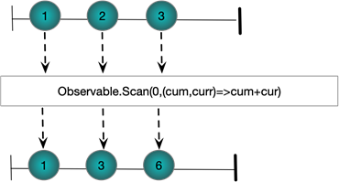

Questions – Aggregating Sequences

Which functions aggregate to a single value observable?

|  |  |
| --- | --- |
| Count() | Returns IObservable<int> with single value |
| Min() | Returns IObservable<T> with single value |
| Max() | Returns IObservable<T> with single value |
| Average() | Returns IObservable<double> with the arithmetic mean |

What are the functional folds/catamorphisms?

|  |  |
| --- | --- |
| First | Return first element as T |
| FirstOrDefault | If sequence is empty return default(T) or we can provide our own default |
| Last | Return the last element |
| LastOrDefault | If sequence is empty return default(T) or we can provide our own default |

What happens if the input sequences call OnError?

They throw an exception

Why do we need to be careful with the catamorphisms?

They are blocking and can introduce deadlocks

What is the difference between scan and aggregate?

Aggregate produces a sequence with a single value

Scan produces a sequence with one element per input sequence element

## Partitioning Sequences

Table Partitioning Operators

|  |  |
| --- | --- |
| MinBy | Returns Observable<List<T>> of a single list of all elements with the minimum key value. Only provides a value when the input sequence completes |
| MaxBy | Returns Observable<List<T>> of a single list of all elements with the minimum key value. Only provides a value when the output sequence completes |
| GroupBy | Returns an observable sequence of observables. Each subsequence provides all values that match a given key |

Questions – Partitioning Sequences

What are the partitioning operators?

|  |  |
| --- | --- |
| MinBy | Returns Observable<List<T>> of a single list of all elements with the minimum key value. Only provides a value when the input sequence completes |
| MaxBy | Returns Observable<List<T>> of a single list of all elements with the minimum key value. Only provides a value when the output sequence completes |
| GroupBy | Returns an observable sequence of observables. Each subsequence provides all values that match a given key |

What is the purpose of the GroupBy operator?

Partition data from one source so it can be shared to multiple sources.

## Transforming Sequences

Table Transformation Methods

|  |  |
| --- | --- |
| Select | Simple transformation from IObservable<TSource> to IObservable<TResult> |
| Cast<T> | Take IObservable<Object> and given IObservable<T> If anything cannot be cast then OnError is called |
| OfType<T> | Take IObservable<Object> and given IObservable<T> If anything cannot be cast then it is excluded |
| Timestamp | Wraps each element in a struct with the element value and the current timestamp |
| TimeInterval | Wraps each element in a struct with the element value and the elapsed time since the previous element |
| Materialize | Transform IObservable<T> into a sequence of IObservable<Notification<T>>  With debug notification |
| Dematerialize | Take a materialzed sequence and dematerialize it |
| SelectMany | Map one sequence to a sequence of sequences and flatten |
| ToArray, ToList,ToDict,ToLookup | Produce an observable with one value containing all the values from the input sequence. Only delivered once input sequence completes |

#### SelectMany

SelectMany seems to work by taking an observable sequence and using each value from that sequence to generate another sequence. The generated sequences are then merged (flattened) together

Subject<int>[] subs = new Subject<int>[]

{

new Subject<int>(),

new Subject<int>()

};

Observable

.Range(0, 2)

.SelectMany(i => subs[i])

.Subscribe(WriteLine);

subs[0].OnNext(1);

subs[1].OnNext(2);

subs[0].OnNext(3);

subs[1].OnNext(4);

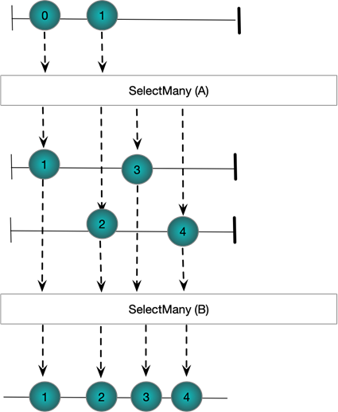

Questions – Transforming Sequences

What are the transformation functions?

|  |  |
| --- | --- |
| Select | Simple transformation from IObservable<TSource> to IObservable<TResult> |
| Cast<T> | Take IObservable<Object> and given IObservable<T> If anything cannot be cast then OnError is called |
| OfType<T> | Take IObservable<Object> and given IObservable<T> If anything cannot be cast then it is excluded |
| Timestamp | Wraps each element in a struct with the element value and the current timestamp |
| TimeInterval | Wraps each element in a struct with the element value and the elapsed time since the previous element |
| Materialize | Transform IObservable<T> into a sequence of IObservable<Notification<T>>  With debug notification |
| Dematerialize | Take a materialzed sequence and dematerialize it |
| SelectMany | Map one sequence to a sequence of sequences and flatten |

## Composing Sequences

Table Sequential Composition Operators

|  |  |
| --- | --- |
| Concat | Appends one sequence to another. The first sequence has to complete. |
| Repeat | Repeate a sequence n times. The sequence must complete |
| StartsWith | Prepend a value to a sequence. |

Table Concurrent Composition Operators

|  |  |
| --- | --- |
| Amb | First sequence wins |
| Merge | Merge values from two sequences |
| Switch | Propagate items from first stream to result stream until second stream starts publishing. At this point only items from the second stream are provided |

Table Pairwise Composition Operators

|  |  |
| --- | --- |
| CombineLatest | Pairs latest value from first stream with latest value from second stream as each value is produced from either stream |
| Zip | Pairs together values from two streams |
| AndThenWhen | Pairs together values from multiple streams |

### Sequential Composition

#### Observable.Concat(IObservable<TSource>)

Observable

.Range(0, 2)

.Concat(Observable.Range(5, 2))

.Subscribe(WriteLine);

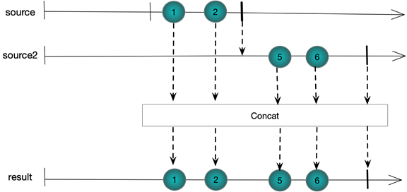

#### Observable.Repeat(int reps)

Observable

.Range(0, 2)

.Repeat(2)

.Subscribe(WriteLine, () => WriteLine("OnCompleted\n"));

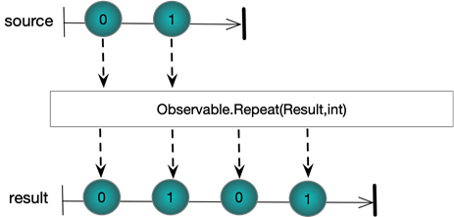

#### Observable.StartsWith

Observable

.Range(10, 2)

.StartWith(8, 9)

.Subscribe(WriteLine);

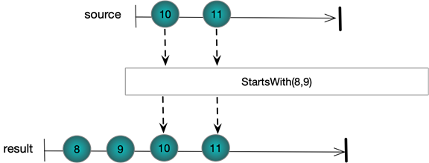

### Concurrent Composition

#### Observable.AMB

Subject<string> a = new Subject<string>();

Subject<string> b = new Subject<string>();

Observable.Amb(a,b)

.Subscribe(WriteLine);

a.OnNext("a");

b.OnNext("1");

a.OnNext("b");

b.OnNext("2");

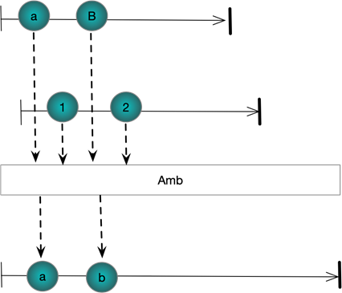

#### Observable.Merge

Subject<string> a = new Subject<string>();

Subject<string> b = new Subject<string>();

Observable.Merge(a, b)

.Subscribe(WriteLine);

a.OnNext("a");

b.OnNext("1");

a.OnNext("b");

b.OnNext("2");

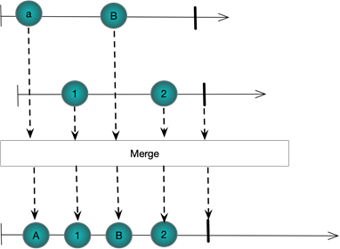

#### Observable.Switch

Works on a stream of streams. When the first stream starts publishing, its events are published into the result stream until the second stream starts publishing. At which point the first stream is unsubscribed

Subject<string> a = new Subject<string>();

Subject<string> b = new Subject<string>();

Subject<Subject<string>> master = new Subject<Subject<string>>();

master.Switch()

.Subscribe(WriteLine);

master.OnNext(a);

a.OnNext("a");

a.OnNext("b");

master.OnNext(b);

b.OnNext("1");

b.OnNext("2");

a.OnNext("c");

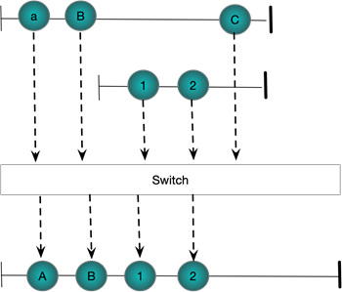

### Pairwise Composition

#### Observable.CombineLatest

Combines the latest value from two streams as each stream produces new values. Requires that each stream has at least one value before anything is published to the result

Subject<string> a = new Subject<string>();

Subject<string> b = new Subject<string>();

Observable.CombineLatest(a,b,(s, s1) => $"({s},{s1})")

.Subscribe(WriteLine);

a.OnNext("a");

a.OnNext("b");

b.OnNext("1");

b.OnNext("2");

a.OnNext("c");

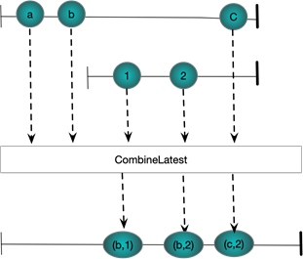

#### Observable.Zip

Pairs together values from two streams.

Subject<string> a = new Subject<string>();

Subject<string> b = new Subject<string>();

Observable.Zip(a,b,(s, s1) => $"({s},{s1})")

.Subscribe(WriteLine);

a.OnNext("a");

a.OnNext("b");

b.OnNext("1");

b.OnNext("2");

a.OnNext("c");

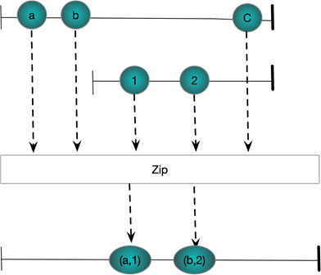

#### And/Then/When

Pairs together values from ,multiple streams.

IObservable<int> a = Observable.Range(1, 3);

IObservable<int> b = Observable.Range(1, 3).Select(x => x * 2);

IObservable<int> c = Observable.Range(1, 3).Select(x => x * 3);

Observable

.When(a

.And(b)

.And(c)

.Then((x, y, z) => (x, y, z)))

.Subscribe(x => WriteLine(x));

// Verbose form to show what is happening

Pattern<int, int> pattern1 = a.And(b);

Pattern<int, int, int> pattern2 = pattern1.And(c);

Plan<(int, int, int)> then = pattern2.Then((i, i1, i2) => (i, i1, i2));

IObservable<(int, int, int)> observable = Observable.When(then);

observable.Subscribe(x => WriteLine(x));

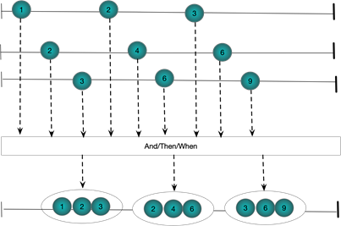

Questions – Composing Sequences

What are the means of composing sequences?

Sequential

Concurrent

Pairwise

What are the sequential composition operators?

Concat

Repeat

StartsWith

What does Concat do?

Concatenates two sequences

What must happen for Concat to work?

The first sequence most complete

What does Repeat do?

Repeats a sequence n times

What must happen for Repeat to work?

The sequence most complete

What does StartsWith do?

Prepends a value to a sequence.

What are the concurrent composition operators?

Amb

Merge

Switch

What does AMB do?

First sequence to start publishing wins

What does Switch do

Propagates items from one sequence until a second sequence starts publishing and then only publishes from the second sequece

What are the pairwise composition operators?

Zip

CombineLatest

AndThenWhen

What does Zip do?

Pairs together values from two streams

What does CombineLatest do?

Combine values from two streams as and when they become ready

## Buffering Operators

|  |  |
| --- | --- |
| Buffer(int count) | Builds perfectly contiguous buffers of size count |
| Buffer(int count, int skip) | Supports non contiguous buffers. If skip is greater than count we miss out elements. If skip is less than count we have overlapping buffers |
| Buffer(TimeSpan timespan) | Build perfectly contiguous buffers by timespan |
| Buffer(TimeSpan timeSpan, TimeSpan timeShift) | If timespan is greater than timeShift we get overlapping buffers. If timestap is less than timeShift we miss out elements |
| Buffer(Func<IObservable<TC>> closingSelector) | Each time a value is published from closing selector the current buffer is closed and flushed |
| Buffer(TimeSpan timeSpan, int count) | Buffer is closed when eiher count it reached or timespan elapses |

### Buffering

The various overloads of Buffer enable one to group together elements from an input stream. The resulting groups are called buffers. The basic idea then is to take a stream IObservable<T> and produce a stream IObservable<IList<T>>. Buffers can be perfectly contiguous with every source element existing in one and only one result buffer; skipping with some source elements being completely left out of the result bugffers or overlapping where some source elements make it into more than once destination buffer.

Buffering Behaviour

* Perfectly contiguous
* Overlapping
* Skipping

Buffers can be defined by source element count, time interval or via open and close signals.

Buffer Definition

* Source element count
* time interval
* opening and closing signals

#### Buffer(int count)

Supports perfectly contiguous buffers in the result stream

Observable

.Range(0, 5)

.Buffer(2)

.Subscribe(ints => WriteLine(string.Join(",", ints)));

The following figure shows graphically what is happening. Each buffer contains at most count items. Notice the final buffer has less than two items because the source stream completes

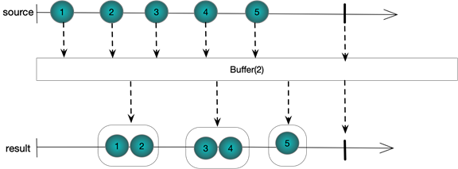

#### Buffer(int count,int skip)

By taking two integer arguments this overload of Buffer supports non-contiguous result buffers. Skip defines the number of elements between each buffer opening and count defines the maximum number of elements in each buffer. If skip is more than count then we miss out some source elements from the destination. If skip is less than count then we have overlapping buffers with some elements making it into more than one buffer. Of course if skip is equal to count we have the exact same behaviour as Buffer(int count), that is to say perfectly contiguous buffers. Let us look at each case in turn

##### Skipping Elements

We set the count to 2 and the skip to 3. A new buffer is started every three elements and hold at most 2 elements.

Observable.Range(1, 5)

.Buffer(2, 3)

.Subscribe(ints => WriteLine(string.Join(",", ints)));

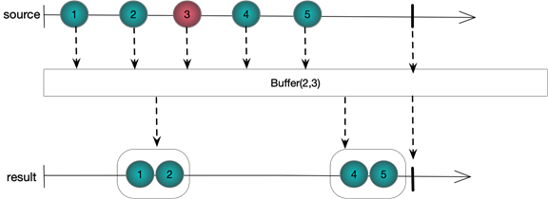

##### Overlapping Elements

We set the count to 3 and the skip to 2. A new buffer is started every two elements and hold at most three elements. The last element from each buffer is also duplicated as the first element in the next buffer

Observable.Range(1, 5)

.Buffer(3, 2)

.Subscribe(ints => WriteLine(string.Join(",", ints)));

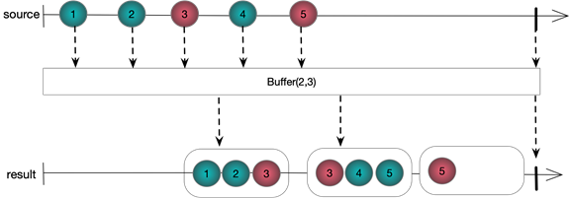

#### Buffer(Timespan timeSpan)

Partitions each element of a source stream into contiguous buffers in the result stream. The buffers in the result stream are defined by the timing of events in the source stream.

EventWaitHandle ewh = new AutoResetEvent(false);

Observable

.Interval(TimeSpan.FromSeconds(0.3))

.Take(6)

.Buffer(TimeSpan.FromSeconds(1.0))

.Subscribe(ints => WriteLine(string.Join(",", ints)),()=>ewh.Set());

ewh.WaitOne();

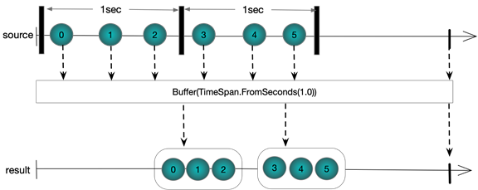*\*Output\**

#### Buffer(Timespan timeSpan, TimeSpan timeshift)

As with using Buffer(int,int) this overloads support overlapping and skipping elements by specifying two TimeSpans. We consider each in turn

##### Overlapping Elements

EventWaitHandle ewh = new AutoResetEvent(false);

Observable

.Interval(TimeSpan.FromSeconds(0.3))

.Take(6)

.Buffer(TimeSpan.FromSeconds(1.0), TimeSpan.FromSeconds(0.4))

.Subscribe(ints => WriteLine(string.Join(",", ints)), () => ewh.Set());

ewh.WaitOne();

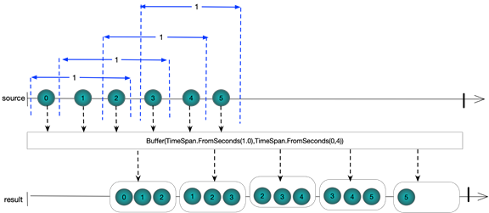

##### Skipping Elements

EventWaitHandle ewh = new AutoResetEvent(false);

Observable

.Interval(TimeSpan.FromSeconds(0.3))

.Take(6)

.Buffer(TimeSpan.FromSeconds(0.4), TimeSpan.FromSeconds(1.0))

.Subscribe(ints => WriteLine(string.Join(",", ints)), () => ewh.Set());

ewh.WaitOne();

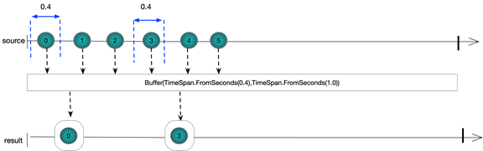

#### Buffer(Func<IObservable<TClosingSelector>> closingSelector)

This form uses a separate observable sequence that produces values in order to flush buffers. Each time a element is published by this observable the current buffer is flushed through

EventWaitHandle latch = new AutoResetEvent(false);

var obs = Observable

.Interval(TimeSpan.FromSeconds(0.3))

.Take(10);

var closing = Observable

.Interval(TimeSpan.FromSeconds(1.0))

.Take(2);

obs

.Buffer(closing)

.Subscribe(ints => WriteLine(string.Join(",", ints)),()=>latch.Set());

latch.WaitOne();

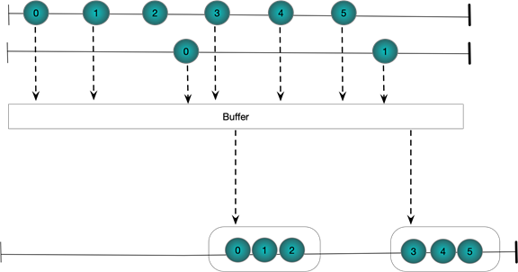

#### Buffer(Iobservable<TBufferOpening> bufferOpenings, Func<TBufferOpening, IObservable<TbufferOpening>> bufferClosingSelector)

The bufferOpenings selector is used to publish events which determine when buffers are opened. The bufferClosingSelector takes the value from the buffer opening event and uses it to generate the buffer closing event.

EventWaitHandle latch = new AutoResetEvent(false);

var obs = Observable

.Interval(TimeSpan.FromSeconds(0.3))

.Take(10);

var opening = Observable

.Interval(TimeSpan.FromSeconds(0.7))

Take(2);

var closing = Observable

.Timer(TimeSpan.FromSeconds(0.5))

.Take(2);

obs

.Buffer(opening, i => closing)

.Subscribe(ints => WriteLine($"({string.Join(",", ints)})"), () => latch.Set());

latch.WaitOne();

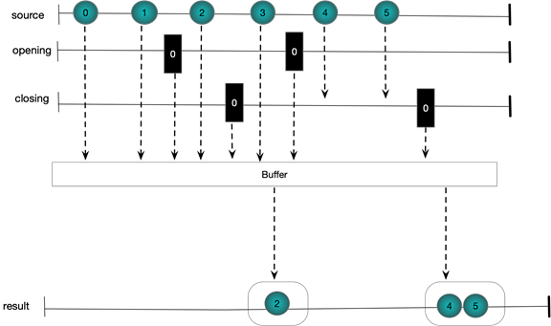

#### Buffer(Timespan timeSpan, int count)

Sometimes it is useful to be able to buffer by both count and timeframe. A buffer is closed and a new one started when either the maximum buffer size is reached or the timespan elapses. This means the buffer does not get too big and also data never gets stale

EventWaitHandle latch = new AutoResetEvent(false);

Observable

.Interval(TimeSpan.FromSeconds(0.1))

.Take(5)

.Concat(Observable.Interval(TimeSpan.FromSeconds(0.5)).Take(4))

.Buffer(TimeSpan.FromSeconds(1.0),5)

.Subscribe(ints => WriteLine($"({string.Join(",", ints)})"), () => latch.Set());

latch.WaitOne();

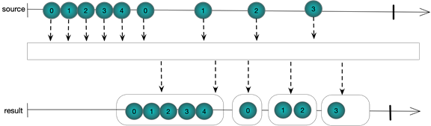

Questions - Buffering

## Delay Operators

#### Delay (Timespan)

Simply delays a sequence by a specified TimeSpan. The times between elements remain the same.

DateTime now = DateTime.Now;

EventWaitHandle latch = new AutoResetEvent(false);

var source = Observable.Interval(TimeSpan.FromSeconds(0.5)).Take(4);

var delays = source.Delay(TimeSpan.FromSeconds(1.0));

source.Subscribe(l => WriteLine($"Original {l} {(DateTime.Now - now).TotalSeconds}"));

delays.Subscribe(l => WriteLine($"Delayed {l} {(DateTime.Now - now).TotalSeconds}"),()=>latch.Set());

latch.WaitOne();

Original 0 0.5671419

Original 1 1.0641751

Original 2 1.5644976

Delayed 0 1.6014948

Original 3 2.0791571

Delayed 1 2.0985018

Delayed 2 2.6119969

Delayed 3 3.1114934

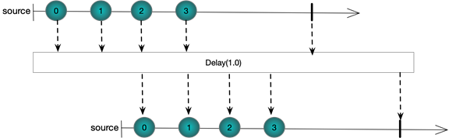

Questions – Delay Operators

## Sample and Throttle

#### Sample (Timespan)

Returns the last element emitted by a source sequence in a buffer interval specified by a TimeSpan

DateTime now = DateTime.Now;

EventWaitHandle waitHandle = new AutoResetEvent(false);

Observable

.Interval(TimeSpan.FromSeconds(0.3))

.Take(10)

.Sample(TimeSpan.FromSeconds(1.0))

.Subscribe(l => Console.WriteLine($"Delayed {l} {(DateTime.Now - now).TotalSeconds}"), () => waitHandle.Set());

waitHandle.WaitOne();

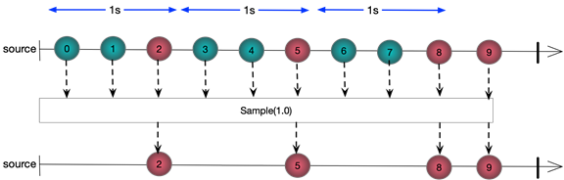

Delayed 2 1.1075141

Delayed 5 2.1179985

Delayed 8 3.1327291

Delayed 9 4.1504981

##### More Examples

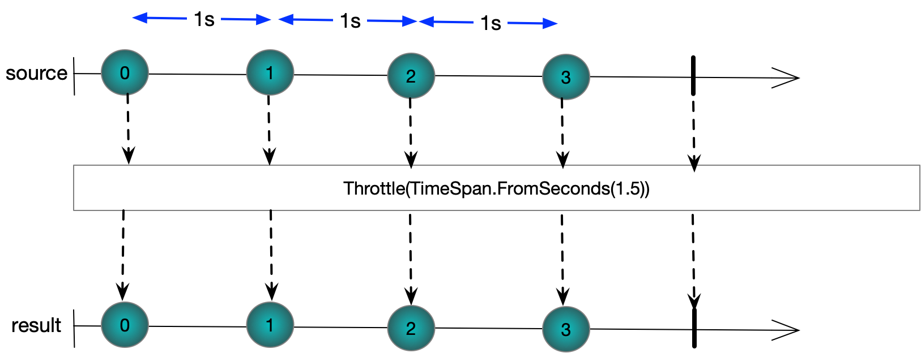

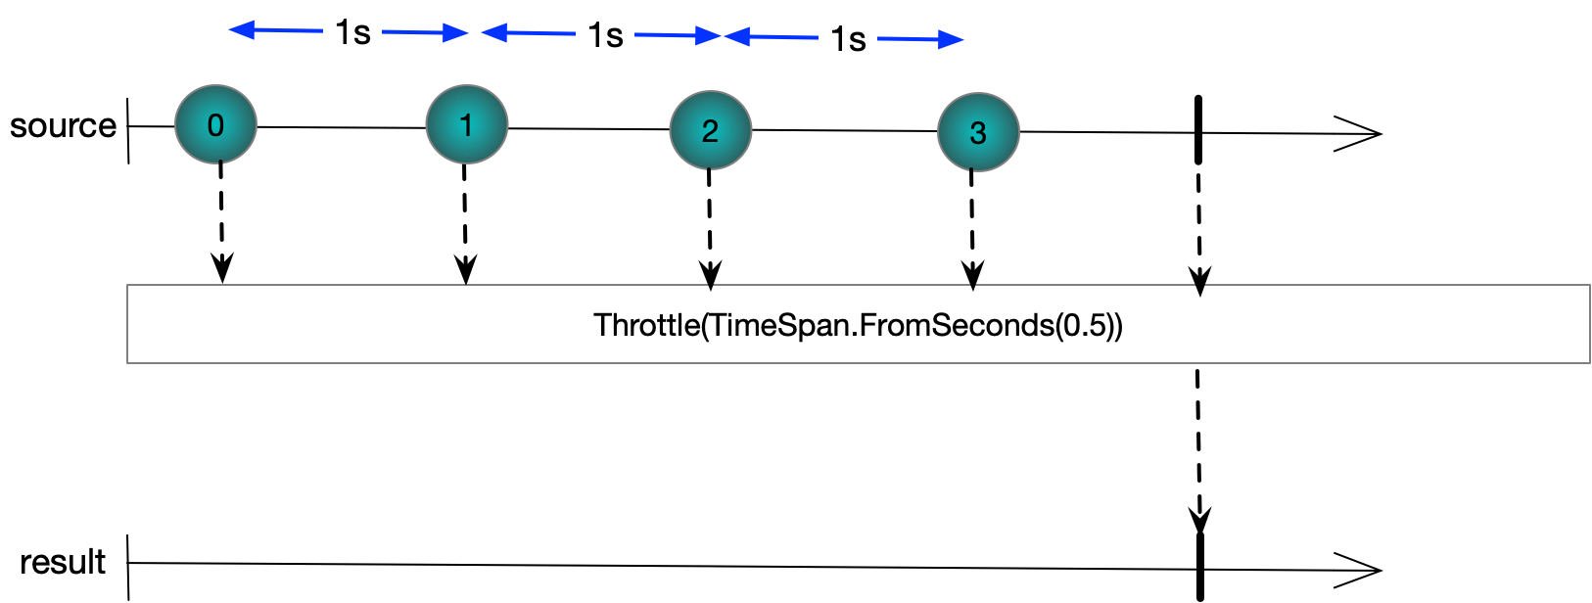

Questions – Sample and Throttle

What does sample do?

Returns the last element emitted by a source sequence in a given interval



What does buffer do?

Returns the last element emitted by a source sequence in a given interval. However, if an element is received inside the window specified by the timespan the window is reset. So if a source produces values in uniform intervals where the interval is less than the buffer length no elements will make it to the destination sequence.

## Timeout

|  |  |
| --- | --- |
| Timeout(TimeSpan dueTime) | Completes with OnError if a sequence does has longer than dueTime between elements |
| Timeout(DateTimeOffset dueTime) | Completes with OnError is sequence does not complete in the given dueTime |
| Timeout(TimeSpan dueTime,IObservable<T>) | Returns second sequence if first times out |

Questions - Timeout

## Testing Rx

### Subject

Rx provides a type called Subject<T> that implements IObserver<T> and IObservable<T> that enables code to publish and subscribe from the same code

var s1 = new Subject<int>();

s1.Subscribe(o => WriteLine($"OnNext({o})"),() => WriteLine("OnCompleted()"));

s1.OnNext(1);

s1.OnCompleted();

Output

OnNext(1)  
OnCompleted()

### ReplaySubject

In addition to the basic subject, RX provides a ReplaySubject<T> that caches values so late subscribers still get them

var s1 = new ReplaySubject<int>();

s1.OnNext(1);

s1.OnNext(2);

s1.Subscribe(o => WriteLine($"OnNext({o})"),() => WriteLine("OnCompleted()"));

s1.OnCompleted();

Output

OnNext(1)  
OnCompleted()

The replay subject can take a buffer size to limit the memory footprint

var s1 = new ReplaySubject<int>(2);

s1.OnNext(1);

s1.OnNext(2);

s1.OnNext(3);

s1.Subscribe(o => WriteLine($"OnNext({o})"),()=>WriteLine("OnCompleted()"));

s1.OnCompleted();

Output

OnNext(2)  
OnNext(3)  
OnCompleted()

### BehaviourSubject

BehaviorSubject<T> remembers the last value published which it delivers to a late subscriber. Its constructor takes a default value that is delivered to a subscriber subscribes before any values are published. All subscribers get a value unless the sequence is completed.

var s1 = new BehaviorSubject<int>(1);

s1.Subscribe(o => WriteLine($"OnNext({o})"),()=>WriteLine("OnCompleted()"));

s1.OnCompleted();

Output

OnNext(1)  
OnCompleted()

### AsyncSubject

Keeps track of the last published value and deliver it and only it when sequence completes. If sequence does not complete never delivers any values.

var s1 = new AsyncSubject<int>();

s1.OnNext(1);

s1.OnNext(2);

s1.OnNext(3);

s1.OnCompleted();

s1.Subscribe(o => WriteLine($"OnNext({o})"),()=>WriteLine("OnCompleted()"));

Output

OnNext(3)

OnCompleted()

Questions – Testing Rx

What is a Subject<T>?

An object that implements both IObserver<T> and IObservable<T>

Enables client to easily publish to the Observable

What is a ReplaySubject<T>?

Caches values so late subscribers do not miss out

Supports cache size and cache interval to limit memory footprint

What is a BehaviourSubject<T>?

Caches last value published. Take default value

Any subscriber always gets a value unless sequence completes

Compare and Contract ReplaySubject<T>(1) and BehaviourSubject

If no values have ever been published a subscriber to BehaviourSubject gets a default value whereas this is not the case with ReplaySubject(1)

ReplaySubject(1) caches value after completion but BehaviourSubject does not.

If we want to test Rx code we can take advantage of the type Microsoft.Reactive.Testing.TestScheduler which provides a set of methods to simulate time moving forward. The following snippet shows how we might make this work.

TestScheduler t = new TestScheduler();

DoSubscription(t);

t.Start();

}

public void DoSubscription(IScheduler scheduler)

{

IObservable<long> observable = Observable

.Interval(TimeSpan.FromSeconds(1),scheduler)

.Take(5);

observable

.ObserveOn(scheduler)

.Subscribe(e => logger.Info(e));

}

Note how we pass in an instance of IScheduler Typically we would use an interface such as ISchedulerProvider to enable us to inject in different implementations of our view model.

## Best Practice

Always favour Observable.Create over writing one own IObservable<T> implementation

Always favour the factory methods that take functions over writing ones own IObserver<T> implementations

Threading should be defined by the subscriber so SubscribeOn and ObserveOm should generally only be seen before a Subscibe call

Subsciptions should be disposed

An OnError handler should be provided

If you return a sequence return empy sequences rather than null

Try not to use blocking operators that break the monad.