Using Windows

## How To

### Common Environment Variables

|  |  |
| --- | --- |
|  | Variable |
| User Directory (C:\Users<username>) | %USERPROFILE% |

### Environment Variables and Terminal

|  |  |
| --- | --- |
| Effect | Command |
| List All Env Variables | Set |
| Show Env Variable | echo %USERPROFILE% |
| Set Env Variable | set HELLO=SomeMessage |

### Environment Variables and PowerShell

|  |  |
| --- | --- |
| Effect | Command |
| List All Env Variables | Set |
| Show Env Variable | echo %USERPROFILE% |
| Set Env Variable | set HELLO=SomeMessage |

##### How do I find which application is holding onto my file handle?

Open Resource Manager from the Window Start

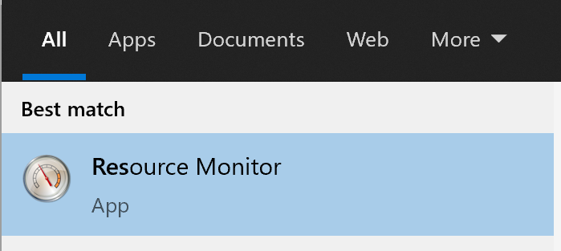

The select the CPU tab and enter the name of the file in the red box shown on associated handles. 