WSL2

## Introduction

This document covers

Introduction

### Basics

|  |  |  |
| --- | --- | --- |
| Task | How to | Description |
| **Access Linux filesystem from Windows** | \\wsl$\Ubuntu\home\kenne |  |
| **Access Window filesystem from Linux** | /mt/c |  |
| **Open Code in Linux** | code . |  |
|  |  |  |

## Getting Started

### Windows Terminal

If we open a windows terminal the default window is Powershell.

We can just click + to add another tab and then use the menu to change from Powershell to a different kind of shell. In this case we want to use Ubuntu.

### Linux/WSL2

We can see the

If we type code inside a Ubuntu shell we see something cool. It opens VS code as a window in Windows but it is running on Linux. Note the WSL:Ubuntu in the bottom left and in the VS Code terminal the home directory is /home/kenne

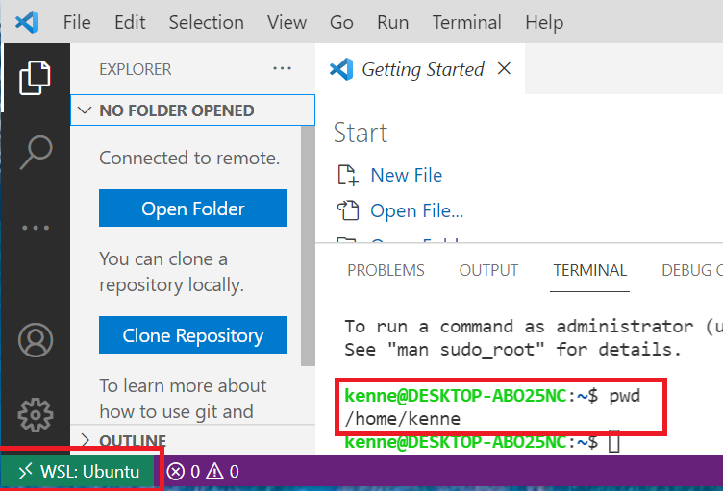

[WSL2](https://docs.microsoft.com/en-us/windows/wsl/) works well together with the windows [terminal](https://github.com/microsoft/terminal).