JavaScript

## Cheat Sheets

### LINQ

|  |  |  |  |
| --- | --- | --- | --- |
| Name | Code | Result | Description |
| every | [1,3,5].every(x=> x%2 == 1) | true |  |
| some | [1,2].some(x=> x%2 == 1) | true |  |
| filter | [1,2,3,5].filter(x=> x%2 == 1) | [1,3,5] |  |
| find | [1,2].find(x=> x%2 == 0) | 2 |  |
| findIndex | [1,2].findIndex(x=> x%2 == 0) | 1 |  |
| map | [1,2].map(x=>x*2 | [2,4] |  |
| reduce | [1,2].reduce((acc,curr)=>acc+curr,0) | 3 | *Also know as inject or fold* |
| reduceRight | [2,3].reduce((acc,curr)=> Math.pow(acc,curr)) | 8 | *Work right to left* |
| Flat | [1,2,[3,4],[5,6]].flat() | [1,2,3,4,5,6] | *Flatten any elements that are arrays* |

### Arrays as Stacks and Queues

|  |  |  |  |
| --- | --- | --- | --- |
| Name | Code | Result | Description |
| pop | let a = [1,2,3];  console.log(a.pop());  console.log(a); | 3  [1,2] | *Remove the last element and returns it* |
| push | let a = [1,2,3];  console.log(a.push(4));  console.log(a); | 4  [1,2,3,4] | *Append to end of array* |
| shift | let a = [1,2,3];  console.log(a.shift());  console.log(a); | 1  [2,3] | *Remove and return the first element* |
| unshift | let a = [1,2,3];  console.log(a.unshift(4));  console.log(a); | 4  [4,1,2,3] | *Append to front of array* |

### Array Slice

Slice does not modify the original array.

|  |  |  |  |
| --- | --- | --- | --- |
| Name | Code | Result | Description |
| slice | [1,2,3,4,5].slice(2,4) | [3,4] |  |
| slice | [1,2,3,4,5].slice(2) | [3,4,5] |  |
| slice | [1,2,3,4,5].slice(-1) | [5] |  |
| slice | [1,2,3,4,5].slice(-3,-1) | [3,4] |  |
|  |  |  |  |

### Array Splice

Splice modifies the array in place. In inserts and removes

|  |  |  |  |
| --- | --- | --- | --- |
| Name | Code | Result | Description |
| splice | a = [1,2,3,4,5]  a.splice(1)  a | [2,3,4,5]  [1] | *Removes and returns all elements starting at index 1.* |
| splice | a = [1,2,3,4,5]  a.splice(1,2)  a | [2,3]  [1,4,5] | *Removes and returns 2 elements starting at index 1.* |
| splice | a = [1,2,3,4,5]  a.splice(1,2,8,9)  a | [2,3]  [1,8,9,4,5] | *Replace two elements starting at index 1 with 8 and 9* |
| splice | a = [1,2,3,4,5]  a.splice(1,2,8,9,10,11)  a | [2,3]  [1,8,9,10,11,4,5] | *Replace two elements starting at index 1 and add four elements 8,9,10,11* |

### Array Fill

|  |  |  |  |
| --- | --- | --- | --- |
| Name | Code | Result | Description |
| fill | a = new Array(3)  a.fill(3)  a | <3 emppty items>  [3,3,3]  [3,3,3] | *Fill the array with the value 3* |
| fill | a = new Array(3)  a.fill(3,1)  a | <3 emppty items>  [undefined,3,3]  [undefined,3,3] | *Fill the array with the value 3 starting at index 1* |
| Fill | a = new Array(4)  a.fill(3,1,2)  a | <4 emppty items>  [undefined,3,3,undefined]  [undefined,3,3,undefined] | *File the array starting and index 1 and ending at 2* |

### Copy Within

Highly performance and modelled on memmove from C.

|  |  |  |  |
| --- | --- | --- | --- |
| Name | Code | Result | Description |
| copyWithin | a = [1,2,3,4,5]  a.copyWithin(1) | [1,1,2,3,4,5] | *Copy array from element 0 to array starting at index 1.* |
| copyWithin | a = [1,2,3,4,5]  a.copyWithin(1,3,4) | [1,4,5,4,5] | *Copy array slice at between 3 and 4 to position 1.* |

### Array Misc.

|  |  |  |  |
| --- | --- | --- | --- |
| Name | Code | Result | Description |
| sort | a = [5,4,3,2,1]  a.sort() | [1,2,3,4,5] | *Sort array* |
| reverse | a = [5,4,3,2,1]  a.reverse() | [1,2,3,4,5] |  |
| join | a = [1,2,3,4,5]  a.join() | “1,2,3,4,5” |  |

### Functions

|  |  |
| --- | --- |
| Name | Code |
| Declaration | function add(a,b) { return a+b} |
| Named Expressions | var f = function add(a,b) { return a+b}; |
| Anonymous Expression | var f = function(a,b) { return a+b}; |
| Rest Parameter | function avg(...args) {  var sum = 0;  for (let value of args) {  sum += value;  }  return sum / args.length;  } |
| Default param value | function add( x, y = 3.0 ) { return x+y}; |
| Lambda (no parameters) | var f = () => 3.0 |
| Lambda (one parameter) | var f = x => x * x ; |
| Lambda two parameters | Var x = (x,y) => x + y; |
| Spread into Rest parameter | var numbers = [10,20,30]  console.log(avg(...numbers)); |
| Spread into normal parameters list | function add(x,y) {return x+y;}  console.log(add(...[3,5])); |
| Method | var o5 = {      Print: function() {          console.log("Hello World");      }  } |
| Method shorthand | var o5 = {      Print () {          console.log("Hello World");      }  } |
|  |  |

### Iterators

|  |  |
| --- | --- |
| Name | Code |
| Generate Iterator | let Iterable = function(count) {  this.count = count;  this[Symbol.iterator] = function* () {  while (this.count >0)  {  yield this.count;  this.count = this.count-1;  }  } |
| Consume Iterable with Spread | console.log(...new Iterable(3)); |
| Consume Iterable with for/of | for(let a of [1,2,3])  console.log(a*2); |

### Objects

let Person ➊ = function(first, second)

{

    // Instance fields

    this.firstName = first;

    this.secondName = second;

    Person.Count = Person.Count+1;

}

Person.prototype.fullName ➌ = function() {

    return this.firstName + " " + this.secondName;

}

Person.Count ➍ = 0;

Person.GetCount ➎ = function() {

    console.log("Person count is " + Person.Count );

}

let p1 ➋ = new Person("Kenny", "Wilson");

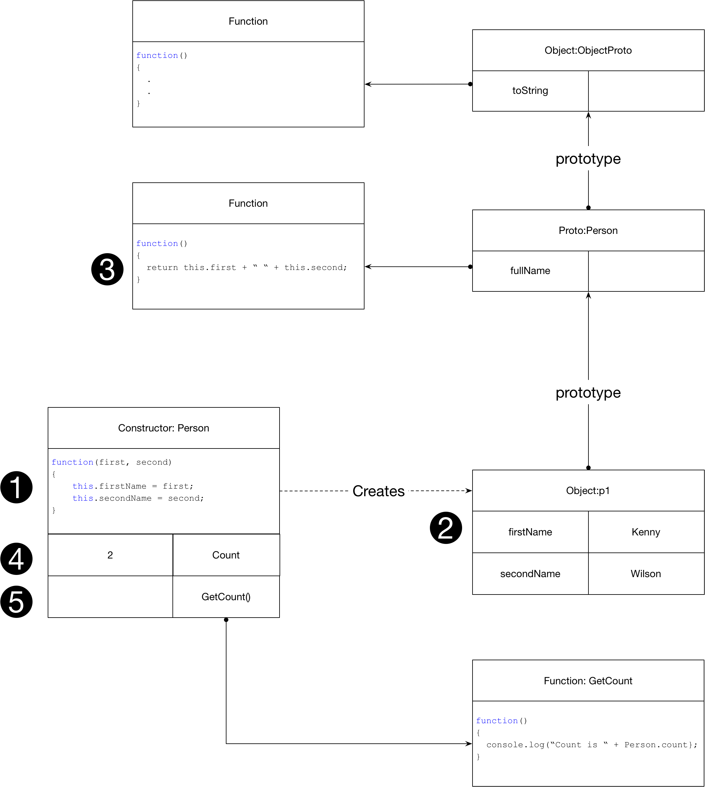

### Inheritance

let Person = function(first, second)

{

    // Instance fields

    this.firstName = first;

    this.secondName = second;

    Person.Count = Person.Count+1;

}

Person.prototype.fullName = function() {

    return this.firstName + " " + this.secondName;

}

Person.Count = 0;

Person.GetCount = function() {

    console.log("Person count is " + Person.Count );

}

let p1 = new Person("Kenny", "Wilson");

Person.GetCount();

let Employee ➊ = function(first,second,salary)

{

    ➋ Person.call(this,first,second);

    this.salary = salary;

}

➍ Object.setPrototypeOf(Employee.prototype,Person.prototype);

Employee.prototype.tax = function () {return this.salary * 0.4};

Employee.prototype.fullName = function() {

    let base = Person.prototype.fullName.call(this);

    return base + " " +  this.salary;

}

let e1 ➌ = new Employee("Kenny", "Wilson", 40000);

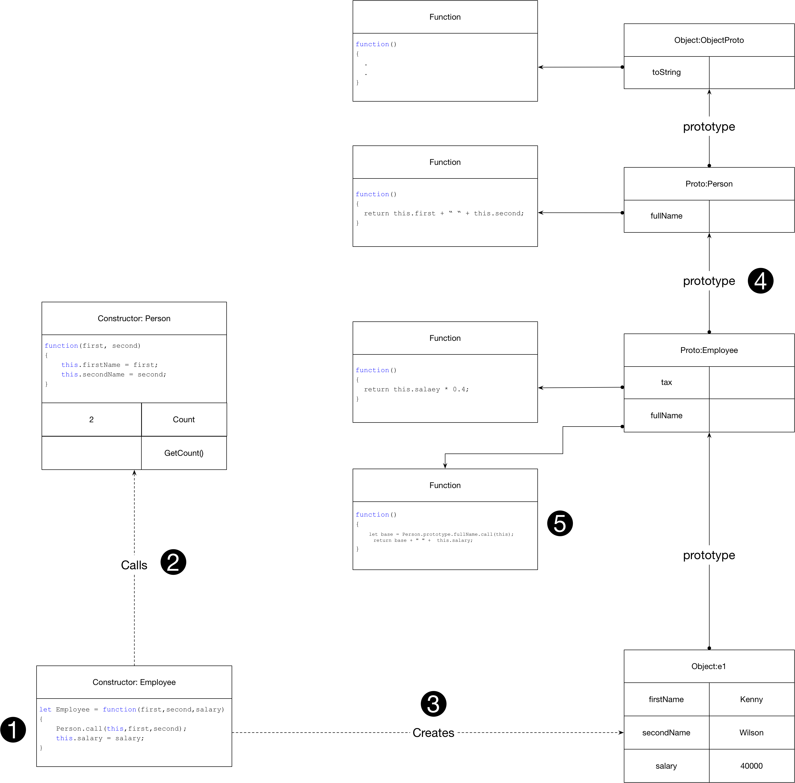

### Objects Prototypes

// Constructor defines prototype

function Person(first,second)

{

    // 2 Instance fields

    this.firstName = first;

    this.secondName = second;

    // Increment static field defined below

    Person.numPeople++;

}

// Instance Method

Person.prototype.fullName = function()

{

    return this.firstName + " " + this.secondName;

}

// Instance Property

Object.defineProperty(Person.prototype,"age", {

    get: function() {return this._age;},

    set: function(age) {this._age=age;}

});

// Static field

Person.numPeople = 0;

// Static method

Person.printCount = function()

{

    console.log(Person.numPeople + " people")

}

// Create instance and set age property

var p1 = new Person("Kenny", "Wilson");

p1.age = 20;

// Create second instance

var p2 = new Person("Isla", "Wilson");

console.log(p1.fullName());

console.log(p1.age);

Person.printCount();

### Classes

class Person

{

    // Static Field

    static count = 0;

    // Static Method

    static printPeeople(...people) {

        people.forEach(p => console.log(p.toString()));

    }

    // Constructor

    constructor(first, second) {

        // Initialize Instance Fields

        this.firstName = first;

        this.secondName = second;

        // Increment Static Field

        Person.count++;

    }

    // Instance Method

    toString() {

        return this.firstName + " " + this.secondName + " " + this._age;

    }

    // Instance Getter/Setter

    get age() { return this._age };

    set age(age) { this._age = age };

}

// Subclass

class Employee extends Person {

    constructor(first, second, salary) {

        super(first, second);

        this.salary = salary;

    }

    // Overriden Method

    toString() {

        return super.toString() + ", salary=" + this.salary;

    }

}

var p1 = new Person("Kenny", "Wilson");

p1.age = 45;

var p2 = new Person("Isla", "Wilson");

p2.age = 50;

var e1 = new Employee("John", "Smith", 50000);

e1._age = 99;

Person.printPeeople(p1, p2, e1);

|  |  |
| --- | --- |
| Name | Code |
| Example | class Person  {  constructor(first, second)  {  this.firstName = first;  this.secondName = second;  }  fullName() {  return this.firstName + " " + this.secondName;  }  } |
| Inheritance | class Employee extends Person {  constructor(first, second,salary)  {  super(first,second);  this.salary = salary;  }  fullName() {  return super.fullName() + " " + this.salary;  }  } |
| Static Method | class Employee extends Person {  constructor(first, second,salary)  {  super(first,second);  this.salary = salary;  }  fullName() {  return super.fullName() + " " + this.salary;  }  static printAll(...employees) {  employees.forEach(e=> console.log(e.fullName()));  }  } |

### For in

Loop over elements in an array

let a = [1,2,3]

for (const e of a ) { console.log(e);}

### APIs

* [String – MDN](https://developer.mozilla.org/en-US/docs/Web/JavaScript/Reference/Global_Objects/String)
* [Number - MDN](https://developer.mozilla.org/en-US/docs/Web/JavaScript/Reference/Global_Objects/Number)
* [Array - MDN](https://developer.mozilla.org/en-US/docs/Web/JavaScript/Reference/Global_Objects/Array)

### JavaScript and the DOM

The query selector methods take any valid CSS selector including pseudo selector. It is immensely powerful.

#### Accessing the DOM

|  |  |
| --- | --- |
| Function | Description |
| element.querySelector(“h1”) | *Get the first descendent of this element whose tag is “h1”* |
| element.querySelector(“#myId”) | *Get the first descendent of this element whose id is “myId”* |
| element.querySelector(“.myClass”) | *Get the first descendent of this element whose class is “myClass”* |
| element.querySelectorAll(“h1”) | *Get the list of descendent nodes whose tag is “h1”* |
| element.querySelector(“#myId”) | *Get a node list whose single element is the element with id “myId” or an empty list if no element has such an Id.* |
| element.querySelector(“.myClass”) | *Get the list of descendent nodes whose class is “myClass”* |
|  |  |

querySelectorAll returns a non-live list. Any elements that are added or removed are not reflected in the node list returned from this method. If we use the getElementsByTagName or getElementsByClassName these return live lists. If add or remove elements to the DOM they will be reflected in these lists.

#### Traversing the DOM

|  |  |
| --- | --- |
| Function | Description |
| element.children | *Get the child element nodes. Text nodes are excluded* |
| element.childNodes | *Get the child nodes including text nodes.* |
| element.firstChild | *Get the first node* |
| element.firstElementChild | *Get the first element child* |
| Element.parentElement | *Returns the parent element* |
| Element.nextSibling | *Get the next sibling node* |
| Element.nextElementSibling | *Get the next sibling element node* |
| Element.previousSibling | *Get the previous Sibling* |
| Element.previousElementSibling | *Get the previous element sibling* |

#### Modifying the DOM

|  |  |
| --- | --- |
| Function | Description |
| element.textContent = “Hello” | *Set the text content of a node* |
| element.className = “class1 class2” | *Set the class string on the element. We add two classes* |
| element.style.backgroundColor = “red” | *Update the elements inline style* |
| Element.innerHtml = “<h1>Different<h1>” | *Replace entire html content with new content* |
| Element.insertAdjacentHtml(‘beforeend’,’<h1>Mode</h1>’ | *Add new html just after its last child* |
| Element.insertAdjacentHtml(‘afterbegin,’<h1>Mode</h1>’ | *Add new html just before its first child* |
| Element.insertAdjacentHtml(‘beforebegin,’<h1>Mode</h1>’ | *Before current html* |
| Element.insertAdjacentHtml(‘afterend,’<h1>Mode</h1>’ | *After current html* | |
| Document.createElement | *Create a new element* |
| Element.appendChild(element) | *Append newly created element* |
| Element.append | *More flexible than appendChild but not supported by IE* |
| Element.prependChild(element) | *Prepend. Not supported by EI* |
| Element.cloneNode | *Clone a node. Argument specified if clone is deep* |
| List.remove | *Remove child. Not supported is* |

If we want to add a existing element somewhere else in the DOM it will be moved and not cloned.

#### Styling the DOM

|  |  |
| --- | --- |
| Function | Description |
| element.style.backgroundColor = “red” | *Update the elements inline style* |
| element.className = “class1 class2” | *Set the class string on the element. We add two classes* |
| Element.classList.add(“class”) | *Add single class to the className* |
| Element.classList.remove(“class”) | *Remove single class from className* |
| Element.classList.toggle(“class”) | *Toggle the class name* |

## Characteristics and Benefits

* Automatic Garbage Collection
* Immutable Strings
* Untyped Variables

## Language Basics

### Scope

Scope defines the visibility of identifiers. Scopes can be nested. An identifier can only be accessed from the scope in which it is declared or by any scope nested inside the scope in which it is declared. Identifiers are created when the scope they belong to comes into existence.

JavaScript provides the var, let and const modifiers to specify the scope of variables. Variables declared with var have function or block scope. Variables declared with let and const have block scope. We will look at let and const first as they are the most modern modifiers.

#### Let

##### Block scope

Variables defined with let have block scope and as such are only visible within their enclosing code block.

{

    let mylex = 4;

}

console.log(mylex);

>> ReferenceError: mylex is not defined

##### Do not Create properties on global object.

Unlike var, variables declared with let at global scope do not create properties on the global object. If we run the following **in a browser**.

var a = 10;

let b = 5;

console.log(this.a);

console.log(this.b);

>> 10

>> undefined

##### Temporal Dead Zone

A variable declared with let comes into existence at the same time as its scope. It cannot, however, be accessed until it is initialized. In contrast with var, the compiler does not provide an automatic initialization to the value undefined at the point a let variable comes into existence.

Consider the following fragment of code. If the shadowing variable with block scope was not in existence when we log, we would see the value 10 from the var defined variable. The fact we see the reference error is proof that on the first line in the block the global variable is already shadowed by the let variable but it has no initial undefined value so we cannot access it.

var a = 10;

{

    console.log(a);

    let a = 5;

}

>> ReferenceError: Cannot access 'a' before initialization

This property of let variables leads to an effect known as the temporal dead zone.

function f()

{

    console.log(a);

    console.log(b);

    var a =5;

    let b = 6;

}

f();

>> Undefined

>> ReferenceError: Cannot access 'b' before initialization

>> undefined

>> 7

#### Const

Const is like let but the variable must be initialized when it is declared, after which it cannot be re-assigned. In most other behaviours it is the same as let. This includes temporal dead zone.

#### Var

A variable declared with var takes the scope of the function it is defined inside or if it is not defined inside a function it takes the global scope.

// Global scope

var a = 5;

function f()

{

    // Scoped to the function b

    var b = 15;

}

f();

console.log(a)

console.log(b);

>> 5

>> Uncaught ReferenceError: b is not defined

##### Hoisting

A variable is declared with the var comes into existence at the same time as the scope in which it is declared (function or global). In addition, and in contrast to let, it is also automatically initialized to undefined at the point it comes into existence. There is no temporal dead zone with var variables. This is sometimes known as hoisting. It is as if the declaration was hoisted to the top of the scope and initialized as undefined.

function f()

{

    console.log(a);

    var a;

}

f();

>> undefined

If we provide an explicit initial value this takes effect from the point in the code where we make the assignment. The explicit initial value is not hoisted.

function f()

{

    console.log(a);

    var a = 5;

    console.log(a);

}

f();

>> undefined

>> 5

##### Blocks have no effect on var.

Blocks have no impact on the scope of variables declared with var.

{

    var a = 5;

}

console.log(a);

>> 5

##### Redeclaring

Redeclaring a variable declared initially with var has no effect and does not clear its value.

{

    var a = 5;

}

var a;

console.log(a);

>> 5

##### Undeclared variables

An undeclared value has no var, let or cost modifier and just takes an initial value. Undeclared variables are implicitly scoped to the global scope. They are disallowed in strict mode which is anywhere we use ES6 modules. Frankly it is beyond me why anyone would ever do this ancient crap but I suppose it could come up in interview so here it is.

function f()

{

    // Undeclared variable. Implicit global scope

    a = 10;

    // Scope of enclosing function

    var b = 15;

}

f();

console.log(a)

>> 10

JavaScript

Undeclared variables do not exist until after they have been assigned to, so the following is a reference exception.

console.log(a);

>> Reference error: a is not defined

#### Global

The first point of note is that using ES6 modules exclusively massively reduces exposure to the global scope. Each module imports what it needs directly from other modules. Nevertheless, there are always somethings we need from the global scope such as the DOM and the window.

#### Scope and Looping

Let us consider some scenarios.

### Functions

Functions are first class objects in JavaScript and there are many ways of creating them.

#### Declarations

The first form we will look at is called a function declaration and it is treated specially. Function declarations are hoisted to the top of their scopes and automatically initialized to their function definition at the same time. This enables us to invoke them as follows.

console.log(declaredAdd(5,6));

function declaredAdd (a,b)

{

    return a + b;

}

>> 11

The declared function itself lives in the scope it is declared it.

function declaredAdd(a,b)

{

    return a + b;

}

console.log(declaredAdd);

>> ƒ declaredAdd(a,b)

Like var, function declarations belong to the nearest enclosing function scope or the global scope. They never belong to a block scope.

#### Named Function Expressions

Now let us consider a named function declaration. Although the variable we assign the function expression to (funcVar) exists in the containing global scope, the actual function itself (namedAdd) only exists inside the function itself.

var funcVar = function namedAdd(a,b)

{

    console.log(namedAdd);

    return a + b;

}

funcVar(5,6);

console.log(namedAdd);

>> ƒ namedAdd(a,b)

>> ReferenceError: namedAdd is not defined

#### Anonymous Function Expressions

var funcVar = function(a,b)

{

    return a + b;

}

console.log( funcVar(5,6));

#### Arrow Functions

Arrow functions are anonymous meaning there is no identifier we can use to directly access the function.

var arrowVar = (a,b) => a+b;

#### Variable Parameter Lists

Variable parameter lists are supported via the rest parameter syntax.

function avg(...args) {

    var sum = 0;

    for (let value of args) {

      sum += value;

    }

    return sum / args.length;

  }

  console.log(avg(2,8));

If we want to use the elements of an array as function arguments, we can use the spread operator. The following uses the spread operator to send all the elements of the array to the variable parameters of avg.

var numbers = [10,20,30]

console.log(avg(...numbers));

We can also use the spread operator to apply array elements to normal parameters.

function add(x,y) {return x+y;}

console.log(add(...[3,5]));

#### Closure

A closure is a combination of a function and its enclosing state. Functions are first-class objects. A function can reference any variable from its enclosing scope. If that function is passed around and used in another scope it will retain access to the original variables.

function factory()

{

    var count = 0;

    return () => count++;

}

var f1 = factory();

var f2 = factory();

console.log(f1()); // > 0

console.log(f1()); // > 1

console.log(f2()); // > 0

console.log(f2()); // > 1

### Comparisons and coercions

Consider difference between equality and equivalence.

=== disallows type coercison

All other comparison operators perform coercion. This includes <, >, <=, >=, ==

These operators typeically prefer to coerce to numbers where possible

For objects === uses identity comparison rather than structural value comparison

Arrays are objects so also using referential compasrions.

JS has no means of performing structural object comparisons. We need to implement it ourselves.

Coercion is when a value of one type is converted to its equivalent representation in another type.

== allows type coercion before the comparions while === does now.

### Objects and Prototypes

#### Collection Of Properties

A JavaScript object is essentially a collection of properties where each property associates a key with a value.

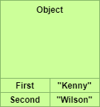

##### Initializing Object Properties

The following defines an object using literal format.

var name = {

    First : "Kenny",

    Second: "Wilson"

}

Although the literal format is the preferred way on initializing a new object, we can also use the following form.

var o1 = new Object();

o1.First = "Kenny";

o1.Second = "Wilson";

We can also use variables to initialise object properties. The property name takes the variable’s name, and the property value takes the variable’s value.

var first = “Kenny”;

var o2 = {first};

console.log(o2);

>> {first:”Kenny”}

##### Accessing Object Properties

Given an object we can access its properties use the ‘.’ operator or by using a string key.

// Accessing using '.’ operator

console.log(o3.Name.FirsName);

// Accessing using string keys

var key = "Name";

console.log(o3[key]["SecondName"]);

##### Complex Properties

An object’s property values can themselves be other objects giving us complex properties.

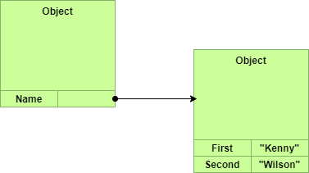

var o3 = {

    Name :

    {

        First: "Kenny",

        Second: "Wilson",

    },

}

#### Methods

Because functions are first class objects, we can set an object’s property value to be a function thereby creating a method.

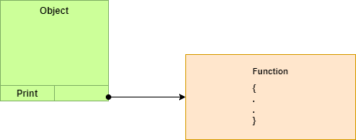

var o5 = {

    Print: function() {

        console.log("Hello World");

    }

}

o5.print();

>> Hello World

##### Execution Context (this)

In JavaScript, this refers to an execution context. It allows us to carry out the following.

var o5 = {

    name:"Kenny",

    print: function() {

        console.log("Hello World " + this.name);

    }

}

o5.print();

>> Hello World Kenny

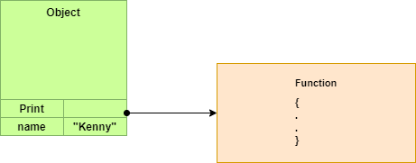

We need to be careful. When invoked through the o5 object using the ‘.’ Operator, this is defined to be the object o5. If we store the method in a variable as follows this becomes the global context.

var o5 = {

    name:"Kenny",

    print: function() {

        console.log("Hello World " + this.name);

    }

}

var f = o5.print;

f();

>> Hello World undefined

##### Bind

To fix the problem mentioned in the previous section we can bind an execution context to a method.

var o5 = {

    name:"Kenny",

    print: function() {

        console.log("Hello World " + this.name);

    }

}

var f = o5.print.bind(o5);

f();

>> Hello World Kenny

A little mind bending is the following. Because the function f is taking the global execution context and because undeclared variables belong to the global context, we get the following.

var o5 = {

    name:"Kenny",

    print: function() {

        console.log("Hello World " + this.name);

    }

}

name= "John";

var f = o5.print;

f();

>> Hello World John

##### Call

An alternative to bind is to use the call method on the function to pass in an execution context.

var f = o5.print.bind(o5);

f.call(o5);

#### Prototypes

Unless explicitly disabled, all objects in JavaScript have a prototype which provides a set of common methods. Consider the following piece of code.

var o5 = {

    name:"Kenny",

}

JavaScript will implicitly set the prototype of this object to be the default prototype.

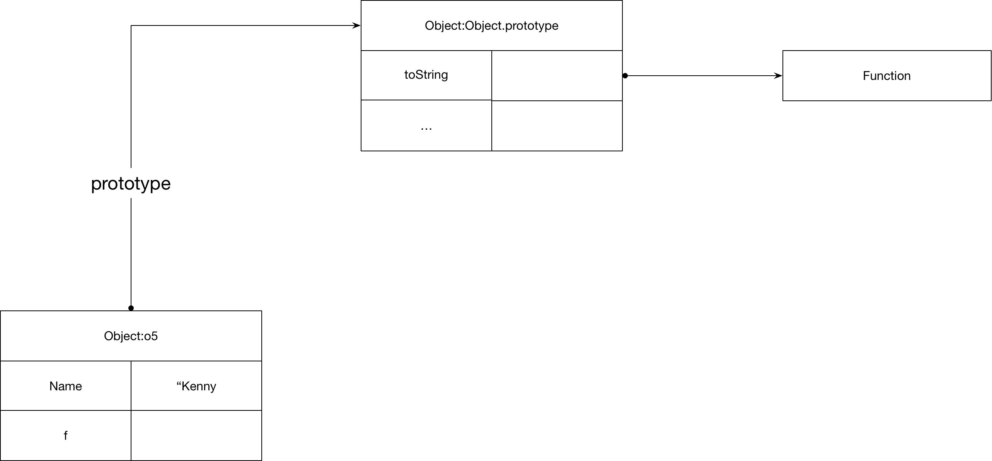

This prototype, which can be accessed explicitly as Object.prototype, provides common behaviour such as the toString method. When we access a property on our object, JavaScript will first look for a definition on the object itself and if none is found it then looks on the prototype.

console.log(o5.toString());

>> [object Object]

We can access the prototype of an object using the Object.getPrototype method.

console.log(Object.prototype == Object.getPrototypeOf(o5));

>> true

#### Custom Prototypes

We can create our own prototypes to provide common behaviour across a set of objects. The following code fragment shows how to create such a prototype. Note the importance of the execution context this. Each object provides its own execution context this We can see from this code that a prototype is just a standard JavaScript object.

var a = {

    first:"Kenny",

    second:"Wilson",

}

var b = {

    first:"John",

    second:"Smith",

}

var NameProto = {

    fullName: function() {

        return this.first + " " + this.second;

    }

}

Object.setPrototypeOf(a,NameProto);

Object.setPrototypeOf(b,NameProto);

console.log(a.fullName());

console.log(b.fullName());

>> Kenny Wilson

>> John Smith

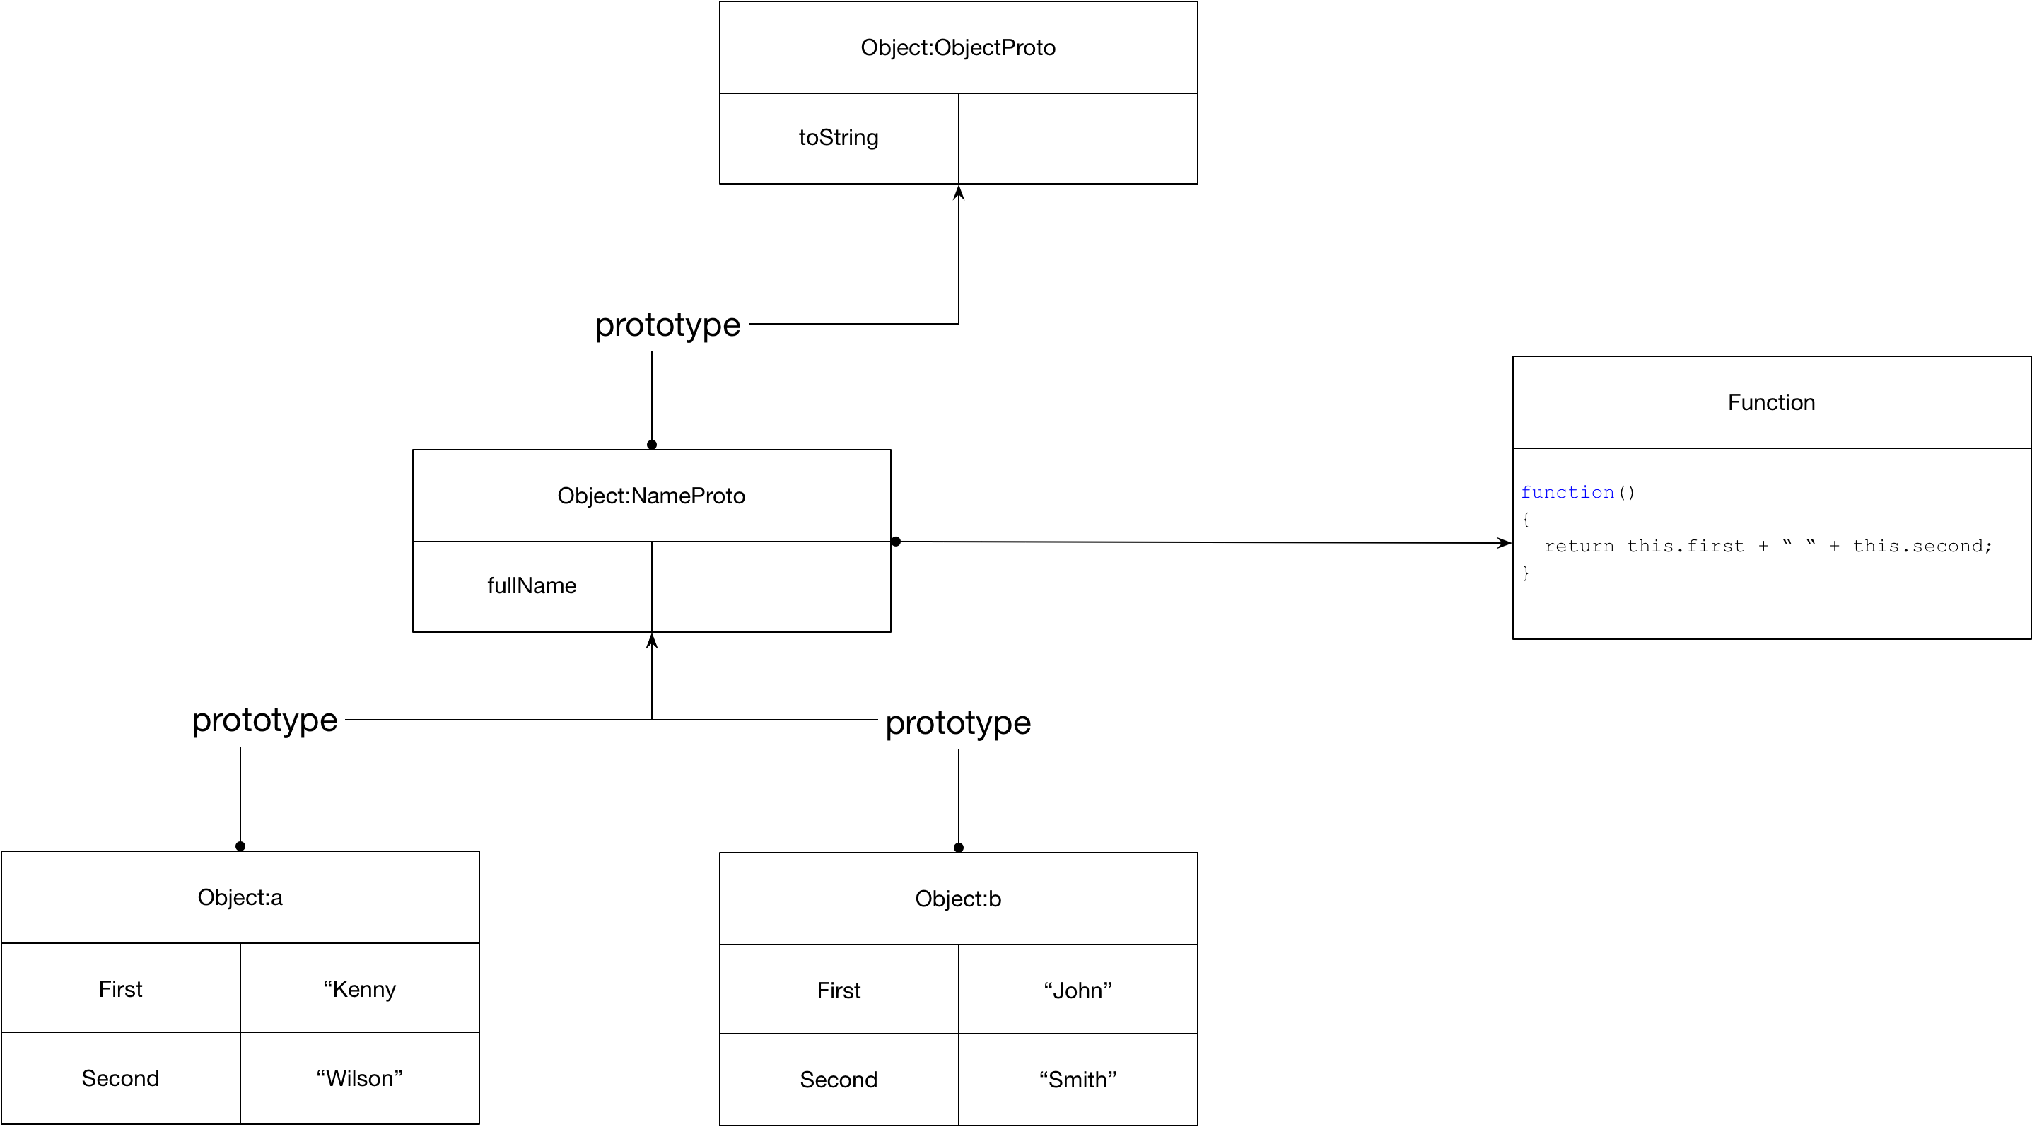

##### Overriding Methods

We saw that Object.prototype provides a toString method. If we want our own implementation, we can add a method to our custom prototype. Because the method resolution walks back up the prototype chain it will find our method first and hence that will override the one further up the chain in Object.prototype.

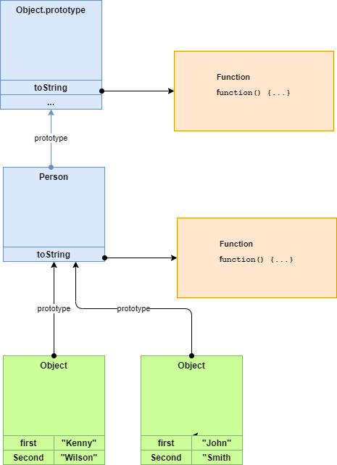

var a = {

    first:"Kenny",

    second:"Wilson",

}

var b = {

    first:"John",

    second:"Smith",

}

var Person = {

toString: function() { return this.first + " " + this.second }

}

Object.setPrototypeOf(a, Person );

Object.setPrototypeOf(b, Person );

console.log(a.toString());

>> Kenny Wilson

#### Constructors

The code in the previous section was a little longwinded. Each object must duplicate the field initialization logic and we need to explicitly set the prototype on each object. Constructor functions provide a much more succinct way of achieving this.

let Person = function(first, second)

{

    this.first = first;

    this.second = second;

}

let a = new Person("Kenny", "Wilson");

let b = new Person("John", "Smith");

console.log(a.toString());

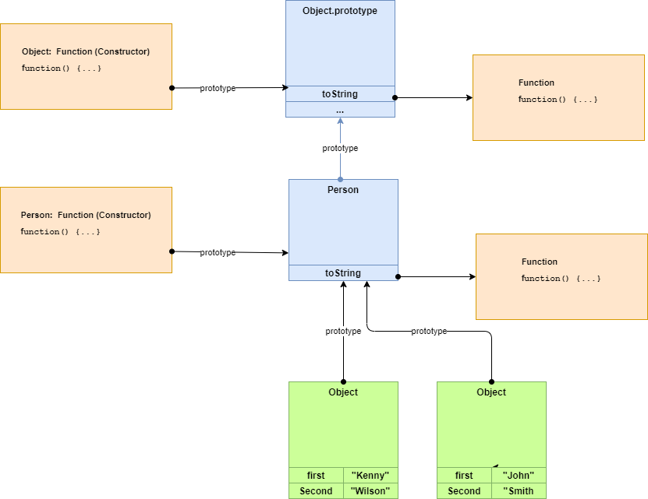

A constructor functions prototype field is, rather confusingly, the prototype of the objects it creates and not its own prototype. The constructor function creates a new object, initializes its fields, and associates it with a prototype of the same name as the constructor function.

##### Chaining Constructors

We need to be careful when chaining constructors.

let Person = function(first,second)

{

    this.firstName = first;

    this.secondName = second;

}

Person.prototype.fullName = function()

{

    return this.firstName + " " + this.secondName;

}

let Employee = function(first,second,salary)

{

**Person.call(this,first,second);**

    this.salary = salary;

}

**Object.setPrototypeOf(Employee.prototype,Person.prototype);**

Employee.prototype.tax = function () {return this.salary * 0.4};

 var emp = new Employee('Kenny', 'Wilson',100000);

 console.log(emp.fullName());

 console.log(emp.tax());

>> Kenny Wilson

>> 100000

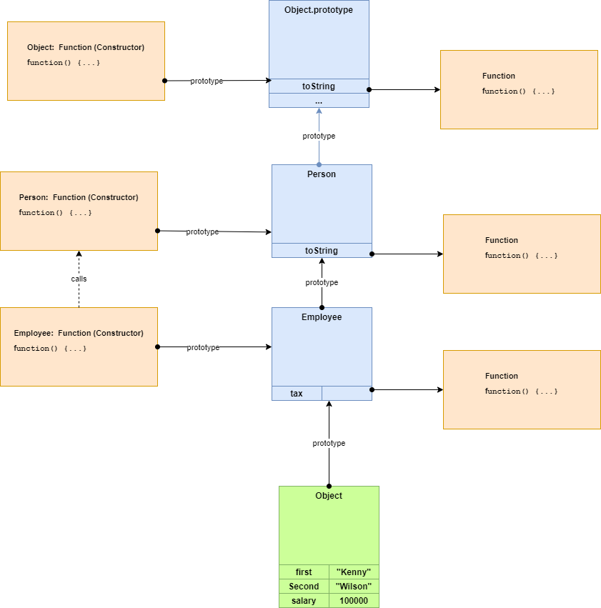

##### Overridden methods

When we override a method, we might want the overridden method to be called from the new method.

Employee.prototype.fullName = function() {

    let base = Person.prototype.fullName.call(this);

    return base + " " +  this.salary;

}

 var emp = new Employee('Kenny', 'Wilson',100000);

 console.log(emp.fullName());

 console.log(emp.tax());

>> Kenny Wilson 100000

>> 40000

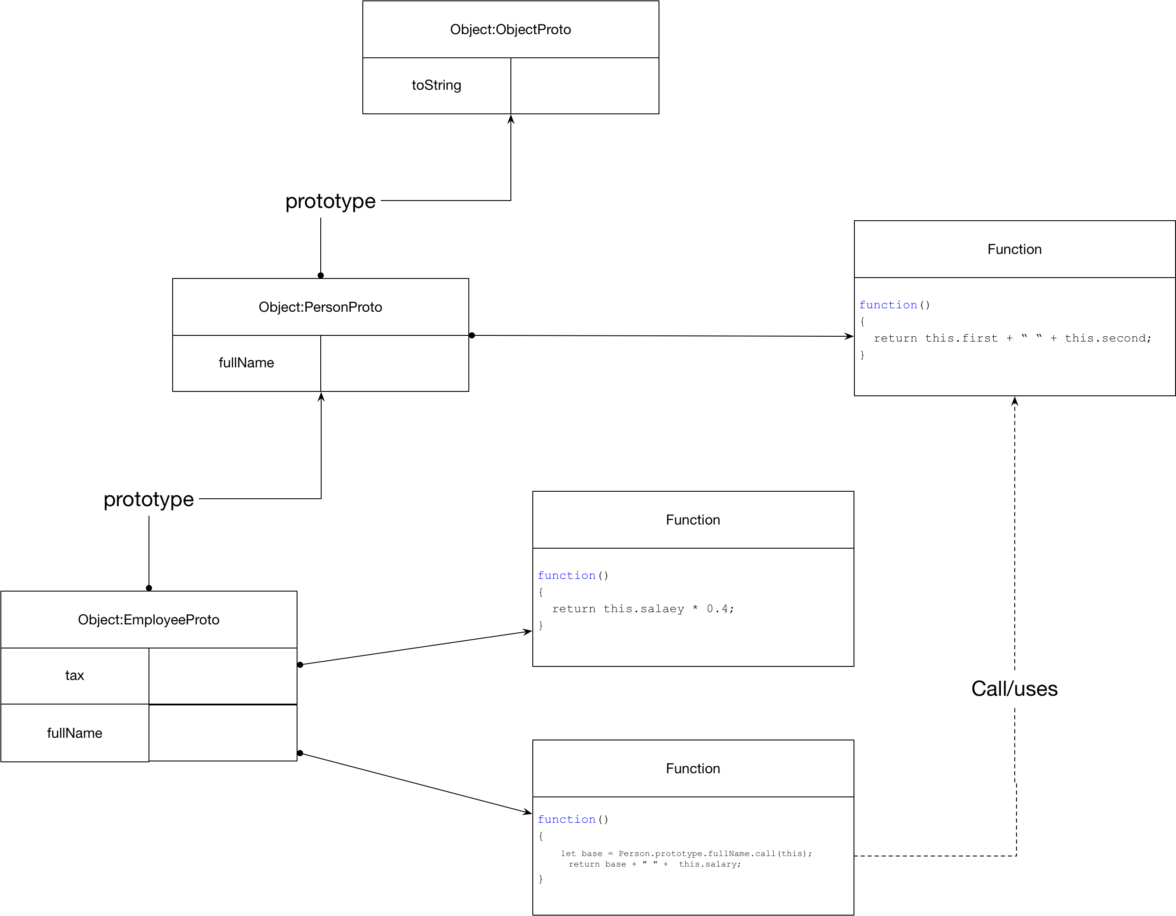

##### Instanceof

var emp = new Employee('Kenny', 'Wilson',100000);

console.log(emp instanceof Person);

console.log(emp instanceof Object);

>> true

>> true

##### Static Properties and methods

Static properties and methods are just properties and methods on the Constructor function object.

let Name = function(first, second)

{

this.first = first;

this.second = second;

Name.count = Name.count+1;

}

Name.prototype.fullName = function() {

return this.first + " " + this.second;

}

// Add a static variable to the Name type

Name.count = 0;

// Add a static method

Name.printCount = function() {

console.log("Count is " +Name.count);

}

console.log(Name);

>> [Function: Name] { count: 2, printCount: [Function] }

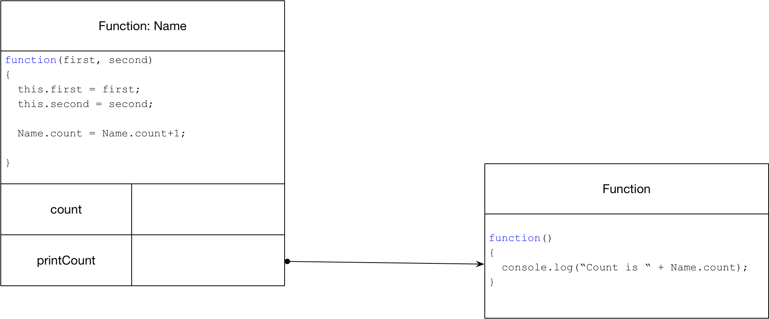

##### Getters and Setters

We can create getters and setters as follows.

Object.defineProperty(Car.prototype,"length", {

    get: function() {return this._length;},

    set: function(length) {this._length=length;}

});

car.length = 100;

console.log(car.length);

#### Properties

##### Checking Existence

The in operator checks if a property exists in an object or in any of the prototypes in its prototype chain.

let aname = {

    first : "Kenny"

}

console.log("first" in aname);

console.log("toString" in aname);

>> true

>> true

The method hasOwnProperty checks if a property exists in an object. The prototype chain is not checked.

console.log(aname.hasOwnProperty("first"));

console.log(aname.hasOwnProperty("toString"));

>> true

>> false

##### Property Attributes

Properties specified in an object literal are writable and enumerable. If we want our properties to have different attributes, we can use the Object.define function. The full list of attributes is listed [here](https://developer.mozilla.org/en-US/docs/Web/JavaScript/Reference/Global_Objects/Object/defineProperty). The following shows how to create a read-only, non-enumerable property.

let n = {

    first: 'kenny',

    second: 'wilson'

}

Object.defineProperty(n, 'age', {

    value: 42,

    writable: false,

    enumerable: false

  });

##### Enumerating properties

Consider the following object.

let n = {

  first: 'kenny',

  second: 'wilson'

}

Object.defineProperty(n, 'age', {

  value: 42,

  writable: false,

  enumerable: false

});

We can list the enumerable properties as following.

console.log(...Object.keys(n)); // first second

We can include the enumerable properties as following.

console.log(...Object.getOwnPropertyNames(n)); // first second age

### Arrays

Arrays in JavaScript can be spare. Consider the following examples.

let a3 = [];

a3[2] = 'a';

console.log(...a3);     // undefined undefined a

console.log(a3.length); // 3

let a4 = ['a'];

a4.length = 3;

console.log(...a4);    // a undefined undefined

let a5 = ['a','b','c'];

a5.length = 1;

console.log(...a5);  // a

#### Adding to Front/Back

We use push to add a new element at the end of the array and unshift to add a new element at the beginning of the array.

let a = ['c'];

a.push('d')

console.log(...a); // c d

a.unshift('b');

console.log(...a); // b c d

### Modules

#### ES5 Vs Es6

JavaScript modules have changed a lot down the years. Let us look at modules in es5 and es6.

##### ES5

The code is listed [here](https://bitbucket.org/kennyrnwilson/javascriptbasics/src/master/language-core/modules/es5/). Run the example by typing the following command from the directory that contains modconsumer.js

node modconsumer.js

Listing 1 es5mod.js

var myModule = {

    add: function(x,y) { return x+y},

    sub: function(x,y) { return x-y}

}

module.exports = myModule;

Listing 2 modconsumer.js

var myModule = require('./es5mod');

console.log(myModule.add(10,20));

##### ES6

ES6 modules, also known as ESM, are file based. One file contains one module. We do not have to explicitly use strict mode with ES6 modules because they are automatically strict mode. Unlike older module formats ES6 modules do not require instantiation. Instead, we just import its exported symbols. ES6 modules are effectively singletons in that there is only ever one instance created.

If we only use ES6 modules each module imports references from other ES6 modules it needs, thereby minimising any interaction with the global scope which is a huge advantage.

The code is listed [here](https://bitbucket.org/kennyrnwilson/javascriptbasics/src/master/language-core/modules/es6/). Run the example by typing the following command from the directory that contains modconsumer.js Note that to run ES6 modules using node we need to add "type": "module" to the package.json at the top level.

node modconsumer.js

Listing 3 es6mod.js

var myModule = {

add: function(x,y) { return x+y},

sub: function(x,y) { return x-y}

}

export default myModule;

Listing 4 modconsumer.js

import myModule from './es6mod.js';

console.log(myModule.add(10,20));

#### Singleton

If multiple modules include the same module then only one copy is created so we can export consts from a module to create effective singletons.

See this [example](https://bitbucket.org/kennyrnwilson/javascriptbasics/src/master/language-core/modules/multipleimports/)

### Types

JavaScript has a simple Type System consisting of the following types.

* string
* number
* boolean
* undefined
* null
* object

Undefined is the default value for uninitialized variables. Undefined is also a data type. Null is also a data type.

#### Truth

|  |  |
| --- | --- |
| Name | Code |
| 0 | false |
| Non-zero number | True |
| Undefined | false |
| NaN | false |
| {} | true |
| [] | true |
| Null | false |
| Null | False |
|  |  |

#### Numbers

64 bit IEEE 754 standard floating point numbers which support integers from -2^53 to 2^53 inclusive.

#### Dates

Number of milliseconds since January 1st 1970.

#### String

[Mozilla String Reference](https://developer.mozilla.org/en-US/docs/Web/JavaScript/Reference/Global_Objects/String)

Immutable sequence of Unicode values. There are no characters in JavaScript only strings with one element.

### Operators

!! Convert to bool.

> !!''

> false

|| to provide default value.

>> const v = input || "kenny"

>> undefined

>> v

>> “kenny

### Equality

JavaScript provides the double equals operator == and the triple equals operator === . The double equals operator uses type coercion where the two operands have different types. The triple equals operator does not use type correction. Where both arguments are of the same type both operators behave the same. Primitive types use value comparison.

let c = "Kenny";

let d = "Kenny";

console.log(c == d);

console.log(c === d);

>> true

>> true

Object types use reference comparison.

let a = { name:"Kenny"};

let b = { name: "Kenny"};

console.log(a == b);

console.log(a === b);

>> false

>> false

Arrays are objects

let a = [1,2,3];

let b = [1,2,3];

console.log(a == b);

console.log(a === b);

>> true

>> true

The double equals performance type correction.

console.log( "1" == 1);

console.log( "1" === 1);

>> true

>> false

### Iterators, Iterables and Generators

The built-in types string, array, Map, Set and all iterable which means they can be consumed by for/of loops and rest operators.

let a = [4,8,12];

for (let idx of a)

{

    console.log(idx);

}

console.log(...a)

In this section we look at how iterables work. There are four key concepts when working with iterables.

* Iterable
* Iterator
* Iterator Result
* Generator

#### Iterator and Iterator Result

An iterator is an object that contains a next method that returns iterator result object. An iterator is ab object with two properties: done and value. Done indicates if the sequence is finished and value gives the value if the sequence is not complete.

{done:false,value:this.count}

Consider the following example.

let iterator = {

    count:0,

    next: function(){

        let res = (this.count < 2) ?

        {done:false,value:this.count} :

        {done: true,value:undefined }

        this.count = this.count+1;

        return res;

    }

}

 console.log(iterator.next());

 console.log(iterator.next());

 console.log(iterator.next());

Running the example we see the following output.

>> { done: false, value: 0 }

>> { done: false, value: 1 }

>> { done: true, value: undefined }

#### Iterable

An iterable object is an object with a special method that returns an iterator. The following shows the relationship between an iterator and an iterable. Note the method that produces the iterator has the special key [Symbol.iterator].

let iterator = {

    count:0,

    next: function(){

        let res = (this.count < 2) ?

        {done:false,value:this.count} :

        {done: true,value:undefined }

        this.count = this.count+1;

        return res;

    }

}

 let iterable = {

    [Symbol.iterator]: function() { return iterator; }

 }

console.log(...iterable);

>> 0 1

#### Putting it together

An iterable can be consumed by the spread operator. The following shows all three parts: iterator, iterable and consumer.

// Iterator

let Iterator = function(count) {

    this.count = count;

    this.next = function() {

        let res = (this.count >=0) ?

        {done:false,value:this.count} :

        {done: true,value:undefined }

        this.count = this.count-1;

        return res;

    }

}

// Iterable

let Iterable = function(count) {

    this.count = count;

    this[Symbol.iterator] = function() {

        return new Iterator(this.count);

    }

}

// Consumer of Iterable

console.log(... new Iterable(2));

#### Generators

The Language has support for generating Iterable. We can simplify our Iterable from the previous example and get rid of the explicit Iterator object.

let Iterable = function(count) {

this.count = count;

this[Symbol.iterator] = function() {

return new Iterator(this.count);

}

}

// Consumer of Iterable

console.log(... new Iterable(2));

#### Iterable Types

The following language types are all iterable.

* String
* Array
* Map
* Set

Most build in iterables support iterating key, values, or entries.

let a = [4,8,12];

for (let idx of a.keys())

{

    console.log(idx);

}

for (let value of a.values())

{

    console.log(value);

}

for (let [idx,value] of a.entries())

{

    console.log(idx, "=",value);

}

#### Consuming Iterables

##### For of

for(let a of [1,2,3])

    console.log(a*2);

>> 2

>> 4

>> 6

##### Spread into function with rest arguments.

console.log(...[1,2,3]);

>> 1 2 3

##### Spread into function with normal arguments.

let a = [1,2,3];

add = (a,b,c) => a+b+c;

console.log(add(...a));

##### Destructuring Assignment

let [a, b, c] = new Set(['a', 'b', 'c']);

console.log(a);

>> a

##### Yield*

let f = function*()

{

    return yield* [1,2,3]

}

console.log(...f());

>> 1 2 3

### For in

The for in construct iterates all enumerable properties. When we add properties to an object by just assigning to them, they are by default enumerable.

var a = {

    first : "k",

    second: "w"

}

for (var name in a) {

    console.log(name);

}

>> first

>> second

If we want non-enumerable properties, we can use the Object.defineProperty method.

var a = {

    first : "k",

    second: "w"

}

Object.defineProperty(Object.prototype,

    "notshown",

    {enumerable:false,value:"good"});

for (var name in a) {

    console.log(name);

}

>> first

>> second

If we want to test whether a property is on the object itself and not coming from one of its prototypes, we can use hasOwnProperty

var a = {

    first : "k",

    second: "w"

}

console.log(a.hasOwnProperty("first"));

console.log(a.hasOwnProperty("toString"));

>> true

>> false

### Exceptions

throw {message: 'a'};

Questions – The Type System

## Collections

### Object as Symbol Table (Keys must be Strings)

var st = {

    kenny: new Employee('Kenny', 'Wilson', 100000),

    sanna:  new Employee('Sanna', 'Hulkki', 40000)

};

console.log(Object.keys(st));

console.log(Object.values(st));

## Collections

Any object in JavaScript can be used as a symbol table. The keys in an object are always strings.

var st = {

    kenny: new Employee('Kenny', 'Wilson', 100000),

    sanna:  new Employee('Sanna', 'Hulkki', 40000)

};

console.log(Object.keys(st));

console.log(Object.values(st));

>> [ 'kenny', 'sanna' ]

>>[

>> Employee { firstName: 'Kenny', secondName: 'Wilson', salary: 100000 },

>> Employee { firstName: 'Sanna', secondName: 'Hulkki', salary: 40000 }

>>]

We can also use a Map as a symbol table when the keys are not strings. It also has a Set which prevents duplicates.

### Lists/Arrays

### Modules

JavaScript modules have changed a lot down the years

#### ES5

Listing 5 es5mod.js

var myModule = {

    add: function(x,y) { return x+y},

    sub: function(x,y) { return x-y}

}

module.exports = myModule;

Listing 6 modconsumer.js

var myModule = require('./es5mod');

console.log(myModule.add(10,20));

#### ES6

var myModule = {

    add: function(x,y) { return x+y},

    sub: function(x,y) { return x-y}

}

export default myModule;

## The Browser

### The DOM

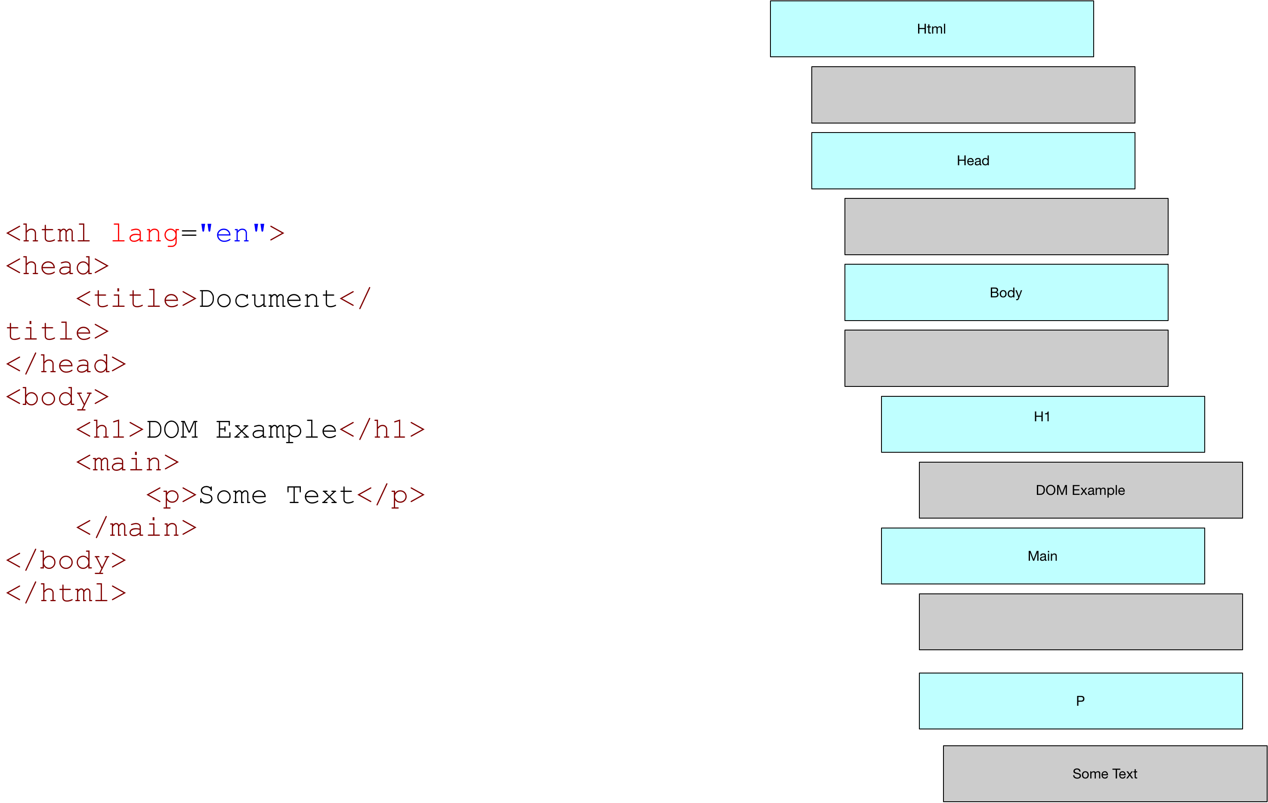

### Chrome Dev Tools

Go to the Elements tab in the dev tools and you will see the DOM tree. Select any node to see it highlighted on the rendered web page.

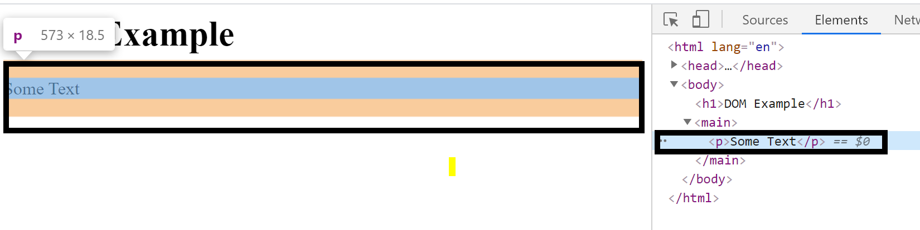

Notice the selected node has $0 beside it. We can use this to reference this node from the Console.

> $0

> <p> Some Text <p>

Notice that when we select the document, we get a view of the html in the console. And again, we can select sub-nodes in this document to see the actual rendered object on the web page.

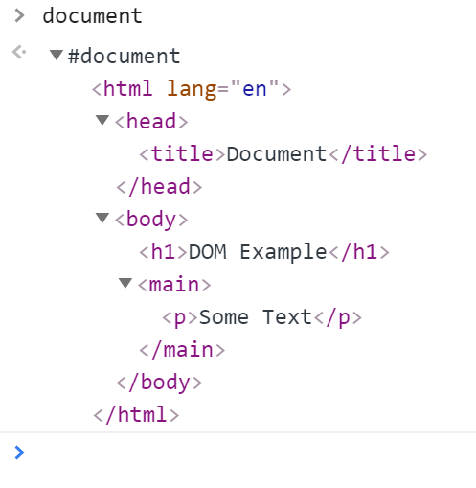

If we want to see the node as an object with its properties use the dir command.

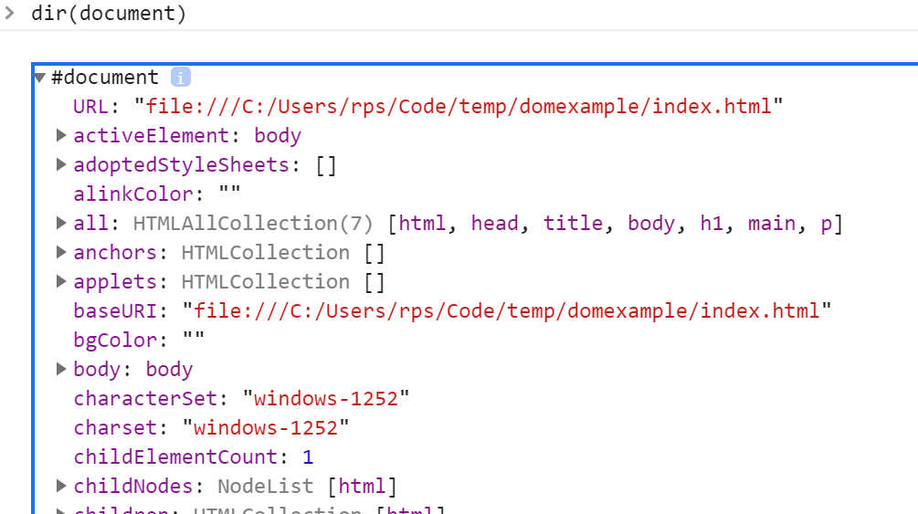

When we have selected a node in the Element tab, we can see the styles and event listeners to the side.

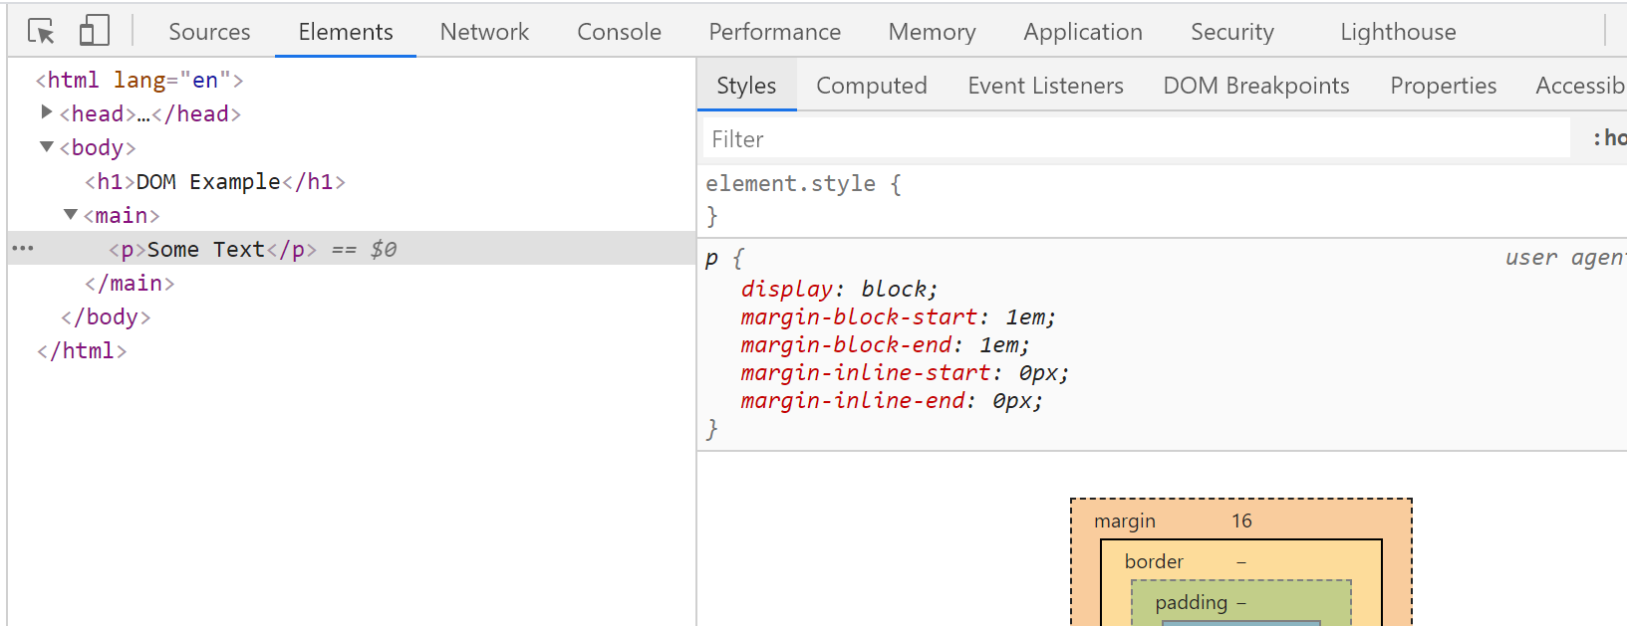

Questions – Language Basics

### Type

What are the types supported by JavaScript?

Boolean

String

Number

Undefined

Object

Null

What are the special type of objects?

Arrays and object

Variables and scope

…\Code\bitbucket\webdev\exposition\javascript\Interview Questions\2. Scope

What keywords can we use to scope variables?

let,var, const

What is the effect of var?

Creates a lexically scoped variable

What does this mean?

The variable is scoped by its execution context

Blocks have no impact on scope

If a variable is declared inside a function with var what is its execution context?

The enclosing function

If a variable is declared outside a function with var what is its execution context?

The global context

When a variable is declared with var outside of all functions the execution context is the global context

What is an undeclared variable?

A variable that is not declared with any scope modifier and is just initialised with a value

What is the scope of an undeclared variable?

The global context.

What is output of this code and why?

function f()

{

    // Undeclared variable. Implicit global execution context

    a = 10;

    // Execution context of enclosing function

    var b = 15;

}

f();

console.log(a)

10 is output because the variable a is undeclared and hence takes the global context

What is output of this code and why?

a = 5;

delete a;

console.log(a);

5

ReferenceError: a is not defined

The reason is undeclared variables can be deleted.

What is output of this code and why?

a = 10;

console.log(10);

var a;

>> 10

Declared variables are declared as if the statement was at the top of the file

What is this known as?

hoisting

What is output of this code and why?

{

    var a = 5;

}

console.log(a);

5. Because blocks have no impact on the scope of var declared variables.

What is output of this code and why?

{

    var a = 5;

}

var a;

console.log(a);

5 because re-declaring has no effect and does not clear the variable

How are variables with block scope declared?

Using let

What is output of this code and why?

{

    let mylex = 4;

}

console.log(mylex);

ReferenceError: mylex is not defined.

What is output of this code and why?

var x = 5;

var y = 6;

 {

  var x = 10;

  let y = 11;

  console.log(x);

  console.log(y);

}

console.log(x);

console.log(y);

>> 10

>> 11

>> 10

>> 6

What is output of this code and why?

let x = 1;

{

var x = 2;

}

>> SyntaxError

Closures

Equality

What is the result of this code?

let s = "10";

let t = 10;

console.log(s==t);

true

Why?

Type coercion

Functions

What is the difference between these two forms?

var sum = function(a, b)  {return a + b;}

function add(a,b) { return a+b;}

The second form allows the function to be used become it definition in the file. This is because it is treated as though the definition is at the beginning of the file.

Objects

What is the output of the following and why?

var calculator = {

    a: 10,

    b: 20,

    sum() {

        return this.a + this.b;

    },

};

var f = calculator.sum;

console.log(f());

NaN because this is not bound at the point that f is invoked because it is not invoked through the object.

Fix the code so it works

var calculator = {

    a: 10,

    b: 20,

    sum() {

        return this.a + this.b;

    },

};

var f = **calculator.sum.bind(calculator)**;

console.log(f());

What is the output of the following and why?

var calculator = {

    a: 10,

    b: 20,

    sum: () => this.a + this.b

};

console.log(calculator.sum());

NaN because the method is defined as a property which returns a lambda. The lambda has no outer function in which this is defined. So this is not defined when it is invoked.

Questions – Miscellaneous

What is transpiling?

Using at tool to covert source code to another textual source code form.

How can forward compatibility be achieved?

Transpiling newer language syntax to older language forms.

Using shims for missing API’s

Do I need to turn on strict mode inside ES6 modules?

No. All ES6 modules automatically assume strict mode.

## Development Environment

### Specified Single File

#### Run

Open a terminal and enter the command.

node hello.js

#### Run and Watch

Setup package.json if you have not already

npm init --yes

Install the nodemon node package as a development dependency.

npm install --save-dev nodemon

If we want to run the dev dependency from the terminal we use the npx command

npx nodemon hello.js

#### Run as Script

As we install it as a dev dependency, we can only run it from the scripts section of package.json

{

"name": "JS",

"version": "1.0.0",

"description": "",

"main": "test.js",

"scripts": {

"test": "echo \"Error: no test specified\" && exit 1",

**"watch" : "nodemon hello.js"**

},

"keywords": [],

"author": "",

"license": "ISC",

"devDependencies": {

"install": "^0.13.0",

"nodemon": "^2.0.4",

"npm": "^6.14.8"

}

}

Run the script npm run watch

#### Debug

{

"version": "0.2.0",

"configurations": [

{

"type": "node",

"request": "launch",

"name": "Launch Program",

"skipFiles": [

"<node_internals>/**"

],

**"program": "${workspaceFolder}\\hello.js"** }

]

}

You can now run or debug the file which has focus by using the command Ctrl-F5 or F5 respectively on windows.

#### Debug with Watch

Setup a launch.json target as follows. Make sure nodemon is installed globally

        {

            "name": "Launch server.js via nodemon",

            "type": "node",

            "request": "launch",

            "runtimeExecutable": "nodemon",

            "program": "${workspaceFolder}/hello.js",

            "restart": true,

            "console": "integrated

Terminal",

            "internalConsoleOptions": "neverOpen"

          }

Now run or debug it using Ctrl-F5 or F5 respectively

For more details see

<https://code.visualstudio.com/docs/nodejs/nodejs-debugging>

### Currently Selected File

#### Debug

Add the following to your launch.json

{

"version": "0.2.0",

"configurations": [

{

"type": "node",

"request": "launch",

"name": "Launch Program",

"skipFiles": [

"<node_internals>/**"

],

**"program": "${file}"** }

]

}

}

Now use Ctrl-F5 or F5 to run or debug the currently selected file

### Tests

#### Run All Tests

First, we install jest

npm install --save-dev jest

Now we can run all the tests as

npx jest

#### Run single test file

npx jest myModule.test

#### Run Specified Test

npx jest myModule.test -t=<TestName>

#### Run all tests in Debug Mode

Add the following to vs code on Mac and run debug from the VS Code console. You will need something else on windows.

{

"name": "Debug tests single run",

    "type": "node",

    "request": "launch",

    "env": { "CI": "true" },

    "runtimeExecutable": "${workspaceRoot}/node_modules/.bin/jest",

    "args": ["test", "--runInBand", "--no-cache"],

    "cwd": "${workspaceRoot}",

    "protocol": "inspector",

    "console": "integratedTerminal",

    "internalConsoleOptions": "neverOpen"

}

#### Run Single Test File in Debug Mode

{

"name": "Debug single tests single run",

    "type": "node",

    "request": "launch",

    "env": { "CI": "true" },

    "runtimeExecutable": "${workspaceRoot}/node_modules/.bin/jest",

    "args": ["--runInBand", "--no-cache"],

    "cwd": "${workspaceRoot}",

    "program": "${fileBasenameNoExtension}",

    "protocol": "inspector",

    "console": "integratedTerminal",

    "internalConsoleOptions": "neverOpen"

}

#### Run Single Test File in Debug Mode With Watch

{

"name": "Debug single tests single run",

    "type": "node",

    "request": "launch",

    "env": { "CI": "true" },

    "runtimeExecutable": "${workspaceRoot}/node_modules/.bin/jest",

    "args": ["--runInBand", "--no-cache", "--watchAll"],

    "cwd": "${workspaceRoot}",

    "program": "${fileBasenameNoExtension}",

    "protocol": "inspector",

    "console": "integratedTerminal",

    "internalConsoleOptions": "neverOpen"

}