React

## Introduction

This document covers

Introduction

## Basics

### JSX

#### What is JSX?

JSX is a syntax extension to JavaScript that enables one to create React elements.

which can be subsequently rendered to the HTML DOM. It enables one to create expressions such as

const element = <h1 className=”myClass”>Hello World</h1>;

Upon compilation the compiler creates something like this

const element = React.createElement(

'h1',

{className: 'myClass'},

'Hello World'

)

The resulting element looks something like this

const element = {

type: 'h1',

props: {

className: 'myClass',

children: 'Hello, world!'

}

};

The generated elements can be thought of as rendering instructions. React uses these instructions to construct and update the DOM. The react elements are lightweight, immutable objects.

ReactDOM.render(

element,

document.getElementById('root')

);

#### Details

Because JSX generates JavaScript objects we can do things like this.

var flag = true;

var jsx = flag ?

<h1>Hello World</h1> :

<h1>Bye World</h1>;

We can put any valid java script inside JSX if we wrap it with curls braces.

var myName =

{

First: "Kenny",

Second: "Wilson"

};

const element = (

<div>

<h1>Name</h1>

<h2>{myName.First}</h2>

<h2>{myName.Second}</h2>

</div>

);

### React Components

#### Props

React components take a collection of properties called props and produce a react element

➊ class Hello extends React.Component {

render() {

return <h1>Hello {this.props.name}</h1>;

}

}

➋ const element = <Hello name="Wilson"/>;

➌ ReactDOM.render(

element,

document.getElementById('root')

);

➊ We create a component called Hello. Note that the component’s render method uses JSX to return a React element.

➋ We now use the component in another piece of JSX to create a higher-level element

➌ We render the element

Notice that our component names must begin with an uppercase letter. This is so JSX can distinguish between React components and HTML elements. JSX assumes anything beginning with a lower-case letter is an HTML element and anything beginning with an uppercase letter is a React Component.

Components can refer to other components in their render methods, encouraging code reuse.

Props

A component must **never** modify its own props collection.

#### State

If we want to update state in a component, rather than update the props collection, we update the **state** collection.

class Timer extends React.Component {

constructor(props) {

super(props);

this.state = {date: new Date()};

}

render() {

return (

<h1>{this.state.date.toLocaleTimeString()}</h1>

);

}

componentDidMount() {

this.timerID = setInterval(

() => this.tick(),

1000

);

}

componentWillUnmount() {

clearInterval(this.timerID);

}

tick() {

this.setState({

date: new Date()

});

}

}

Setting State

State should never be directly updated. Instead it needs to be updated inside a call to the **setState** method. We don’t use this.state.date = new Date(); Instead we use this.setState({date: new Date()});

Multiple updates can be batched together or executed asynchronously for performance. For this reason, we should use the following form when using current state to calculate the next value.

this.setState(function(➊state, ➋props) {

return {

counter: state.counter + props.increment

};

});

➊ previous state

➋ props at the time the update is applied.

Where we use separate calls to independently update different parts of state the updates are merged.

#### Events

In HTML we pass a string that contains a JavaScript statement when we register an event handler with an event. Also note the event itself is all lowercase.

<button onclick=**"handleEvent()"**>Click Me</button>

In React the event itself is camel case and the event handler is an actual java script function

<button on**C**lick=**{handleEvent}**>Click Me</button>

With HTML we generally use addEventListener if we want to add a handler to an event after the DOM element is created. In React we can just provide a handler when the element is rendered. If a component is created as a class, typically an event handler is a method on the class. Because java script methods are not bound by default, we need to make sure we bind to ensure this is available in the handler.

class MyComponent extends React.Component {

constructor(props) {

super(props);

// Make this available in the handler

this.handleEvent = this.handleEvent.bind(this);

}

handleEvent() {

/* Do Something */

}

}

### Keys

When creating lists of elements, we need to give each a special string key attribute. The keys enable react to know when list items are added, removed or changed. The value of the key must uniquely identify the element among its siblings in the list. Keys must only be unique within the containing list. They do not need to be unique among all lists. It is not recommended to use the index of an element itself as a key.

### Forms and controlled components

HTML form elements have their own state. The react component generating the form elements also has its own state in its state property. A controlled react component is a react component whose state property is the single source of truth. In a controlled component every state mutation has an associated handler function. We can use this to modify or validate user input.

## Overview

### Why

* UI state is hard to manage in basic JavaScript.
* Highly performant.
* Build highly scalable web applications.

## Cheating

### Basic Component

#### Functional

function FunctionalComponent() : ReactElement {

  return <h1>FunctionalComponent</h1>;

}

#### Class

class ClassBasedComponent extends Component {

  render(): ReactElement {

    return <h1>ClassBasedComponent</h1>;

  }

}

### Props

#### Functional

interface PropsShape {

  name: string;

}

function FunctionalComponent(props: PropsShape) : ReactElement {

  return <h1>Functional Component {props.name}</h1>

}

#### Class

interface PropsShape {

  name: string;

}

class ClassBasedComponent extends Component<PropsShape,{}> {

  constructor(props: PropsShape) {

    super(props);

  }

  render() : ReactElement {

    return <h1>ClassBasedComponent {this.props.name}</h1>

  }

}

### Props and State

Let us now consider a stateful component. First as a class as it is easier. Note how we also deal with event handling in this sample.

#### Class

interface PropsShape {

 initialNumber: number;

}

interface StateShape {

 current: number;

}

export default class ClassBasedComponent extends

Component<PropsShape,StateShape> {

   constructor(props:PropsShape)

   {

       super(props);

       this.state = {current:props.initialNumber};

       this.handleClick = this.handleClick.bind(this);

   }

render() : ReactElement {

return <button onClick={this.handleClick}>

{this.state.current}

</button>;

}

   handleClick() {

       this.setState((state:StateShape) => {

           return ({current:state.current*1.1});

       });

   }

}

#### Functional

And now maybe we can use a functional component. Note we must use hooks for this.

interface PropsShape {

initialNumber: number;

}

export default function FunctionBasedComponent(props:PropsShape)

: ReactElement

{

const [value, setValue] = useState(props.initialNumber);

return <button onClick={()=>setValue(value*1.1)}>{value}</button>;

}

## Lifecycle

### Simple Class Based Example

This section shows how react renders a simple class-based component.

#### Initial Render

React Lifecycle

export class SubComponent extends Component<{}, any>

{

  constructor(props: any) {

    super(props);

    console.log("SubComponent()")

    this.state = { ctr: 0 }

  }

  handleClick = () => this.setState({ ctr: this.state.ctr + 1 });

  render = () => {

    console.log("SubComponent.render()");

    return <button onClick={this.handleClick}>{this.state.ctr}</button>

  };

}

export default class App extends Component<{}, any>

{

  constructor(props: any) {

    super(props);

    console.log("App()");

    this.state = { ctr: 0 }

  }

  incrementCounter = () => this.setState({ ctr: this.state.ctr + 1 });

  render(): ReactNode {

    console.log("App.render()");

    return (

      <div>

        <button onClick={this.handleClick}>{this.state.ctr}</button>

        <SubComponent></SubComponent>

      </div>

    )

  };

  handleClick = () => this.setState({ ctr: this.state.ctr + 1 });

}

The following diagram shows the logical structure of our two react components and the DOM elements they create.

React Components and DOM Elements

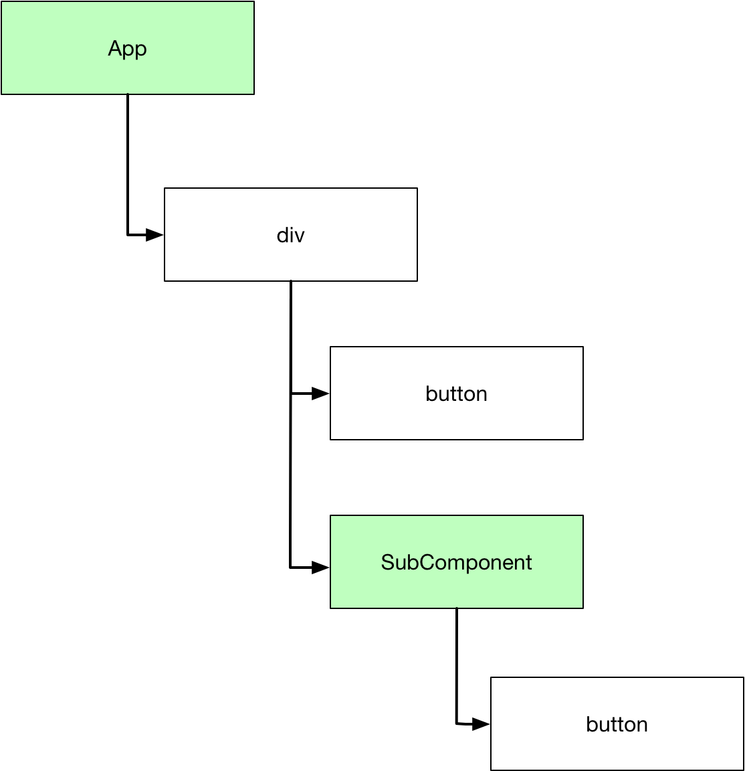

When the application starts, React asks each component to render its content. We can see the order of events by looking at the log statements output in the browser console.

App()

App.render()

SubComponent()

SubComponent.render()

#### Updates

After rendering we say the application is in a reconciled state which means the rendered content is consistent with component state. React keeps a mapping between components and the DOM elements the render

Mapping between React Components and DOM elements

Once in a reconciled state the app waits for change . Change is most likely caused by a call to setState which updates the state. Once state is updated it is possibly inconsistent with the rendered DOM so setState marks the component and any child components as stale. So If we click the button on the App to change its state then both the App and the SubComponent render methods are invoked.

App.render()

SubComponent.render()

If we click the SubComponent button so only its state is changed then its render method is called. The parent App component is not rendered.

SubComponent.render()

In order to decide whether to update the DOM react compares the content produced by components with cache of previous results knows as the virtual DOM. This mechanism prevents React from having to query the DOM to determine if anything has changed. This improves performance.

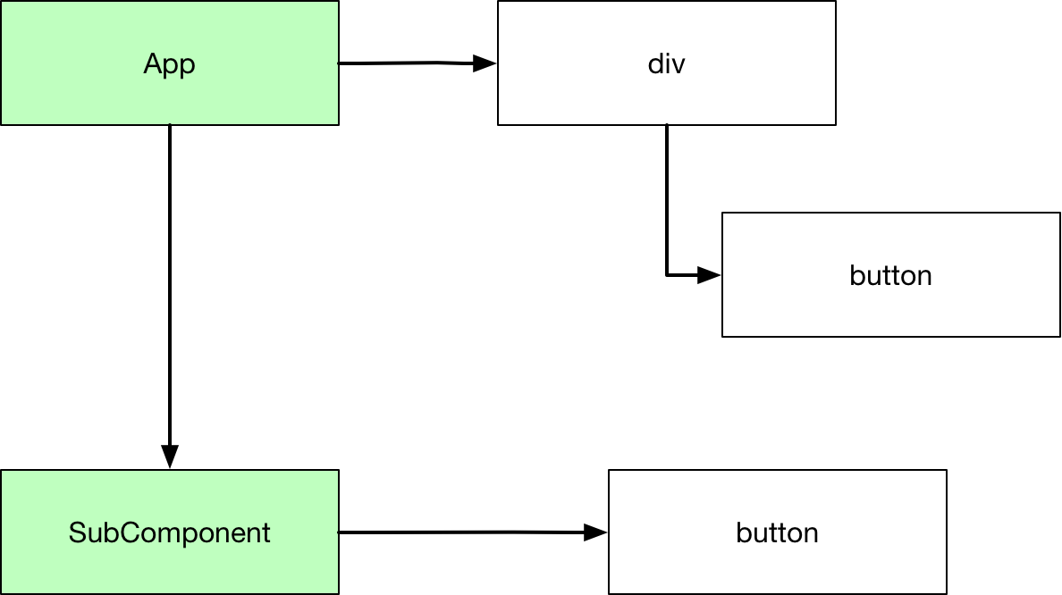

#### Full Lifecycle Events

We add some other methods and logging.

export class SubComponent extends Component<{}, any>

{

  constructor(props: any) {

    super(props);

    console.log("SubComponent()")

    this.state = { ctr: 0 }

  }

  handleClick = () => this.setState({ ctr: this.state.ctr + 1 });

  componentDidMount = () =>

    console.log("SubComponent.componentDidMount()");

  componentDidUpdate = () =>

    console.log("SubComponent.componentDidUpdate()");

  render = () => {

    console.log("SubComponent.render()");

    return <button onClick={this.handleClick}>{this.state.ctr}</button>

  };

}

export default class App extends Component<{}, any>

{

  constructor(props: any) {

    super(props);

    console.log("App()");

    this.state = { ctr: 0 }

  }

  incrementCounter = () => this.setState({ ctr: this.state.ctr + 1 });

  componentDidMount = () => console.log("App.componentDidMount()");

  componentDidUpdate = () => console.log("App.componentDidUpdate()");

  render(): ReactNode {

    console.log("App.render()");

    return (

      <div>

        <button onClick={this.handleClick}>{this.state.ctr}</button>

        <SubComponent></SubComponent>

      </div>

    )

  };

  handleClick = () => this.setState({ ctr: this.state.ctr + 1 });

}

On startup the logged events become.

App()

App.tsx:37 App.render()

App.tsx:8 SubComponent()

App.tsx:18 SubComponent.render()

App.tsx:6 SubComponent.componentDidMount()

App.tsx:26 App.componentDidMount()

And if we click a button to change the App state we see

App.render()

App.tsx:18 SubComponent.render()

App.tsx:6 SubComponent.componentDidUpdate()

App.tsx:26 App.componentDidUpdate()

### Unmounting

Now we show how unmounting works. We modify our code to conditionally show the SubComponent and add to SubComponent more logging to show what happens

export class SubComponent extends Component<{}, any>

{

  constructor(props: any) {

    super(props);

    console.log("SubComponent()")

    this.state = { ctr: 0 }

  }

  handleClick = () => this.setState({ ctr: this.state.ctr + 1 });

  componentDidMount = () =>

    console.log("SubComponent.componentDidMount()");

  componentDidUpdate = () =>

    console.log("SubComponent.componentDidUpdate()");

  componentWillUnmount = () =>

    console.log("SubComponent.componentWillUnmount()");

  render = () => {

    console.log("SubComponent.render()");

    return <button onClick={this.handleClick}>{this.state.ctr}</button>

  };

}

export default class App extends Component<{}, any>

{

  constructor(props: any) {

    super(props);

    console.log("App()");

    this.state = { show: false }

  }

  componentDidMount = () => console.log("App.componentDidMount()");

  componentDidUpdate = () => console.log("App.componentDidUpdate()");

  render(): ReactNode {

    console.log("App.render()");

    return (

      <div>

        <button onClick={this.handleClick}>{this.state.show.toString()}</button>

        {this.state.show ?

          <SubComponent></SubComponent> : ""

        }

      </div>

    )

  };

  handleClick = () => this.setState({ show: !this.state.show});

}

#### Startup

So now on startup the subcomponent is not displayed. Our messages are then

App()

App.tsx:39 App.render()

App.tsx:29 App.componentDidMount()

Now we click the button to add the subcomponent

App.render()

App.tsx:7 SubComponent()

App.tsx:21 SubComponent.render()

App.tsx:5 SubComponent.componentDidMount()

App.tsx:29 App.componentDidUpdate()

Now we click the subcomponent button to modify the subcomponent

SubComponent.render()

App.tsx:5 SubComponent.componentDidUpdate()

Now click the App button to remove the subcomponent

App.render()

App.tsx:5 SubComponent.componentWillUnmount()

App.tsx:29 App.componentDidUpdate()

### Functional Components

#### Basics

The lifecycle is a little more complex with functional component. Our code is rewritten as follows

export function SubComponent() : ReactElement {

  console.log("SubComponent()");

  const [ctr, setCtr] = useState(-0);

  return <button onClick={() => setCtr(ctr + 1)}>{ctr}</button>

}

export default function App() : ReactElement {

console.log("App()");

const [showSub, setShowSub] = useState(false);

return (

<div >

<button onClick={() => setShowSub(!showSub)}>

{showSub.toString()}</button>

{showSub ?

<SubComponent></SubComponent> : ""

}

</div>

);

}

On startup there is no subcomponent and so we see the following

App()

}

If we click the App button the subcomponent becomes visible.

App()

App.tsx:4 SubComponent()

Now if we click the subcomponent button, we see

SubComponent()

Now we click the App button to remove the subcomponent and see

App()

#### Effects

We do not have the same lifecycle events in function components that we have in classes. We do have effects though. The useEffect feature registers a function that is invoked when a component is

* Mounted
* Updated
* Unmounted

We modify out code as follows.

export function SubComponent() : ReactElement {

  console.log("SubComponent()");

  const [ctr, setCtr] = useState(-0);

  useEffect(

      () => {

         console.log("Subcomponent.useEffect()");

         return () => {

          console.log("Subcomponent.effectTeardown()");

         }

      }

  );

  return <button onClick={() => setCtr(ctr + 1)}>{ctr}</button>

}

export default function App() : ReactElement {

  console.log("App()");

  const [showSub, setShowSub] = useState(false);

  useEffect(

    () => {

       console.log("App.useEffect()");

       return () => {

        console.log("App.effectTeardown()");

       }

    }

);

  return (

    <div >

      <button onClick={() => setShowSub(!showSub)}>

        {showSub.toString()}</button>

      {showSub ?

        <SubComponent></SubComponent> : ""

      }

    </div>

  );

}

Now when we start the app we see.

App()

App.tsx:26 App.useEffect()

If we click the button to add the subcomponent we see.

App()

App.tsx:4 SubComponent()

App.tsx:9 Subcomponent.useEffect()

App.tsx:29 App.effectTeardown()

App.tsx:26 App.useEffect()

Questions – Basics

Overview

What is the philosophy of React?

Couple together rendering and logic.

What is the React abstraction that facilitates this?

React Components contain both markup and logic.

JSX

What is JSX?

A Syntax extension to JavaScript

What is JSX used for?

To create react elements.

The elements can be rendered to the DOM.

Given the following JSX show what JS a compiler might generate?

const element = <h1 className=”myClass”>Hello World</h1>;

const element = React.createElement(

'h1',

{className: 'myClass'},

'Hello World'

)

What are react elements?

Descriptions of what we want rendered to screen.

React uses them to construct the DOM and keep it up to date

How do we modify react elements?

We cannot. They are immutable once created.

How do react elements differ from DOM elements?

They are lightweight and cheap to create.

How does React optimise the rendering process?

React only applies DOM updates needed to bring DOM to desired state.

How does one set literal attributes for HTML elements?

Using quotes

const element = (

<input type="text" value="word">

</input>

);

How does one specify expression to the value of attributes?

Using curly braces. No quotes

var myName = "John";

const element = (

<input type="text" value={myName}/>

);

What are the HTML attributes class and tabindex called in React DOM?

className and tabIndex (Note the camel case)

Components, Props and State

What does a React Component do?

Take a collection of properties and produce a React element.

What two ways are components created?

As a function or as a class

What restrictions are there on React component names?

They must start with an uppercase letter

Why?

React treats components starting with lower case letters as DOM tags

What is the top-level component in a standalone React app called by convention?

App

When should we factor out components?

If part of the UI is used several times it is a good candidate for a component.

Props

What golden rule must all components respect?

They must behave like pure functions with respect to their props.

State

How does state differ from props?

It is private and fully controlled by the component?

How do we update state?

Always using the setState method. We only directly set the state collection in the constructor.

How do we update state?

Life Cycle

What life-cycle method runs after a component has been rendered to the DOM?

componenetDidMount

What life-cycle method is for tear down?

componnentWillUnmount

How do we update the state of a react component?

Using a set of lifecycle methods

Event Handling

## Examples

### Card

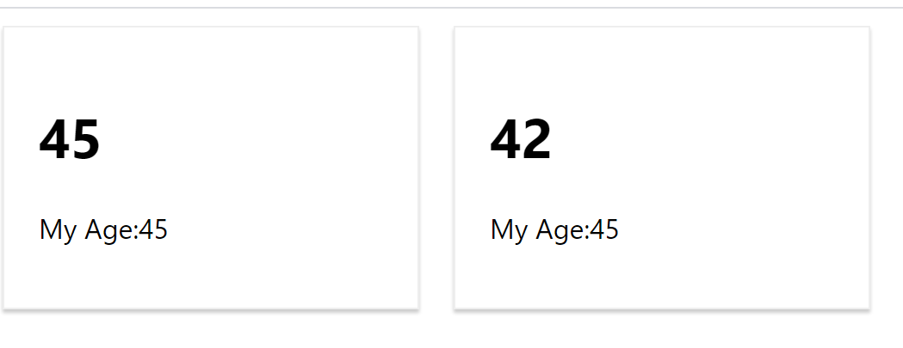

React

import React, { ReactElement } from "react";

import './Card.css';

export interface CardProps

{

    name: string;

    age: number;

}

export function Card(props: CardProps) : ReactElement

{

    return (

        <div className="person">

            <h1>{props.age}</h1>

            <p>My Age:{45}</p>

        </div>

    );

}

CSS

.person {

    display: inline-block;

    margin: 10px;

    border: 1px solid #eee;

    box-shadow: 0 2px 2px #ccc;

    width: 200px;

    padding: 20px;

  }

## Development Environment

### JavaScript

The following sections use code from [Code](https://bitbucket.org/kennyrnwilson/reactbasics/src/master/devenvs/js/jest-tests/)

#### Run all tests with Filewatch

If you create you react app using npx create-react-app my-react-app then run tests with filewatch is the default for the npm test script. From the terminal just enter the following command

npm test

#### Debug All Tests

Add the following code to your launch.config

{

"name": "Debug CRA Tests",

"type": "node",

"request": "launch",

"runtimeExecutable": "${workspaceRoot}/node_modules/.bin/react-scripts",

"args": ["test", "--runInBand", "--no-cache", "--watchAll=false"],

"cwd": "${workspaceRoot}",

"protocol": "inspector",

"console": "integratedTerminal",

"internalConsoleOptions": "neverOpen",

"env": { "CI": "true" },

"disableOptimisticBPs": true

}

Then just press F5.

#### Debug Single Test

Install the Jest plugin to Visual Studio Code

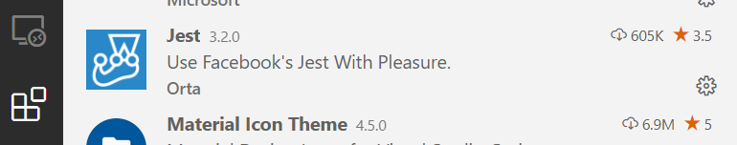

And add the following to the .vscode/settings.json

{

    "jest.debugCodeLens.showWhenTestStateIn": [

        "fail",

        "unknown",

        "pass",

        "skip"

    ]

}

You should now see the debug icon above each test

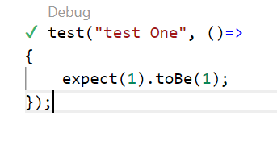

### TypeScript

The code is [here](https://bitbucket.org/kennyrnwilson/reactbasics/src/master/devenvs/ts/jest-tests/).

The following sections assume the project was setup using the following command.

npx create-react-app jest-tests --template typescript

Add the following two files to the src directory.

Listing Math.ts

export function add(a:number, b:number)

{

    return a+b;

}

Listing Math.test.ts

import { add } from "./Maths";

test("Test  One", ()=>

{

    expect(add(5,5)).toBe(10);

})

#### Run all tests with Filewatch

Simply type.

npm run test

#### Code Coverage

npx jest --coverage

#### Debug/Run Single Test No Watch

Install the Jest plugin to Visual Studio Code



And add the following to the .vscode/settings.json

{

    "jest.debugCodeLens.showWhenTestStateIn": [

        "fail",

        "unknown",

        "pass",

        "skip"

    ]

}

You should now see the debug icon above each test

