NAMES: RWAGASUNZU Seleman
:NIZEYIMANA Bernard
:NSHUTINZIZA Maxime
:MUGISHA Christian
:TUMUSIFU Cosmas
:CYIZA robert
:Adjira Bkiran Kevine
ASSESSMENT OF VERSION CONTROL

STEP 1 . git clone

Create copy of remote to local computer

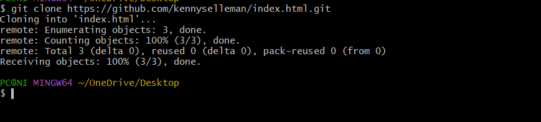

Step2

Git status

To check the current state of my local repository

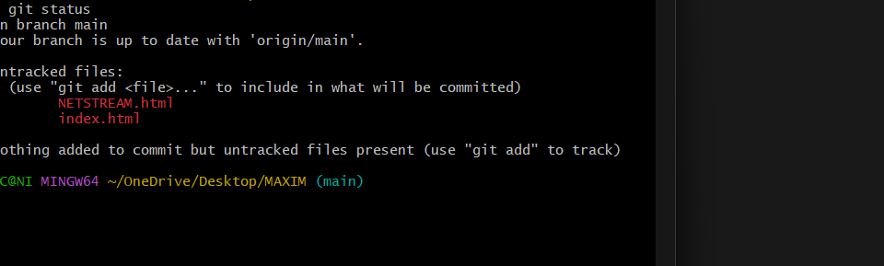

Step 3 git add .

To adding something from local to staging area

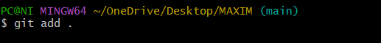

Step 4 git commit
Git commit are used to recording changes
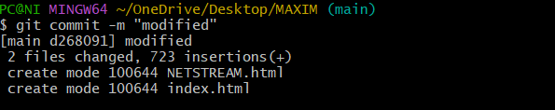
Step 4 git push

Used to put something to remote from local

