Kenneth Sexton

**Functionality –** Users can log into the Ice Cream locator tool. From there they can add store information and add what flavors they carry. Users hope that by adding their information they will be able to get more customers.

**Marketing Material -** Are you a big ice cream fan? Do you ever crave a flavor of ice cream? Using the Ice Cream Locator, you can see what stores are carrying your favorite flavors of ice cream before you even leave your house. The locator also allows you to see unique flavors in your area you have yet to try. Store owners can use the locator to promote new flavors they carry.

**Data Model**

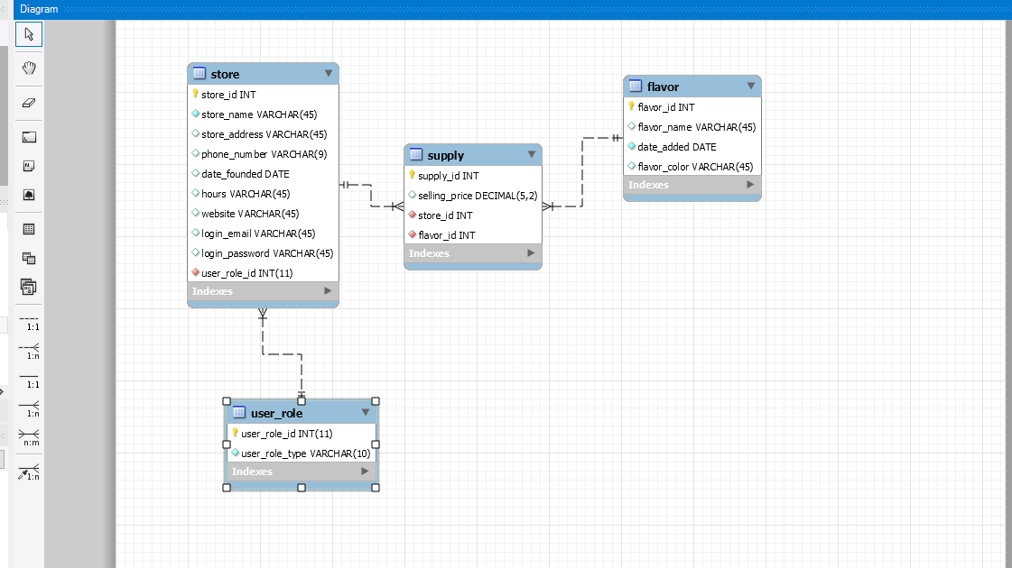

**Table Designs**

**store**

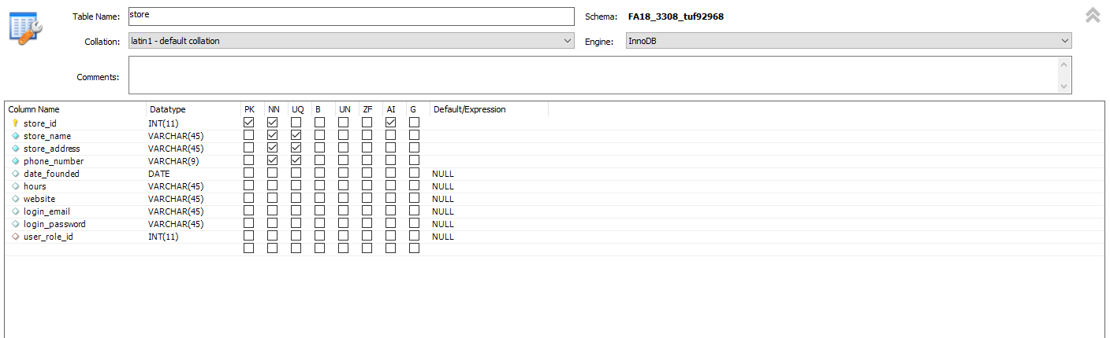

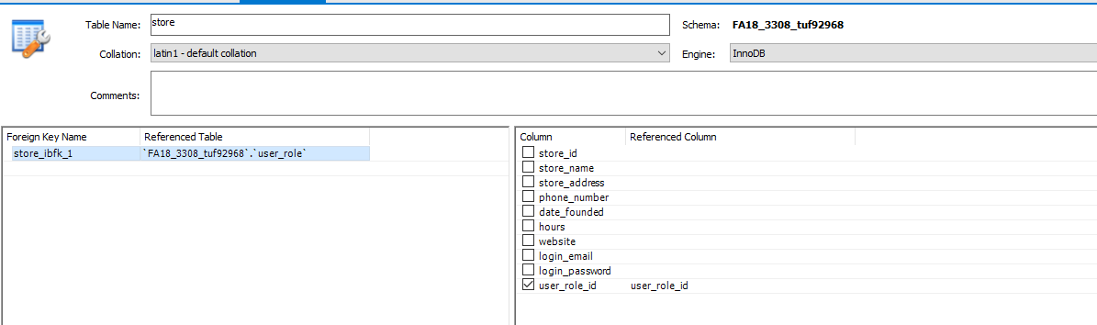

**Supply**

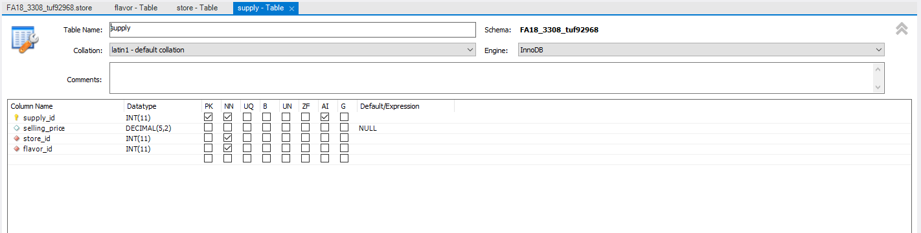

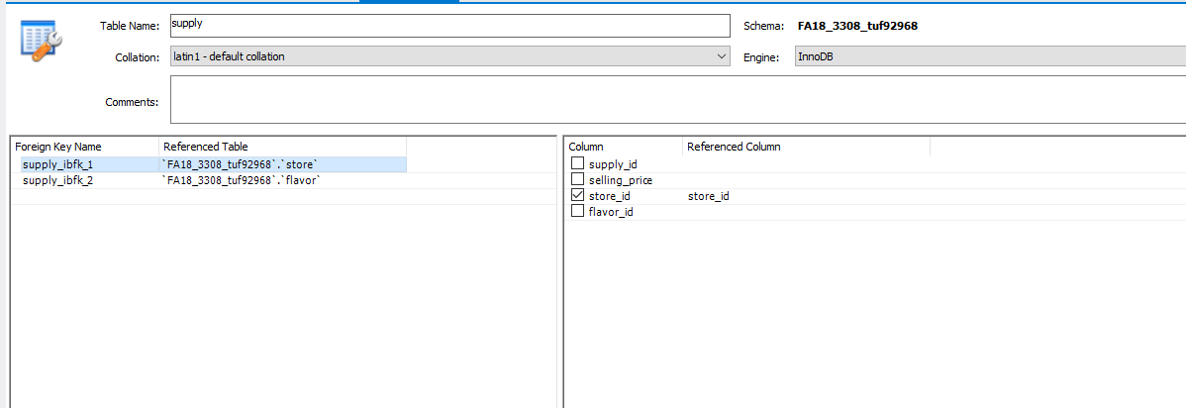

Flavor

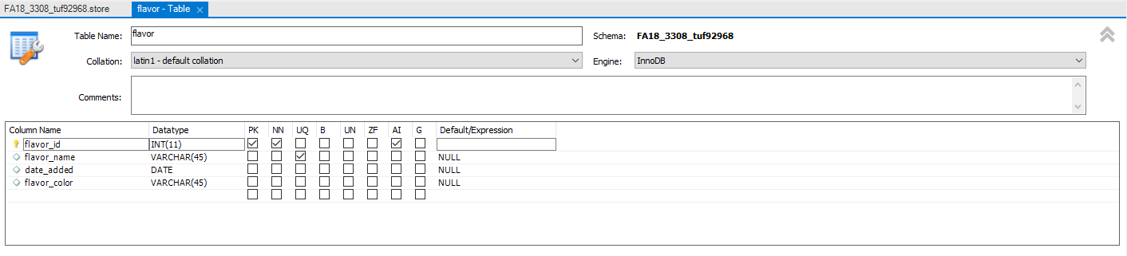

User Table

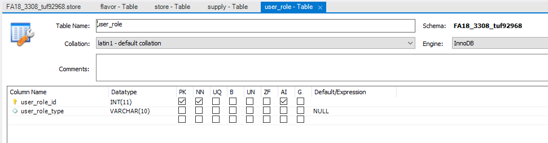

**Feedback from Class Mates**

Ryan Batschelet-

*Most of your project looks good! The functionality sounds great.*

*I think login_email is supposed to be not nullable. You need a nullable non-character field in the "other table". You need a LongText field in one of your tables. Probably like "store_description" field or something. For your associative table you need one more field and your PK should auto-increment.*

*9/10 pretty great*

*10/10 awesome, meets requirements – Christian Lomboy*

**My Feedback**

To Ryan Batschelet

*I think you might run into trouble with the game_host foreign key.  I guess every board game has an owner, but I feel like that could make this model too complex for this project.  Besides the potential issues with that, all the tables look good and fit the requirements!*

To Hyunseung Do

*Everything looks good. I suggest maybe adding a user name to the web_user table.*

**SELECT Statements**

A

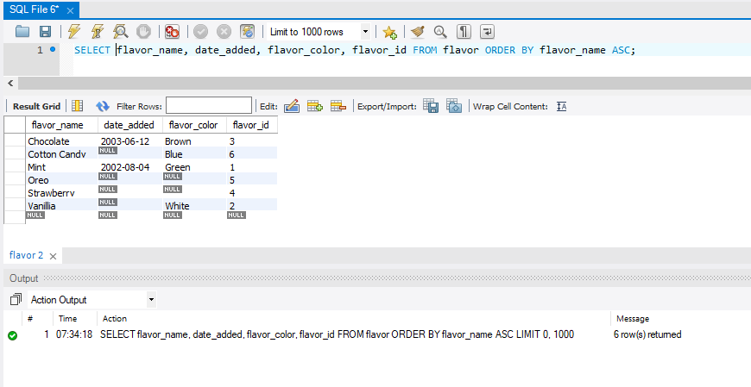

B

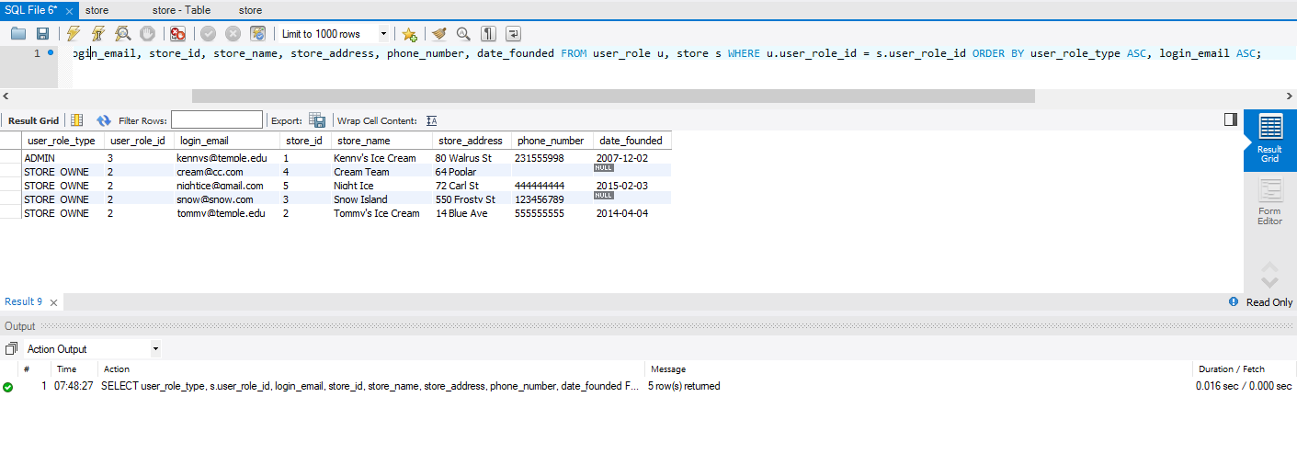

C

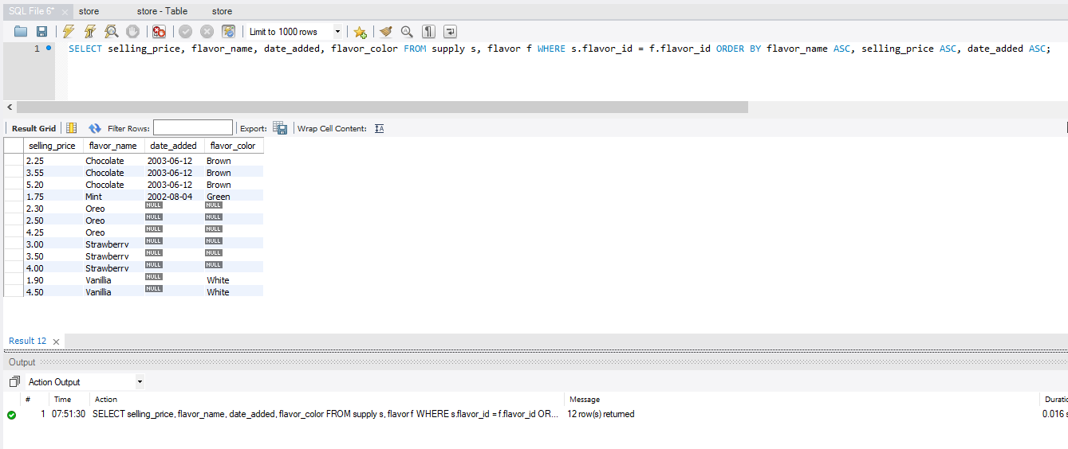

D

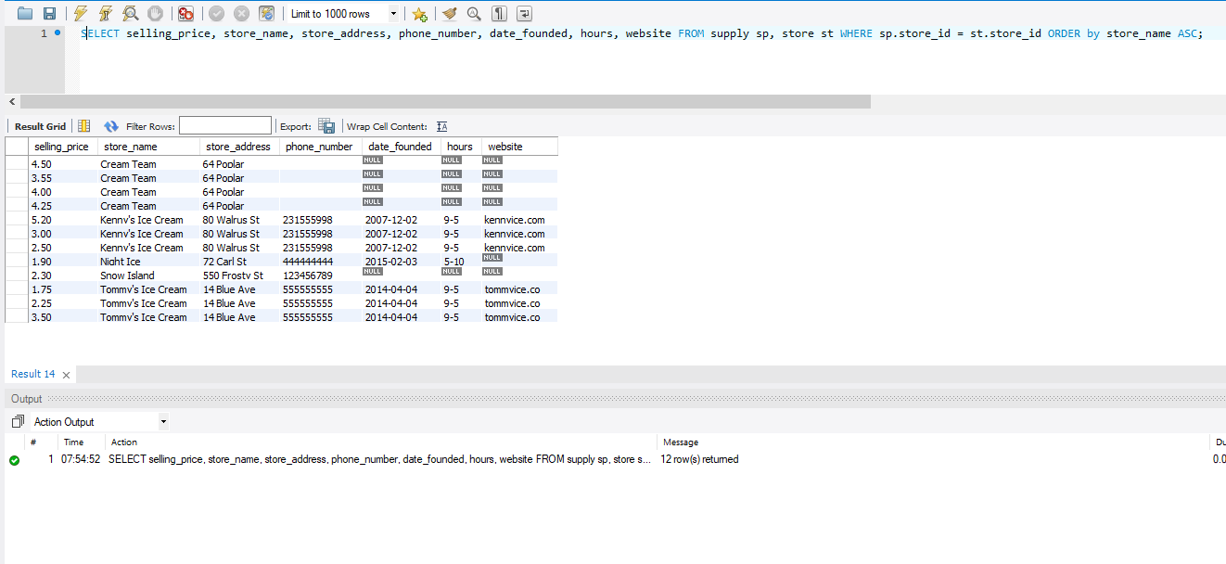

E

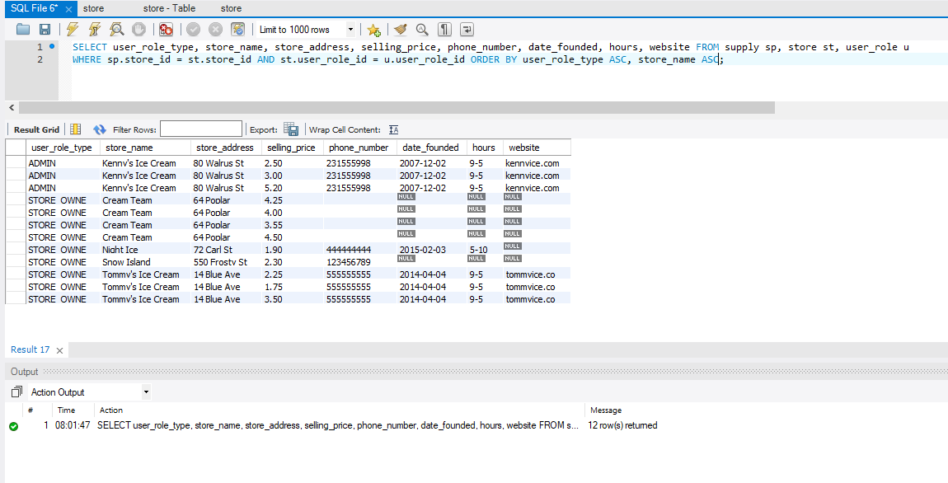

F

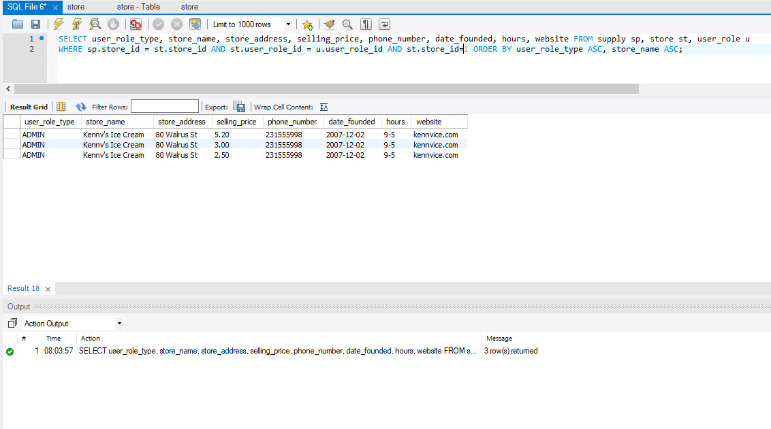

G

