# Homework 1

1. What is the title of your web application?

1. Ice Cream Locator

2. Who will be users of your web application?

• What attributes will you store for each of your users?

1. “user” table will be *Ice Cream stores*
   1. Store ID
   2. Store name
   3. Address
   4. Phone number
   5. Date founded
   6. Hours

3. What “other” table will be part of your database?

• What attributes will be stored for each record of this table?

1. “Other” table will be *Flavors*
   1. Flavor ID
   2. Flavor name
   3. Flavor img

4. What information will be stored in your associative table (the table that implements a "many to many" relationship between your "other table" and your user table)?

1. “associative” table
   1. Store ID
   2. Flavor ID

5. Explain how there is a many to many relationship between your user table and your “other” table.

1. Stores can have multiple flavors of ice creams, and ice cream flavors can exist at multiple stores

6. What functionality will your web application provide? Your application will provide the following at a very "mechanical" level, but functionally, how will users benefit from your web app?

• Users will be able to register, log on, and log off.

• Users will be able to insert (edit and delete) "other" records (whatever you decided to keep in your "other" table.

• You can pretend that users will be able to insert (edit/delete) associative records (even if you don't choose to do the "insert associative" challenge).

1. Users can log into the Ice Cream locator tool. From there they can add store information and add what flavors they carry. Users hope that by adding their information they will be able to get more customers.

7. Write 1-2 paragraphs of “marketing material” that attempts to entice people to become registered users and/or viewers of your web site. This will become the content area of your home page. In your paragraphs, do not explain to me what your web site will be able to do, write text that will entice users to visit your site.

1. Are you a big ice cream fan? Do you ever crave a flavor of ice cream? Using the Ice Cream Locator, you can see what stores are carrying your favorite flavors of ice cream before you even leave your house. The locator also allows you to see unique flavors in your area you have yet to try. Store owners can use the locator to promote new flavors they carry.

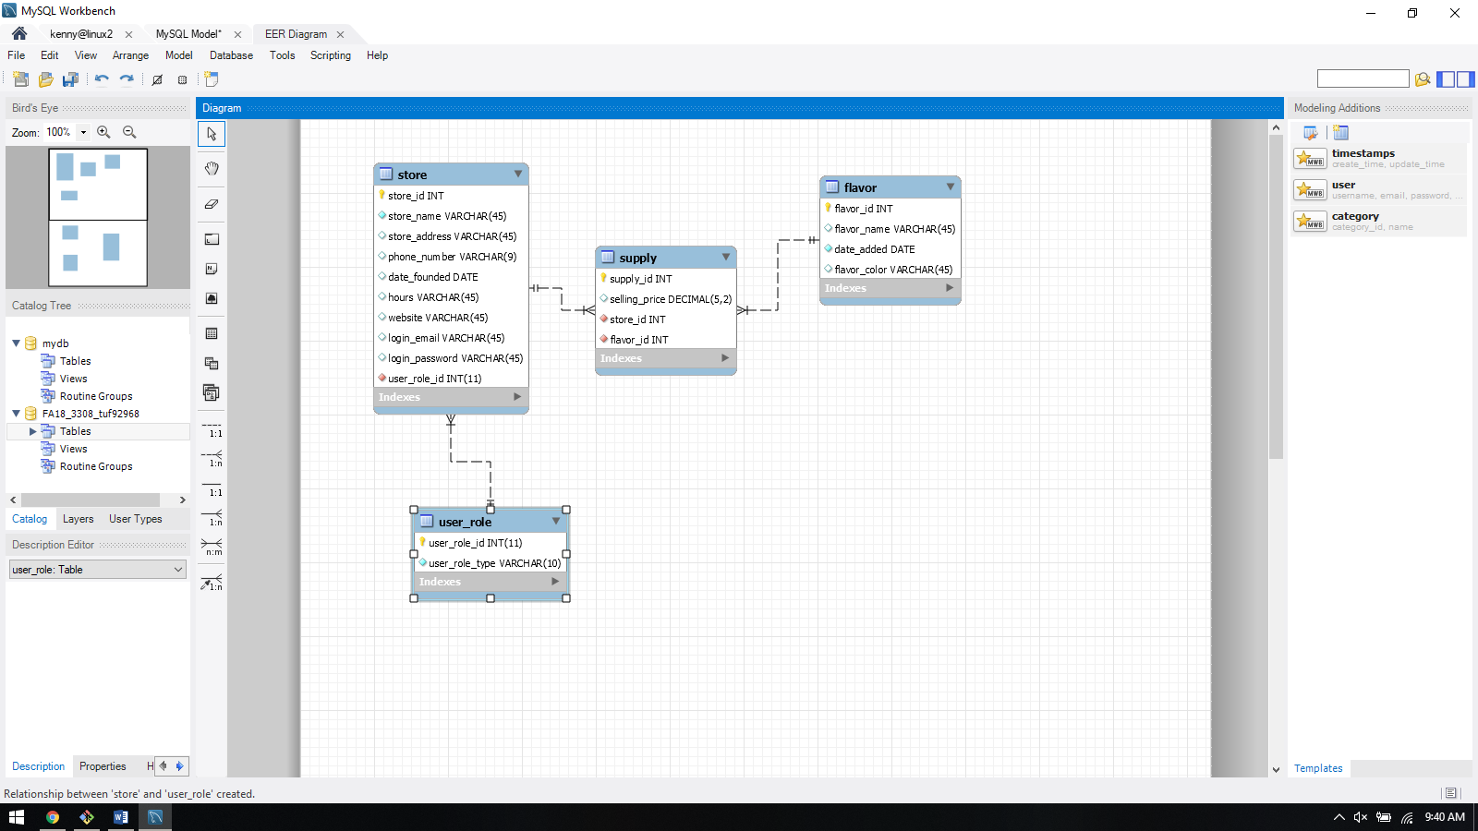**Data Model**

**Store table**

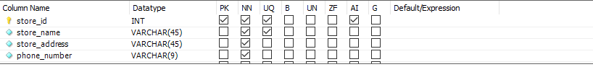

Foreign key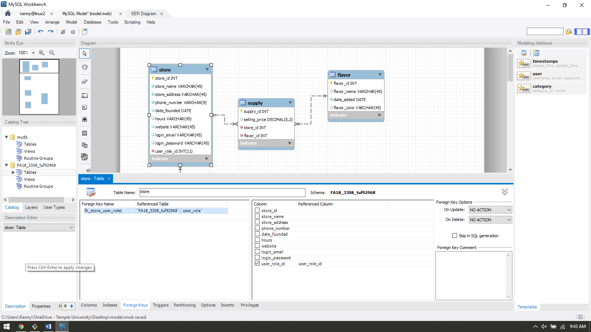

**Supply Table “associative”**

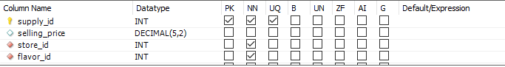

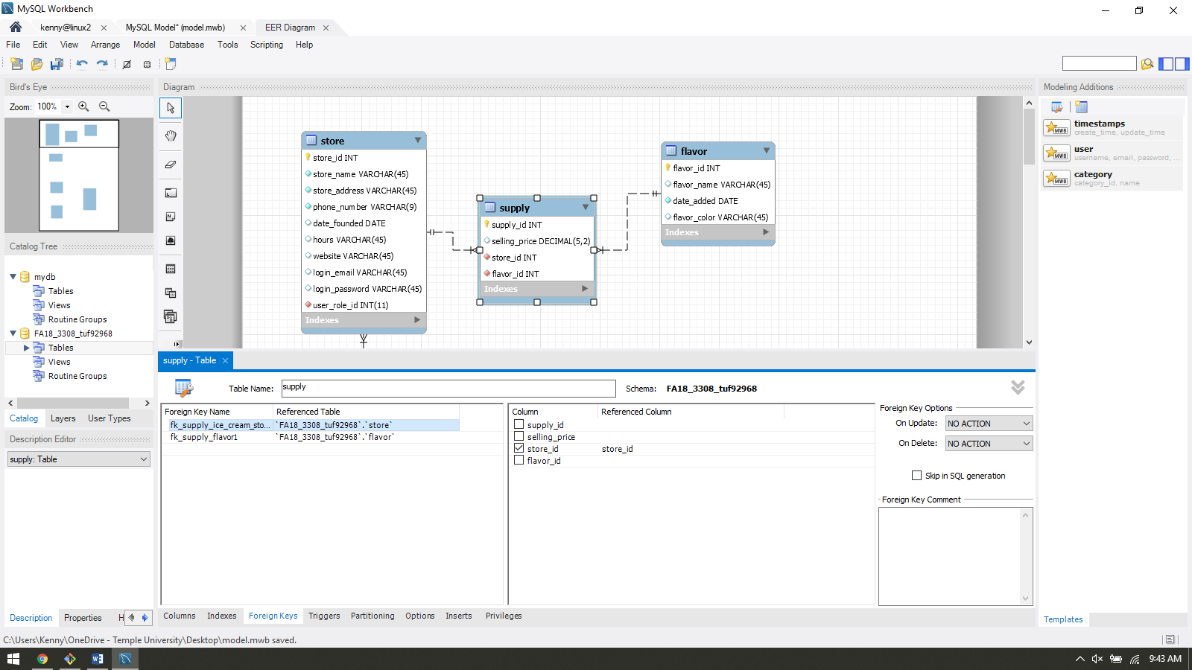

**Flavor table “other”**

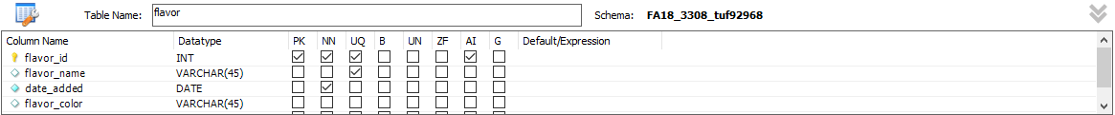

**User Table**

