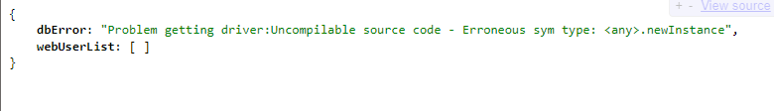

**Missing Database Driver**

Missing: Problem getting driver:Uncompilable source code - Erroneous sym type: <any>.newInstance

Description: This is caused by an error in the DBConn code that is causing a problem getting the driver. Check your DbConn code for errors.

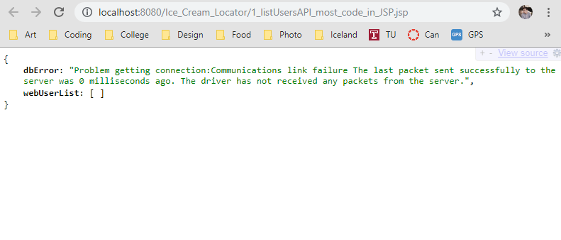

**Database Unreachable**

Message: Problem getting connection:Communications link failure The last packet sent successfully to the server was 0 milliseconds ago. The driver has not received any packets from the server.

Description: This is the error I got when I was not tunneled it. In order to retrieve the data, you need to either tunnel or be connected to the server network.

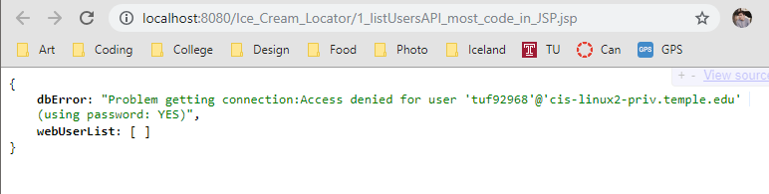

**Database Not Authorized**

Message: Problem getting connection:Communications link failure The last packet sent successfully to the server was 0 milliseconds ago. The driver has not received any packets from the server.

Description: The dbConn file does not have the database password, so the jsp code cannot create a connection to the database. Check to see if you entered in the right DB password.

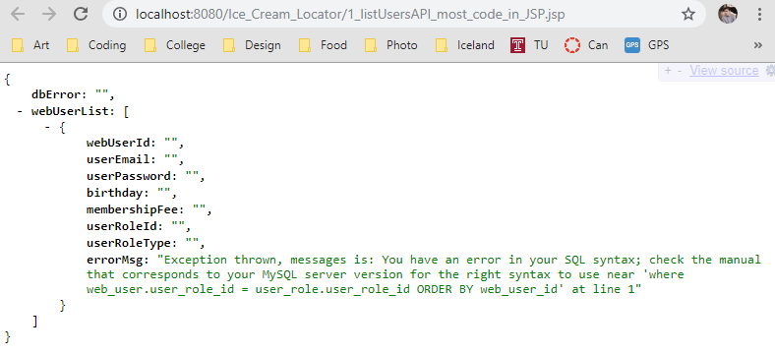

**Syntax error in Sql Statement**

Message: Exception thrown, messages is: You have an error in your SQL syntax; check the manual that corresponds to your MySQL server version for the right syntax to use near 'where web_user.user_role_id = user_role.user_role_id ORDER BY web_user_id' at line 1

Description: This problem simply means that you have an SQL syntax error. You can resolve this issue by reviewing your SQL statement and check for missing syntax. I would suggest that you open MySQL workbench to check your query first to see if you are getting the result you expect.

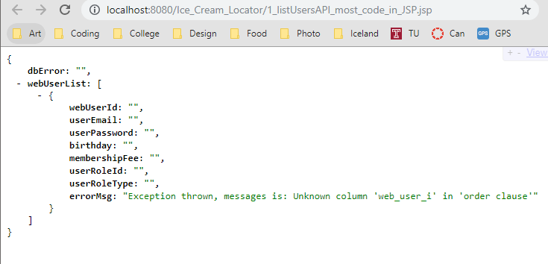

**ERROR Extracting Data from Result Set (bad column name)**

Message: Exception thrown, messages is: Unknown column 'web_user_i' in 'order clause

Description: When you have an SQL syntax error. That SQL error will print out as an exception. The is telling that we have a bad column name.

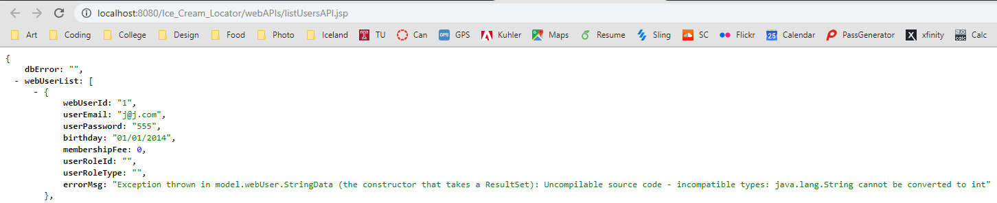

**Error Extracting Data from Result Set (wrong data type)**

Message: Exception thrown in model.webUser.StringData (the constructor that takes a ResultSet): Uncompilable source code - incompatible types: java.lang.String cannot be converted to int

Description: You did not see the right data type in your Java code. You need to check how you are declaring the results in the constructor.