Python | Plotting charts in excel sheet using openpyxl module | Set – 1

**Prerequisite:** [Reading](https://www.geeksforgeeks.org/python-reading-excel-file-using-openpyxl-module/) & [Writing](https://www.geeksforgeeks.org/python-writing-excel-file-using-openpyxl-module/) to excel sheet using openpyxl

**Openpyxl**is a Python library using which one can perform multiple operations on excel files like reading, writing, arithmatic operations and plotting graphs. Let’s see how to plot different charts using realtime data.

Charts are composed of at least one series of one or more data points. Series themselves are comprised of references to cell ranges.

For plotting the charts on an excel sheet, firstly, create chart object of specific chart class( i.e BarChart, LineChart etc.). After creating chart objects, insert data in it and lastly, add that chart object in the sheet object.

**Code #1 :** Plot the Bar Chart  
For plotting the bar chart on an excel sheet, use BarChart class from openpyxl.chart submodule.

filter_none

brightness_4

|  |
| --- |
| # import openpyxl module  import openpyxl    # import BarChart class from openpyxl.chart sub_module  from openpyxl.chart import BarChart,Reference    # Call a Workbook() function of openpyxl  # to create a new blank Workbook object  wb = openpyxl.Workbook()    # Get workbook active sheet  # from the active attribute.  sheet = wb.active    # write o to 9 in 1st column of the active sheet  for i in range(10):      sheet.append([i])    # create data for plotting  values = Reference(sheet, min_col = 1, min_row = 1,                           max_col = 1, max_row = 10)    # Create object of BarChart class  chart = BarChart()    # adding data to the Bar chart object  chart.add_data(values)    # set the title of the chart  chart.title = " BAR-CHART "    # set the title of the x-axis  chart.x_axis.title = " X_AXIS "    # set the title of the y-axis  chart.y_axis.title = " Y_AXIS "    # add chart to the sheet  # the top-left corner of a chart  # is anchored to cell E2 .  sheet.add_chart(chart, "E2")    # save the file  wb.save("barChart.xlsx") |

**Output:**  
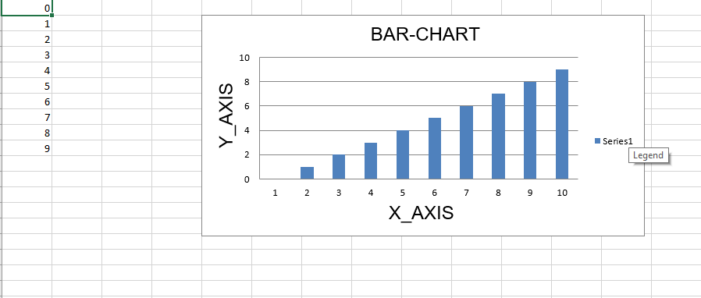

**Code #2 :** Plot the 3D Bar Chart

For plotting the 3D bar chart on an excel sheet, use BarChart3D classfrom openpyxl.chart submodule.

filter_none

brightness_4

|  |
| --- |
| # import openpyxl module  import openpyxl    # import BarChart3D class from openpyxl.chart sub_module  from openpyxl.chart import BarChart3D,Reference    # write o to 9 in 1st column of the active sheet  for i in range(10):      sheet.append([i])    values = Reference(sheet, min_col = 1, min_row = 1,                           max_col = 1, max_row = 10)    # Create object of BarChart3D class  chart = BarChart3D()    chart.add_data(values)    # set the title of the chart  chart.title = " BAR-CHART3D "    # set the title of the x-axis  chart.x_axis.title = " X AXIS "    # set the title of the y-axis  chart.y_axis.title = " Y AXIS "    # add chart to the sheet  # the top-left corner of a chart  # is anchored to cell E2.  sheet.add_chart(chart, "E2")    # save the file  wb.save("BarChart3D.xlsx") |

**Output:**  
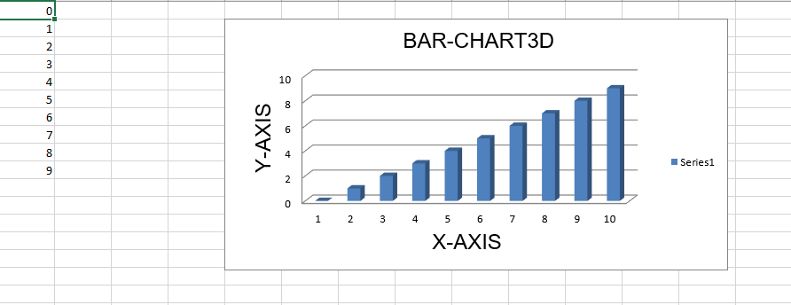

**Code #3 :** Plot the Area Chart

For plotting the Area chart on an excel sheet, use AreaChart classfrom openpyxl.chart submodule.

filter_none

brightness_4

|  |
| --- |
| import openpyxl    # import AreaChart class from openpyxl.chart sub_module  from openpyxl.chart import AreaChart,Reference      wb = openpyxl.Workbook()  sheet = wb.active    # write o to 9 in 1st column of the active sheet  for i in range(10):      sheet.append([i])    values = Reference(sheet, min_col = 1, min_row = 1,                           max_col = 1, max_row = 10)    # create object of AreaChart class  chart = AreaChart()    chart.add_data(values)    # set the title of the chart  chart.title = " AREA-CHART "    # set the title of the x-axis  chart.x_axis.title = " X-AXIS "    # set the title of the y-axis  chart.y_axis.title = " Y-AXIS "    # add chart to the sheet  # the top-left corner of a chart  # is anchored to cell E2 .  sheet.add_chart(chart, "E2")    # save the file  wb.save("AreaChart.xlsx") |

**Output:**  
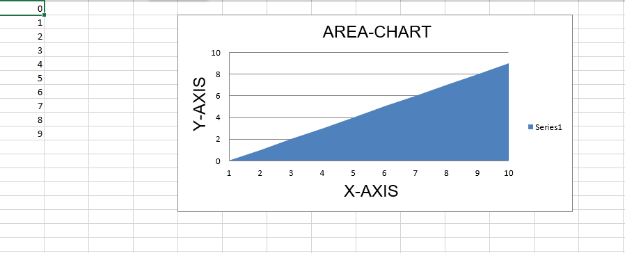

**Code #4 :** Plot the 3D Area Chart

For plotting the 3D Area chart on an excel sheet, use AreaChart3D classfrom openpyxl.chart submodule.

filter_none

brightness_4

|  |
| --- |
| import openpyxl    # import AreaChart3D class from openpyxl.chart sub_module  from openpyxl.chart import AreaChart3D,Reference    wb = openpyxl.Workbook()  sheet = wb.active    # write o to 9 in 1st column of the active sheet  for i in range(10):      sheet.append([i])    values = Reference(sheet, min_col = 1, min_row = 1,                           max_col = 1, max_row = 10)    # Create object of AreaChart3D class  chart = AreaChart3D()    chart.add_data(values)    # set the title of the chart  chart.title = " AREA-CHART3D "    # set the title of the x-axis  chart.x_axis.title = " X-AXIS "    # set the title of the y-axis  chart.y_axis.title = " Y-AXIS "    # add chart to the sheet  # the top-left corner of a chart  # is anchored to cell E2 .  sheet.add_chart(chart, "E2")    # save the file  wb.save("AreaChart3D.xlsx") |

**Output:**  
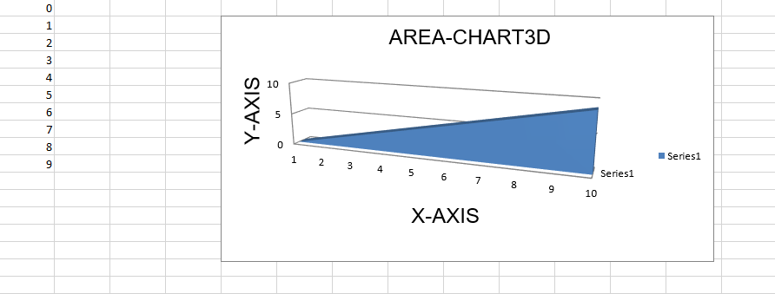

**Code #5 :** Plot a Line Chart.  
For plotting the Line chart on an excel sheet, use LineChart class from openpyxl.chart submodule.

filter_none

brightness_4

|  |
| --- |
| # import openpyxl module  import openpyxl    # import LineChart class from openpyxl.chart sub_module  from openpyxl.chart import LineChart,Reference    wb = openpyxl.Workbook()  sheet = wb.active    # write o to 9 in 1st column of the active sheet  for i in range(10):      sheet.append([i])    values = Reference(sheet, min_col = 1, min_row = 1,                           max_col = 1, max_row = 10)    # Create object of LineChart class  chart = LineChart()    chart.add_data(values)    # set the title of the chart  chart.title = " LINE-CHART "    # set the title of the x-axis  chart.x_axis.title = " X-AXIS "    # set the title of the y-axis  chart.y_axis.title = " Y-AXIS "    # add chart to the sheet  # the top-left corner of a chart  # is anchored to cell E2 .  sheet.add_chart(chart, "E2")    # save the file  wb.save("LineChart.xlsx") |

**Output:**  
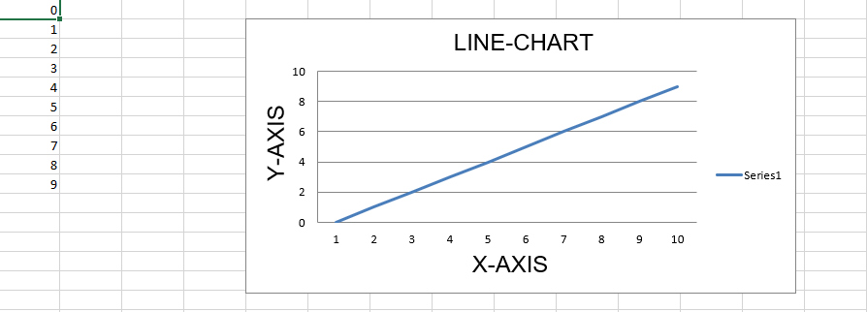

**Code #6 :** Plot a 3D Line Chart.  
For plotting the 3D Line chart on an excel sheet we have to use LineChart3D class from openpyxl.chart submodule.

filter_none

brightness_4

|  |
| --- |
| import openpyxl    # import LineChart3D class from openpyxl.chart sub_module  from openpyxl.chart import LineChart3D,Reference    wb = openpyxl.Workbook()  sheet = wb.active    # write o to 9 in 1st column of the active sheet  for i in range(10):      sheet.append([i])    values = Reference(sheet, min_col = 1, min_row = 1,                           max_col = 1, max_row = 10)    # Create object of LineChart3D class  chart = LineChart3D()    chart.add_data(values)    # set the title of the chart  chart.title = " LINE-CHART3D "      # set the title of the x-axis  chart.x_axis.title = " X-AXIS "    # set the title of the y-axis  chart.y_axis.title = " Y-AXIS "    # add chart to the sheet  # the top-left corner of a chart  # is anchored to cell E2 .  sheet.add_chart(chart, "E2")    # save the file  wb.save("LineChart3D.xlsx") |