The A/H Premium: What Actually Drives It
Evidence from 61 A+H pairs in the Hong Kong IPO book (2021–2026), benchmarked against the 202-pair market universe
Delta One / ECM · HK IPO Database v24 · prepared 26 August 2026
The one-paragraph version
Size explains the A/H premium; almost nothing else does. Across our 58 pairs the correlation between the premium and log market cap is -0.71 — mega-caps trade at a median +25% premium while mid-caps trade at +109%, and three megas trade with the A line BELOW the H. Valuation does not explain it (correlation with P/E at IPO is +0.08), and the listing board does not explain it once size is held. The mechanism is access on the H side: a large H-line enters Southbound Connect within weeks and is then bid by mainland and global money at once, while an H-line below the HK$5bn index floor may never qualify and stays thin against a retail-priced A line. Borrow does not differentiate the cross-section — A-share shorting has been effectively shut for every name since the relending channel was zeroed on 30 September 2024 — but it is why the gap never closes anywhere: with no borrow and no share fungibility, the premium is a segmentation price, not an arbitrage.
What this means for the desk
- On a mega A+H deal, the H typically converges toward the A as Southbound inclusion lands roughly two to four weeks after listing — the premium compresses from the H side, and that window is the tradeable event.
- On a sub-HK$5bn H-line, there is no such flow catalyst. The discount you buy at IPO is broadly the discount you keep, so it must be underwritten on fundamentals, not on convergence.
- Do not size a convergence trade on borrow. Short-A/long-H is unexecutable at any size in the current regime; the only expressible leg is the H.
- Premiums have been widening, not mean-reverting: since their IPOs the median pair moved +7pp wider (35 of 60 widened).

1. Size is the story — and everything else is mostly size in disguise
Convention throughout this note: premium = A over H, so a positive number means the A-share is the more expensive line. Market backdrop first: across the 202-pair universe the median premium is 59%, the 10th–90th percentile range is 17% to 182%, and only 5 pairs trade with A below H. An A line cheaper than its H line is rare and elite.
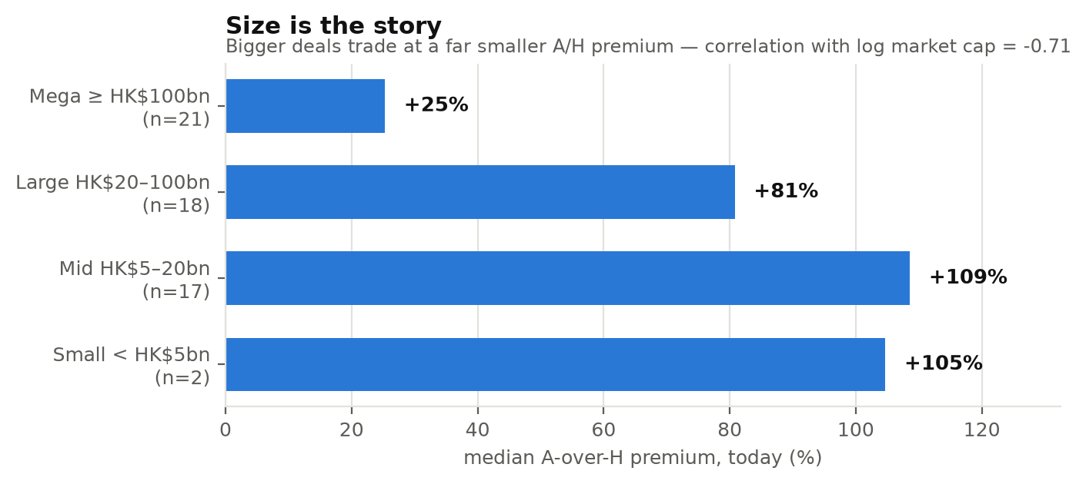
Median A-over-H premium by market cap at IPO. Our 61 pairs, priced today.
Market-cap band | Pairs | Median premium
Mega ≥ HK$100bn | 21 | +25%
Large HK$20–100bn | 18 | +81%
Mid HK$5–20bn | 17 | +109%
Small < HK$5bn | 2 | +105%

The relationship is monotonic and strong (correlation -0.71 against log market cap). Fitted, the premium falls roughly 45 percentage points for every tenfold increase in size.
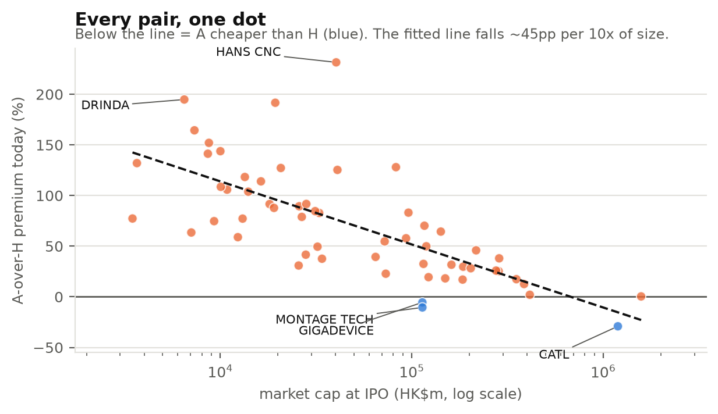
Every pair as one dot. Blue = the A line trades below the H line.

2. The board effect (STAR vs ChiNext vs Main) is size in disguise
Raw venue medians suggest a STAR/ChiNext story. They do not survive a size control: inside the mega band every venue sits in a narrow 19–38% range, and inside the mid band every venue sits at 84–141%. STAR and ChiNext read high because the companies listed there are smaller and more thematic — not because of the board itself.
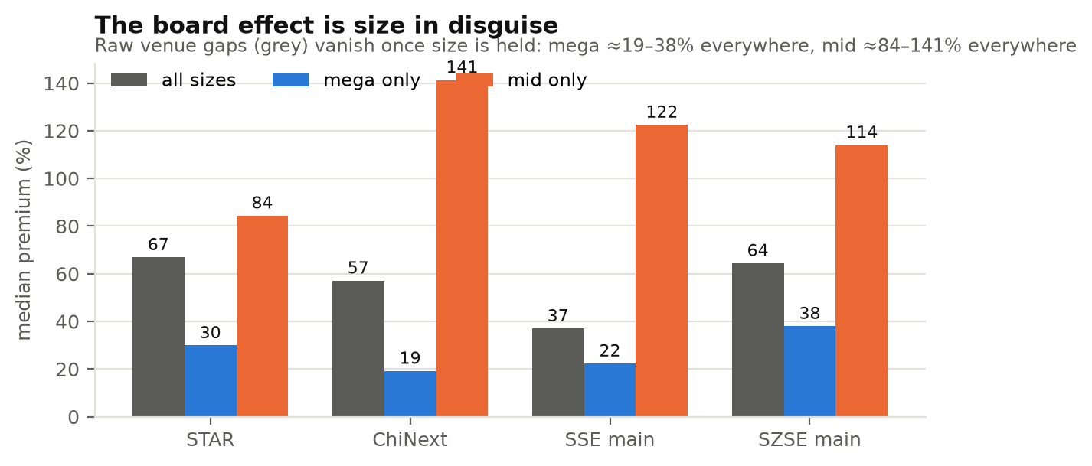
Grey = all sizes (the naive read). Blue/orange = the same venues within one size band.
A-share venue | Pairs | Median, all sizes | Mega only | Mid only
STAR | 10 | +67% | +30% (n=2) | +84% (n=6)
ChiNext | 16 | +57% | +19% (n=6) | +141% (n=4)
SSE main | 18 | +37% | +22% (n=8) | +122% (n=2)
SZSE main | 17 | +64% | +38% (n=5) | +114% (n=5)

3. Valuation does not explain the premium
Correlation between the premium and P/E at IPO is +0.08 on 48 pairs — effectively nothing. The intuitive story (a more defensible multiple attracts international investors, which lifts the H and closes the gap) does not hold in-sample: CATL priced around 20x and trades with A below H, while single-digit P/E banks in the wider universe still carry chunky premiums. What decides the gap is who is allowed to buy the H line and in what size — ownership and flow, not the multiple.

4. Thematics are real, and they show up by subsector
Within the same sector, the premium separates by business type. Domestic-policy and theme subsectors — the ones mainland retail rewards — sit at the top; globally-priced franchises sit at the bottom.
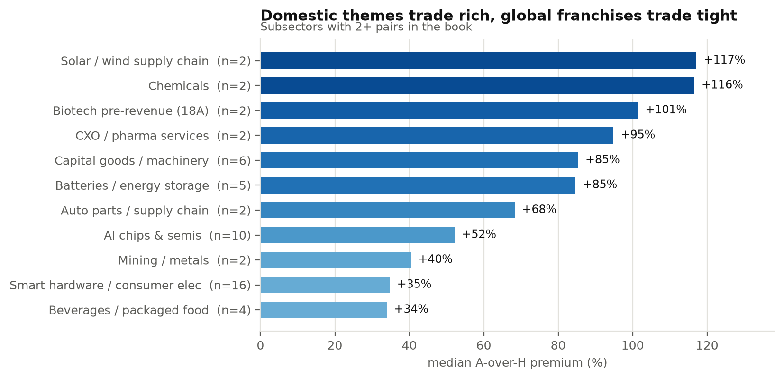
Subsectors with at least two A+H pairs in the book.
Sector | Subsector | Pairs | Median premium
Industrials | Solar / wind supply chain | 2 | +117%
Materials/Energy | Chemicals | 2 | +116%
Healthcare | Biotech pre-revenue (18A) | 2 | +101%
Healthcare | CXO / pharma services | 2 | +95%
Industrials | Capital goods / machinery | 6 | +85%
Industrials | Batteries / energy storage | 5 | +85%
Consumer | Auto parts / supply chain | 2 | +68%
Tech/AI | AI chips & semis | 10 | +52%
Materials/Energy | Mining / metals | 2 | +40%
Tech/AI | Smart hardware / consumer electronics | 16 | +35%
Consumer | Beverages / packaged food | 4 | +34%

5. The two tails, by name
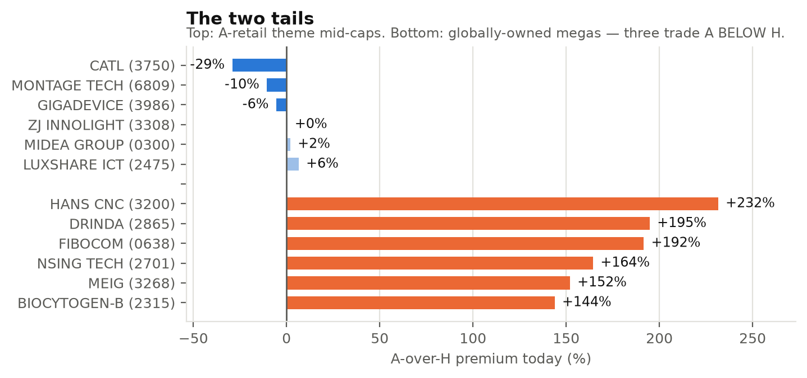
Top six and bottom six of the 61 pairs, priced today.
Rich A lines (theme mid-caps) | Code | Venue | Mkt cap at IPO | Premium
HANS CNC | 3200 | ChiNext | HK$40bn | +232%
DRINDA | 2865 | SZSE main | HK$6bn | +195%
FIBOCOM | 0638 | ChiNext | HK$19bn | +192%
NSING TECH | 2701 | ChiNext | HK$7bn | +164%
MEIG | 3268 | SZSE main | HK$9bn | +152%
BIOCYTOGEN-B | 2315 | STAR | HK$10bn | +144%

Tight / inverted (global megas) | Code | Venue | Mkt cap at IPO | Premium
CATL | 3750 | ChiNext | HK$1,193bn | -29%
MONTAGE TECH | 6809 | STAR | HK$114bn | -10%
GIGADEVICE | 3986 | SSE main | HK$114bn | -6%
ZJ INNOLIGHT | 3308 | ChiNext | HK$1,577bn | +0%
MIDEA GROUP | 0300 | SZSE main | HK$414bn | +2%
LUXSHARE ICT | 2475 | SZSE main | — | +6%

6. Why the gap persists: borrow, Connect and fungibility
Three structural facts, each verified against primary sources, explain why these premiums are stable rather than arbitraged away.
- A-share borrow is effectively dead — for everyone. The CSRC tightened securities lending from October 2023, banned lending of locked-up shares in January 2024, and suspended the securities-relending (转融券) channel entirely from 11 July 2024; the relending balance reached zero on 30 September 2024 and has not been revived. Market-wide lending is roughly RMB22bn against a RMB3.0tn margin book (about 0.7%). Every name in this study is technically margin-eligible, including the high-premium mid-caps — even CATL's lending balance peaks near RMB170m against a float above US$100bn. Borrow therefore does not explain why premiums differ; it explains why none of them can be compressed by shorting the A.
- A and H shares are not fungible. There is no conversion mechanism between the two listed lines — standard HKEX prospectus language states they are "neither interchangeable nor fungible". Unlike an ADR against its ordinary share, no share flow can equalise the two prices. The premium is a price of market segmentation, not a mispricing with a closing mechanism.
- Southbound access is the real differentiator. An IPO whose first-day market cap ranks in the top 10% of Hang Seng Composite constituents joins the index — and Southbound — after its 10th trading day; an A+H issuer's new H line enters once the post-IPO stabilisation window closes, roughly a month (Midea listed 17 Sep 2024 and was in Southbound by 14 Oct 2024; CATL, GigaDevice and Zhongji Innolight followed the same path). An H line below the HK$5bn threshold may never qualify. That is the fork in the road: mega H lines get mainland plus global demand, small H lines get neither.
7. Sector-by-sector read
Sector | Pairs | Median premium today | Median at IPO
Financials | 1 | +104% | +77%
Industrials | 14 | +84% | +49%
Materials/Energy | 4 | +71% | +70%
Healthcare | 6 | +70% | +51%
Tech/AI | 28 | +52% | +71%
Consumer | 8 | +40% | +31%

- Tech/AI is the barbell and the most instructive sector: the same label contains semiconductor and optics mega-caps trading at or below parity (Montage, GigaDevice, Zhongji Innolight — the AI-capex names global funds must own) and module/device mid-caps at +150% to +190% (Fibocom, MEIG, NSing). Identical sector, opposite ownership base.
- Industrials carries the book's ceiling — machinery, robotics and solar theme names, with Hans CNC at +232%. SANY at +17% is the exception that proves the rule: it is the mega-cap with genuine global revenue.
- Healthcare splits by stage: pre-revenue 18A names around +101% (Biocytogen +144%, where a STAR biotech culture meets a thin H float) against CXO/pharma services near +95%.
- Consumer is the tightest sector in the book — brands international investors understand and can underwrite, with deep Southbound sponsorship.
- Materials/Energy divides cleanly: chemicals rich (Befar +141%), miners tight (+40%), because miners are priced off globally-quoted commodities.
- Financials is a single pair in our IPO book and not meaningful on its own; in the wider universe bank pairs sit near the market median despite enormous size — the one place the size rule bends, since A-share bank lines are retail yield favourites while H bank lines are priced as value traps.
Method and provenance
Premiums are A-over-H: a_premium_now = A close × CNY→HKD ÷ H close − 1, computed per session so the FX is the same day on both legs. The IPO-date premium uses the A close the day before H pricing against the H offer price. Sample: 61 A+H pairs from the 511-deal Main Board IPO book, priced as of the current build; the market universe is the 202 AAStocks A/H pairs. Market cap is at the IPO offer price. Every figure in this note is generated from the database at build time, so the tables, charts and prose cannot drift apart. Regulatory and Connect facts are sourced to CSRC and exchange notices, HKEX prospectuses and Hang Seng Index methodology; per-name margin and lending balances to mainland market-data providers.

