A and H Share IPO Premiums
Hong Kong IPO database. Closing observations through 2026-10-02. Prepared 6 October 2026.
35 of 60 usable A/H IPOs had a smaller absolute price gap after one month. Convergence is common, but deal size and company-capitalisation proxies do not explain it reliably. GigaDevice narrowed mainly through H-share gains; Montage narrowed mainly through A-share declines. Several other pairs retained large A-share premiums.

Scope and price convention
The study covers all 62 A/H pairs in the IPO database. Sixty have usable first-month observations. The first-month endpoint is the 21st H-traded session after the listing-day close. A premium is the A-share CNY price converted to HKD and divided by the H-share HKD price, less one. A positive premium means A is dearer; a negative premium means H is dearer.

GigaDevice and Montage
Pair | Offer ref | Day 1 | 1 month | H move | A move
GIGADEVICE (3986) | +80.5% | +32.2% | +8.7% | +32.9% | +8.0%
MONTAGE TECH (6809) | +72.3% | +11.6% | -4.9% | +0.3% | -15.5%

GigaDevice reached an 8.7% A premium on 11 February 2026: H rose 32.9% while A rose 8.0% from Day 1. Montage crossed to a 4.9% H premium on 13 March: H rose only 0.3%, while A fell 15.5%. Similar-looking convergence therefore came from different price legs. Offer-reference gaps of 80.5% and 72.3% had already narrowed sharply by their first H closing prices.
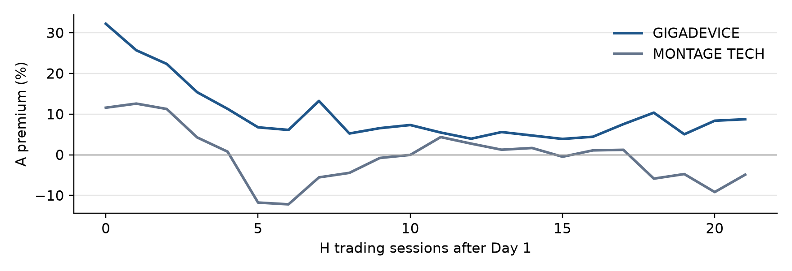

Deal size and capitalisation
Larger deals and larger listing-company capitalisations have weak negative rank correlations with the change in A premium. Their confidence intervals include zero. None of the six exploratory tests has an adjusted p-value below 0.05. The data do not justify a rule that a larger issue will converge faster.
Factor | n | Rank rho | 95% low | 95% high | Adjusted p
Deal size HK$m | 60 | -0.182 | -0.432 | 0.089 | 0.228
Listing cap at A reference | 60 | -0.242 | -0.475 | 0.021 | 0.135
Offer value divided by A reference cap | 60 | 0.235 | -0.012 | 0.445 | 0.135
Day 1 premium | 60 | -0.021 | -0.301 | 0.249 | 0.876
A run up before H IPO | 60 | -0.116 | -0.373 | 0.156 | 0.452
Current company cap at A price | 60 | -0.263 | -0.484 | -0.014 | 0.135

Capitalisation must be defined carefully. The historical proxy revalues the database listing-company share count at the A and FX closes before H debut. It is not the market cap of the A-share float. Current company cap uses a later snapshot and has look-ahead bias, so it is descriptive only. Offer value divided by company cap measures funding size, not tradable free float. These proxies cannot settle whether A-line float size explains convergence.
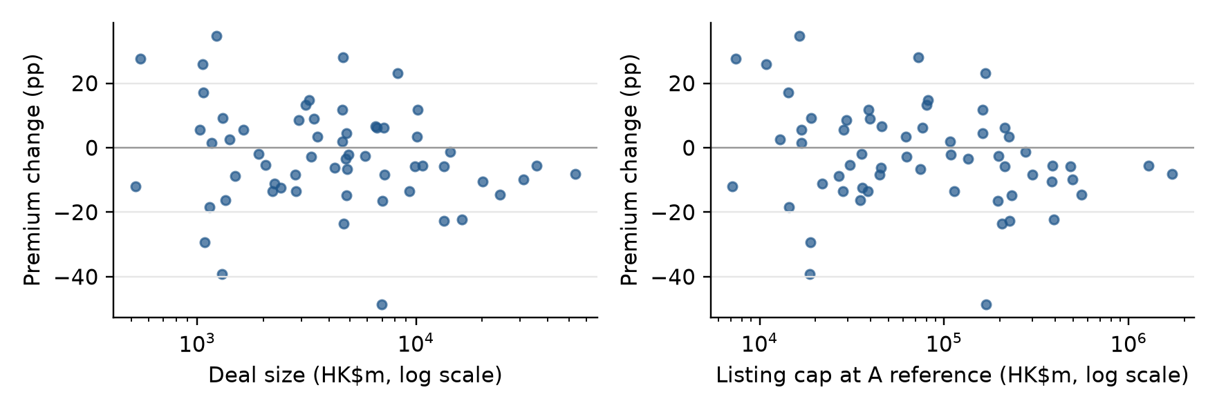
The outcome is the first-month premium minus Day 1 premium, in percentage points. A negative change can reduce a positive A premium or deepen an existing H premium; absolute-gap narrowing is counted separately. Initial premium is also part of the change metric mechanically, which complicates interpretation. Spearman uses ranks. Confidence intervals resample pairs 1,000 times; permutation p-values use 1,999 draws and are adjusted across six tests.

Why some premiums remain large
Large remaining A premiums occur across chemicals, electronics, instruments and futures brokers. This breadth argues against a single semiconductor-specific explanation. A company can also converge partly and still retain a large absolute gap. The examples below are first-month closing premiums, not today's live premiums.
Pair | First month date | A premium | H move | A move
2465 LOPAL TECH | 2024-11-28 | +157.1% | +25.3% | +42.5%
6745 BEFAR GROUP | 2026-08-10 | +156.3% | +19.1% | +36.6%
1688 LINGYI ITECH | 2026-07-28 | +118.1% | -34.2% | -26.7%
2701 NSING TECH | 2026-04-24 | +114.3% | +10.0% | +11.9%
0537 RIGOL | 2026-08-07 | +104.0% | -12.3% | -20.2%
2691 NANHUA FUTURES | 2026-01-23 | +98.9% | +15.1% | -5.0%
3268 MEIG | 2026-04-13 | +91.4% | -21.2% | -21.7%

The arithmetic identifies the price leg responsible for a change, but investor motives require additional evidence. Segmented investor access can sustain different valuations. H-line liquidity, stock-borrow costs and investable free float can restrict trades that would otherwise narrow the gap. Stock Connect eligibility, IPO price discovery, stabilisation and company news can change demand over time. Their timing and effects differ by pair; none is established as the cause of GigaDevice or Montage's first-month move by this price dataset.

What to test next
- Use admission dates and daily Stock Connect turnover or flows to test changes around access events.
- Measure A and H tradable float, turnover and borrow availability at the H listing date rather than using current total-company cap.
- Match stabilisation notices, lock-up releases and company announcements to daily price-leg contributions. Control for the sector, listing period and starting premium.

Sector comparisons
Sector | n | Median Day 1 | Median first month
Consumer | 8 | +25.0% | +21.7%
Financials | 1 | +138.1% | +98.9%
Healthcare | 5 | +44.9% | +54.2%
Industrials | 14 | +57.1% | +61.3%
Materials/Energy | 4 | +66.4% | +50.9%
Tech/AI | 28 | +42.8% | +32.3%

These are medians of each period, not the median of within-pair changes. Small groups and different listing dates prevent causal sector comparisons. Semiconductor peer groups now separate compute and AI, memory and interface, analog and power, image and display, equipment and materials, foundries, and diversified businesses. Product exposure, profitability and legal listing regimes should remain separate comparison attributes.

Methods and sources
H and A use unadjusted daily traded closes. The latest prior known A and FX observations are aligned to each H session, with maximum carry of 10 and 5 calendar days. Quote dates are retained. Different closing times mean these are dated relative prices, not simultaneous executable arbitrage quotes. No dividends are included. Raw price-leg movements around share-scale actions require care.
Offer reference uses A and FX closes before H debut divided by the H offer price. It is not a premium measured at the book pricing timestamp. Day 1 and first month use their own dated closes. Latest paired closing premiums are separate from live Bloomberg ratios in Excel.
BIOCYTOGEN has no aligned A close at its H debut and is excluded from first-month tests. HUAQIN has a first-month H share-scale action; its class conversion needs validation and it is also excluded. Unverified HUAQIN premiums after the action are withheld in the appendix and the live monitor. All 62 pairs remain in the appendix. Historical company-cap and deal-size inputs inherit their source share-count and proceeds basis, including differing gross, net and shoe conventions.
The exact log-ratio change equals the A-price log change plus the FX log change minus the H-price log change. The underlying record for each horizon retains those contributions and a reconciliation residual. These are log points, not percentage points. All calculated bridges reconcile within numerical tolerance. Repeated exploratory tests, sample heterogeneity and unobserved liquidity mean association cannot establish causation.
Tencent raw daily price history
Yahoo dated CNYHKD closing history
AAStocks current A and H market snapshot
HKEX Stock Connect investor access and eligibility framework
The companion database retains original IPO and market-data provenance. The study observations and correlation inputs are stored in data/batches/ah_study.json, with raw dated history in data/ah_study_cache. Current company-cap snapshot retrieval date is recorded per pair; it is not treated as a historical explanatory variable.

All A and H IPO pairs
Closing observations through 2026-10-02. Premiums are A over H. Change is first month minus Day 1 in percentage points. N/A means the aligned period is unavailable; review flags override the raw calculation.
Pair | Sector | H IPO date | Day 1 | 1 month | Change pp | Latest | H close date | First month status
6127 JOINN | Healthcare | 2021-02-26 | +19.8% | +26.4% | +6.6 | +89.7% | 2026-10-02 | Included
6821 ASYMCHEM | Healthcare | 2021-12-10 | +55.3% | +61.4% | +6.1 | +32.5% | 2026-10-02 | Included
6680 JLMAG | Industrials | 2022-01-14 | +63.6% | +57.3% | -6.3 | +90.6% | 2026-10-02 | Included
9696 TIANQI LITHIUM | Materials/Energy | 2022-07-13 | +83.0% | +60.2% | -22.8 | +67.0% | 2026-10-02 | Included
1880 CTG DUTY-FREE | Consumer | 2022-08-25 | +39.5% | +17.2% | -22.3 | +31.3% | 2026-10-02 | Included
2315 BIOCYTOGEN-B | Healthcare | 2022-09-01 | N/A | N/A | N/A | +119.9% | 2026-10-02 | A absent at H debut
2402 SINOHYTEC | Industrials | 2023-01-12 | +52.3% | +78.1% | +25.8 | +139.1% | 2026-10-02 | Included
0300 MIDEA GROUP | Tech/AI | 2024-09-17 | +18.0% | +8.2% | -9.8 | +2.8% | 2026-10-02 | Included
2465 LOPAL TECH | Industrials | 2024-10-30 | +129.4% | +157.1% | +27.7 | +146.7% | 2026-10-02 | Included
6936 SF HOLDING | Industrials | 2024-11-27 | +31.0% | +28.4% | -2.5 | +25.7% | 2026-10-02 | Included
6693 CHIFENG GOLD | Materials/Energy | 2025-03-10 | +49.4% | +36.0% | -13.4 | +30.8% | 2026-10-02 | Included
2865 DRINDA | Industrials | 2025-05-08 | +69.9% | +72.6% | +2.7 | +274.4% | 2026-10-02 | Included
3750 CATL | Industrials | 2025-05-20 | -6.8% | -12.4% | -5.6 | -28.6% | 2026-10-02 | Included
1276 HENGRUI PHARMA | Healthcare | 2025-05-23 | +7.4% | +1.6% | -5.8 | +11.2% | 2026-10-02 | Included
2603 JIHONG CO | Tech/AI | 2025-05-27 | +43.0% | +30.9% | -12.1 | +98.5% | 2026-10-02 | Included
3288 HAITIAN FLAV | Consumer | 2025-06-19 | +15.7% | +19.1% | +3.4 | +53.5% | 2026-10-02 | Included
2050 SANHUA | Consumer | 2025-06-23 | +18.9% | +5.4% | -13.5 | +73.0% | 2026-10-02 | Included
2648 ANJOY FOOD | Consumer | 2025-07-04 | +46.8% | +34.3% | -12.5 | +53.2% | 2026-10-02 | Included
1304 FORTIOR | Tech/AI | 2025-07-09 | +42.6% | +31.5% | -11.2 | +96.2% | 2026-10-02 | Included
6613 LENS | Tech/AI | 2025-07-09 | +25.1% | +21.6% | -3.5 | +77.0% | 2026-10-02 | Included
2631 SICC | Tech/AI | 2025-08-20 | +58.0% | +52.6% | -5.4 | +78.1% | 2026-10-02 | Included
0638 FIBOCOM | Tech/AI | 2025-10-22 | +58.5% | +67.0% | +8.5 | +238.9% | 2026-10-02 | Included
6031 SANY HEAVY IND | Industrials | 2025-10-28 | +9.5% | +3.6% | -5.9 | +20.5% | 2026-10-02 | Included
6166 CIG | Tech/AI | 2025-10-28 | +41.3% | +53.0% | +11.7 | +113.1% | 2026-10-02 | Included
9927 SERES | Consumer | 2025-11-05 | +21.1% | +19.9% | -1.2 | +47.1% | 2026-10-02 | Included
0699 JOYSON ELEC | Consumer | 2025-11-06 | +62.1% | +71.1% | +9.0 | +125.2% | 2026-10-02 | Included
2579 CNGR | Industrials | 2025-11-17 | +61.9% | +65.3% | +3.5 | +110.5% | 2026-10-02 | Included
2676 NOVOSENSE | Tech/AI | 2025-12-08 | +54.5% | +41.0% | -13.4 | +62.7% | 2026-10-02 | Included
2691 NANHUA FUTURES | Financials | 2025-12-22 | +138.1% | +98.9% | -39.2 | +161.9% | 2026-10-02 | Included
0501 OMNIVISION | Tech/AI | 2026-01-12 | +22.5% | +27.1% | +4.6 | +37.1% | 2026-10-02 | Included
3986 GIGADEVICE | Tech/AI | 2026-01-13 | +32.2% | +8.7% | -23.5 | -8.9% | 2026-10-02 | Included
9611 LONGCHEER | Tech/AI | 2026-01-22 | +67.9% | +73.5% | +5.6 | +104.4% | 2026-10-02 | Included
9980 EASTROC | Consumer | 2026-02-03 | +13.4% | +25.1% | +11.7 | +39.7% | 2026-10-02 | Included
2768 GON TECHNOLOGY | Tech/AI | 2026-02-04 | +54.7% | +25.3% | -29.4 | +116.9% | 2026-10-02 | Included
3200 HANS CNC | Industrials | 2026-02-06 | +50.6% | +44.1% | -6.5 | +179.8% | 2026-10-02 | Included
2714 MUYUAN | Consumer | 2026-02-06 | +29.0% | +23.5% | -5.5 | +35.1% | 2026-10-02 | Included
6809 MONTAGE TECH | Tech/AI | 2026-02-09 | +11.6% | -4.9% | -16.5 | -18.3% | 2026-10-02 | Included
0470 WUXI LEAD | Industrials | 2026-02-11 | +36.7% | +34.6% | -2.0 | +49.2% | 2026-10-02 | Included
9981 WOER | Materials/Energy | 2026-02-13 | +49.8% | +41.5% | -8.3 | +127.0% | 2026-10-02 | Included
2715 ESTUN | Tech/AI | 2026-03-09 | +92.2% | +83.5% | -8.7 | +134.4% | 2026-10-02 | Included
2692 ZHAOWEI | Industrials | 2026-03-09 | +75.5% | +73.5% | -2.0 | +119.0% | 2026-10-02 | Included
3268 MEIG | Tech/AI | 2026-03-10 | +89.8% | +91.4% | +1.6 | +183.6% | 2026-10-02 | Included
1989 DELTON | Tech/AI | 2026-03-20 | +30.1% | +27.2% | -2.9 | +75.0% | 2026-10-02 | Included
2701 NSING TECH | Tech/AI | 2026-03-23 | +108.7% | +114.3% | +5.6 | +214.4% | 2026-10-02 | Included
2476 VGT | Tech/AI | 2026-04-21 | +20.6% | +10.2% | -10.4 | +26.1% | 2026-10-02 | Included
3296 HUAQIN | Tech/AI | 2026-04-23 | +35.4% | N/A | N/A | Withheld | 2026-10-02 | Class review
2493 MABWELL-B | Healthcare | 2026-04-28 | +44.9% | +54.2% | +9.3 | +51.5% | 2026-10-02 | Included
1187 COFOE MEDICAL | Healthcare | 2026-05-06 | +46.7% | +63.9% | +17.2 | +116.8% | 2026-10-02 | Included
1081 DAJIN | Industrials | 2026-06-05 | +10.9% | +17.2% | +6.3 | +70.0% | 2026-10-02 | Included
6067 SENIOR MATERIAL | Industrials | 2026-06-23 | +99.2% | +83.0% | -16.2 | +164.5% | 2026-10-02 | Included
3661 SG MICRO | Tech/AI | 2026-06-26 | +21.2% | +23.1% | +1.9 | +53.8% | 2026-10-02 | Included
1688 LINGYI ITECH | Tech/AI | 2026-06-26 | +95.1% | +118.1% | +23.0 | +154.2% | 2026-10-02 | Included
9630 CFMEE | Tech/AI | 2026-06-26 | +18.4% | +33.0% | +14.7 | +42.1% | 2026-10-02 | Included
0668 ANKER | Tech/AI | 2026-07-02 | +0.9% | +29.0% | +28.1 | +27.9% | 2026-10-02 | Included
0537 RIGOL | Industrials | 2026-07-09 | +122.3% | +104.0% | -18.3 | +134.8% | 2026-10-02 | Included
2475 LUXSHARE ICT | Tech/AI | 2026-07-09 | +19.2% | +4.6% | -14.6 | +9.2% | 2026-10-02 | Included
6951 CCTC | Tech/AI | 2026-07-09 | +46.8% | +38.4% | -8.4 | +10.6% | 2026-10-02 | Included
1377 DTECH | Tech/AI | 2026-07-09 | +49.4% | +34.7% | -14.8 | +53.1% | 2026-10-02 | Included
6745 BEFAR GROUP | Materials/Energy | 2026-07-10 | +121.7% | +156.3% | +34.6 | +137.4% | 2026-10-02 | Included
2249 NEXCHIP | Tech/AI | 2026-07-10 | +93.3% | +44.8% | -48.5 | +49.2% | 2026-10-02 | Included
3308 ZJ INNOLIGHT | Tech/AI | 2026-07-30 | +4.3% | -3.8% | -8.1 | -11.7% | 2026-10-02 | Included
3223 INGENIC | Tech/AI | 2026-08-25 | +56.3% | +69.5% | +13.2 | +69.8% | 2026-10-02 | Included

