AAPL Stock Analysis — Insight Summary
AnalystLab Africa Data Analytics Internship — Week 6: Advanced Python for Data Analysis
Analyst: Timothy Kehinde Promise

Dataset Overview
Daily OHLCV price data for Apple Inc. (AAPL), sourced from Yahoo Finance, covering the full trading history from IPO in December 1980 through November 2024 (11,084 trading days). Detailed feature engineering and analysis was scoped to the most recent five full years, 2020 to 2024, a window that captures the COVID-19 crash, the 2021 rally, the 2022 rate-driven drawdown, and the 2023-2024 recovery.

Data Transformation Techniques Applied
- Converted timestamped date strings to a clean DatetimeIndex and standardized all column names to lowercase
- Validated OHLC logic (high never below low, no zero or negative prices) rather than assuming the source data was clean
- Confirmed zero missing values and zero duplicate records across the full 44-year series
- Filtered the working dataset to a 5-year analysis window while retaining the full series for long-run context

Features Created
- Daily price change and daily percentage return
- 7-day and 30-day rolling moving averages (short vs. medium-term trend signal)
- 30-day rolling annualized volatility (standard deviation of returns, scaled by sqrt(252) trading days)
- Monthly and yearly resampled returns for seasonal and year-over-year comparison

Trends Identified
Year | Start Price | End Price | Total Return | Avg. Volatility
2020 | $72.80 | $129.75 | +78.2% | 44.8%
2021 | $126.54 | $174.71 | +38.1% | 24.4%
2022 | $179.08 | $128.58 | -28.2% | 35.0%
2023 | $123.77 | $191.59 | +54.8% | 21.0%
2024* | $184.73 | $237.33 | +28.5% | 22.7%
*2024 figures reflect data through November 29, 2024.
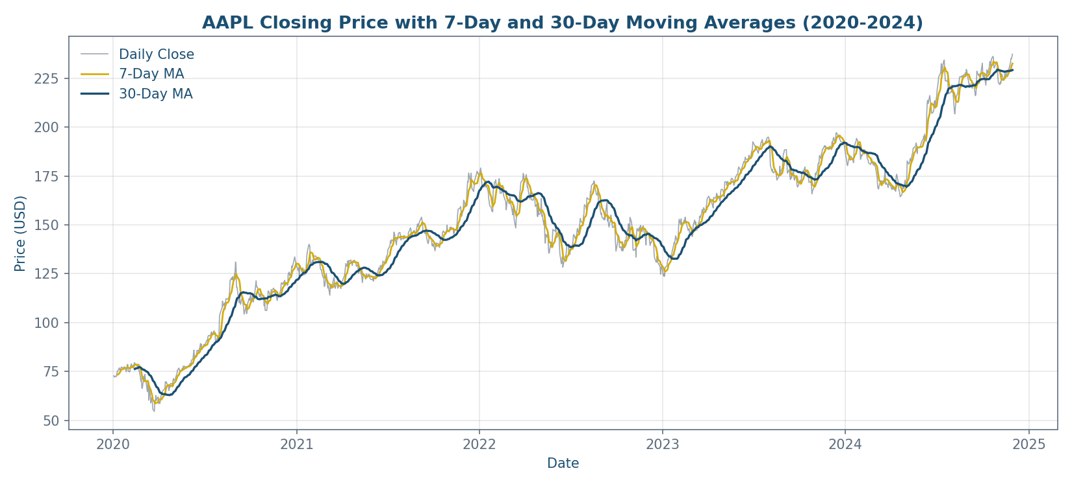

Key Insights
- AAPL grew from a split-adjusted fraction of a dollar at IPO to over $230 by late 2024, but the growth was concentrated in specific multi-year windows rather than a smooth climb.
- The 7-day moving average led above the 30-day moving average for extended stretches of the 2023-2024 recovery, a standard technical signal of sustained (not short-lived) upward momentum.
- The strongest month in the window was August 2020 (+21.7% return); the weakest was December 2022 (-12.2% return), aligning with the broader 2022 rate-driven equity drawdown.
- Annualized volatility peaked at roughly 96% in early April 2020 during the COVID crash, over 4x the stock's typical 2024 baseline of around 22%, and has compressed steadily since 2023.
- Average daily trading volume declined from 2021 onward even as price climbed, suggesting steadier institutional conviction rather than high-frequency speculative flow.

Recommendations
- Use the 7-day/30-day moving average crossover as a transparent, rules-based signal for entry and exit timing screening.
- Size positions and set stop-loss width using the rolling volatility feature, widening stops during high-volatility regimes (e.g., March 2020) and tightening them during compressed periods (e.g., 2024).
- Extend this analysis by benchmarking AAPL's return and volatility against the S&P 500 or Nasdaq-100 over the same window to isolate stock-specific performance from broad market movement.

