All of this comes from and it’s good for reference.
https://www3.ntu.edu.sg/home/ehchua/programming/webprogramming/JavaScript_Introduction.html

JavaScripts run inside a browser. There are standards on JavaScript. But the Big-5 (Chrome, Firefox, IE, Safari and Opera), in particular the IE, does not adhere to all the standards strictly. Furthermore, they create their own extensions. Hence, the behavior of JavaScript could be different in different browsers. You may need to test your JavaScripts on more than one browsers. [That's where jQuery comes in handy, as jQuery provides cross-browser support.]

- JavaScript statements are terminated by a semicolon ';'.

The current web page is represented by the so-called document object in the JavaScript. The document.lastModified (Line 16) property stores the last modified date of the current document.
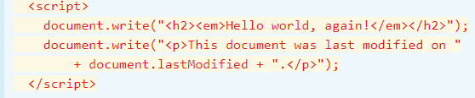
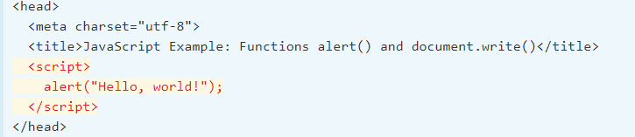

Don't Get Caught by the Cache - Do Control-Refresh (or Control-F5)
If you modify the codes and reload the web page, the new codes may not get executed because the browser caches the previously loaded version. You could use Control-F5 (Control-Refresh) to ask the browser to discard the cache, and fetch a new page.

A good graphic debugger is a MUST for programming in any language. Programming in JavaScript, in particular, requires a graphic debugger. It is because JavaScripts are interpreted and does not need to be compiled. Hence, there is no compiler to show you the syntax errors. A simple and trivial syntax error (e.g., missing bracket, mis-spelling) will render the entire script not workable. Worst still, you would not see any error message when the script did not work. Can you debug without any error message or clue?
Without a graphic debugging, the only mean to debug JavaScript is to insert alert() at strategic locations to print out selected data.
After modifying a JavaScript, I recommend that you use Ctrl-F5 to refresh the page, which shall load a fresh copy instead of loading from the cache. You might need to clear the browser's cache or re-start the browser, if you modification does not take effect.

IDE Integrated Development Environment – mjukvarusvit för programmerare
En utvecklingsmiljö (engelska Integrated Development Environment, IDE), är ett datorprogram eller en programsvit som vanligtvis innehåller en textredigerare, kompilator, och debugger, tillsammans med ett antal andra funktioner avsedda att underlätta vid programmering.
JavaScripts are embedded inside an HTML document, and executed by the browser.
The browser executes the javaScript
You can place your JavaScript in either the HEAD section (called Header Script) or BODY section (called Body Script) of an HTML document. Typically, global variables and function definitions are placed in HEAD section, which will always be loaded and available to be used by the scripts in the BODY section. If you script refers to the DOM elements. place it before the </body>, so as to ensure that the DOM is constructed. Placing the <script> outside the HEAD or BODY causes a HTML5 validation error.

Comments are ignored by the JavaScript runtime but greatly useful in explaining your codes to others (and also to yourself three days later)

A block consists of zero or more statements enclosed in a pair of curly braces { statements }. No semicolon is needed after the closing brace.

A literal is a fixed value, e.g., 5566, 3.14, "Hello", true, that can be assigned to a variable, or form part of an expression.
- null: A special literal value for unallocated object.

avaScript is loosely type (similar to most of the scripting languages such as UNIX Shell Script, Perl, Python). You do not have to explicitly declare the type of a variable (such as int and float) during declaration. The type is decided when a value is assigned to that variable
strongly type,java, c
An undeclared variable (via var keyword) takes on a special type called undefined. You cannot refer to its value.
When a variable is declared (via var keyword) without assigning an initial value, it takes on the type undefined and holds a special value called undefined (uninitialized is probably more precise?!), As soon as a value is assigned, the variable takes on the type of that value. The act of putting a value into a variable sets its type. You can change the type of a variable by re-assigning a value of another type. Types are converted automatically as needed during execution (known as dynamically-typed).

The strictly equality operator === returns true if both operands have the same type and same value; while == returns true if both operands have the same value, but may or may not be the same type.
- It is RECOMMENED to use === (or !==), instead of == (or !=), unless you are certain that type is not important.

- .length: the number of items including undefineds. In fact, .length is set to the last index plus 1.

pass a null value (which is a special literal for unallocated object).

Anonymous (Inline) Functions
In JavaScript, you can define an anonymous function (without a function name) using the following syntax:
function( parameters ) { .... }

When you declare a variable outside of any function, it is called a global variable, and available to all codes in the current document.
When you declare a variable within a function, it is called a local variable, and available only within that function.
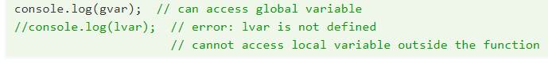
- document.write(string), document.writeln(string): Write the specified string to the current document. The writeln() (write-line) writes a newline after the string, while write() does not. Take note that browsers ignores extra white spaces (blanks, tabs, newlines) in an HTML document, and treat multiple white spaces as a single blank character. You need to write a <br> or <p>...</p> tag to ask the browser to display a line break.
- console.log(value): write to the JavaScript console, used mainly for debugging.

It is crucial to understanding objects to be proficient in JavaScript, as they are everywhere, and they are used extensively in JavaScript plug-ins like jQuery, AngularJS, and etc.
object is a collection of properties and methods under a common name:
For example, a Car object has properties such as make, model, price, capacity; and methods such as startEngine(), move(), brake(), stopEngine().

A JavaScript object is simply a collection of properties. A property is an association between a name (or key) and value (i.e., name-value pair or key-value pair). If the value is a function, the property is known as a method. In other words, JavaScript does not differentiate between properties and methods like conventional OO languages. A method is simply a property holding a function.

You can create a new object by directly assign an object literal to a variable, known as Object Initializer.
- Objects created via Object Initializer are instances of class Object.

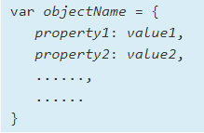
The dot (.) operator: In the form of anObjectName.aPropertyName or anObjectName.aPropertyMethodName(arguments)
- The index ([]) operator (or bracket notation): In JavaScript, you can also use the index operator to access the object properties, in the form anObjectName[aPropertyName], just like accessing an array item.

Many developers do not enquote the string name, if it is a valid identifier (a valid identifier begins with an alphabet, '_' or '$'; and does not contain special characters like blank and '-'). For example, var a = {b:'c', d:'e'} is the same as var a = {'b':'c', 'd':'e'}. However, you need to enquote a string name if it is NOT a valid identifier, e.g., var a = {'1b':'c', 'my name':'peter', 'font-size':'14px'}.
The string value must be enquoted; otherwise, it will be treated as a variable name.

Dot Operator vs. Index (Square Bracket) Operator

JavaScript's OO is prototype-based, instead of class-based like Java/C++/C#.
- Every JavaScript object has a prototype. The prototype is also an object. A JavaScript object is created from a prototype object and gets its initial properties from the prototype.
- Every JavaScript object has an internal property called __proto__, which holds its prototype obje

Keyword this
"this" refers to the current object. this.aPropertyName refers to the property of this object.

Document Object Model (DOM), is a standard API that allows programmers to access and manipulate the contents of an HTML/XHTML/XML document dynamically inside their program.
jQuery is much better in selecting and manipulating DOM element. You should use jQuery in production.
You can access and modify the content of an element via the "innerHTML" property, which contains all the texts (includes nested tags) within this element.

