TITLE
Det viktigaste HTML-elementet för din sajt är titeln - <title>. Det är det HTML-element som har störst påverkan på din rankning och den visas även som rubriker i sökmotorresultaten, i bokmärken och webbläsarens flikar.
Good reading on this: http://www.seo-guide.se/title-elementet

Only javaScript web page: NyNarvaro, ceno, keno1se

HEAD
The <head> element is a container for all the head elements.
The <head> element can include a title for the document, scripts, styles, meta information, and more.
The following elements can go inside the <head> element:
- <title> (this element is required in an HTML document)
- <style>
- <base>
- <link>
- <meta>
- <script>
- <noscript>
In HTML5, the <head> element can be omitted

META

Metadata is data (information) about data.
The <meta> tag provides metadata about the HTML document. Metadata will not be displayed on the page, but will be machine parsable.
The metadata can be used by browsers (how to display content or reload page), search engines (keywords), or other web services.
Note: <meta> tags always go inside the <head> element.

META UTF-8
This one is important to create a proper HTML tag to render ok!
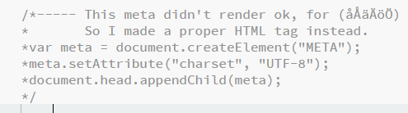

Some test I did
var htmlLang = document.getElementsByTagName('HTML');
var metaInd = document.getElementsByTagName('META');
var headInd = document.getElementsByTagName('HEAD')[0];
//htmlaaa.setAttribute('lang', 'en');
//document.appendChild(htmlaaa);
//console.log(htmlLang);
//console.log(htmlaaa[0].draggable);
//console.log(metaInd);
// console.log(metaInd.length);
// for (var i = 0; i < metaInd.length; i++) {
// console.log(metaInd[i]);
// console.log(metaInd[i].content);
// console.log(metaInd[i].name);
// } // end loop
// console.log(headInd);
// console.log(headInd.childNodes.length);
// for (var i = 0; i < headInd.childNodes.length; i++) {
// console.log(headInd.childNodes[i]);
// } // end loop

// console.log(metaInd[0]);
// console.log(metaInd[1]);
// console.log(metaInd[2]);
// console.log(metaInd[3]);
//console.log(headInd.childNodes[0]);

