Adding more CSS files to the header slows down page load. CSS files are render-blocking
You can add only important part of this file if you care about rendering

HTML5 UTF-8 Character Codes
To find go to w3school and search for utf and a good page comes up. https://www.w3schools.com/charsets/ref_html_utf8.asp
This page is also good:
http://www.fileformat.info
http://www.fileformat.info/info/emoji/list.htm

You find tables with characters, take the Hex value and put \u in front of to render in C/C++/Java source code
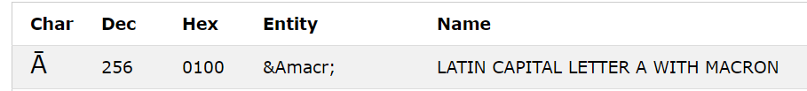

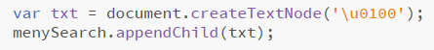 Will render:

Will render:

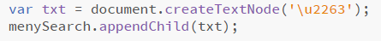 Will render:

Will render:
You can also type it like this, with no plus sign

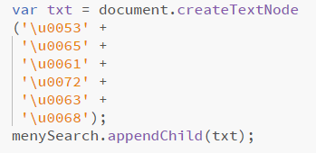 Will render:

Will render:

/*----------------------------*/
/* DIV - meny and search
*/
var menySearch = document.createElement('DIV');
menySearch.setAttribute('class', 'navTop');
var txt = document.createTextNode('\u2263');
menySearch.appendChild(txt);
document.body.appendChild(menySearch);

//\u039E
//\u2261

//\u2263

//\u00D7
//&#9776

