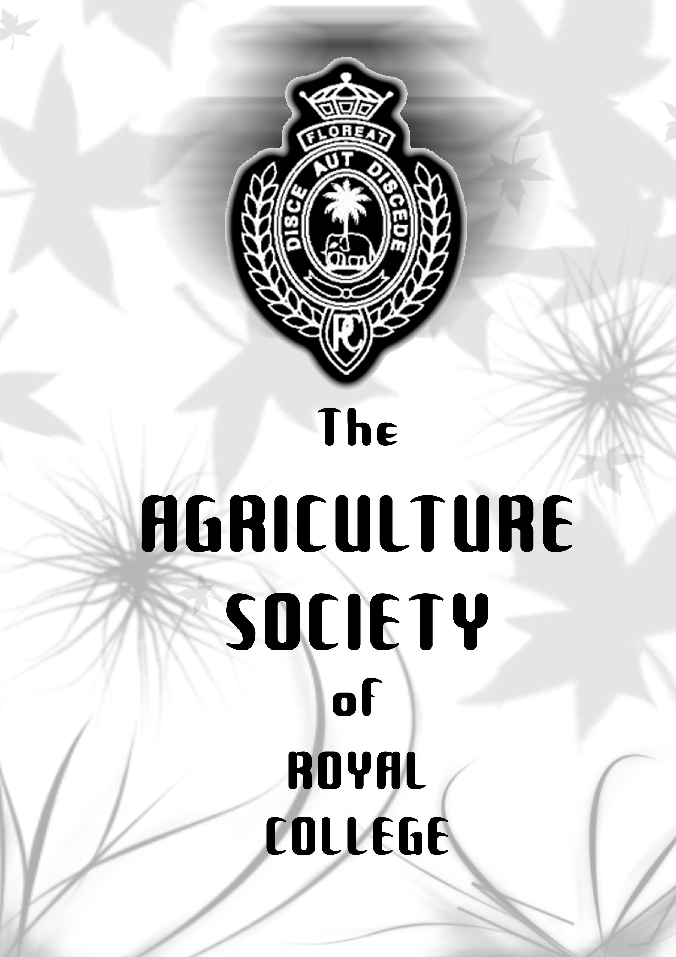

Contents

- Who are we???? 3

- Main Projects
  - Ran Aswenu Mangalya 2007 5
  - Exporting of Harvest 6
  - Waste management and compost 7
Production
  - The I.U.C.N project 8
  - Make Royal College Greener
Project 9
  - Annual Plant exhibitions 10
  - The polytunnel project 11

- Sub projects
  - The tree naming project 11
  - The red palm project 12
  - Anthurium Planting Project 12
  - Daily duties carried out 12

- Future Projects 13

- Names of Chairmen of the agriculture 16
Society of royal college for the
Past 10 years

Who are we????

The Agriculture Society of Royal College which has a rich history of 38 years (since 1970) has been serving and bringing Royal College glory by various means & ways and Since the inception of the Agriculture Society, it has been an active society within this great institution but since the year 2003 it has been one of the most active societies and reaching great attainments while it also has provided the students a great opportunity to gain valuable hands on experience in the agriculture field as well as a sound knowledge of the agriculture sector.

The development of the agriculture society has amplified since the latest principal of Royal College initiated his duties within college and since then the agricultural society has developed vastly and has moved in to greater horizons.

Even though Royal College is situated in the heart of Colombo 7, it has approximately 40 perches of land where each and every inch is utilized in a way that maximum output can be derived from a minimum amount of land by using special agricultural equipment and by effectively using the sound knowledge the members of the agriculture society has in order to exploit its productivity.

Another special fact which has a link between the agriculture society is that it has been able to grow more than 160 different species of vegetables and fruits within this limited amount of space where fertile land is very limited. And for the very 1st time history Royal College became the only school in Sri Lanka to export its harvest to both Maldives and the U.A.E recently.

One of the other major achievements is being awarded the 2nd place at the recent “Ran Aswenu Mangalya 2007”, where schools from the whole island competed but the Agriculture Society of Royal College emerged as the runners up in this competition from the heart of Colombo competing against various other schools around the island.

The Agriculture Society of Royal College also has been able to successfully produce compost fertilizers from the waste produced within college and to earn a satisfactory profit from this project while also making sure that royal college has a cleaner environment than any other school while also being able to utilize the 5s system which was initiated in Royal College in order to separate the inner school waste

A project in collaboration between the I.U.C.N and Royal College was also organized in order to safeguard the bio diversity within Royal College and as an initiative to bring an urban bio diversity conservation program among other urban schools in Sri Lanka.

Unlike any other club or society within Royal College, The agriculture society of Royal College plays a main role in this institution since it has to safeguard the greenery within college while making sure that each and every tree in Royal College(which is approximately 161 acres)in size is healthy and obtains every requirement in order to continuously grow while also making sure that the 40 perches of land within Royal College which is utilized to grow vegetables, fruits and herbs is provided the necessary fertilizers and other requirements and thus has become one of the most active and most accomplished societies within Royal College.

Ran Aswenu Mangallaya 2007

The agricultural society of royal college emerged as the runners up in the “ran Aswenu Mangallaya 2007” organized by the Sri Lanka rupawahini corporation under the guidance made by the current government. the theme of this all island agricultural competition is- “api wawamu rata nagamu” and in this competition schools from all parts of the island competed in order to be crowned as the best agriculture society in a school around the island.
The criteria’s which were judged are as follows,
- The most productive agriculture society
- The school which had the best pest and disease control
- Organic manure usage and production
- Various ways to produce compost
- The amount of various vegetable, fruits and herbs
- Urban agriculture
- Various ways to conserve the land
- Water supply

the prize that royal college was awarded was rs.300,000 in cash since it emerged as the runners up in this competition. The specialty of royal college emerging as the runners up in this competition is because it was able to achieve such a target while being in the commercial hub of Sri Lanka even though schools from rural districts where agriculture was the main source of income took part in this competition. Royal college agriculture society underwent stiff competition from outstation schools which have abundant space to grow their crops while our college in the other hand was handicapped by the lack of space. Therefore it certainly is a huge achievement of the agriculture society of royal college.

Royal college was placed 2nd after experts in the agriculture sector inspected the agricultural garden of royal college and concluded that the gardens are of a high standard. The inspectors were clearly impressed by the wide variety of vegetable that were cultivated.
Exporting of Harvest

For the very first time in the history of any school in Sri Lanka, the agriculture society of royal college has succeeded in exporting their harvest of vegetables and fruits to the Maldives and the U.A.E. from the heart of Colombo 7 which is considered as the commercial hub of Sri Lanka. The agriculture society has managed to find fertile land within an urban environment and gain maximum output from a very limited amount of resources.
The specialty of this project is that no other school in sri lanka was able to carry out such a feat while Royal college was able to export a considerable amount of vegetables, fruits and herbs through the IFSO(International Food Stuff Organization-which is one of the 20 private companies in sri lanka which exports vegetables and fruits)to the Maldives and the U.A.E and gained a considerable amount of profit through this project while by continuing this project constantly Royal College will be able to derive a large amount financial benefit.

This project was carried out by the students of the agriculture society under the guidance of the teacher in charge Mrs.Premarathne and the current principal of royal college who has helped the agriculture society to reach this great landmark.

The fertilizer which was used in this project was produced solely by utilizing the waste produced within royal college so the cost for this project was very limited and the profit earned by this project was used solely to develop the agriculture society of royal college.

The main objective of starting such a project was to send a valuable message to the world and that is that nothing is impossible since there is a common understanding that efficiency in agriculture can only be derived in rural areas in Sri Lanka and that it is impossible to cultivate in urban districts and to gain maximum output.
The agriculture society has been 100% successful in this project and has brought Royal College glory.

Waste management and compost production

The agriculture society of royal college succeeded in producing compost from the bio waste that is produced within royal college. The members of the agriculture society worked hard using all their practical experience and their knowledge of agriculture in order to successfully carry out this project.

This project was initiated in order to make royal college more greener and the members of the agriculture society worked relentlessly by first cleaning the school environment and then by utilizing the 5s program initiated within college in order to separate the waste produced within college.
The waste was separated as decomposable, and the non-decomposable. the decomposable were used to produce fertilizers within royal college and to use them effectively in order to reap more benefit from the limited land that royal college poseses.since the effectiveness of this project was very high, the agriculture society of royal college was able to distribute compost to various schools in rural areas and schools which are under privileged for no fee at all.
Due to this project Royal College has become more greener while the agriculture society has been able to develop compost fertilizer within college to fulfill its needs and to also help the under privileged schools in Sri Lanka as a social responsibility project.

The excess fertilizer is sold at the annual plant exhibitions(Esala Mal Dekama, Mihikatha Mal Dekma, Royal Flora)where the royal college agriculture society holds a stall in. The most interesting fact about this is that the other stall holders in the above mentioned annual plant exhibitions usually orders the compost fertilizers that Royal College produces and commercially sells them.

The I.U.C.N Project

A special project was initiated in collaboration of The I.U.C.N (Or the world conservation union) and Royal College in order to protect and preserve the bio diversity within Royal College while the main objective of this project was to initiate an urban bio diversity conservation project among urban schools in Sri Lanka while Royal College was the first school in Sri Lanka to begin this project.
The I.U.C.N is hoping to begin this project in other schools in urban areas in Sri Lanka in the near future.

The agreement between the principal of Royal College, Mr.Upali Gunasekara and the I.U.C.N country coordinator Mrs. Yasarathne was signed on the 1st of April 2007 and since then the agriculture Society of Royal College has been working determinedly in order to carry out this project systematically and in order to protect and preserve the bio diversity within Royal College.

Thus far 20 different varieties of butterflies have been discovered within Royal College, Colombo 7 by specialists.

The Agriculture society of Royal College hopes to conclude this project by organizing a special event by inviting members of other agriculture societies of various schools in Sri Lanka and by sharing the experiences gained by this project & the knowledge which the agriculture society derived by the I.U.C.N. project by organizing various workshops and lectures on this specific day.

Make Royal College Greener

Royal college has experienced a green revolution in recent times owing to various projects carried out by the agriculture society of royal college. The members of the agriculture society have worked hard and dedicated their selves to make royal college greener among the different projects carried out by them are,

- Growing different varieties of flora that add to the beauty & attractiveness of the surrounding environment
- Planting trees with foliage to provide shade to various pathways
- Growing different varieties of vegetables and fruits that produce a considerable harvest
- Growing plants that have herbal as well as medicinal value
- Growing various plants that attract different species of wild life such as butterflies and species of birds that increase the bio diversity at the college premises

All of the mentioned projects have helped to make the college a more echo friendly place in an urban environment such as Colombo where every direction you look is filled with concrete structures royal college is an oasis with its lush gardens. The college has benefited immensely from these projects the abundance of plants insures the air quality and temperature at college are purer and cooler. Although we have achieved a considerable amount of success in the agricultural sector we have plans to further develop agriculture at royal college with the necessary finances and support we are sure we can achieve our goal in the near future and make royal college a green paradise since we have already made Royal College 50% greener than it has been in the past.

Annual plant exhibitions

- esala mal dekma(Between June & August)
- mihikatha mal dekma(Between March & May)
- royal flora(June)

for the very first time in history a school based agriculture society entered in to a commercial plant exhibition in the year 2006 and since then the agriculture society of royal college has been a part of the above mentioned annual plant exhibitions.

Once again for the very first time in history, the royal college agriculture society won an award for the best plant exhibit in the esala mal dekma in the year 2006.

A profit of at least rs.30000 is derived per stall when the agriculture society enters in to these plant exhibitions.

The fertilizer which is produced within royal college is sold at these plant exhibitions even though the main products in these exhibitions are vegetables and fruits.

Other commercial stall keepers make it a point to purchase fertilizer from the royal college stall.

These exhibitions which are held in the viharamahadevi gardens usually last for four days and since the year 2006 the agriculture society of royal college had a total of 5 stalls.

The Polytunnel project

A project was initiated by the agriculture society of Royal College where a special section of the agricultural gardens of Royal College was utilized for the polytunnel project where the conditions (which the plants, vegetables, fruits and herbs were cultivated) were controlled and where the tunnel network which is also known as hydroponics network which was covered by a protective structure. The conditions are,

- Temprature-35C
- Humidity -80%

An Albert solution (which contains Potassium, Phosphorous and sodium mixed in water) was sent through the network of tunnels which were connected to the plant, vegetables, fruits and herbs which were planted. 250 Liters of Albert solution was circulated within a month.

The Tree Naming Project

Each and every tree within Royal College was named and labeled in order to improve the knowledge of agriculture within the students of Royal College which has nearly 8500 students.
New trees were also planted in various locations within college and the new trees were also named in the same manner.

Red Palm project

As a fund raising project for the agriculture society of Royal College, Red Palm plants worth two hundred thousand rupees were purchased while they were sold for six hundred thousand rupees deriving a massive profit from this project.

Anthurium Planting Project

A special anthurium planting project was initiated in a rather small scale compared to other projects while the agriculture society of Royal College was able to continue growing of anthurium plants.

The Daily Duties

The agriculture society unlike other societies has a responsibility towards college and the students of Royal College and that is the reason why the agriculture society plays a main role in the day to day activities of royal college and also the reason why it has become one of the most active societies in the oldest institution in the island.
Some of the daily duties that the members of the agriculture society have to carry out are,

- Watering of flowers, vegetables, herbs and trees within Royal College
- maintenance of the 40 perches of land of which vegetables, fruits and herbs which are been cultivated within royal college
- taking care of the agricultural gardens within college
- maintaining the agriculture nurseries
- to constantly continue the waste management and compost production project

Future Projects

The agriculture society of Royal College unlike any other club or society within Royal College plays a main role in this institution since it has to safeguard the greenery within college while making sure that each and every tree in Royal College(which is approximately 16 acres)in size is healthy and obtains every requirement in order to continuously grow while also making sure that the 40 perches of land within Royal College which is used to grow vegetables, fruits and herbs is provided the necessary fertilizers and other requirements. Other than the daily projects, the agriculture society of Royal College is hoping to carry out the following projects.

- A Plant Exhibition organized by the agriculture society of Royal College-Since the agriculture society of royal College was the first school to come in to commercial plant exhibitions, the agriculture society has decided to organize a commercial plant exhibition organized by a school in which they are also hoping to give an opportunity to other agriculture societies in Sri Lanka to hold stalls in commercial plant exhibitions. To initiate this project a sum of four hundred thousand rupees is required)

- Repairing of the Arch-the arch which vegetables and fruits were cultivated in the vegetable garden in the principal’s garden was damaged since the weight of the arch with the harvest exceeded the weight it could carry. The repairing process would cost approximately four hundred thousand rupees)

- Repairing of the poly tunnel-it is a known fact that the lifetime of the plastic which is used in the polytunnel is four years and since it certainly has passed that time limit, in order to continue cultivating using the polytunnel system, a repairing process needs to be carried out which will cost at least fifty thousand rupees

- Helping under privileged agriculture societies in Sri Lanka-as a continuation of the social responsibility project which the agriculture society of Royal College initiated by donating the compost to various under privileged schools in Sri Lanka, the agriculture society of Royal College once again decided to initiate a project to help under privileged agriculture societies of various schools in the country by various means and ways

- An agriculture consultation center within Royal College-another project which the agriculture society of Royal College hopes to initiate is to begin an agriculture consultation center for any one who is interested in agriculture since the agriculture society of Royal College has a vast amount of knowledge in the field of agriculture

- Launching of a tissue Culture center-this certainly is a large scale project and will require at least Rs.twenty five lakhs in order to successfully carry out the project

- Planting of mushrooms

- To begin a butterfly house within Royal College-As a follow up project to the I.U.C.N project, the agriculture society of Royal College is making plans to begin a butterfly house within Royal College to preserve the bio diversity within Royal College while giving the Students of Royal College an opportunity to study the different species of butterflies within this great institution. A sum of fifty thousand rupees is required to initiate this project.

- To begin an agriculture lab-An agriculture lab is a requirement for the students who are studying agriculture for the advance level examination and the agriculture society of Royal College has seen this as a prospective future project but this too will need at least four hundred thousand lakhs in order to successfully initiate this project.

- Continuing the exporting project-The agriculture society of Royal College is hoping to continue the exporting of the harvest of Royal College while it’s also hoping to develop the harvest and to begin exporting to other countries as well.

- To upgrade the anthurium Project-The agriculture society of Royal College is also hoping to develop the growing of anthurim plants project while that will also require two hundred thousand rupees in order to successfully carry out this project.

- To have workshops and lectures for the current members of the agriculture society of Royal College-in order to develop the knowledge and understanding that each and every member has in agriculture.

The agriculture society of Royal College has been planning various other projects but since financial insufficiency has blocked the way for the agriculture society of Royal College to develop and to move on to greater prospects.

Names of the Chairmen of the Agriculture Society of Royal College for the past 10 years

- 2008-2009- Sanka Heshan Silva

- 2007-2008- Melaka Kodikara/Malka Deneththi

- 2006-2007- Malka Deneththi

- 2005-2006- T.Lokukatagoda

- 2004-2005- y.Malalasekara

- 2003-2004- D.Cooray

- 2002-2003- Chanaka Wickramasinghe

- 2001-2002- L.Kasthuriarachchi

- 2000-2001- E.M.K.Nilupul

- 1999-2000- Nayanajith Kotasaru

