Chapter 1:
Introduction 1.1 Project Background
Managing employee records and leave requests is essential for any organization. Traditional methods, like using paper files or basic digital tools, can often lead to mistakes, delays, and lack of clarity, which can cause frustration for both employees and HR staff. This is especially true for processes like adding new employees and handling leave requests, where manual work can create miscommunication, slow approvals, and inconsistent records.

1.2 Objectives
The HR Information System was created to improve how employee information and leave requests are managed. This system focuses on two main tasks: adding employees and managing leave requests. By digitizing the process of adding new employees, the system ensures that all information is entered quickly and accurately, reducing workload and errors. For leave requests, the system provides a clear and easy way for employees to apply for leave, and for managers to review and approve or deny requests. This setup makes it easier for everyone to access and manage important HR information.

1.3 Scope and Limitations
Scope:
Includes:
Employee Management: Allows for adding and managing employee information, including personal details, department, position, and employment status.
Leave Management: Provides a structured leave application process, enabling employees to submit leave requests, managers to review them, and administrators to approve or deny based on organizational policies.
User Roles: Incorporates roles for instructors, program heads, and HR administrators, each with specific access and permissions.
Technologies: Developed using HTML and CSS, with XAMMP as the database for secure and structured data storage.
Platform: Designed as a desktop application, accessible on Windows OS, for use within the IBACMI organization.
Excludes:
  - Payroll Processing: The system will not handle any payroll-related functions, such as salary computation or wage tracking.
  - Time-In/Time-Out Tracking: Employee attendance or time-in/out functionalities are not covered in this system, as it focuses only on employee data and leave requests.

Limitations:
- Resource Constraints: Limited to the organization's available resources for development, testing, and implementation.
- Technology Limitations: Compatibility is primarily with Windows OS; additional adaptations may be needed to expand to other operating systems.
- User Training: Proper training is required for all users to maximize the system’s efficiency, which may be time-intensive during the initial rollout.
- Data Dependency: The accuracy and functionality of the system heavily depend on timely and correct data input by users, which can impact reliability if not consistently managed.

1.4 Project Significance
This project is significant because it addresses the need for efficient and reliable HR management, specifically in the areas of employee onboarding and leave application. By providing a centralized system, the HR Information System helps streamline these processes, reducing administrative workload and minimizing errors.
For users, the system offers a more straightforward and accessible way to manage their leave requests and keep their information up-to-date. For the organization, it improves accuracy in employee records and ensures a faster, more transparent leave approval process, which can lead to better employee satisfaction and productivity. In a broader sense, implementing an efficient HR system helps foster a more organized and responsive work environment, which benefits overall organizational growth and operational effectiveness.

Chapter 2: System Architecture

2.1 High-Level Design Present
Client Devices (Browsers, Mobile Apps)

Presentation Layer
- User Interface (UI)
- Login and Access Control
- Panels for HR System

Application Layer
- Business Logic
- User Authentication
- Appointment System
- Leave Management System

Data Layer
- MySQL Database
-Tables (Employee, Leave, Daily Workload, etc.)
- Data Management

Interaction Flow (High-Level Overview)

User Requests: Employees, HR, Admin, or Program Heads log in and make requests (e.g., submitting a leave request.
Authentication: The system verifies user credentials through the Application Layer.
Request Processing: Based on the request, the Application Layer handles the business logic.
Data Retrieval/Update: The Application Layer interacts with the Data Layer to retrieve or update information in the database.
Response to User: The Presentation Layer displays the requested information or confirms successful operations (e.g., leave approved).

2.1.1 System Architecture Diagram
User Devices
(Browser, Mobile Device)

Frontend Layer
- HTML/CSS
- Web Pages & Forms
- User Panels & Forms

Backend Layer (API)
- Web Server (e.g., IIS, NGINX)
- API Endpoints (RESTful APIs)
- Data Processing
Backend Layer (Logic)
- Business Logic
- Authentication
- Leave

Database Layer
- Database Server (Xampp)
- Employee, LeaveDetails, etc.
- CRUD Operations

2.1.2 Flow Chart

Start: Employee logs into the HR Information System.
Submit Leave Request:
- Employee fills in the leave form and submits.
Store Leave Request:
- The system stores the request in the LeaveDetails table.
Notification to HR/Admin:
- The system notifies HR/Admin of the new leave request.
Review Leave Request:
- HR/Admin reviews the request details.
Decision:
- If Approved: Update LeaveStatus to "Approved" and adjust LeaveDays.
- If Rejected: Update LeaveStatus to "Rejected."
Notify Employee:
- Employee is notified of the decision.
End:
Process is complete.

2.2 Detailed Design
User Interface (UI)
Login and Registration: Allows users to log in and administrators to register new users, with simple forms for entering usernames, passwords, and other basic info.
Dashboard: Displays the main functions users can access, like adding employees or handling leave requests.
Employee Management Panel: Lets administrators add, view, and update employee details like name, department, and position.
Leave Management Panel: Allows employees to apply for leave and view their leave history, and enables managers to review, approve, or reject requests.
Navigation Buttons: Clear, easy-to-find buttons for accessing different sections, like Employee, Department, Leave Request, and Appointment.
2. Backend Logic
Employee Management: Handles adding, viewing, updating, and deleting employee information, ensuring the data is entered correctly.
Leave Management: Manages leave requests, including calculating remaining leave days, checking leave types, and updating leave statuses.
Role-Based Access: Controls what each user role can do, like allowing managers to approve leave but not change employee records.
3. Database
Employee Table: Stores basic employee details.
Leave Table: Tracks leave applications, including type of leave, dates, and approval status.
Role Table: Defines user roles (e.g., employee, manager) and their permissions.
Supporting Tables: Includes tables for departments, leave types, and request statuses.

4. Application Logic
Leave Calculation: Ensures employees don’t exceed their allowed leave days.
Notifications: Updates employees on the status of their leave requests, either through dashboard alerts or emails.
Data Checks: Makes sure information is entered correctly, such as checking that all fields are filled out.
5. Security
Login Security: Checks login credentials and encrypts passwords to keep data secure.
Role-Based Access Control: Ensures that each user only sees and interacts with sections they’re allowed to access.
Data Backup: Backs up data regularly to avoid data loss and enables recovery if needed.
6. System Settings
Leave Policies Setup: Allows HR to set up and update leave policies as needed.
User Account Management: Enables administrators to reset passwords and manage user permissions.
Activity Logs: Tracks actions in the system (e.g., updating employee records or approving leave requests) for record-keeping.

2.2.1 Data Flow Diagram (DFD)

DFD: Employee Leave Request Process (Level 0 and Level 1)
Level 0: Context Diagram

- Entities:
  - Employee: Requests leave.
  - HR/Admin: Approves or rejects leave requests.
- Process: Leave Management
- Data Stores:
  - Employee Database: Stores employee information.
  - Leave Database: Stores leave request information.
Level 1: Detailed Processes
- Request Leave:
  - Input: Employee submits leave request with details like TypesLeaveId, StartDate, and EndDate.
  - Output: Leave request is submitted to the database.
- Approve/Reject Leave:
  - Input: HR/Admin reviews the request.
  - Decision: Approves or rejects the request.
  - Output: Updates the LeaveStatus in LeaveDetails.
- Update Employee Leave Days:
  - Input: Approved leave requests.
  - Process: Deduct leave days based on the approved request.
  - Output: Updates LeaveDays in the database.

2.2.2 Entity-Relationship Diagram (ERD)

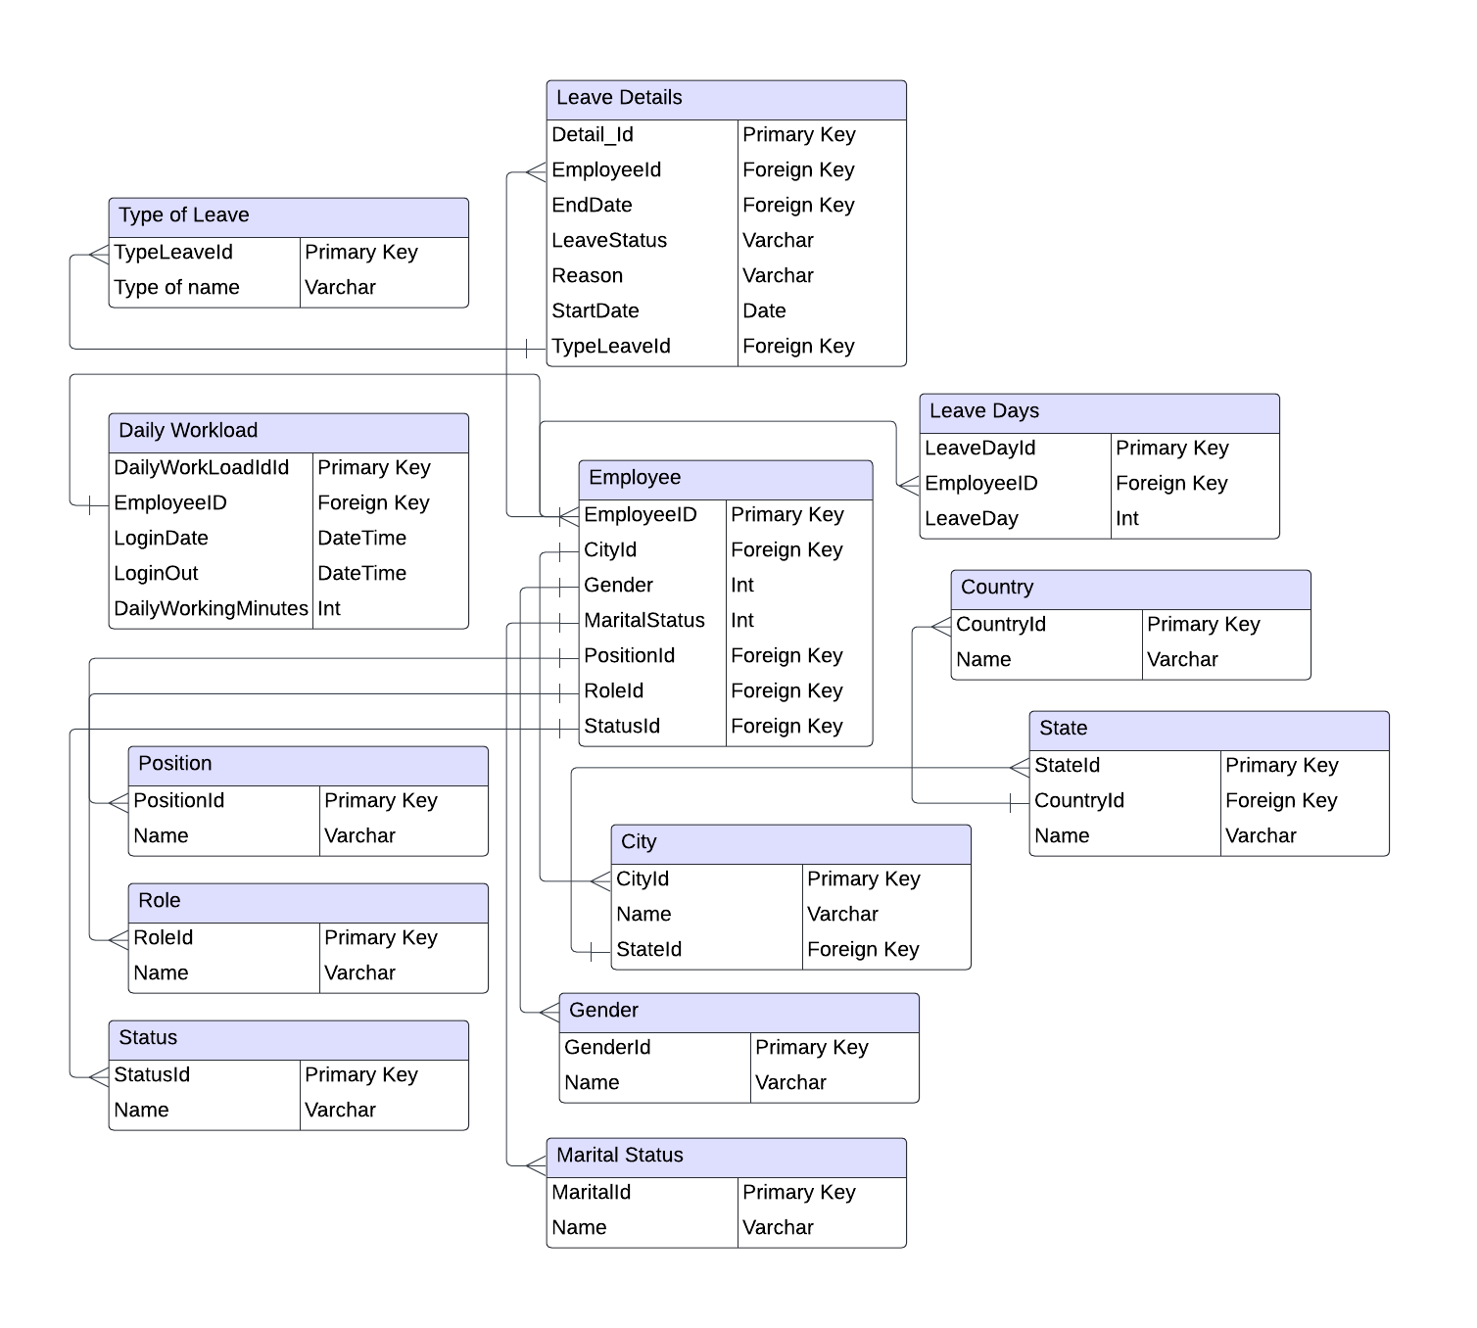

2.2.3 Technology Stack
Frontend:
HTML, CSS: Used to create the structure and styling of the user interface, providing a clean and responsive design for forms, buttons, and other visual elements.
JavaScript: Enhances interactivity on the frontend, enabling dynamic content updates and user interactions.
Backend:
Node.js: A popular JavaScript runtime that allows you to run JavaScript on the server-side. It’s well-suited for building APIs and handling backend logic.

Express.js: A web application framework for Node.js, making it easier to manage routes and handle HTTP requests.
Database:
MySQL: Stores data for employees, leave requests, roles, and departments. MySQL ensures efficient data management and security within the HR system.

Development Environment:
Visual Studio Code: A lightweight code editor that supports JavaScript, HTML, and CSS, and integrates well with Node.js development.

Chapter 3: Implementation

3.1 Development Environment
Hardware:
Laptop/PC:
Specifications:
    - Processor: Intel Core i5 or equivalent
    - RAM: 8 GB or higher
    - Storage: 256 GB SSD or larger
    - Operating System: Windows 10 or later
Software:
Integrated Development Environment (IDE):
Visual Studio Code (using JavaScript/Node.js) for writing and debugging code.
Version Control:
Git: Used for tracking changes in the code and collaborating with other developers.
Database Management Tools:
XAMPP: Provides a visual interface for designing, managing, and querying the database.
Web Browsers:
Google Chrome or Mozilla Firefox for testing the web interface and ensuring compatibility across different browsers.

3.2 Code Structure
Frontend:

/Frontend

index.html
css
styles.css

js
main.js

leave.js
images
logo.png

HTML: The index.html file serves as the main entry point, containing the layout for the application.
CSS: The styles.css file styles the HTML elements to create a user-friendly interface.
JavaScript:
- main.js handles general frontend logic.
- leave.js contains functions specifically for managing leave requests, such as form validation and dynamic updates.

Backend:
/backend

app
controllers
employeeController.Php
leaveController.Php

models
employeeModel.Php
leaveModel.Php
views
employeeView.Php
leaveView.Php

main.Php

config
database.config

Controllers: Contain logic for processing user requests related to employees and leave management.
Models: Define data structures and interactions with the database for employee and leave information.
Views: Handle the rendering of user interfaces related to employees and leave requests.
Main: The main entry point initializes the application and sets up necessary configurations.
Config: Stores configuration files, such as database connection settings.

Database
/xampp

/mysql
/data
/ibacmi_hr_system
employee.sql
leave_requests.sql
roles.sql
departments.sql
insert_data.sql
queries.sql
database.config

3.3 Key Modules and Components

Authentication Module
Role: Manages user login, registration, and session management.
Components:
Login Form: Captures username and password, verifying credentials against the database.
Registration Form: Allows administrators to create new user accounts, storing relevant details in the database.
Session Management: Maintains user sessions to ensure users stay logged in while using the system.
Interaction: When a user logs in, the module checks credentials and establishes a session. If the user is an admin, they can access additional functionalities like employee management and leave approval.
2. Employee Management Module
Role: Handles the addition, viewing, and updating of employee records.
Components:
Employee Form: A form for inputting employee details such as name, department, and position.
Employee Database: A database structure that stores all employee information.
Employee List View: Displays a list of employees with options to edit or delete records.
Interaction: This module interacts with the database to store or retrieve employee data. The UI connects with the backend to process user requests for adding or updating employee records.

3. Leave Management Module
Role: Manages leave requests from employees and the approval process by program heads.
Components:
Leave Request Form: Allows employees to apply for leave, specifying type and dates.
Leave History View: Displays past leave requests for employees to review.
Leave Approval Interface: Used by program heads to review and approve or reject leave requests.
Interaction: Upon submission of a leave request, the module communicates with the database to store the request and updates the employee's leave history. Program heads use the approval interface to make decisions based on submitted requests.

4. Data Processing Module
Role: Handles data validation, processing, and storage for both employee and leave management.
Components:
Validation Logic: Ensures that input data is complete and correctly formatted before submission to the database.
Calculation Logic: Computes available leave balances and checks for conflicts (e.g., overlapping leave requests).
Interaction: This module works behind the scenes, validating and processing data whenever a user submits a form, ensuring that only valid data is stored in the database.

5. Reporting Module
Role: Generates reports based on employee and leave data.
Components:
Report Generator: Creates summary reports of employee information and leave usage.
Export Functionality: Allows reports to be exported in formats such as PDF or CSV for distribution.
Interaction: Users can request reports through the interface, which triggers the report generator to fetch data from the database, compile it, and format it for presentation or export.

3.4 Challenges and Solutions

Challenge: Data Validation and Input Errors
Solution: Implemented robust client-side and server-side validation. Client-side validation checks were added using JavaScript to provide immediate feedback to users. Additionally, server-side validation in the backend ensured that no invalid data was processed, with error messages displayed to users for correction.
Challenge: User Authentication Security
Solution: Utilized encryption for passwords and established secure session management practices. Implemented HTTPS for secure communication between the client and server. This ensured that user credentials were encrypted during transmission, significantly enhancing security.
Challenge: Handling Concurrent Leave Requests
Solution: Developed a conflict-checking mechanism within the leave management module. When a leave request was submitted, the system automatically checked the database for overlapping leave dates before allowing the submission. This prevented conflicts and ensured that approvals were based on accurate leave balances.

Challenge: Integration of the Frontend and Backend
Established clear API endpoints and used AJAX calls to asynchronously fetch data from the backend. This allowed the frontend to dynamically update without needing to refresh the entire page. Documentation was created to ensure consistent communication between the frontend and backend teams.
Challenge: Database Management and Performance
Solution: Optimized database and utilized indexing on frequently accessed columns to speed up data retrieval. Regular database maintenance tasks, such as cleanup and archiving old data, were implemented to keep the system performant.

