User Manual – My Pet Store E-Commerce
Welcome to My Pet Store E-Commerce System! This guide will walk you through how to use the system—from registration to placing an order and tracking it.

🐾 1. Register an Account
To start using the system, you must register first.
Steps:
- Go to the homepage.
- Click on the “Register” button.
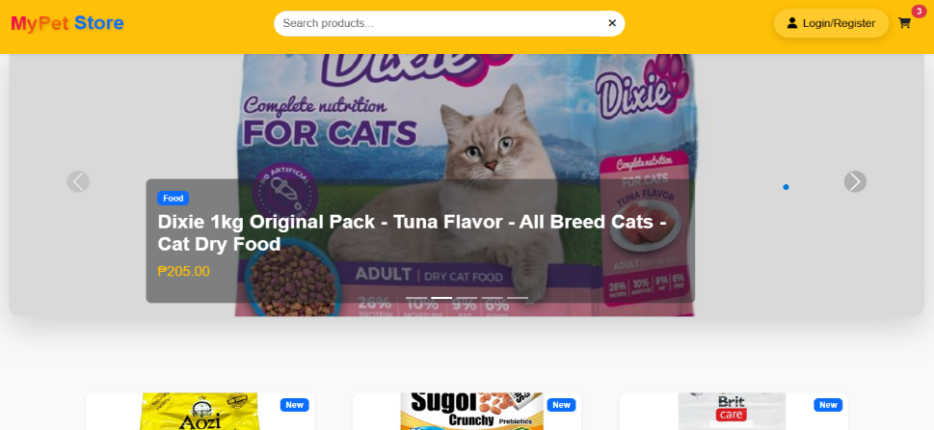
- Fill in the required fields:
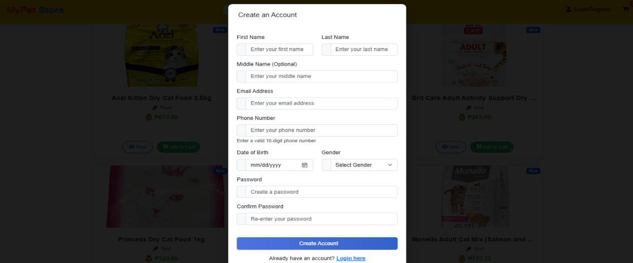
- Click “Register”.
📝 Once registered successfully, you will be redirected to the login page.

🔐 2. Log In to Your Account
Use your credentials to log in.
Steps:
- On the login page, enter:
  - Email Address
  - Password
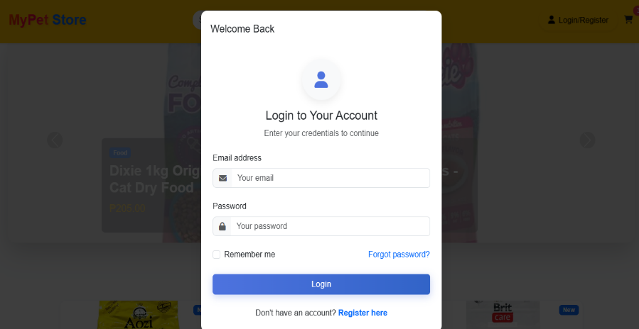

- Click “Login”.
🟢 If your login is successful, you'll be redirected to the homepage where you can start browsing products.

🛍️ 3. Browse Products
Once logged in, you can browse available pet products.
Features:
- View product images, names, and prices.
- Use categories or search bar to find specific items.
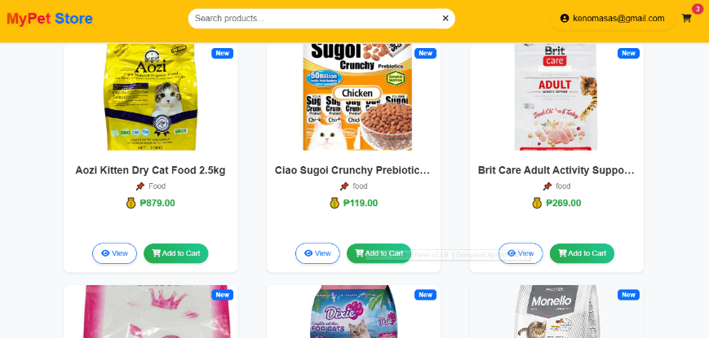

🔎 4. View Product Details
Click on any product to view more information.
You can see:
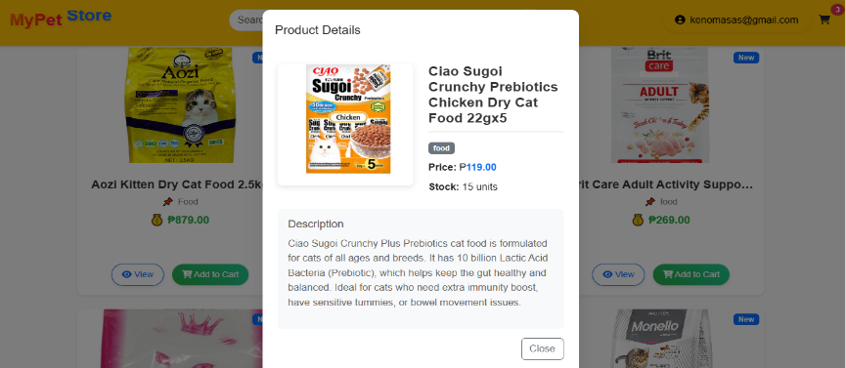

🛒 5. Add to Cart
When you find a product you like:
Steps:
- Click “Add to Cart” on the product detail page.
- Choose quantity if applicable.
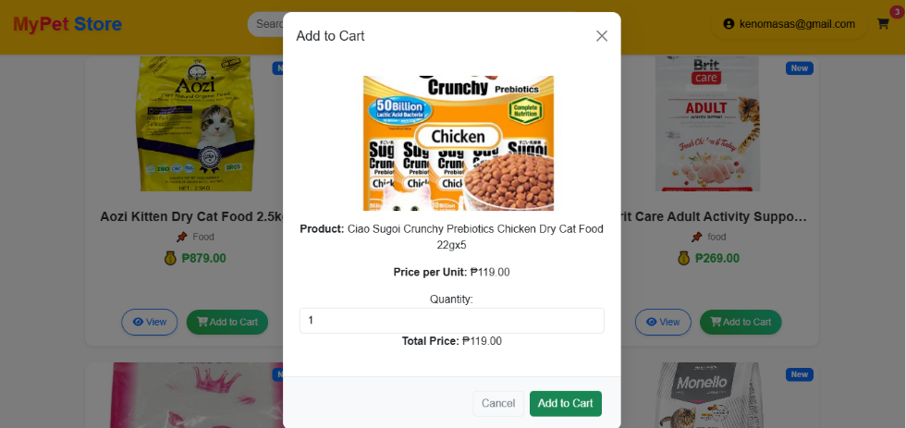
- Confirm that the product is added to your cart.

✅ 6. Checkout
Once you've added all desired products to your cart:
Steps:
- Click on the Cart icon.
- Review your selected items.
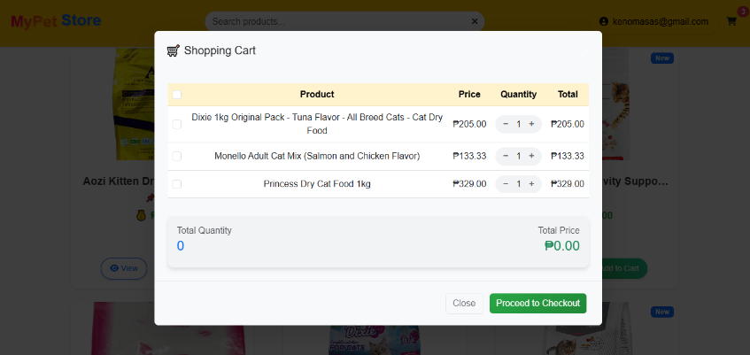
- Click “Checkout”.
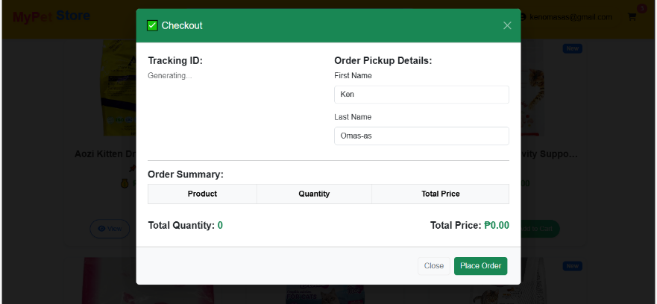

- Click “Place Order”.
🧾 You will receive an order Generated Tracking ID.

📦 7. Track Your Order
To view the details of your order:
Steps:
- Go to the “Homepage” section.
- Click your account here
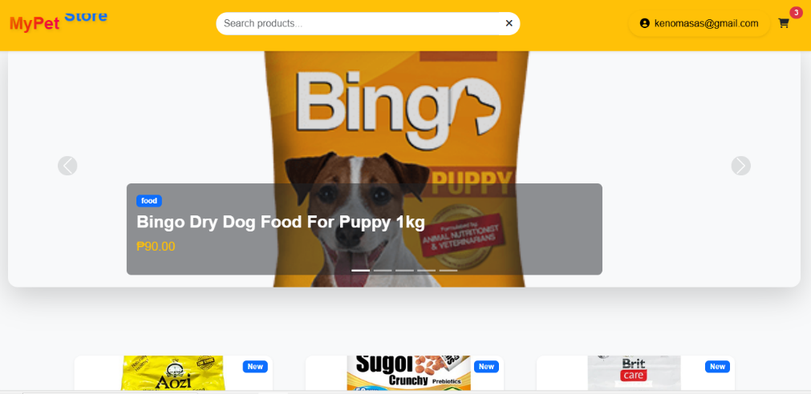
- You can see:
  - My Profile
  - My Orders
  - Logout
- Click My Orders
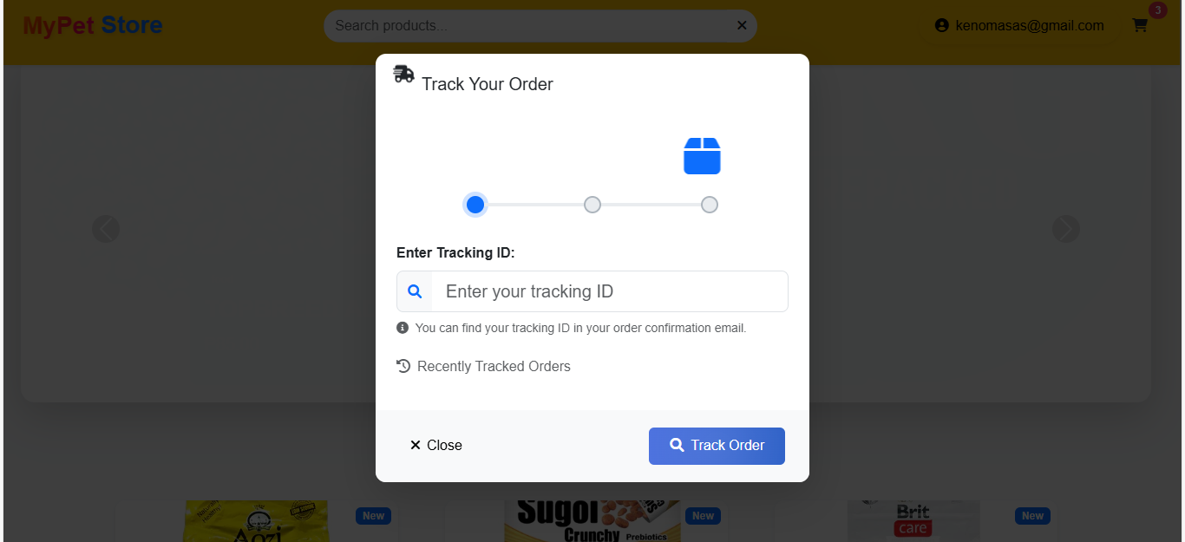
- Enter you tracking Id then click Track order then it view your order details

💬 Support
If you encounter any issues, please contact our support team through the Contact Us page.

