Wundler: A Linker-Inspired Module Graph Architecture
  - Architecture Brief — Executive Software Architect Review
2026-05-13

Wundler: A Linker-Inspired Module Graph Architecture
Architecture Brief · 2026-05-13

The Problem
Every extant JS bundler — Vite, webpack, esbuild, Rspack, Rolldown — performs eager global analysis on every invocation. The module graph is re-traversed from scratch regardless of what changed. Build time is O(n) in total module count, not O(Δ). At 50,000+ modules this is not a profiling problem or a parallelism problem; it is an architectural category error. The linker world solved this in 2019–2022. We’re applying those solutions here.

Intellectual Foundation: The Linker Isomorphism
The central insight is that JavaScript bundling and native-code linking are structurally isomorphic problems. The linker world’s solutions map directly — sometimes identically — to the bundler domain.
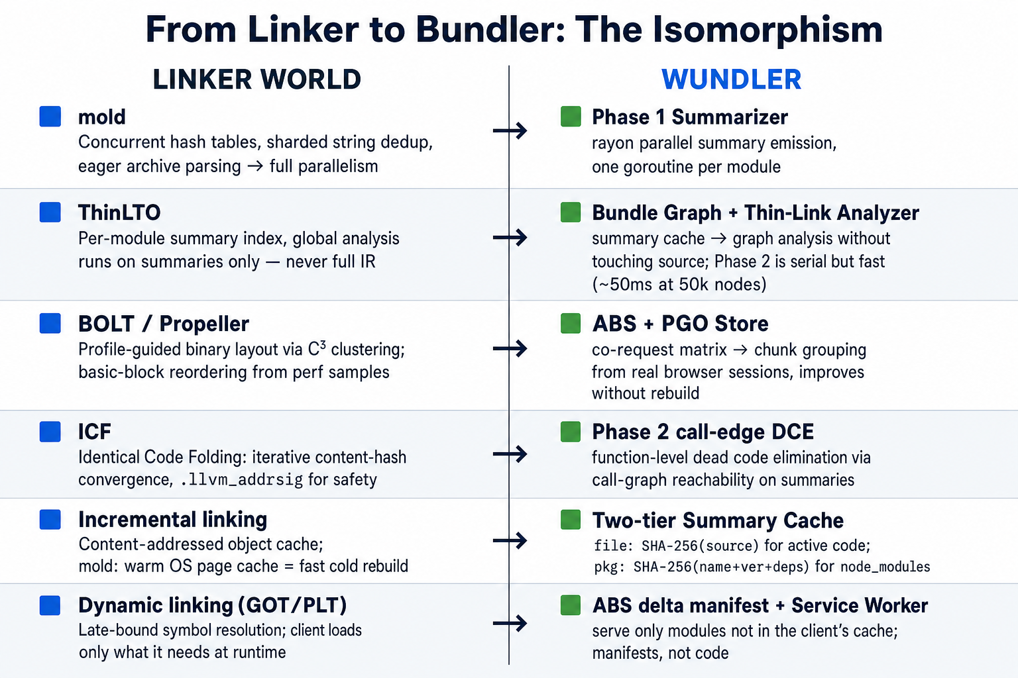
Figure 1: Direct concept mapping from the linker world to Wundler
mold’s parallelism model rewrote LLD’s 35%-serial symbol-table insertion into a concurrent oneTBB::concurrent_hash_map with sharded string dedup. The key architectural insight: LLD’s DenseMap (single-threaded) was the bottleneck, not the computations themselves. Wundler’s Phase 1 applies the same principle: rayon parallel iterators, one summarizer task per source file, zero shared mutable state.
ThinLTO is the closest prior art. It splits monolithic LTO into three decoupled phases: (1) per-module compile → summary index (parallel, incremental), (2) thin-link on summaries only (serial, fast — summaries are kilobytes, not megabytes), (3) per-module backend guided by thin-link decisions (parallel). A FunctionSummary in ThinLTO carries call edges, type IDs, hotness, and side-effect markers — exactly what a ModuleSummary in Wundler carries for JavaScript exports. The key insight ThinLTO proved: you can do accurate cross-module optimization without ever loading the full IR of every module simultaneously. Summaries are sufficient for all global decisions.
BOLT and Propeller introduced profile-guided binary layout — reordering basic blocks and functions by measuring actual runtime call patterns rather than guessing at static heuristics. BOLT’s C³ clustering algorithm and Propeller’s --symbol-ordering-file (derived from perf profiles) are the direct ancestors of Wundler’s PGO chunk grouping in the Adaptive Bundle Service.
Incremental linking (mold’s approach over gold’s) avoids on-disk state persistence — mold just re-runs so fast that the OS page cache makes the “second link” essentially free. For summaries that are 2KB each, Wundler’s Phase 1 is the same: re-summarizing an unchanged module is cheaper than deserializing a complex on-disk structure.
Dynamic linking — GOT/PLT, late-bound symbol resolution, ld.so loading only what’s referenced — is the conceptual ancestor of Wundler’s Adaptive Bundle Service. The browser client resolves module dependencies at runtime against a manifest server, fetching only what it doesn’t already have. The service worker is ld.so. The content-hashed CDN chunks are shared libraries. The delta manifest is the .so lookup.

Architecture
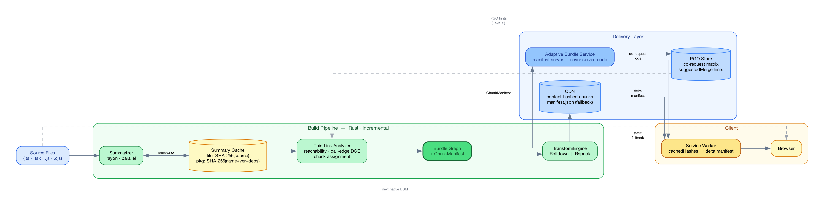
Figure 2: Wundler System Architecture

Components
Bundle Graph — the primary artifact. Not a bundle file. A content-addressed DAG where nodes are modules and edges are import relationships. The Bundle Graph is persisted across builds. All output artifacts (static bundles, chunk files, ABS delta responses, native ESM for dev) are materializations — different query strategies over the same graph. There is no separate dev/prod build; there is one graph and two materialization modes.
Summary Cache — two-tier, content-addressed. File-level key: SHA-256(source). Package-level key: SHA-256(pkg-name + version + dep-tree-hash) for node_modules, which are structurally stable between dev iterations. A CI-seeded remote layer (Azure Blob / S3) populates the cache for developers on cold builds. Phase 1 cost for a developer is proportional to |changed_source_files|, not |total_modules|.
Thin-Link Analyzer — operates exclusively on summaries. At 50k modules × ~2KB/summary ≈ 100MB total. Single-threaded bandwidth-bound scan: ~50ms. Three passes: (1) BFS/DFS reachability from entry points — dead modules skip Phase 3 entirely and are never transformed; (2) call-edge DCE — exports unreachable from live entry points via the call graph are marked dead; (3) chunk assignment — route-based splits at import() boundaries on day 1, PGO-refined after Level 1 collects data. Re-runs only when a summary changes (new imports or exports); pure implementation edits don’t touch Phase 2.
ChunkManifest — Phase 2’s output. The handshake between the build system and the Adaptive Bundle Service:
ChunkManifest {
buildId: string // SHA of entry points
chunks: Chunk[]
entryChunks: Record<EntryPoint, ChunkId[]> // what to load per route
moduleIndex: Record<ContentHash, ChunkId> // O(1) lookup
Chunk {
id, modules: ContentHash[], hash: ContentHash
loadCondition: INITIAL | LAZY | PREFETCH
coRequestScore?: number // P(this chunk | initial load) — ABS-populated
suggestedMerge?: ChunkId // ABS recommendation, no rebuild required
}
}
TransformEngine — pluggable interface behind transformChunk(modules, chunkId, decisions) → ChunkOutput. Two concrete adapters: RolldownAdapter (Rust-native, default, no FFI on hot path) and RspackAdapter (webpack-compatible, for stacks already on Rspack). Phase 3 wall-clock time scales as |changed_alive_modules| / cores. Unchanged modules hit the transform cache (keyed on ContentHash). Dead modules — those marked alive: false by Phase 2 — never reach Phase 3.
CJS Stub Generator — module.exports = { ... } is evaluated, not declared. For CJS packages: execute the package entry in an isolated happy-dom worker, enumerate Object.keys(module.exports), emit a synthetic .mjs stub with named exports. The stub is what Phase 1 summarizes. Same approach as Cloudpack; only accurate method for dynamic export patterns.

The Bundle Graph Node
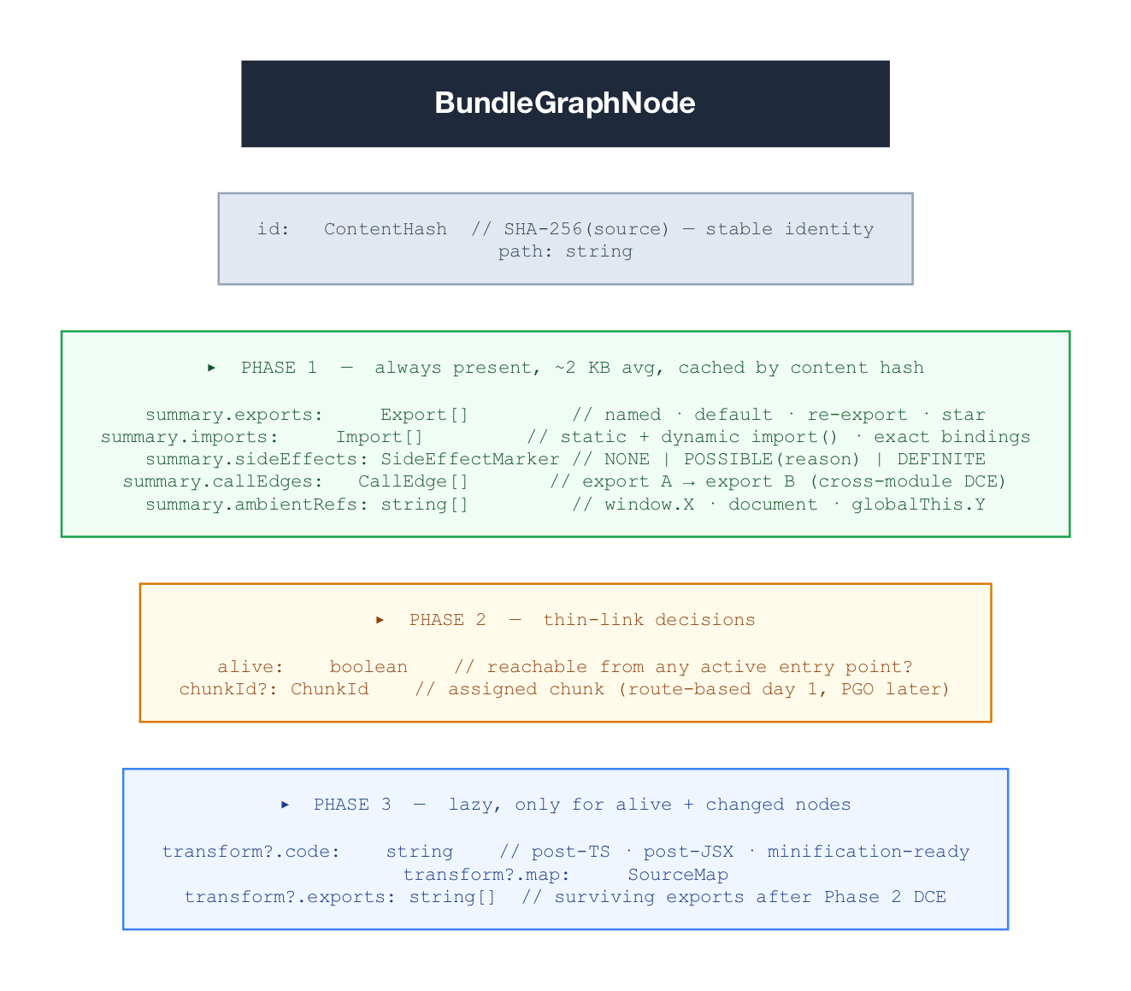
Figure 3: BundleGraphNode — three production phases, one data structure
The SideEffectMarker deserves specific mention. JavaScript’s module-level code is the hardest correctness problem in the system. The rule applied here is the ThinLTO rule: conservative at module boundaries, aggressive at function boundaries. Module-level code (any statement that executes at import time) is conservatively assumed to have side effects unless proven otherwise. Function-level code (named exports, helper functions) is aggressively eliminated if unreachable from live entry points via call-edge reachability. A correctness audit mode diffs Conservative-only output against the heuristic on every build and alerts on divergence — this is a non-negotiable safety net before any tree-shaking reaches production.

Adaptive Bundle Service & PGO Feedback Loop
The ABS is a manifest server, not a code server. CDN serves code. This distinction drives the security model: ABS compromise lets an attacker redirect clients to different existing content-hashed chunks, not inject arbitrary code. Build-time ed25519 signing of chunk hashes enables the service worker to detect manifest tampering.
Protocol:
Client → ABS: { entryPoint, cachedHashes: ContentHash[], buildId? }
ABS → Client: { buildId, fetchUrls: URL[], prefetchUrls: URL[], ttl }
The ABS records which chunks were served together per session — the co-request log. Over time this builds a matrix approximating P(chunk_A | chunk_B). C³-style clustering (BOLT-derived) identifies chunks that are always co-fetched and proposes suggestedMerge hints into the ChunkManifest. The chunk reorganization applies to future requests without a rebuild — the graph is unchanged, only the ChunkManifest’s suggestedMerge entries update. This is the PGO feedback loop closing: usage data from production flows back into chunk assignment decisions, improving delivery without engineering intervention.
Every client already has a service worker managing module assets at this scale. The delta-manifest protocol is a SW configuration update. Failure degrades transparently to manifest.json on CDN.

Correctness Invariants
Invariant | Mechanism
Module-level side effects preserved | Conservative SideEffectMarker at module boundary
Function-level dead code eliminated | Call-edge reachability across summary graph
CJS exports correctly enumerated | Worker execution + synthetic .mjs stub
Tree-shaking correctness verified | Audit mode: diff Conservative vs heuristic on every build
Build output immutable | Content-hash keyed chunks on CDN; buildId invalidation
ABS never a SPOF | SW timeouts at 100ms p99 → falls back to manifest.json
Transform engine correct-by-default | Rolldown / Rspack behind TransformEngine interface

Deployment Levels
Level | What ships | New infra | When
0 — Static | ThinBundle replaces build pipeline; chunks + manifest.json on CDN | None | Month 3
1 — Adaptive | ABS manifest server + SW delta protocol | ABS service | Month 4+
2 — PGO | Co-request matrix drives suggestedMerge chunk refinement | PGO store | Month 6+
Level 0 is independently valuable: faster CI builds, dead-code elimination at scale, no dev/prod divergence. Levels 1 and 2 are additive optimizations that degrade cleanly to Level 0 if unavailable. The Month 1 gate — run Phase 1 across the full production module graph and confirm ~100MB summary cache size — validates the entire architecture before any further investment.

