MINISTRY OF EDUCATION AND TRAINING
EASTERN INTERNATIONAL UNIVERSITY

BUSINESS DATA MANAGEMENT
MIS 443
FINANCE ANALYSIS WITH POSTGRESQL
Individual Project Report
Student | Doan Phan Minh Vu
Student ID | 2232300049
PostgreSQL • pgAdmin 4 • SQL Analysis

Table of Contents
1. Introduction 3
2. Dataset and Database Overview 3
3. Database Design and Entity–Relationship Diagram 4
4. Implementation Workflow 4
5. SQL Analysis Results 5
6. Key SQL Techniques and Findings 12
7. Challenges and Solutions 12
8. Conclusion 12
9. GitHub Repository Guide 12
Report focus: This report presents the completed SQL analysis, verifies the database structure, and explains the business meaning of the main outputs. The full SQL scripts are included in the GitHub repository for reproducibility and practice.

1. Introduction
This project analyses a small retail-banking database using PostgreSQL and pgAdmin 4. The database is designed to support common management questions about customer portfolios, account balances, branch performance, and transaction activity. The work was completed as an individual MIS 443 Business Data Management exercise.
The analysis moves from basic filtering and aggregation to multi-table joins, subqueries, tie-aware ranking, window functions, and a Common Table Expression (CTE). Each query was executed in pgAdmin and the result was captured as evidence of successful implementation.
2. Dataset and Database Overview
The supplied PostgreSQL script creates four related tables in the public schema and inserts the complete practice dataset. The database contains 6 customers, 15 branches, 15 accounts, and 15 transactions.
Table | Purpose | Rows
customers | Customer names and locations | 6
branches | Branch names and locations | 15
accounts | Ownership, branch assignment, account type and balance | 15
transactions | Transaction date and amount for each account | 15
Positive account balances represent customer funds. Negative Credit Card balances represent amounts owed. Positive transaction amounts are credits and negative amounts are debits.

3. Database Design and Entity–Relationship Diagram
The relational structure connects customers and branches through accounts, while transactions are linked to individual accounts. Primary keys identify each record and foreign keys enforce valid relationships between the tables.
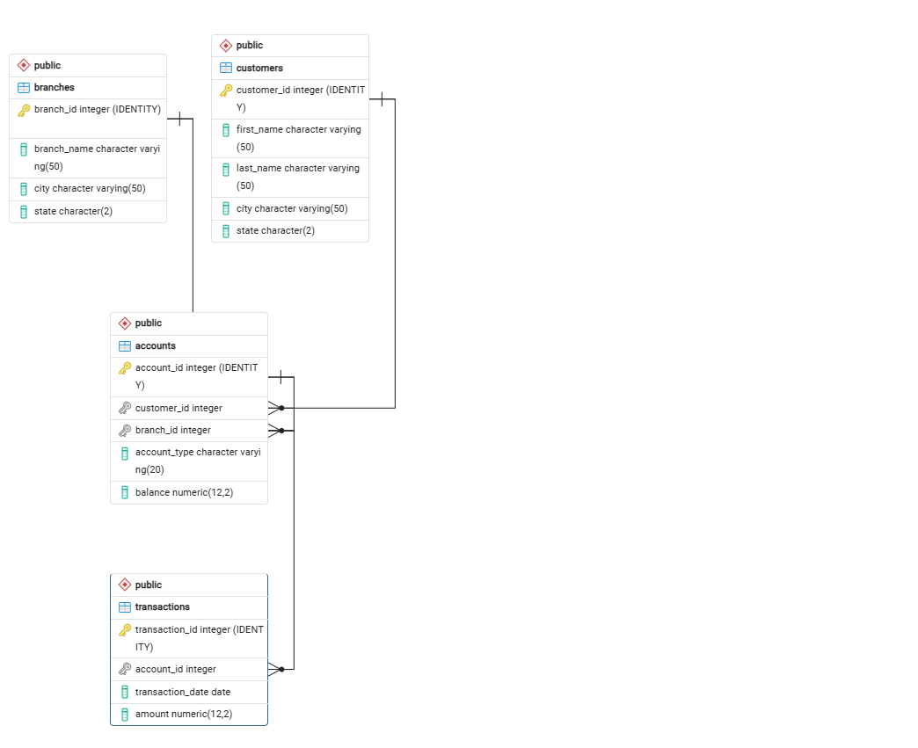
Figure 1. Entity–Relationship Diagram of the finance database
- One customer can own many accounts; each account belongs to one customer.
- One branch can hold many accounts; each account is assigned to one branch.
- One account can have many transactions; each transaction belongs to one account.
4. Implementation Workflow
Step | Action
1 | Create a personal PostgreSQL database using the required naming convention.
2 | Run MIS443_Finance_PostgreSQL.sql to create the four tables, constraints, and sample records.
3 | Verify that customers, branches, accounts, and transactions exist in the public schema.
4 | Run the completed finance-analysis queries in pgAdmin.
5 | Check the outputs against the expected values and capture screenshots for the report.

5. SQL Analysis Results
5.1 Question 1 – Database Setup
Technique | information_schema filtering
Result | Four required tables are available: accounts, branches, customers, and transactions.
Interpretation | This confirms that the supplied schema was loaded successfully before the analysis queries were executed.
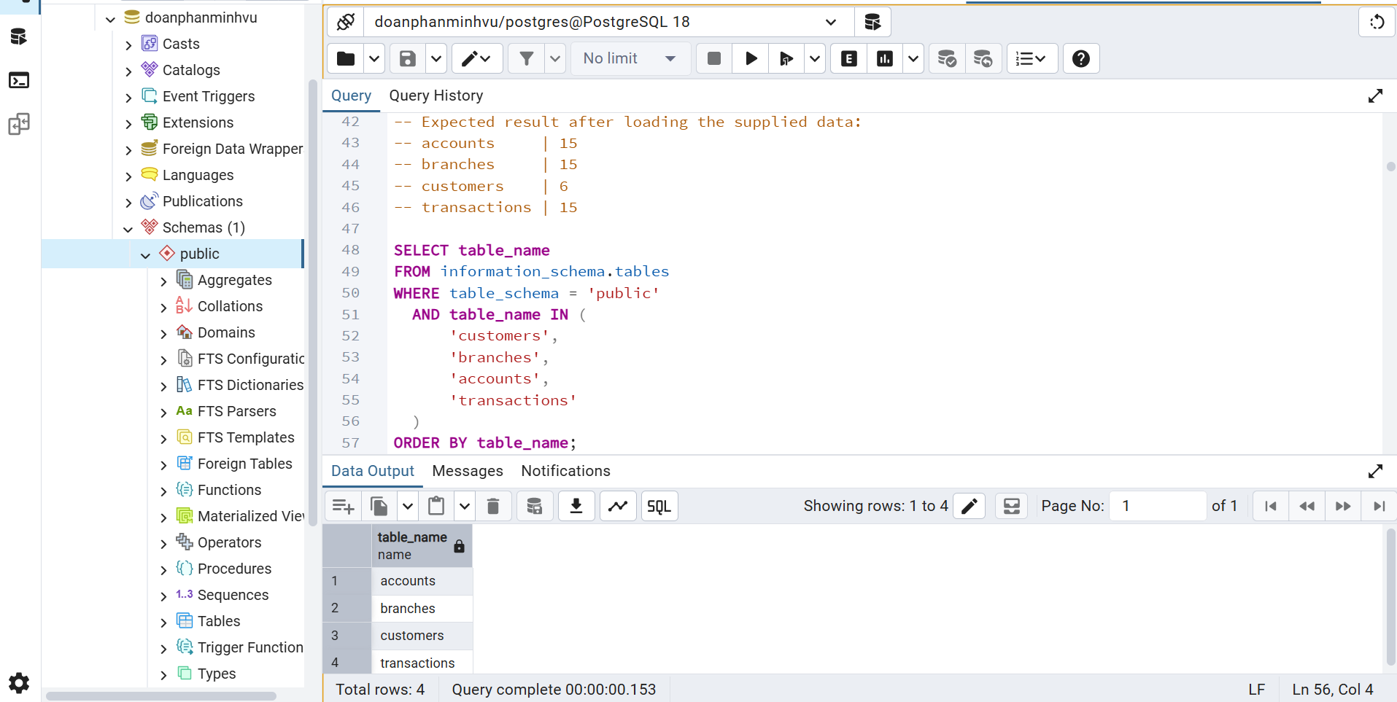
Figure 2. Database setup verification in pgAdmin
5.2 Question 2(a) – New York Customer Contact List
Technique | WHERE, CONCAT, ORDER BY
Result | John Doe and Jane Doe are the two customers located in New York.
Interpretation | The query produces a clean customer-service contact list and demonstrates basic filtering and readable full-name construction.
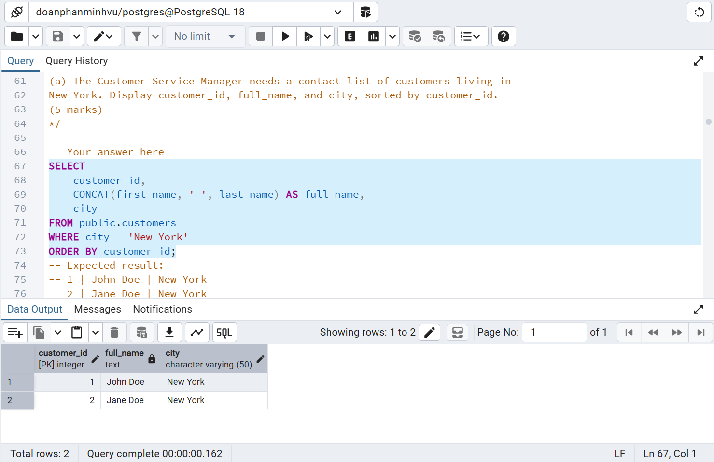
Figure 3. New York customer contact list

5.3 Question 2(b) – Account Portfolio Size
Technique | COUNT(*)
Result | The bank dataset contains 15 accounts.
Interpretation | This gives management a direct measure of the current account portfolio represented in the practice database.
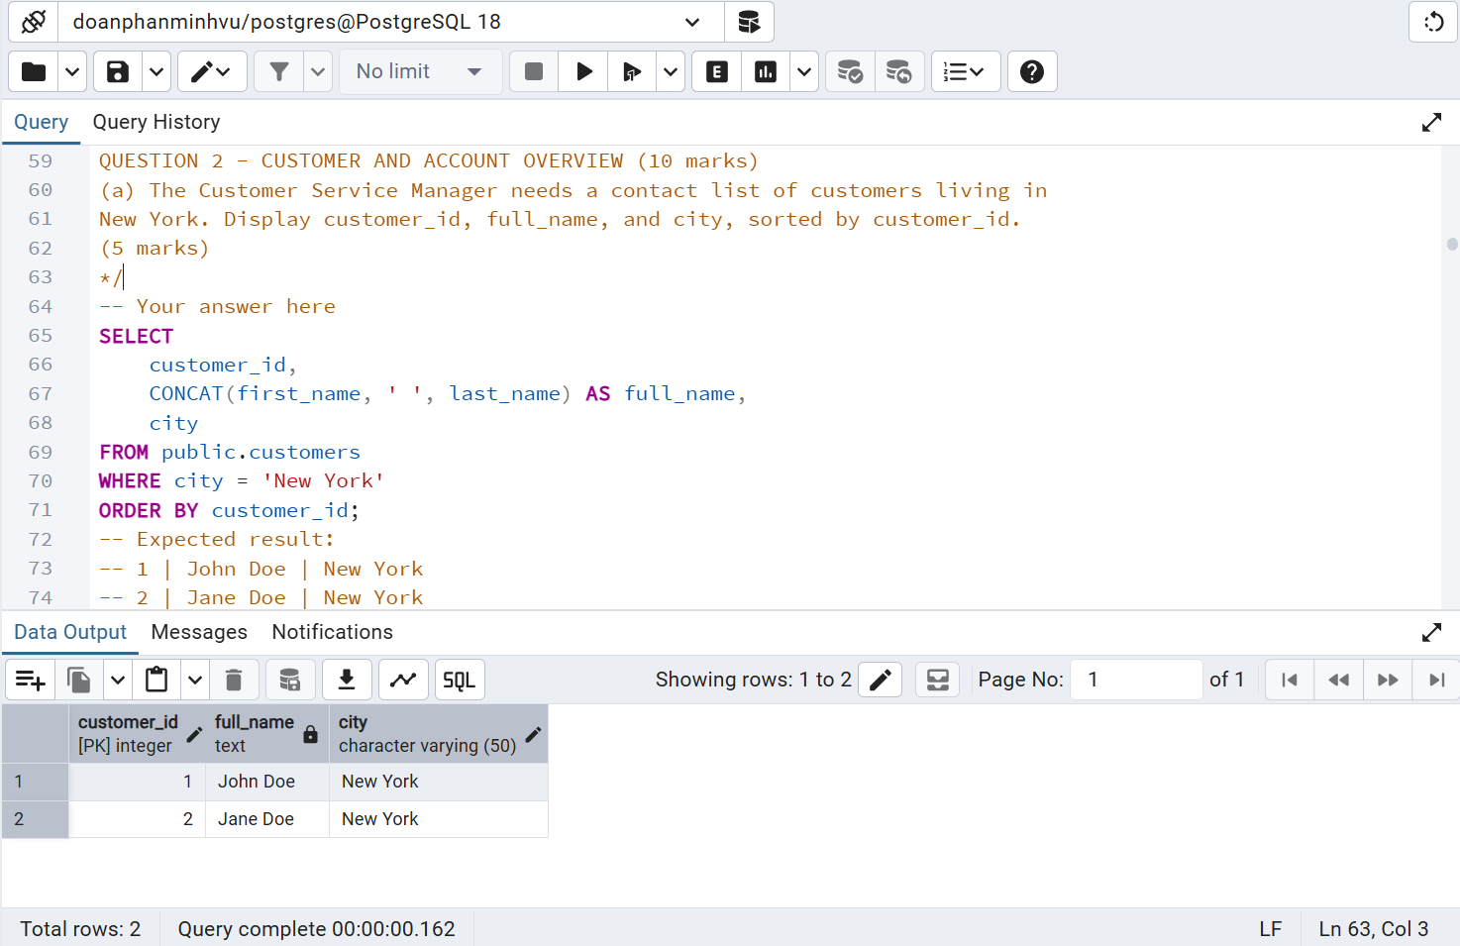
Figure 4. Total number of accounts
5.4 Question 3(a) – Total Checking Balance
Technique | SUM with account-type filtering
Result | Total Checking balance = 31,000.00.
Interpretation | The result isolates funds held in Checking accounts and summarizes them into one finance-monitoring metric.
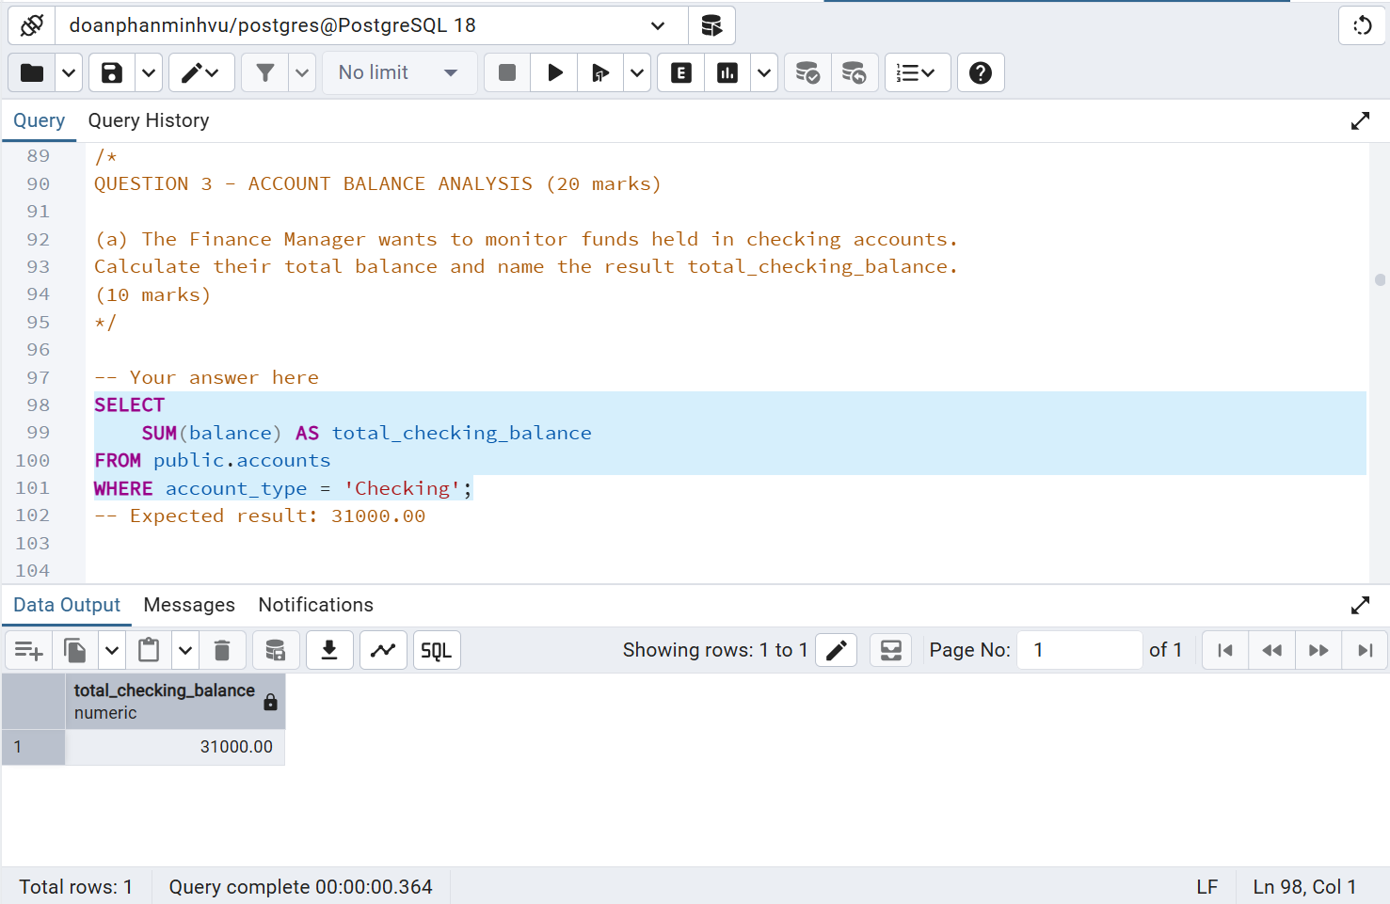
Figure 5. Total balance held in Checking accounts

5.5 Question 3(b) – Los Angeles Customer Portfolios
Technique | JOIN, GROUP BY, SUM, descending sort
Result | Michael Lee has a total balance of 60,000.00; Jennifer Wang has 15,000.00.
Interpretation | Michael Lee holds the larger Los Angeles portfolio in this dataset, with a combined balance four times Jennifer Wang’s.
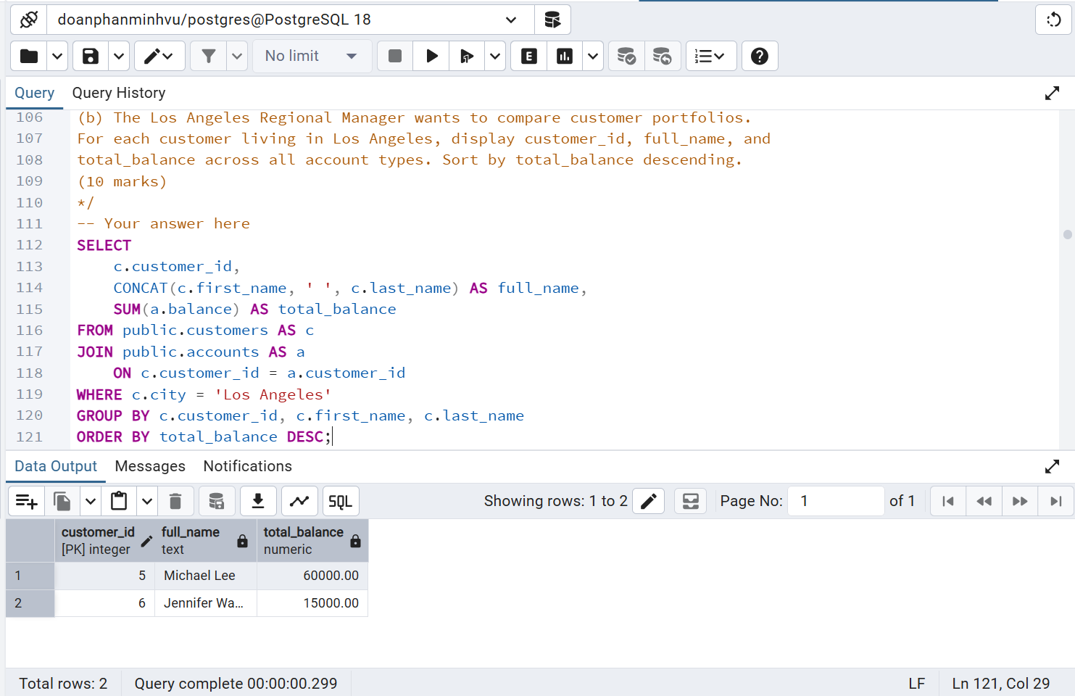
Figure 6. Total balances for Los Angeles customers
5.6 Question 4(a) – Highest Average Branch Balance
Technique | JOIN, AVG, ROUND, FETCH FIRST ... WITH TIES
Result | North Beach (San Francisco) has the highest average account balance at 30,000.00.
Interpretation | Using WITH TIES keeps the query correct even if multiple branches share the same highest average.
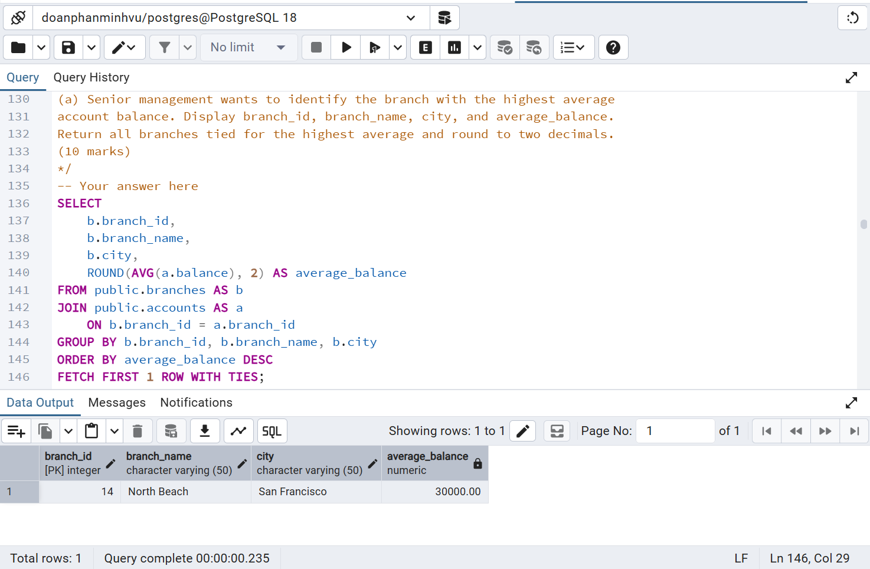
Figure 7. Branch with the highest average account balance

5.7 Question 4(b) – Highest Single Account Balance
Technique | JOIN plus scalar MAX subquery
Result | Michael Lee owns Account 10, a Savings account with a balance of 50,000.00.
Interpretation | The subquery finds the maximum balance first, while the join returns the customer and account details associated with that value.
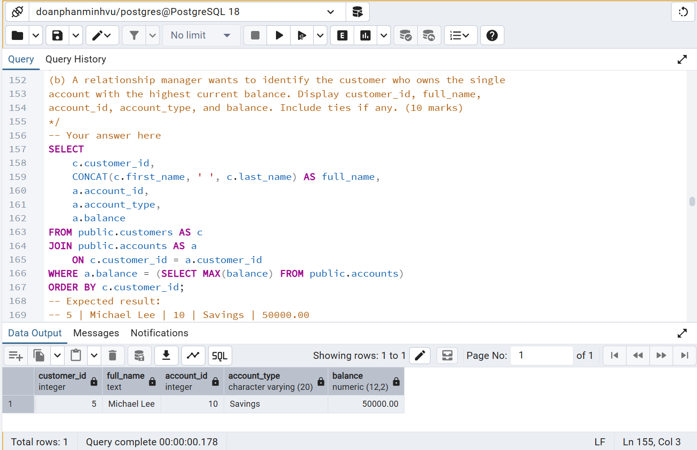
Figure 8. Customer owning the highest-balance account
5.8 Question 5(a) – Most Active Customers
Technique | LEFT JOIN, COUNT, GROUP BY, WITH TIES
Result | Jane Doe and Alice Johnson are tied with 4 transactions each.
Interpretation | The query counts activity across all accounts and preserves tied leaders. LEFT JOIN also keeps the logic compatible with customers who may have no transactions.
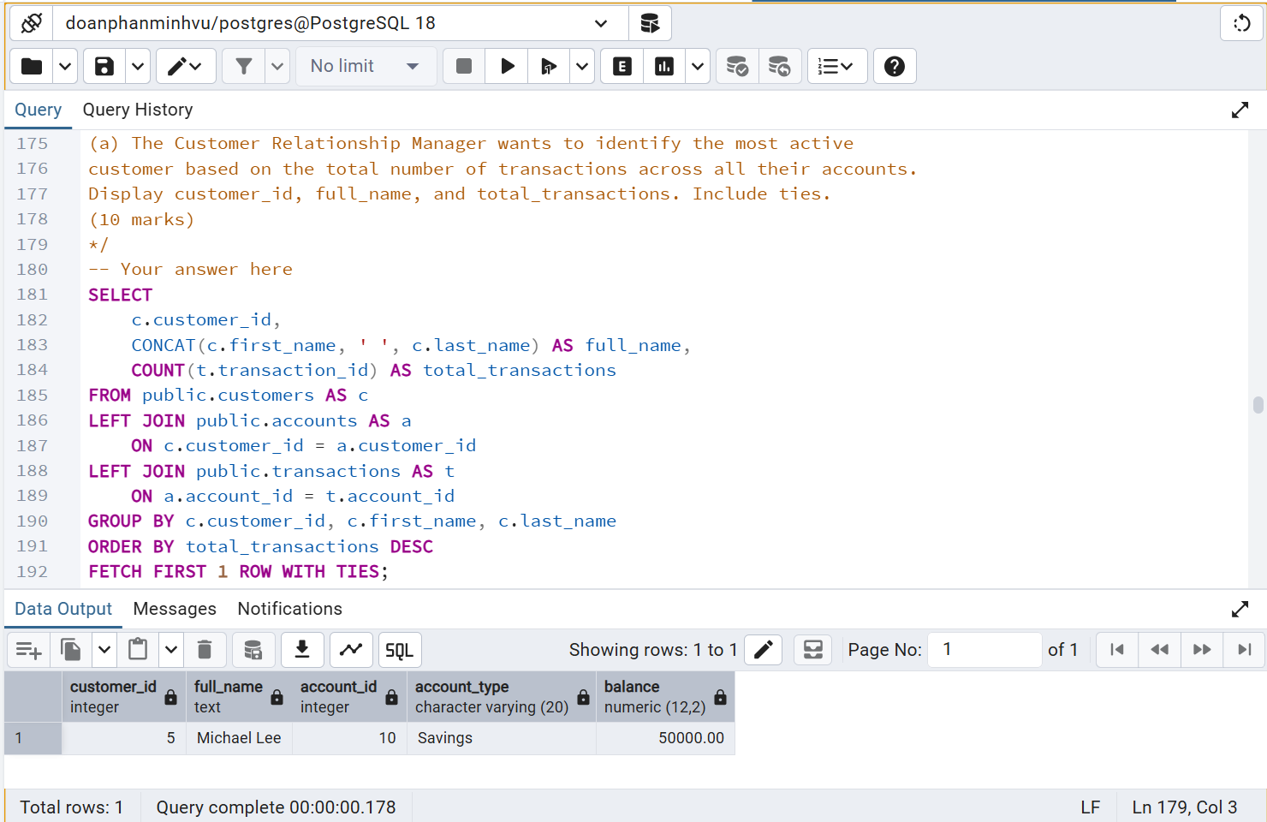
Figure 9. Customers with the highest transaction activity

5.9 Question 5(b) – Highest Deposit Balance
Technique | JOIN, IN filter, SUM, GROUP BY
Result | Michael Lee has the highest combined Checking and Savings balance at 60,000.00.
Interpretation | Credit Card accounts are excluded so the result focuses only on deposit products.
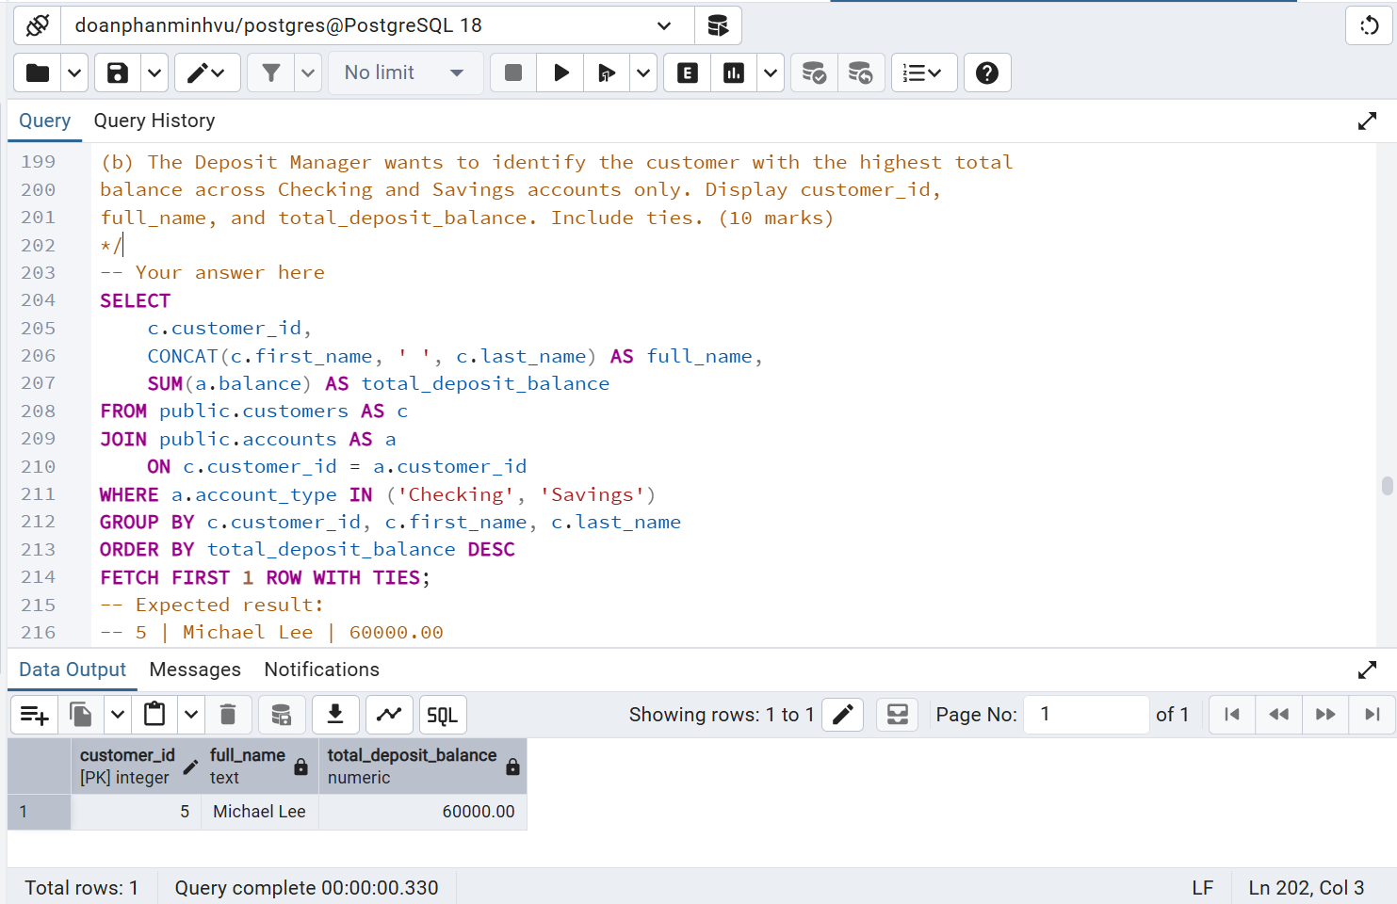
Figure 10. Highest combined Checking and Savings balance
5.10 Question 6(a) – Highest Total Branch Balance
Technique | JOIN, SUM, GROUP BY, WITH TIES
Result | North Beach has the highest total balance at 60,000.00.
Interpretation | This branch-level aggregation identifies where the largest total account balance is concentrated in the dataset.
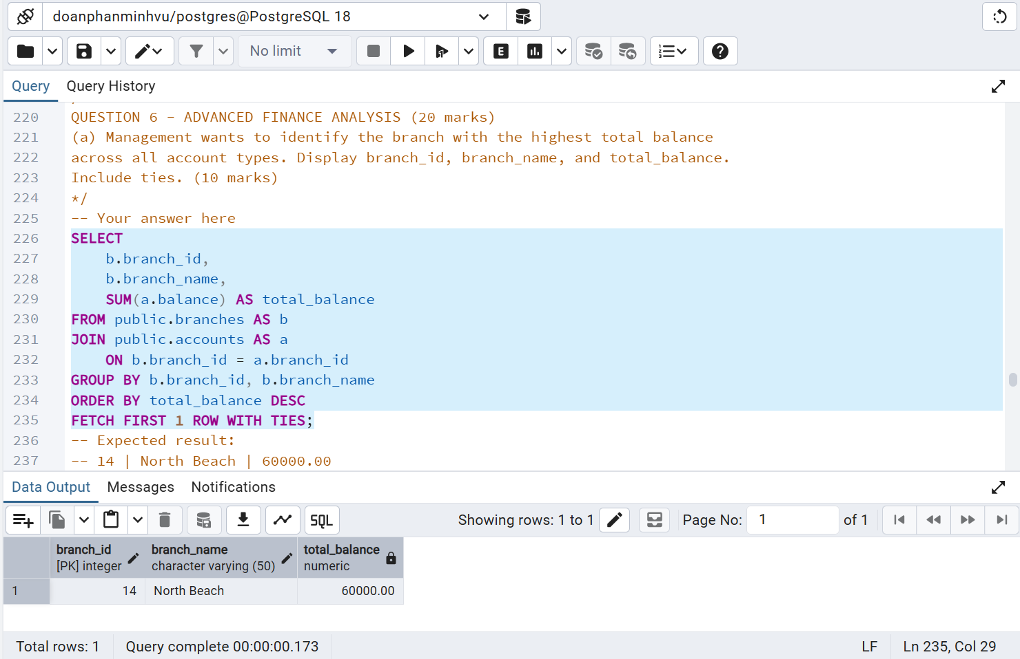
Figure 11. Branch with the highest total account balance

5.11 Question 6(b) – Customer Balance Ranking
Technique | SUM with DENSE_RANK window function
Result | Michael Lee ranks 1st with 60,000.00, followed by Alice Johnson (25,000.00) and Bob Smith (20,500.00).
Interpretation | DENSE_RANK gives equal totals the same rank without leaving gaps, matching the examination requirement while keeping all customers in the result.
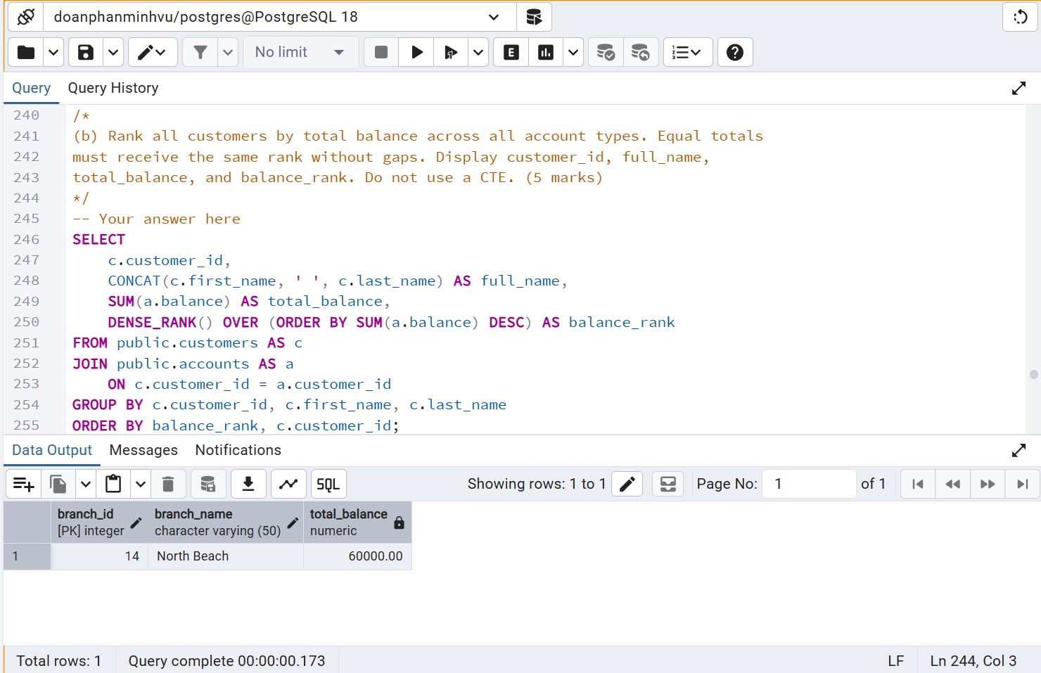
Figure 12. Customer ranking by total balance
Rank | Customer | Total Balance
1 | Michael Lee | 60,000.00
2 | Alice Johnson | 25,000.00
3 | Bob Smith | 20,500.00
4 | Jennifer Wang | 15,000.00
5 | Jane Doe | 11,500.00
6 | John Doe | 5,500.00

5.12 Question 6(c) – Branch Transaction Leader Using a CTE
Technique | CTE, LEFT JOIN, COUNT, MAX
Result | Main and South Bay are tied for the highest total, with 4 transactions each.
Interpretation | The CTE first calculates transaction totals for every branch, including branches with no transactions. The outer query then returns all branches tied at the maximum.
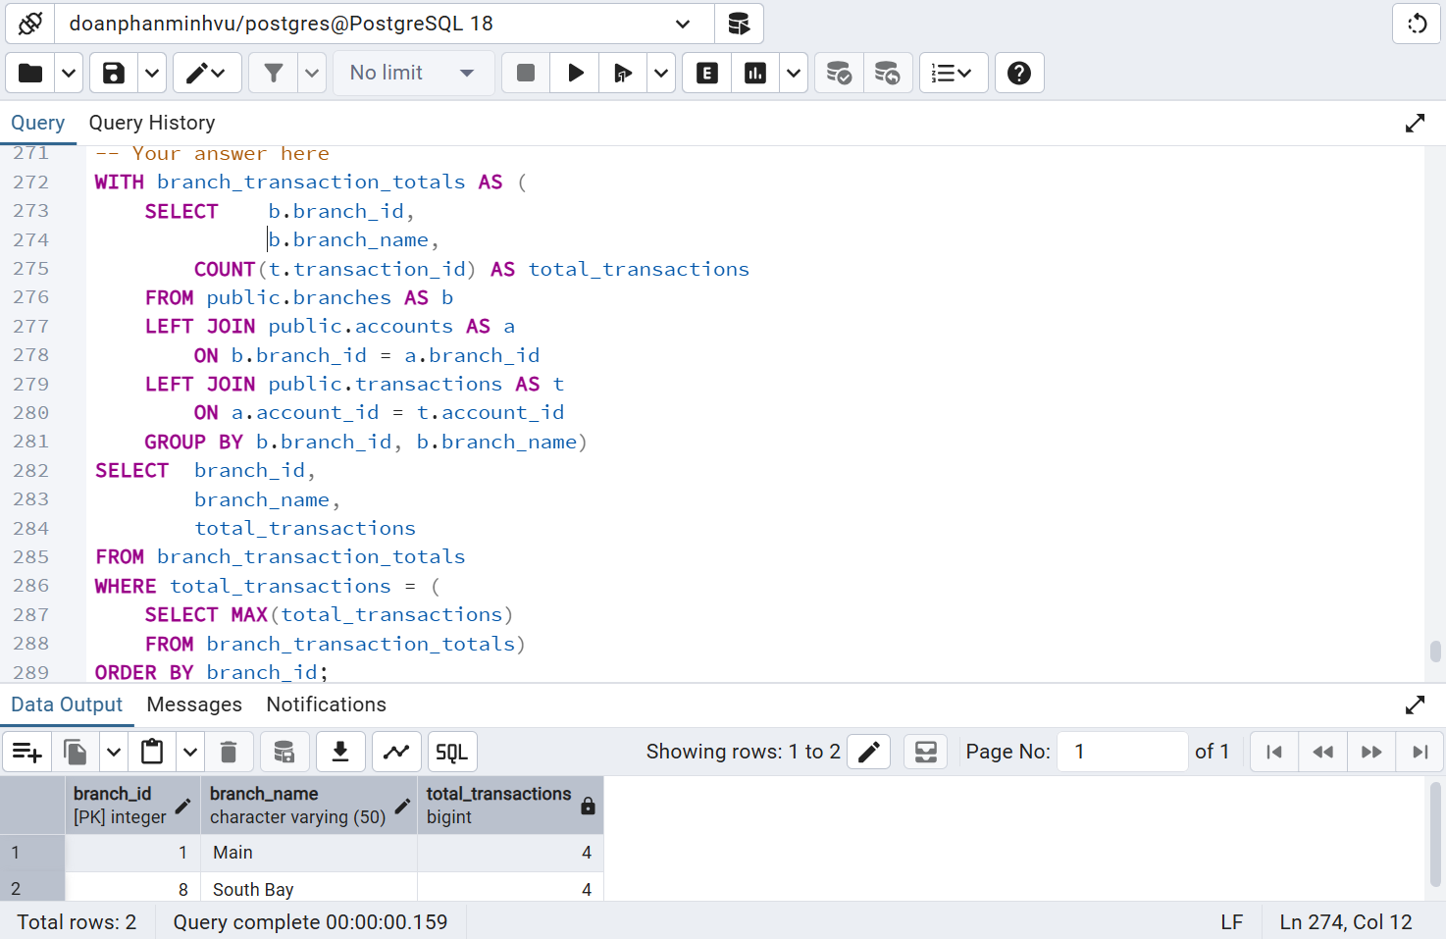
Figure 13. Branches with the highest transaction count using a CTE
Key Business Findings
- Michael Lee is the strongest customer by both total portfolio balance (60,000.00) and deposit balance (60,000.00).
- North Beach is the leading branch by both average account balance (30,000.00) and total account balance (60,000.00).
- Jane Doe and Alice Johnson are the most active customers in the available transaction history, with four transactions each.
- Main and South Bay share the highest branch transaction count, with four transactions each.

6. Key SQL Techniques and Findings
Technique | Where Used | Why It Matters
Filtering & sorting | Questions 2–3 | Returns business-specific subsets and prioritised results.
Aggregate functions | Questions 2–6 | Summarises account counts, balances, averages and activity.
JOIN / LEFT JOIN | Questions 3–6 | Combines customer, account, branch and transaction information.
Subquery | Question 4(b) | Finds the maximum account balance before returning its owner.
FETCH FIRST ... WITH TIES | Questions 4(a), 5, 6(a) | Returns every record tied for the highest value.
DENSE_RANK | Question 6(b) | Creates a no-gap customer ranking when totals are equal.
CTE | Question 6(c) | Separates branch-level transaction calculation from final maximum filtering.
7. Challenges and Solutions
- Tie handling: a simple LIMIT 1 could hide valid tied results. FETCH FIRST 1 ROW WITH TIES was used where the question required all leaders.
- Customer activity: transactions are stored at account level, so activity must be traced from customers → accounts → transactions before counting.
- No-gap ranking: DENSE_RANK was selected because equal customer balances must share a rank without gaps.
- Zero-activity branches: LEFT JOIN was required in the CTE so branches without accounts or transactions were still included in the branch totals.
8. Conclusion
The project successfully recreates and analyses a relational banking database in PostgreSQL. The completed queries answer operational and analytical questions about customers, accounts, branches, balances, and transaction activity. The exercise demonstrates a progression from foundational SQL to more advanced techniques such as window functions and CTEs, while maintaining reproducible results through a clear database-loading script and solution file.
9. GitHub Repository Guide
The repository is organised so another student can download the project, recreate the database, attempt the questions independently, and compare their work with the completed solutions.
Folder / File | Purpose
codes/MIS443_Finance_PostgreSQL.sql | Creates the tables, constraints, and sample dataset.
codes/MIS443_Finance_Analysis_Solutions.sql | Contains the completed SQL answers.
report/MIS443_DoanPhanMinhVu_Finance_Analysis_Report.docx | Documents the workflow, outputs, and interpretation.
Entity_Relationship_Diagram.png | Shows the table structure and relationships.
README.md | Explains the project and how to run it.
Github link: https://github.com/kenphan303/MIS443-Finance-Analysis-PostgreSQL
Author: Doan Phan Minh Vu | Student ID: 2232300049

