MINISTRY OF EDUCATION AND TRAINING
EASTERN INTERNATIONAL UNIVERSITY

BUSINESS DATA MANAGEMENT
MIS 443
Assignment 4 - Individual PostgreSQL Database Project: School Schema
Lecturer: Mr. Dang Thai Doan
Course: MIS 443
Date Submission: 22/07/2026

First name | Student ID
Đoàn Phan Minh Vũ | 2232300049

Quarter 4: 2025-2026

Table of Contents
1. Introduction 4
2. Overview of the School Database 4
3. Main Tables and Relationships 5
3.1 Students Table 5
3.2 Professors Table 5
3.3 Courses Table 6
3.4 Enrollments Table 6
3.5 Relationships Between the Tables 7
4. Entity-Relationship Diagram 7
5. Database Implementation 8
5.1 Database Creation 8
5.2 Creation of Tables and Relationships 8
5.3 Preparation of CSV Files 8
5.4 Data Insertion 9
5.5 Data Verification 9
6. Summary of the SQL Questions 9
7. pgAdmin Query Results and Screenshots 10
7.1 Question 1: Complete Student Roster 10
7.2 Question 2: Computer Science Students 11
7.3 Question 3: Courses Ordered by Credits 12
7.4 Question 4: Students Graduating in 2026 12
7.5 Question 5: Total Number of Courses 12
7.6 Question 6: Average Credits per Course 13
7.7 Question 7: Students Enrolled After 2022 13
7.8 Question 8: Computer Science Professor 14
7.9 Question 9: University Email Addresses 14
7.10 Question 10: Professors and Their Courses 15
8. Challenges and Solutions 16
8.1 Creating Tables in the Correct Order 16
8.2 Inserting Data in the Correct Order 16
8.3 Handling an Undeclared Major 16
8.4 Using Consistent Date Values 16
8.5 Maintaining Data Integrity 16
9. Conclusion 16
10. GitHub Repository 17

1. Introduction
This report presents the development of a PostgreSQL database based on a School schema. The project was completed as an individual assignment for the MIS 443 - Business Data Management course.
The main purpose of the project was to create a relational database for storing and managing information about students, professors, courses, and course enrollments. PostgreSQL was used as the database management system, while pgAdmin 4 was used to create the database, define the tables, insert the data, execute SQL queries, and review the results.
The project contains separate SQL scripts for creating the database, creating the tables and relationships, inserting the data, and answering ten SQL questions. It also includes a separate CSV file for each table, an Entity-Relationship Diagram, pgAdmin screenshots, and a public GitHub repository containing the complete project.
Through this project, I applied important database concepts such as data types, primary keys, foreign keys, constraints, table relationships, data insertion, filtering, sorting, aggregate functions, and joins.

2. Overview of the School Database
The School database is designed to store and manage academic information about students, professors, courses, and enrollments.
The database contains four main tables:
- students
- professors
- courses
- enrollments
The students table stores personal and academic information about each student. The professors table stores information about professors and their academic departments. The courses table stores information about the available courses and identifies the professor responsible for each course. The enrollments table records the courses taken by students, together with the semester, year, and grade.
The database follows a relational structure. Each table has a primary key that uniquely identifies its records. Foreign keys connect related records between the tables. This design reduces unnecessary duplication and helps maintain data consistency.
The completed database contains seven student records, four professor records, six course records, and ten enrollment records.

3. Main Tables and Relationships

3.1 Students Table
The students table stores personal and academic information about each student.
Column | Data Type | Description
student_id | INTEGER | Unique identifier for each student
first_name | VARCHAR(50) | Student's first name
last_name | VARCHAR(50) | Student's last name
email | VARCHAR(100) | Student's email address
enrollment_date | DATE | Date when the student enrolled
graduation_year | INTEGER | Expected graduation year
major | VARCHAR(100) | Student's academic major

The student_id column is the primary key. The first_name, last_name, and enrollment_date columns are defined as NOT NULL. The email column has a UNIQUE constraint, while the major column may contain a null value. In the current dataset, David Kim has not declared a major, so his major is stored as NULL.

3.2 Professors Table
The professors table stores information about university professors.
Column | Data Type | Description
professor_id | INTEGER | Unique identifier for each professor
first_name | VARCHAR(50) | Professor's first name
last_name | VARCHAR(50) | Professor's last name
email | VARCHAR(100) | Professor's email address
department | VARCHAR(100) | Professor's academic department
hire_date | DATE | Date when the professor was hired

The professor_id column is the primary key. The first_name, last_name, department, and hire_date columns are defined as NOT NULL. The email column has a UNIQUE constraint. The dataset includes four professors from the Computer Science, Mathematics, Physics, and Chemistry departments.

3.3 Courses Table
The courses table stores information about the courses offered by the school.
Column | Data Type | Description
course_id | VARCHAR(10) | Unique identifier for each course
course_name | VARCHAR(100) | Name of the course
credits | INTEGER | Number of credits for the course
department | VARCHAR(100) | Department offering the course
professor_id | INTEGER | Professor responsible for the course

The course_id column is the primary key. Course IDs contain letters and numbers, so VARCHAR(10) is used. The course_name and department columns are NOT NULL. The credits column has a CHECK constraint requiring the value to be greater than zero. The professor_id column is a foreign key referencing professors.professor_id and uses ON DELETE SET NULL.
The database contains six courses: Introduction to Programming, Data Structures, Calculus I, Linear Algebra, General Physics I, and General Chemistry.

3.4 Enrollments Table
The enrollments table records the relationship between students and courses.
Column | Data Type | Description
enrollment_id | INTEGER | Unique identifier for each enrollment
student_id | INTEGER | Student associated with the enrollment
course_id | VARCHAR(10) | Course associated with the enrollment
semester | VARCHAR(20) | Semester when the course was taken
year | INTEGER | Academic year of the enrollment
grade | VARCHAR(2) | Grade received by the student

The enrollment_id column is the primary key. The student_id column references students.student_id, and the course_id column references courses.course_id. Both foreign keys use ON DELETE CASCADE. The semester and year columns are NOT NULL, while the grade column may contain a null value.

3.5 Relationships Between the Tables
The relationship between professors and courses is one-to-many: one professor can teach multiple courses, while each course can be associated with one professor.
The relationships between students and enrollments, and between courses and enrollments, are also one-to-many. Therefore, students and courses have a many-to-many relationship that is resolved through the enrollments table.

4. Entity-Relationship Diagram
Figure 1 presents the Entity-Relationship Diagram of the School database. It shows the four tables, their columns, primary keys, foreign keys, and relationships.

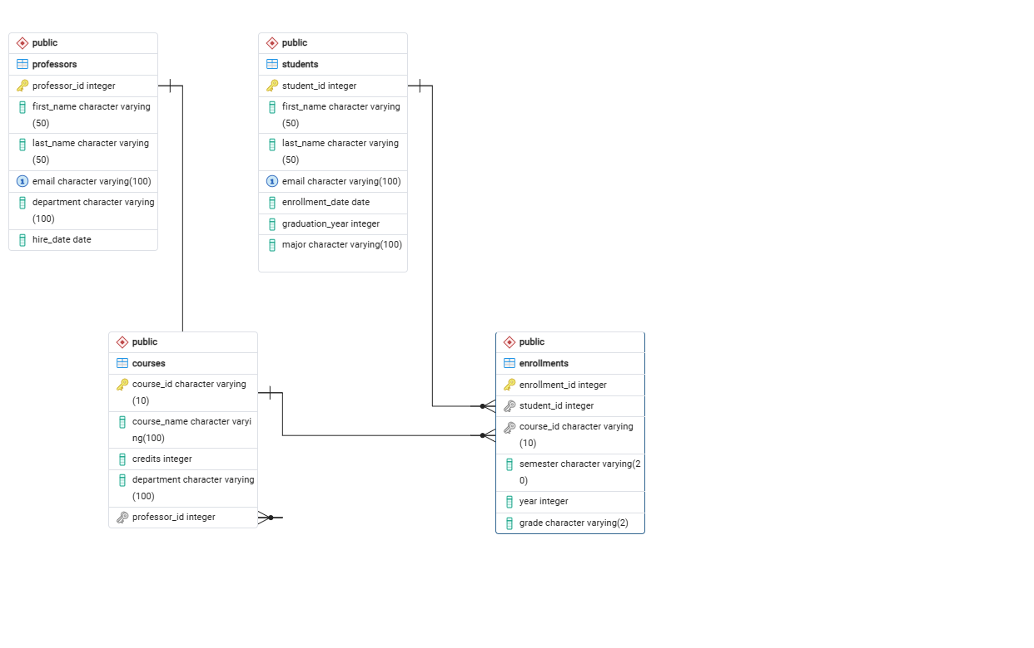
Figure 1. Entity-Relationship Diagram of the School Database
The professors table is connected to the courses table through professor_id. The students table is connected to the enrollments table through student_id, and the courses table is connected to the enrollments table through course_id. The diagram also helped identify the correct order for creating the tables and inserting the data.

5. Database Implementation

5.1 Database Creation
The database was created using the 01_create_database.sql script. The database name is school_db.
CREATE DATABASE school_db;
After the database was created, the remaining scripts were executed inside school_db.

5.2 Creation of Tables and Relationships
The tables and relationships were created using the 02_create_tables_relationships.sql script. DROP TABLE IF EXISTS commands were placed at the beginning of the script so that the table structure could be recreated without manually deleting existing tables.
The tables were created in the following order:
- students
- professors
- courses
- enrollments
Students and professors were created first because they do not depend on other tables. Courses was created after professors because courses.professor_id references professors.professor_id. Enrollments was created last because it references both students and courses.
Primary keys, foreign keys, NOT NULL constraints, UNIQUE constraints, and a CHECK constraint were used to maintain data quality and referential integrity.

5.3 Preparation of CSV Files
A separate CSV file was prepared for each table. Every CSV file contains a header row that matches the column names of its PostgreSQL table.
CSV File | Number of Records
students.csv | 7
professors.csv | 4
courses.csv | 6
enrollments.csv | 10

The CSV files contain the complete data used in the database. Identifiers, dates, departments, course information, and grades were checked against the table structure.

5.4 Data Insertion
The data was inserted using the 03_insert_data.sql script. Records were inserted into students and professors first, followed by courses and enrollments. This order ensured that referenced parent records existed before foreign-key values were inserted.
The script uses grouped INSERT INTO ... VALUES statements. This keeps the script organised and allows multiple records to be inserted with one statement.

5.5 Data Verification
After inserting the records, the number of rows in each table can be checked using the following queries:
SELECT COUNT(*) FROM students;
SELECT COUNT(*) FROM professors;
SELECT COUNT(*) FROM courses;
SELECT COUNT(*) FROM enrollments;
Table | Expected Number of Records
students | 7
professors | 4
courses | 6
enrollments | 10

6. Summary of the SQL Questions
Ten SQL questions were completed in the 04_questions_01_10.sql file. The questions demonstrate data retrieval, filtering, sorting, counting, averaging, date comparison, text pattern matching, and joining related tables.
Question | Task | Main SQL Technique | Expected Result
1 | Return the complete student roster | SELECT * | 7 student records
2 | Find Computer Science students | WHERE | Alex Thompson and Emily Chen
3 | Order courses by credits | ORDER BY DESC | 4-credit courses before 3-credit courses
4 | Find students graduating in 2026 | WHERE | 3 students
5 | Count all courses | COUNT | 6 courses
6 | Calculate average course credits | AVG | Approximately 3.67 credits
7 | Find students enrolled after 2022 | Date comparison | Emily Chen and David Kim
8 | Find Computer Science professors | WHERE | Dr. John Smith
9 | Find university email addresses | LIKE and ORDER BY | All 7 students
10 | Match professors with courses | INNER JOIN | 6 professor-course records

7. pgAdmin Query Results and Screenshots
This section provides a brief explanation of each SQL question. A pgAdmin screenshot should be inserted below each explanation to show the SQL query and its result.

7.1 Question 1: Complete Student Roster
Question 1 returns all columns and all seven records from the students table. It demonstrates the basic use of SELECT * to retrieve a complete table.
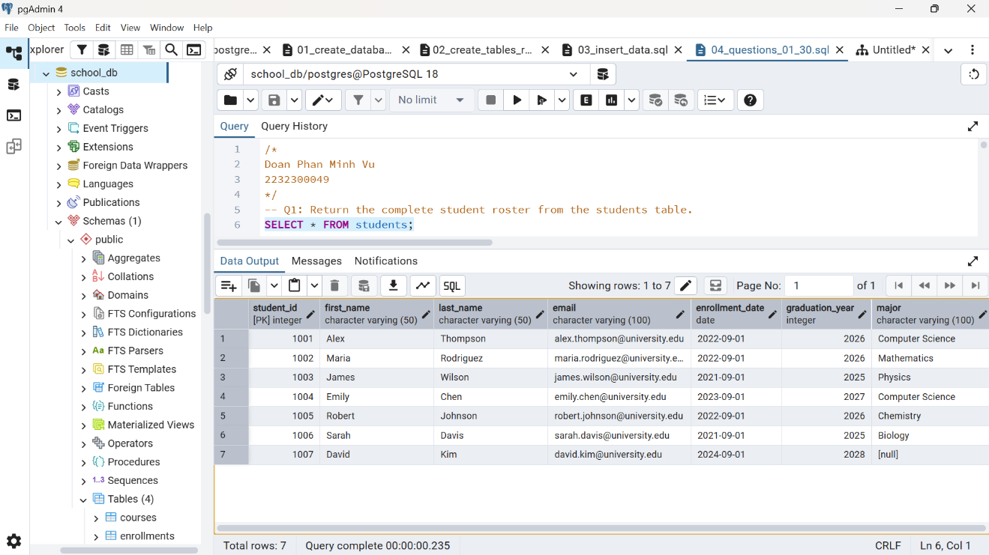
Figure 2. Complete Student Roster

7.2 Question 2: Computer Science Students
Question 2 uses a WHERE condition to return students whose major is Computer Science. The result contains Alex Thompson and Emily Chen.
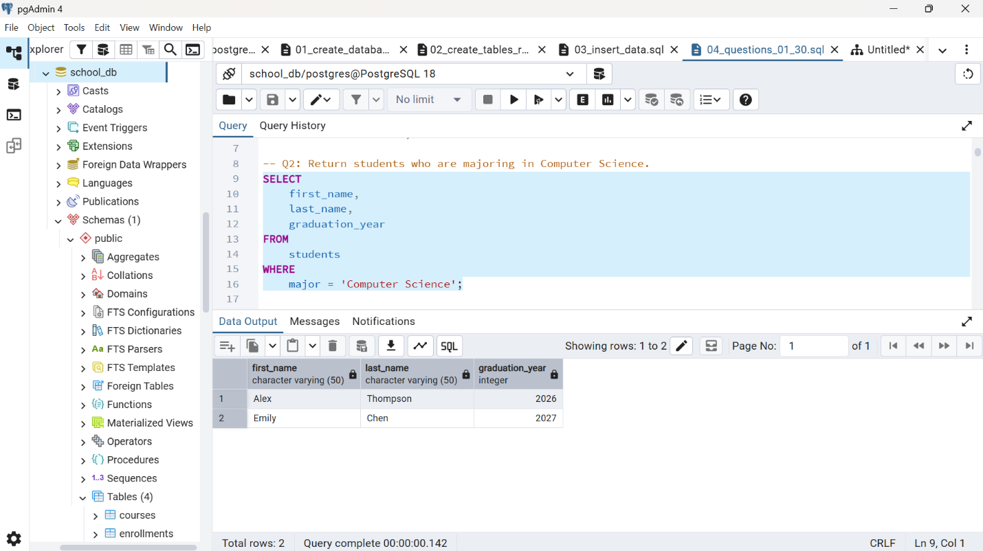Figure 3. Students Majoring in Computer Science

7.3 Question 3: Courses Ordered by Credits
Question 3 sorts courses from the highest number of credits to the lowest using ORDER BY credits DESC. Four-credit courses appear before three-credit courses.
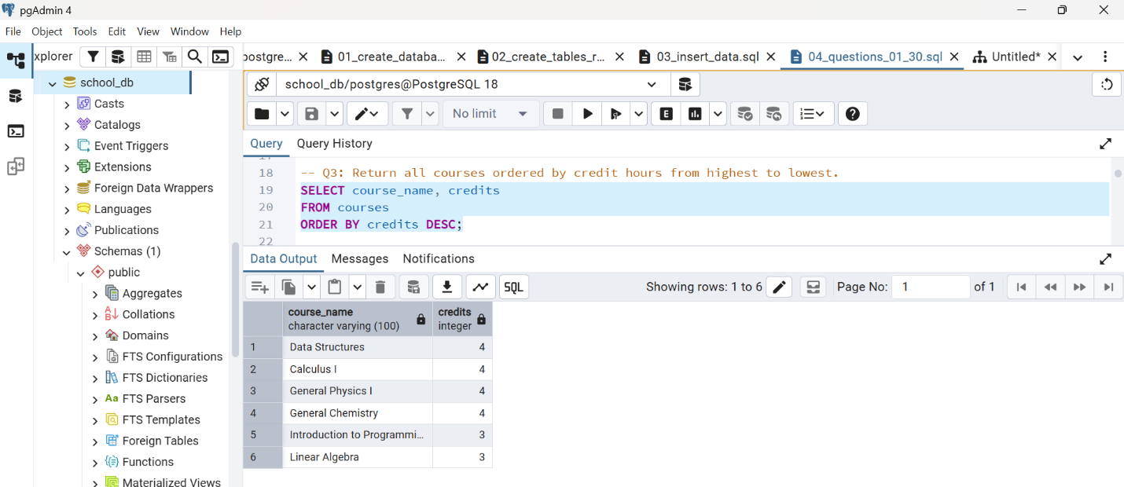Figure 4. Courses Ordered by Credit Hours

7.4 Question 4: Students Graduating in 2026
Question 4 filters the students table by graduation_year = 2026. The result contains Alex Thompson, Maria Rodriguez, and Robert Johnson.
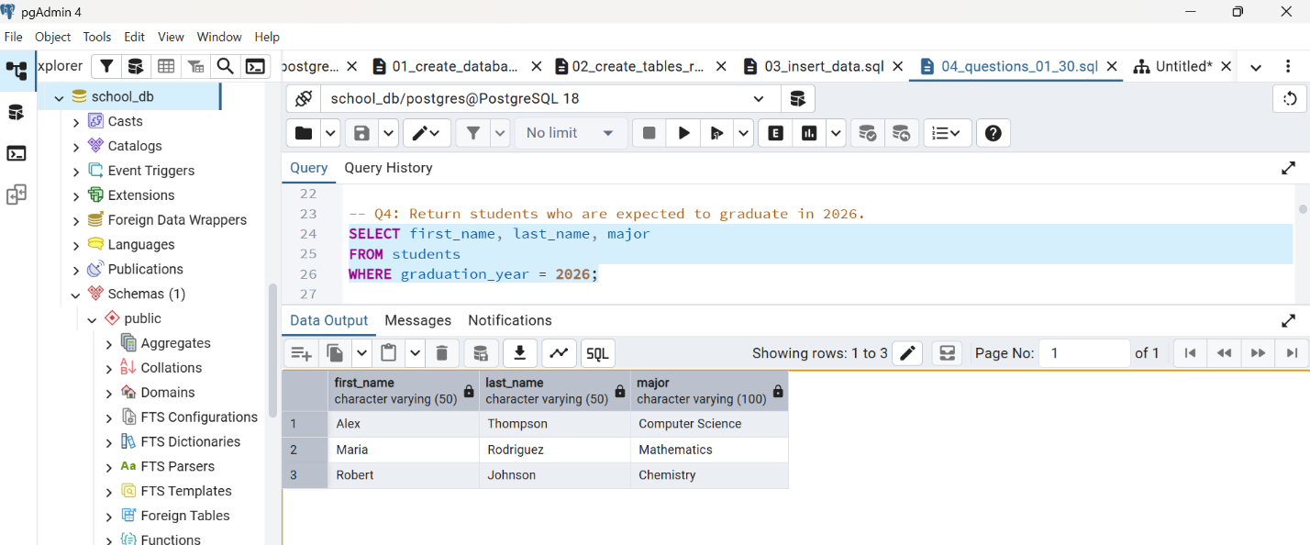
Figure 5. Students Expected to Graduate in 2026

7.5 Question 5: Total Number of Courses
Question 5 uses COUNT(*) to calculate the total number of courses. The result is six.
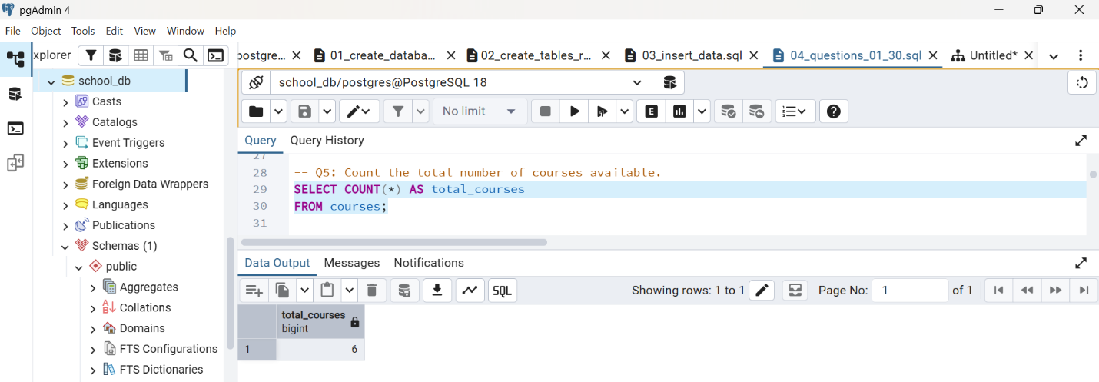Figure 6. Total Number of Courses

7.6 Question 6: Average Credits per Course
Question 6 uses AVG(credits) to calculate the average number of course credits. The result is approximately 3.67 credits.
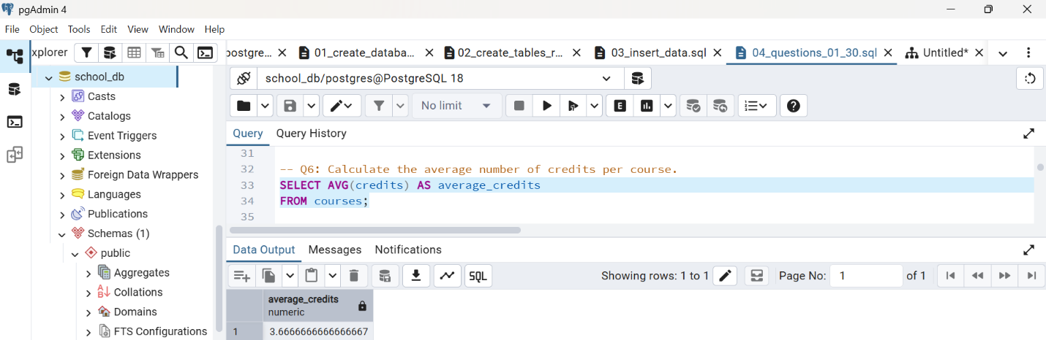Figure 7. Average Number of Credits per Course

7.7 Question 7: Students Enrolled After 2022
Question 7 compares enrollment dates and returns students who enrolled after December 31, 2022. The result contains Emily Chen and David Kim.
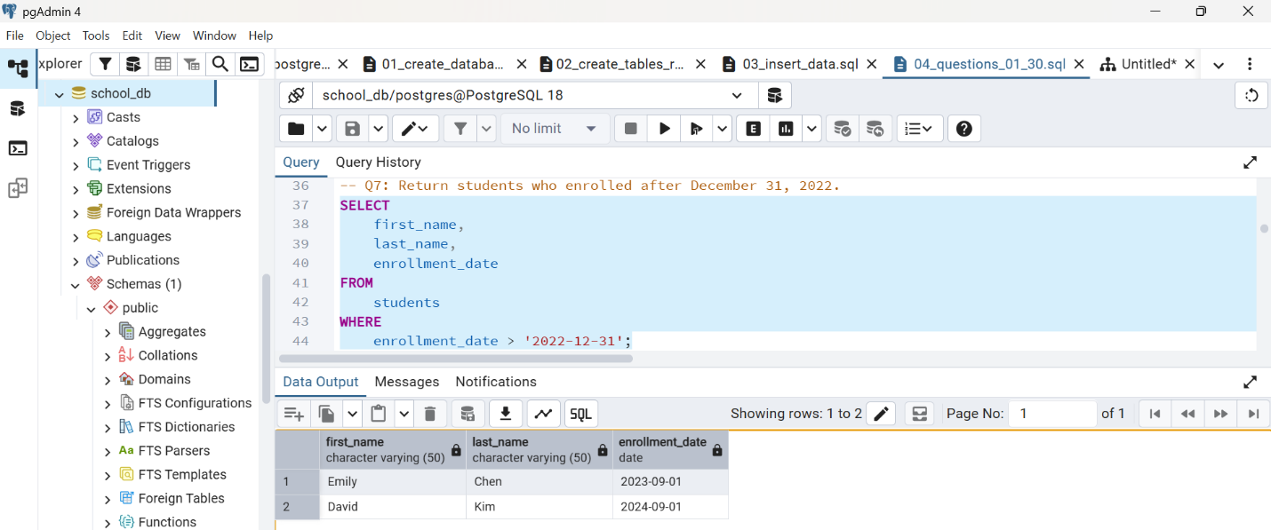Figure 8. Students Enrolled After December 31, 2022

7.8 Question 8: Computer Science Professor
Question 8 filters the professors table by department. The result identifies Dr. John Smith as the Computer Science professor.
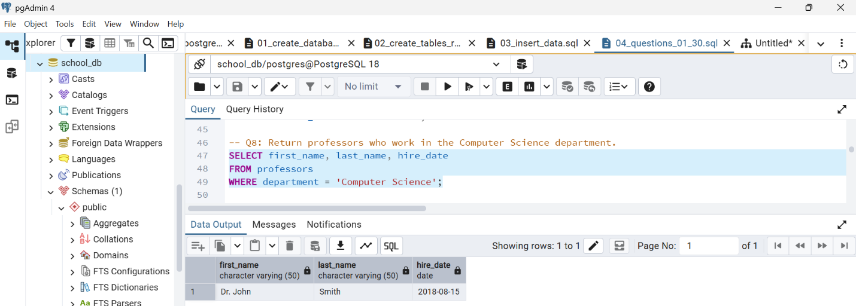Figure 9. Professor in the Computer Science Department

7.9 Question 9: University Email Addresses
Question 9 uses LIKE to return students whose email addresses contain the university.edu domain. All seven students meet this condition, and the output is ordered by last name.
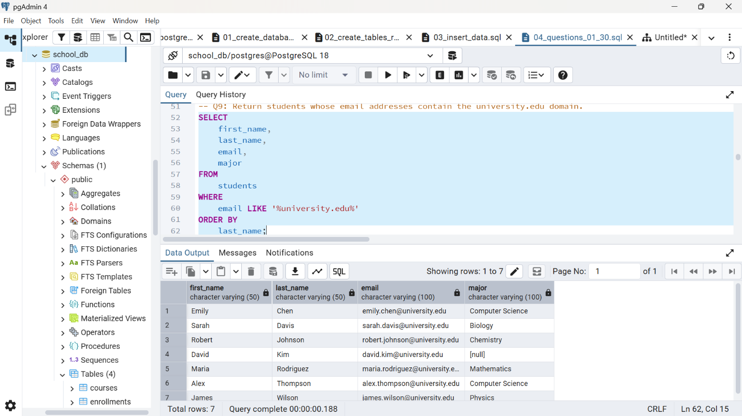Figure 10. Students with University Email Addresses

7.10 Question 10: Professors and Their Courses
Question 10 joins professors and courses through professor_id. It displays each professor, department, assigned course, and number of credits. The result contains six professor-course records.
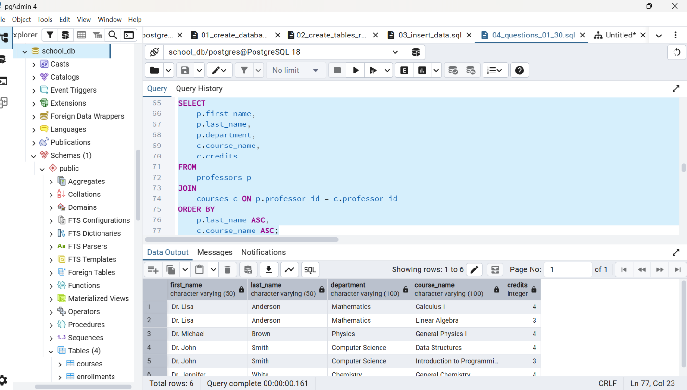Figure 11. Professors and Their Assigned Courses

8. Challenges and Solutions

8.1 Creating Tables in the Correct Order
One challenge was determining the correct order for creating the tables. The courses table depends on professors, while enrollments depends on both students and courses. The parent tables were therefore created before the dependent tables.

8.2 Inserting Data in the Correct Order
Data also had to be inserted in an order that respected the foreign-key relationships. Students and professors were inserted first, followed by courses and enrollments. This prevented foreign-key violations.

8.3 Handling an Undeclared Major
One student had not declared a major. The value was stored as NULL instead of an empty or incorrect text value. This correctly represents information that is not yet available.

8.4 Using Consistent Date Values
The SQL insertion script uses the ISO date format YYYY-MM-DD. This format reduces confusion between day, month, and year and helps make the database reproducible.

8.5 Maintaining Data Integrity
Primary keys prevent duplicate identifiers, UNIQUE constraints prevent duplicate email addresses, the credits CHECK constraint prevents invalid course credits, and foreign keys prevent records from referring to missing students, professors, or courses.

9. Conclusion
This project demonstrated the process of creating and managing a relational School database using PostgreSQL and pgAdmin 4.
The database contains four related tables: students, professors, courses, and enrollments. Primary keys, foreign keys, unique constraints, required fields, and a check constraint were used to maintain data integrity.
Separate SQL scripts were prepared for creating the database, creating the tables and relationships, inserting the data, and answering ten SQL questions. Separate CSV files were also prepared for each table.
The ten questions demonstrated data retrieval, filtering, sorting, aggregate functions, date comparisons, text pattern matching, and joins. Through this project, I improved my understanding of relational database design, foreign-key dependencies, data insertion, PostgreSQL syntax, and SQL query testing.

10. GitHub Repository
The complete School Database Project is available in the following public GitHub repository:
https://github.com/kenphan303/MIS443_2232300049_School
The repository contains the SQL scripts, CSV data files, Entity-Relationship Diagram, Word report, README.md file, and instructions for recreating the database.

