Online Store

## Team Members:

| Name | Email | Student No. |
| --- | --- | --- |
| Ken Borja | kenpatrick.borja@gmail.com | 34279007 |
| Alvin Edward | alvinedward12@gmail.com | 34331539 |
| Vedricko Angkasa | vedrickoangkasa19@gmail.com | 34315379 |
| Lee Ming Han | chah3929@gmail.com | 34307477 |

## Project Description:

An online store that allows the user to search for available products in the store. A variety of items and other components are listed on the site.

## Description of the User Interface:

This is the temporary look of our online shop application. It contains a header part which consists of the online shop brand name, menu button as well as main image. The main image part will have three images in which the user will be able to use the image slider button to see the other photo.

For the body section of the online shop, there will be 4 sections which include the top seller, category, new products and what’s new section. Customers can search through our products in these sections.

At the very bottom of the online shop application will be the footer section. Customers will be able to sign up for the online shop newsletter to gain any information about promo or news from the online shop.

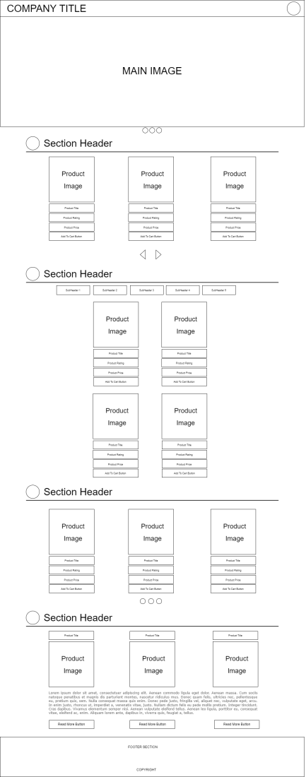

Fig 1. Sketch of the user interface.

## Interactions Implementation:

The user can add the desired product to their wishlist or cart. When they have decided what they want to buy, they may go to the checkout page to place their order. A relevant platform or method for online payment can be selected. The user would need to sign up with their email address, and there would be a check to verify the users. Also, there will be a search function to find specific products more efficiently.

## Database Implementation:

For this project, we will use MySQL for our database with the help of PHP for our backend, which allows us to collect form data, send and receive cookies, modify data in the database, etc.

## Additional Features:

No additional features for the current project, however, as the project progresses, the team might include additional features on the application if needed.

Team Charter

## The Team:

| Name | Contact Details |
| --- | --- |
| Email |
| Ken Borja | [kenpatrick.borja@gmail.com](mailto:kenpatrick98@gmail.com) |
| Alvin Edward | [alvinedward12@gmail.com](mailto:alvinedward12@gmail.com) |
| Vedricko Angkasa | [vedrickoangkasa19@gmail.com](mailto:vedrickoangkasa19@gmail.com) |
| Lee Ming Han | [chah3929@gmail.com](mailto:chah3929@gmail.com) |

## Communication with the team:

Communication with the team will be on Telegram as due to the pandemic we are advised to remain at home and not to conduct a face-to-face meeting.

## Expectations of each team member:

We expect that all team members can manage and find some time to discuss and complete this assignment together as a group.

## Constraints on each team member:

| Name | Constraints |
| --- | --- |
| Ken Borja | Work part time. |
| Lee Ming Han | Work full time |
| Vedricko Angkasa | Work part time |
| Alvin Edward | Work part time |

## Conflict Resolution Procedure:

We will prioritize this assignment and discuss the available time with each of our team members.

The leader will make sure everyone will voice out their opinion not only just for assignment related but also team member problems (if any) that affect their performance in this assignment.